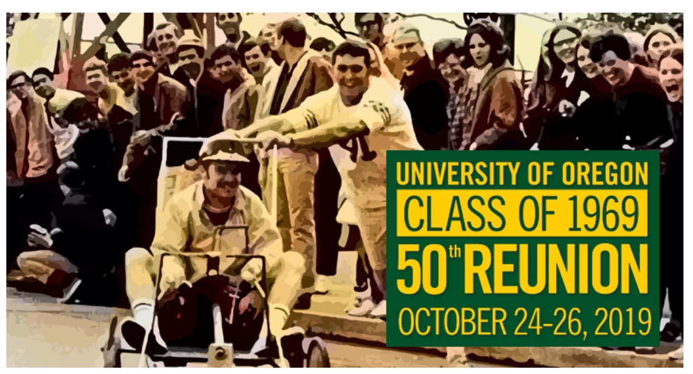
Actors Needed for 2019 UO Homecoming Event

Date: Friday, October 25th
Time: 6:00pm-7:15 pm
Location: Ford Alumni Center

Event specifics: The Class of 1969 is having a cocktail hour reunion in the Ford Alumni Center which would feature 14 students modelling 1960’s outfits during the event. If you are interested we would love to have you flash dance to a 60s tune towards the end of the cocktail time.

Outfits will be provided by the Alumni Center staff

Thursday, 10/25 from 6:30-7:15 (arriving around 6 to be given/fitted into your outfit).

Compensation: Students would be compensated with a gift card to a local business.

Interested students can contact Gail Hayes Davis at: 503-803-7192 (text okay) or at gailhayesdavis@gmail.com

