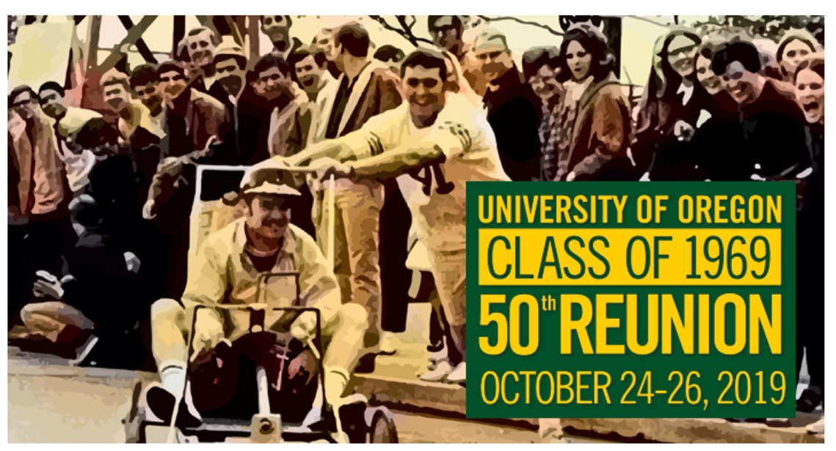
Actors Needed for 2019 UO Homecoming Event

Date: Thursday, October 24th
Time: 6:00pm-7:15 pm
Location: Ford Alumni Center

Event specifics: The Class of 1969 is having a cocktail hour reunion in the Ford Alumni Center which would feature 10-12 students modelling 1960’s outfits during the event. If you are interested we would love to have you flash dance to a 60s tune towards the end of the cocktail time. We also need a volunteer specifically to wear a Black Panther outfit-this along with the Vietnam War dominated our years at the University and we would to acknowledge their contribution.

Outfits will be provided by the Alumni Center staff

Thursday, 10/24 from 6:30-7:15 (arriving around 6 to be given/fitted into your outfit).

Compensation: Students would be compensated with a gift card to a local business.

Interested students can contact Gail Hayes Davis at: 503-803-7192 (text okay) or at gailhayesdavis@gmail.com

