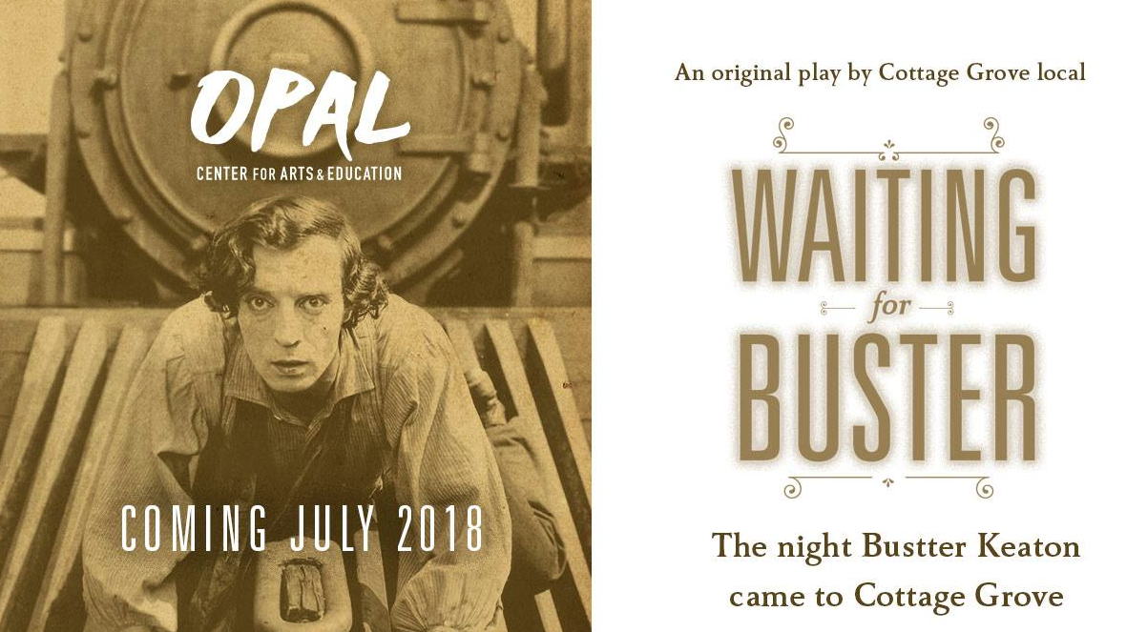

AUDITIONS!
ABOUT THE SHOW
On the night Buster Keaton, scouting locations for his film "The General," first comes to Cottage Grove, the town erupts with excitement. A cast of locals wonders what Buster's arrival will mean for them, while Frances, pianist for the local movie house, faces the biggest decision of her life. Peppered with Cottage Grove history, a few songs, and many laughs, Waiting for Buster looks back at the 1920s, showing that as times have changed, deep down people are very much the same.
AUDITION DATES
June 1, 7pm
June 2, 2pm

REHEARSALS
MON—THURS, JUN 4—July 12, Opal Theater, Cottage Grove

EVENT CAST & PARTICIPANTS
Martha Watson, 40s, owner of The Arcade Theater
Owen Watson, 20, theater projectionist and Martha's son
Frances, 20, pianist for the theater
Helen, 20, Frances' best friend
Uncle Frank, 40s, Frances' uncle
Harry Barnes, 30s, Hollywood producer
Home Galloway, city councilman
Berk Homer's, right-hand man
Juanita Chapelle, leader of anti-Hollywood protests
FOR THE AUDITION
Before the audition, we'll post pages from the script if you'd like to read before the audition. For the parts of Frances and Helen, singing is required—but it doesn't have to be the best singing ever. Bonus points for the part of Helen if the actor can play ukulele.
SHOW DATES
July 13, 8pm
July 14, 8pm
July 15, 2pm (Sunday matinee)
July 20, 8pm
July 21, 8pm
July 22, 2pm (Sunday matinee)

