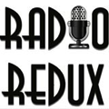

Radio Redux Marketing Strategy
Creating awareness for younger audience attendance
Tara Burke. MMCII. Winter Term 2015

I. Overview
Radio Redux is a theater company based in Eugene, Oregon. The mission of Radio Redux is to celebrate “theater of the mind” programming heard on the radio between 1935-1960. Radio Redux focuses on Old Time radio programs from such hallmark radio series as Mercury Theatre of the Air, Lux Radio Theatre, Suspense and Screen Guild Players. Radio Redux performs at the Hult Center for the Performing Arts’ Soreng Theater. The Hult Center is the premier performing arts center that holds nationally recognized theatrical and musical performances. They have participated in several venues and events all throughout Eugene. Fred Crafts founded radio Redux in 2009. The primary goals for Radio Redux are to celebrate radio’s rich history, revive its most-memorable moments, preserve its unique art form, and introduce its wonders to new audiences.

Summary of Marketing Goals and Objectives

Main Goal: To increase younger audience demographic attendance throughout the season.

Objectives

- To spread Radio Theater to generations that haven’t had direct exposure.
- Providing youthful audience for this specialized niche. Radio is hip! Lets show it through audience support!
- To provide an opportunity for college students to get experience marketing for an arts organization and non-profit.

Marketing Strategies
These objectives can be implemented through the proposed marketing strategies of guerilla marketing, social media, and a brand ambassador position targeted towards hiring college students.

Desired Outcomes
- Creative audience engagement tactics
- To build a stronger social media presence
- A rise in attendance of ages 25-40
- Greater awareness for Radio culture amongst the Eugene community
- Building stronger arts marketers

II Situational Analysis
Environmental Scan
Economic: Radio Redux is supported with a consistent fan base that sells out productions regularly throughout their season. The main demographic usually has enough accessible income to be able to pay for the current priced ticketing structure. They usually sell out their seats every show, so their current marketing strategies have proven to be successful.
Cultural: Radio Redux is a cultural experience that enriches entertainment through bringing back the golden age of radio. Fred Crafts is an ambassador to the arts in Lane County and this also provides a lot of encouragement and prestige around the production. Radio Redux wants to begin to explore youth culture as there is a definitive revivalist movement happening among millennials.
Demographic: Radio Redux typically attracts an older demographic with the average age range between 50-65. This is due in part to how the content is being presented and the direct experience many audience members have had with radio their past, which provides nostalgia around the radio generation.
SWOC Analysis of 4P’s
Product | Price | Place | Promotion
Unique product niche  Good price points for Seniors (main demographic)  Variety in program variation.  Sustained audience, consistently selling out audience  Consistent programming without too many shows, doesn’t get boring or overdone in a season | High priced tickets for younger audiences  Biggest discount is to oldest audience  Perks for season ticket holders Loyal audience that returns each production  Competitive pricing with the rest of Hult Center shows | Highly visible venue-Soreng theater  Not the most welcoming environment, slightly elitist (Hult Center)  Centrally located near downtown | $18-Seniors  $21-Adults  Is the organization's virtual presence as inviting as the real world location?  Needs the building of a communications infrastructure and the creation of content. Selling experience, not tangible objects

Audience Analysis
Radio Redux provides a value to the audience for the Golden Age of radio. With prior knowledge and past experience of this content, it makes it easily accessible for an older demographic. However, it is important to want to build more variety in their audience base. Radio Redux does not need to worry about filling their seats; they just want to allow for several different types of audience members to enjoy the experience. There has to be more emphasis on how Radio Redux can connect with this younger generation and bridge their programming attendance gap. Radio Redux has a nostalgia that is currently trending because it brings back old time radio culture through guerilla marketing, social media marketing, and reaching out for a student ambassador position, Radio Redux can begin to bring younger audience members through the door.

Marketing Strategies

Guerilla Marketing
Radio Redux currently markets by flyering around town, small radio ads, and word of mouth. If Radio Redux is wanting to engage a younger audience, it would be recommended to figure out ways to bring more awareness to channels in which a younger demographic currently utilizes. Radio Redux is looking for more creative channels that bring more attention to their product. When targeting the specific demographic, Radio Redux is looking to engage the 25-34-age range that currently makes up 13.4% of Eugene (eugene.areaconnect.com).
Radio Redux could benefit from branching out beyond the Hult Center doors and expose younger audiences and families in their programming. Strategies towards this engagement include guerilla-marketing tactics such as co-sponsoring an event such as the First Friday Art Walk, sticker decals throughout the event, and flash mob radio.
Guerilla Marketing
Guerilla marketing would provide a great context for younger audiences to become aware that something like Radio Redux is happening around Eugene. It relies on personal interactions utilizing a small to no cost budget. The idea is to create Radio Redux as an edgier product, which would likely attract younger audiences, to respond positively.
- Co-Sponsoring an event (4X/Year): One way to engage in guerilla marketing would be to co-sponsor an event such as Lane Art Councils’ First Friday Art Walk. This art walk promotes downtown revitalization, arts, and entertainment every first Friday of the month. Event sponsorship is a great way to get the product out there. This is an excellent way to give away free promo materials. There is power in collaboration and when working within a smaller budget, joint funds can be pooled together to increase outreach efforts.
- Sticker/Window decals (Maximum 2 month project): This removable window decal could be a symbol for the event as well as a great way to market two great existing organizations. Stickers are great because they are generally low cost, easily distributed, and are definitely a favorite for younger audiences. Radio Redux and Lane Arts could design an event specific sticker for the First Friday Art Walk, and an additional Radio Redux sticker could be created to stand on its own and have the schedule of shows on the back side of the sticker. Below are examples of stickers and window decals.
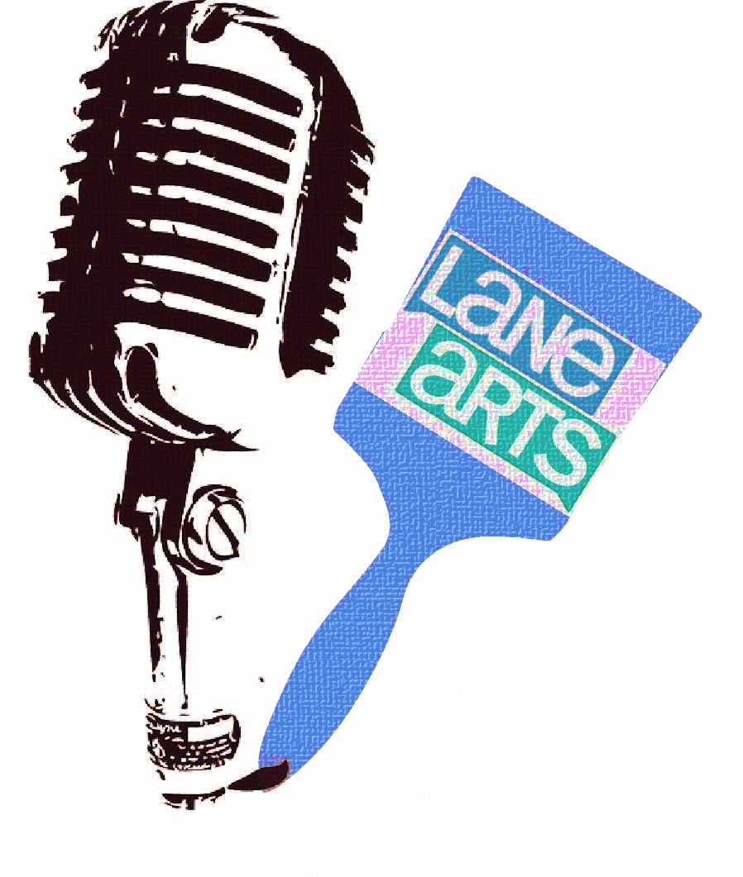

- Flash Mob Radio Bulletin (2 weeks to rehearse & plan): The Flash Mob Bulletin is a refreshing approach towards promotion for an upcoming production. Radio Redux could enlist help from volunteers, longtime audience members, and actors if they were interested in participating. They would simply script a small bulletin advertising the upcoming show similar to a breaking news bulletin. This doesn’t necessarily have to include any of the actors either. During the Art Walk, the radio bulletin could pop up; just how radio news bulletins would be announced in the past (breaking news!) This would create excitement around what Radio Redux actually does on stage without giving away too much of the show.

Implementation//Resources//Budget
Personnel
- Current existing staff//existing marketing budget
- Lane Arts Council Staff//education intern per UO
- Volunteers//time required to train them by Actors for Flash Mob
- Actors for Flash Mob (optional)
Materials and Supplies:
- Outreach materials for Radio Redux to have at each stop on Art Walk (brochures, pamphlets-part of printing budget, in-house printing poss.)
- Sticker Materials ($150 for 250 stickers via stickergiant.com-prices may vary)
- Costumes for Volunteers for Flash Mob just effort
Technological resources:
- Computer access for marketing Art Walk
- Access to Graphic Designer for Sticker Design (hourly wage $25-30/hr)

Media:

- Social media//print distributions//stickers//word of mouth

Printing, production, distribution:

- Flyers throughout Eugene businesses//radio ads with KRVM//partnerships with QSL for discounted printing

Sponsors and Service trades:

- Eugene Arts and Business Alliance, Lane Arts Council, Hult Center, Downtown Eugene businesses, Eugene chamber of Commerce

Timeline

Every month of Co-sponsorship event (4X per year)
One-Month Out:
*Connect with Lane Arts council about event details
*Putting together necessary materials for outreach of event (the 5 W’s/4 P’s)
Three Weeks Out:
*Making sure that graphic for sticker/window decal fits specs.*Doing research on most affordable sticker pricing
*Beginning to draft radio flash bulletin script
Two Weeks out: Write Facebook event, start posting Instagram content, gathering interested individuals for flash mob bulletin, making necessary orders for stickers/window decals, contacting First Friday art venues that want to collaborate and use the window decals.
One Week out: Beginning to put stickers up in unusual places and using them in Social Media ads, getting ads in newspapers and local media channels. Following weekly social media calendar.
Three Days prior: Connecting with Lane Arts Council about last minute details, writing emails gathering all interested members of flash mob bulletin, handing stickers out to First Friday art venues
Day of Event: Making sure to capture footage for Facebook, Instagram. Taking soundbytes of the Radio Flash Mob, capture footage for other social media apps (i.e. Snap Chat)

Social Media Plan (Weekly)
When looking at how to run a successful Social Media, we need to have more listening and less talking. Radio Redux needs to be able to read the target audience’s online content and join discussions that are relatable. Since this marketing plan is focusing on a younger demographic it is important to stick with this content that would engage a younger demographic. Contests, content sharing, and trivia are all aspects on social media platforms that help build more viewers. Within this social media strategy, Facebook, Instagram and Soundcloud serve as great resources for Radio Redux to get the word out on events as well as engage younger generations in radio culture.

Facebook
It will be important to utilize Facebook for Radio Redux’s upcoming events and performances. Currently Radio Redux uses Facebook to promote their upcoming shows about two-three weeks before. The Facebook page currently has 464 likes. When looking at the social media plans for Facebook there are several suggestions to improve their presence.
- Using Facebook to post about upcoming events that deal with Radio Culture. Posting interesting articles, Weekly voices in Radio (giving folks a connection to the history of Radio), this day in the history of Radio posts. Putting up content that isn’t all about Radio Redux, but centrals around the theme of “The Golden Age of Radio”.
- New engagement strategies of Facebook such as asking for “shares”, posting fill-in-the-blank posts.
- Using Facebook for extended outreach and consistent posting (not just posting happening before events). Great way to build communication with younger demographics

Benefits: Large audience to reach. Used mostly by younger audience members to gain access to upcoming events. Facebook provides free advertising towards upcoming events with collaboration being possible with other arts organizations. For example, in the upcoming co-sponsorship of the First Friday Art Walk an event page could be created to gain more interest

Challenges:
Facebook will only reach so many for free. They have started to monetize their advertisements. Facebook is oversaturated with personal opinions that can lead to bias representation.

Instagram
Instagram helps with social engagement through photos and content sharing. There are currently 130 million active users on Instragram and every day 1 billion photos are liked. Hashtags are a major part of Instagram. They have become a big way in which users can find content through their mobile searches. Unlike on other sites,
When Radio Redux creates an Instagram they can instantly connect to their Facebook page, boosting their marketing efforts. When looking exclusively for Instagram content sharing, Radio Redux can do the following:
- “Behind the Scene” photo sharing which currently holds space on the website. This can now transition onto Instagram, allowing for wider audience outreach. Generating more photos that can lead up to production, premieres and post production are great places for engagement.
- Include the business name in some of your post hashtags (#redux, #revivalradio). Using unique tags for particular marketing campaigns you run. For example, hosting a ticket giveaway contest, making a unique tag just for the contest. These tactics will both promote the contest, and gives consumers a distinct tag to connect with others participants (so they can see their competition!).

Benefits: Instagram maximizes user following. With pictures being worth a thousand words, this picture can pull in the audience allowing them to create meaning with using little or no words. With the use of hash tags, you have created essentially a search database to filter out specifically on needs/wants/desires. You can make 15 second videos that operate as commercials for you are delivering. This would be a great opportunity for Radio Redux to focus on gaining a younger target audience. With the rise of contests and giveaways on Instagram, this would allow Radio Redux a wider audience range to present and spread the art of radio-theater.

Challenges: Similar to that of Facebook. The open forum concept also allows for feedback that can be negative and promote undesired attention. Instagram account users have also found ways to gain “followers” through artificial means. It seems that users are more concerned with how many followers they contain then the actual content that is being created.
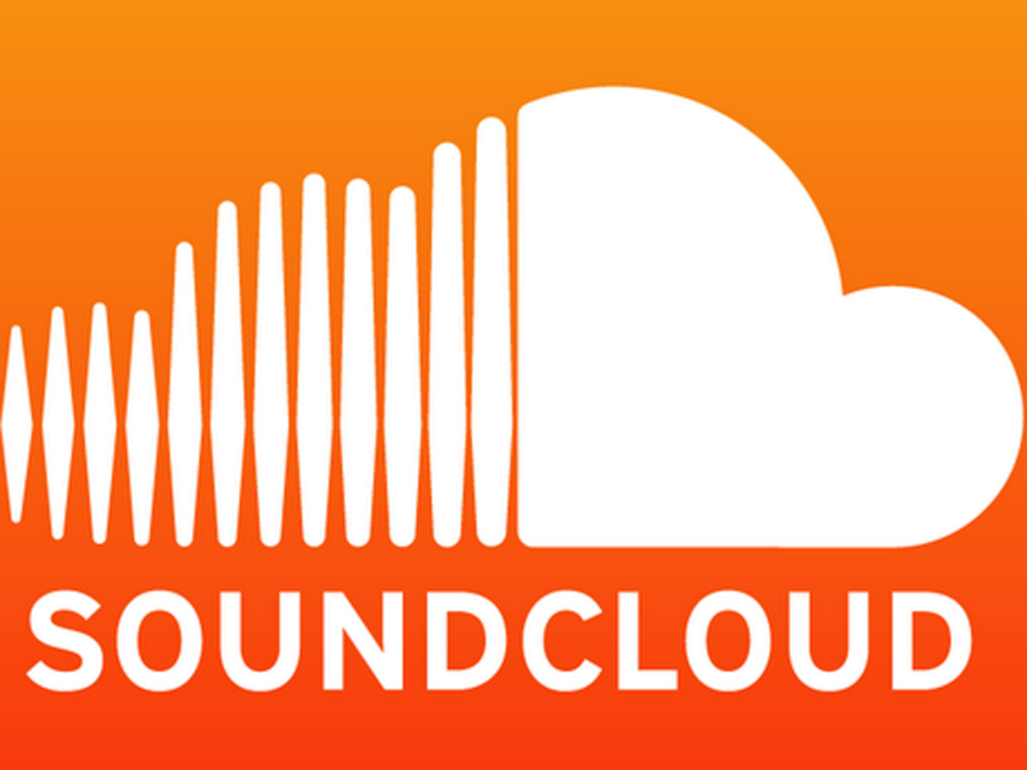
Soundcloud
Soundcloud has the least amount of social media presence of Instagram and Facebook, but it grabs a different type of social media fan, one that is drawn by audio rather than visual. Soundcloud provides the experience for an audience member who wants to relive and recreate in the experience from the comfort of his or her own home. Soundcloud is a great platform for audio files, interviews and podcasts about radio culture. Here are some suggestions when utilizing SoundCloud:
- Soundcloud would be a great platform for interviews with cast members. There has been some activity on Soundcloud in the past. To generate more followers and plays on Soundcloud one can:
- Add more tracks to Radio Redux
- Following people’s whose music relates to Radio Redux
- Leaving genuine comments on tracks that can promote Radio Redux simultaneously
- After each show, Radio Redux would be able to offer the availability to download the show for free. A QR code would be included in the back of the program that would ONLY paying patrons the opportunity to have access to the download.

Benefits: SoundCloud provides a different medium than Instagram or Facebook. SoundCloud is a free audio sharing platform that allows for recording to be embedded into websites and other social media platforms. It is a great way for users to share sound bytes between each other and build an audience just by providing sound. Radio Redux currently is using SoundCloud to embed on their website for listening. This would be great to offer as a stream for those who may not be in state to attend the show. Being able to use and share these recordings would allow for Radio Redux to reach an audience outside of Eugene, Oregon.

Pitfalls: SoundCloud has been around since 2008, so it has seen the rise and fall of the trends around social media marketing. The biggest pitfall with SoundCloud would be lack of use. Soundcloud has artificial metrics that display popularity of certain tracks. The number of listens, likes, and reposts are made public like other social media platforms. Again, this can be beneficial or hurtful depending on exactly what the client is trying to create out of using the platform. Just like Facebook and Instagram, Soundcloud is completely user generated so the sound quality is not regulated and low-quality recordings with questionable sources including copyrighting still can remains a serious issue.

Social Media Calendar (Weekly)

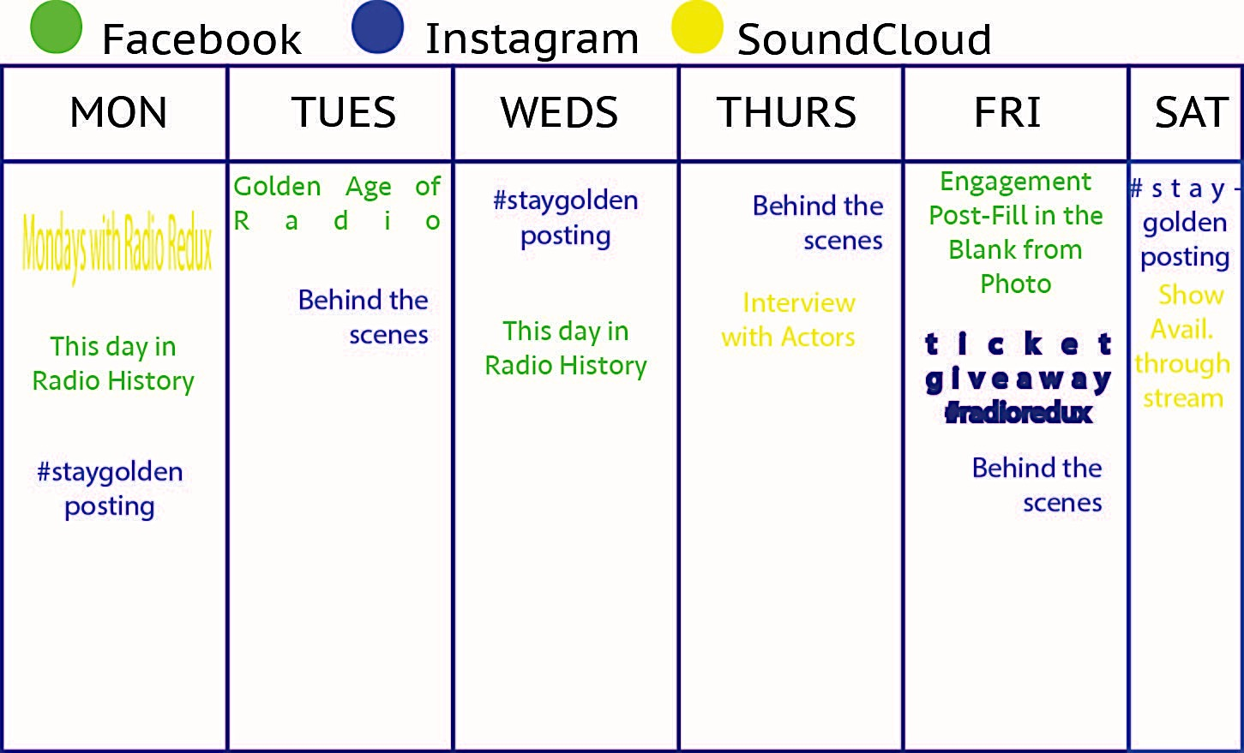

Implementation//Resources//Budget
Personnel
- Current existing staff (have to volunteer time to train intern)
- Part time Brand Ambassador (Intern/Practicum Credit)-FREE
Technological resources:
- Computer/Smart Phone (utilize already existing resources)-$0

Media:
- Social Media subscriptions/ /$0 (Facebook, Instagram, Soundcloud)

Sponsors and Service trades:
- University of Oregon, marketing students

Student Ambassador
This strategy will combine the previous two strategies, as they will become part of the tasks set out for the Brand Ambassador to complete. Brand marketing allows for employment by an organization or company that promotes products or services. The brand ambassador is meant to embody the identity and values of the organization. With a youth ambassador that is specifically hired through the college, this allows for Radio Redux to bring their identity to a younger demographic and begins to reach out to their much-needed audience.

Student Ambassador Position (Sample Job Description)
Radio Redux is looking to build the organizational outreach to the student population. Would you like direct experience marketing for an arts organization? Do you want to learn more about event planning and outreach for nonprofits? Do you want to build skills on how to fully run a successful social media campaign? The Student Ambassador acts as the liaison for the program and will help to direct marketing towards university audiences.

Tasks/Responsibilities

- Acts as campus contact for Radio Redux
- Learn about the upcoming season for Radio Redux
- Help coordinate guerilla marketing for First Friday Art Walk
- Assist in developing media package (press releases, Facebook events, Merchandise)
- Manages Facebook Acct (event postings, following other organizations)
- Manages Instagram Acct (photos, contest sharing, follows other organizations)
- Manages Soundcloud (uploading content, sharing content)

Position Requirements

- Enrolled in undergraduate/graduate study
- Ability to work for full ten weeks and possibly extend practicum throughout other terms
- Available 10-15/hrs per week to spend on spreading the good word of Radio Redux
- Basic understanding of Adobe Suite

Implementation//Resources//Budget
Personnel
- PODS department contacts//AAD Internship Instructor//AAD Faculty
-Discuss internship/practicum opportunities to take on for quarterly basis
- Excited student candidates for position
Materials and Supplies:
- Any written materials for student candidates to read about Radio Redux (scripts, magazine articles, anything that has been archived)
- Minimal supplies as student will have access to University resources
Technological resources:
- Personal computer access
- Adobe Creative Suite (free trial versions or retail price for package)
- Smart Phone for access to social media apps

Media:

- Social media//print distributions//stickers//word of mouth

Printing, production, distribution:

- Partnerships with QSL for discounted printing

Sponsors and Service trades:

- University of Oregon
Timeline for Hiring Process
1 Month before Fall Term starts
*Beginning to talk with PODS, AAD Program about the practicum opportunities
*Getting information in practicum packet for all incoming graduate students
3 Weeks before Fall Term
*Putting it out on the AAD List serves
2 Weeks before Fall Term
*Beginning to filter through applications, follow up questions, scheduling interviews
*Interviewing potential candidates and selecting ambassador
1 Week before Fall Term
*Orientation for Student Ambassador. Getting Facebook page access, setting up Instagram page. Talking about tasks and responsibilities as included in job description. Planning posts for the social media calendar. Getting approval from departments for necessary paperwork and contracts.

Evaluation Plan

Evaluating the success of Radio Redux means measuring quantitative and qualitative results that will be done by looking at the number of tickets every season that were bought by the targeted youth demographic, the amount of traffic on Facebook, Instagram and Soundcloud (overall) and the amount of stickers that were passed out throughout the course of our co-sponsorship events. Utilizing the analytics for sites such as Facebook is very effective for figuring out total reach of the posts that are being created. We will use bit.ly as a shortener for all of the “likes” that we share to help measure the number of clicks that we receive. This will measure the engagement of Radio Redux’s user and whether or not we are reaching our target audience.
Radio Redux will open up for word of mouth testimonials that will provide reflection on achieving the desired objectives. During the actual season, an evaluation form will be available both physically and online (QR Codes) for participants to respond with their thoughts about the production. They will also reply on where they found out about the show, to give further data to what channels Radio Redux is most successful when reaching their audiences. When looking into measuring the results of student ambassador, this can be done through the practicum report, weekly check-ins and learning goals/reflections that were developed by the ambassador and site supervisor at the beginning of their position.
We can measure the effectiveness of the guerilla marketing through how much the organization remains prominent/viral post-event. For example, noticing sticker decals in venues around town, an increase in ticket prices post-event as well as increase in the amount of users/followers/listeners on all our social media channels. When looking at the social media calendar, we can determine effectiveness by the amount of sharing we receive from other organizations. Reciprocity is essential in social media marketing, and there is value placed on collaboration. The Student Ambassador effectiveness can be measured through the quantitative and qualitative as mentioned above as well as the quantitative/qualitative measures of the other strategies. Since the student ambassador is carrying out the other two strategies, the success is directly connected with the success of hiring a student ambassador.
Radio Redux has potential to grow their future marketing tactics. They could move onto to bigger pieces of guerilla radio in an “a call to artists” for future merchandise or stickers. They could build stronger relationships and connections with KRVM and the local high school program that inspires students to have a voice in radio. Depending on Radio Redux desire to remain strictly within Oregon, crowdsourcing could be a possible outlet if there was an organizational objective to expand their performance scope into a national tour. Crowdsourcing is a great revenue generator to take art organizations to the next level in their performance production. The sky is the limit for Radio Redux, it is essential however that they find the personnel, time and energy to fulfill this marketing plan.

