Russian Vinaigrette
A very pretty & vibrant Russian salad!
http://natashaskitchen.com/2010/06/21/russian-vinaigrette-recipe-with-beets-and-sauerkraut/

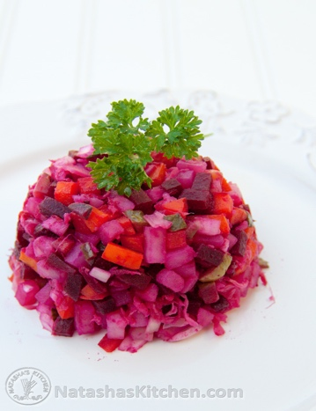
Ingredients for Russian Vinaigrette
3 medium beets (or 2 (14.5 oz.) cans of beets, drained)
3 medium potatoes
3 medium carrots
1/2 cup sauerkraut, drained
3 medium pickles
2 tbsp. sunflower or olive oil
1 tbsp. vinegar
1 small onion, finely chopped (about 1/2 cup)
How to Make Russian Vinaigrette
1. In a medium pot, boil beets for 1 hour or until they can easily be pierced by a knife (or use canned beets which don’t require any cooking).
2. In a separate pot, boil potatoes and carrots for about 30 minutes. Don’t overcook the potatoes.
3. Drain the vegetables and let them cool to room temperature.
4. Peel the skins from the potatoes, beets and carrots, then dice pickles, beets, potatoes, carrots & finely dice onion. Place diced beets in a separate bowl.
5. Mix the beets with the first tbsp. of sunflower oil separately, so that the beets will not stain the other ingredients.
6. Mix the beets and the rest of ingredients together with the second tbsp. of sunflower or olive oil and one tbsp. of vinegar. If desired, add more sauerkraut or pickles to taste. Refrigerate until ready to eat.
Bon appetite! = Приятного аппетита!

