AAD 610
  - Media Strategies Map
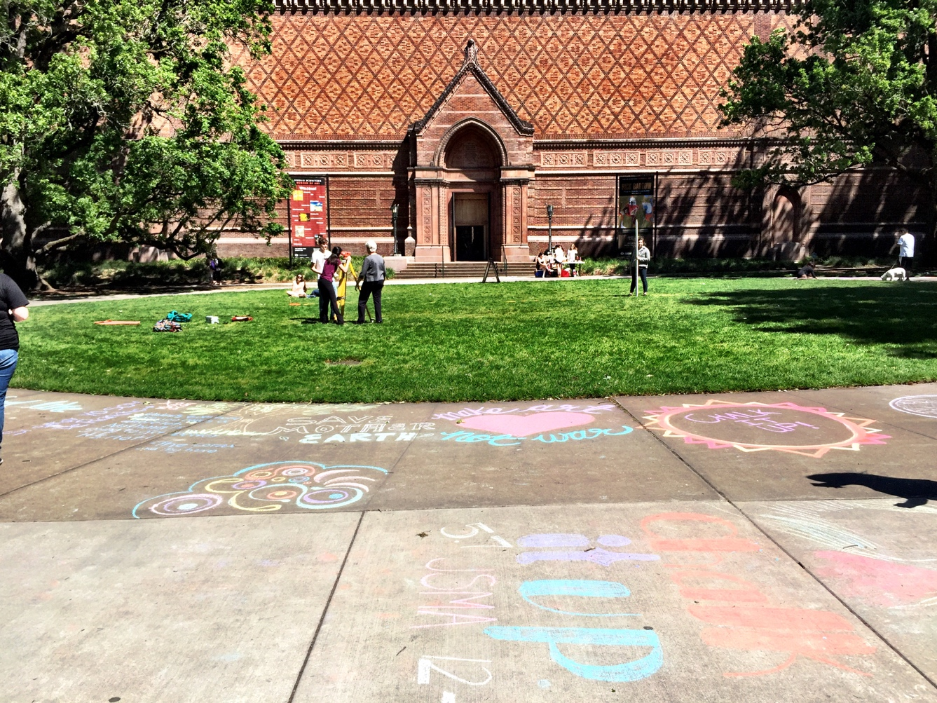
Sarah Wyer
22 Jan. 2016

MEdia Strategies
Web-based & Social Media
Current Media Inventory // Jordan Schnizter Museum of Art
Website // jsma.uoregon.edu website has current and upcoming exhibitions listed out, a calendar of events, a collections database, a staff list, a JSMA news feed, social media “share” buttons, and a contact form.
Social Media Presence // Facebook, Twitter, and Instagram.
Publications // JSMA publishes their own catalogs for in-house exhibitions, a quarterly member newsletter in magazine format, a calendar of events, and mail-able postcards with information about upcoming events and exhibitions.
Signage // JSMA puts up signs regularly outside their museum.

This Media Strategies Map draft gives an overview of 4 potential social media marketing techniques: Facebook, Instagram, and the E-Newsletter. I will explore how these social media strategies could benefit the marketing efforts of the Jordan Schnitzer Museum of Art, and what downfalls are also associated with them.

Facebook
Facebook is a membership-based social media website that is a popular social media presence. Facebook began as a University-based service, but has since expanded to anyone with an email address. Facebook is used to connect with other people, comment about your own experiences via status updates, upload pictures, and build a network, whether professionally or socially. Facebook can also be used to create and invite people to events.
Benefits // Facebook is a fantastic event resource. It can alert people to upcoming or ongoing events, and draw in people who are on Facebook and in the geographic area, but not necessarily connected to JSMA on Facebook. Facebook also has an excellent platform for communication. Constituents can post on Facebook, whether directly on the JSMA Facebook page or by hashtagging or tagging the JSMA. This is a quick way to find out when people are talking about the organizations, and a quick and easy way to respond to them.
Downfalls // You cannot base your expectation of event attendance on how many people “Join” a Facebook event. While creating a Facebook event is a good way to promote outreach, it does not actually provide an accurate estimation of attendance. Facebook also only allows JSMA to connect with people who use that particular platform. Many older constituents do not use Facebook. If the JSMA chose to promote events and exhibitions primarily on Facebook, they would be loosing a solid portion of their customer-base.

Instagram
Instagram is a platform that uses photographs to communicate with other uses. Users must sign up for an account, and must be active to receive any following. Instagram allows the user to “tag” things (like subject matter) with hashtags, and those are searchable by anyone signed into the community. Instagram also features visuals in the attempt to illicit inspiration or interest in people.
Benefits // Instagram is visually-based. It is an excellent platform for people who are interested in aesthetics, or their own photographic fodder. Instagram can encourage people to come and take photographs of your space, and is especially relevant for a visual arts organization like the Jordan Schnitzer Museum of Art. Keeping this visually-focused audience in mind, the JSMA can encourage engagement by holding photographic contests, perpetuating their hashtag, and posting JSMA-related content that is visual and, thus, not attached to any particular value-based opinions. Instagram is particularly popular with the younger generation today, especially as Smart Phones contain cameras that translate easily into Instagram photographs.
Downfalls // Instagram is a visual medium, and it is purely dependent on a community that is primarily photographic (or at least visual) in order for its message to spread. If a user is not overly active on Instagram, or not signed up at all, then they will miss out on JSMA updates.

E-Newsletter
An e-newsletter is usually sent via the communications department of a museum. It targets members, anyone who has signed up via their email address, and potential members. The e-newsletter can provide a large amount of information in a short amount of time. The e-newsletter is sent from the organization’s main email and is a great way for stakeholders to stay abridged of museum events and communicate with museum staff. The e-newsletter is also highly personable, and can help with reinforcing the branding of the organization.
Benefits // The e-newsletter reaches people are have already shown interest in the institution. By carefully timing out the newsletter, the JSMA can pinpoint potential donors, sponsors, and/or members with information about the institution. This reinforces the connection that that JSMA already has with members and stakeholders. The e-newsletter format is also particularly useful for reaching people who are not as interested in social media profiles like Facebook, Twitter, or Instagram. The e-newsletter also helps people feel connected with the organization, as well as providing an invitation to communication. The e-newsletter can contain a large amount of information. It can also reinforce the museum’s brand. An e-newsletter can also be divvied up via relevant audiences. For example, the JSMA has a student member e-newsletter that is very different from the regular member’s e-newsletter.
Downfalls // The e-newsletter is not 100% opened or read by constituents. It is a risky way to communicate important information, because of how few people actually read it completely through. The e-newsletter can also be unengaging when prepared to interactive formats of social media interactions, like Facebook, Twitter, and Instagram. If the museum decides to go the e-newsletter route to communicate important information, then they might be missing a large segment of their constituents.

