Creating an Accessible PDF

There are two ways to create an accessible PDF. One is to start in Word and the second is to start with a scan.
When we start with Word these are the steps we need to follow to create an accessible PDF from our Word document.

- Create an accessible word document.
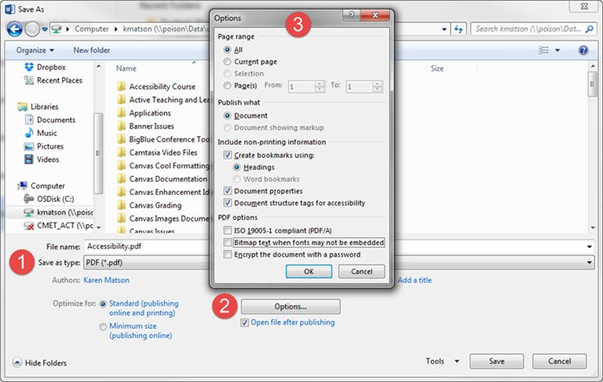
- Save As type = PDF (*.pdf)

- Click on the Options button (NOTE: you see this after you select pdf file type).
- On the Options window in the section under Include non-printing information make sure the Create bookmarks using: is checked. Document properties and Document structure tags for accessibility should also be checked.
- On the Options window make sure the Bitmap text when fonts may not be embedded is NOT checked.
- Click OK and then Save your document as a PDF. This will tag all of the text formatting so page headings and lists are correctly interpreted by a screen reader.
- Run the PDF accessibility wizard

Running the accessibility wizard on your PDF file.

After you save your document as a PDF your default PDF viewer will open the application. (Note: this setting option is directly under (Options when you save as PDF) Set your default viewer to Adobe Acrobat.

In Adobe Acrobat look at the tools in the right hand menu or under Tools (top left) and select Action Wizard (under Customize very bottom). When we select this we now have an Actions list of tools pop up and we want to click on Make Accessible and Start the wizard to help you through a few steps like the title and adding image tags.

After you run the Wizard the final accessibility check is there to be run with results.

