Faculty Info for the Sustainable Design Seminar
- Prof. Brown, G. Z. (Charlie) (Architecture) Host
Professor G. Z. (Charlie) Brown directs the UO Energy Studies in Buildings Laboratory (ESBL) http://aaa.uoregon.edu/esbl/ in Portland and Eugene that innovates on energy saving solutions and provides professional consulting. He challenges students to seek design solutions that integrate energy awareness and aesthetics in his design studios and seminars, and in his courses on site and building climatology, daylighting, and energy simulation. Brown is the author of a pioneering book on the practice of sustainable design, Sun, Wind and Light: Architectural Design Strategies (John Wiley & Sons, 1985, 2001) and co-author of Natural Ventilation in Northwest Buildings (2004) and Inside Out: Design Procedures for Passive Environmental Technologies (John Wiley & Sons, 1982, 1992).
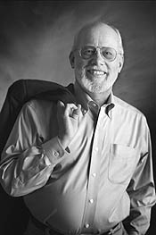

- Cartwright, Virginia (Architecture) Tour
Virginia Cartwright, associate professor of architecture and the director of the UO Baker Lighting Lab, explores light, form, and space through her research and practice, as well as in her design studios and seminars on the architecture of Alvar Aalto and on architecture in the cinema. She also teaches courses in daylighting, electric lighting, site and climate, and media.
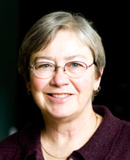

- Prof. Cheng, Nancy (Architecture) Host+Lecture
Associate Professor Nancy Cheng directs the Architecture Department's Portland program, teaches studios on sustainable communities and researches how tools and methods shape the design process. She is interested in maximizing creative engagement through sketching, handcraft and material observation combined with computer modeling and machine processes. Her Shaping Light project manipulates lasercut sheet materials into dynamic sun-shading devices, testing light transmittance, developing large-scale prototypes and analyzing the digital-analog design process. She has lead the Association for Computer Aided Design in Architecture (ACADIA), and the national AIA Technology in Architectural Practice knowledge community. http://architecture.uoregon.edu/about/faculty/chengn
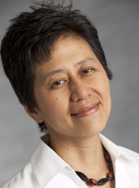

Ihab Elzeyadi (Architecture) Lecture

Associate Professor Ihab Elzeyadi's interest in architecture that enhances quality of life directs his research into high performance building design and evaluation, design for productivity, adaptive reuse, and lighting. He engages students in hands-on research and design explorations in design studios, seminars, and courses in environmental control systems. He is a member of the Center for Housing Innovation, Oregon Solar Energy Center, UO Baker Lighting Lab, and Oregon Survey Research Lab. http://hipe.uoregon.edu/
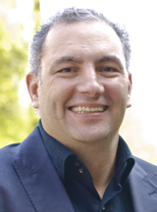

- Dr. Gillem, Mark (Architecture) Lecture
Dr. Gillem addresses sustainability, social responsibility, and historic preservation through his research and his professional practice, The Urban Collaborative http://www.urbancollaborative.com/. He challenges students to balance theory and practice through participation in community design and interaction with clients, fostering collaboration in the shaping of sustainable urban form. He initiated the City Design Lecture Series in Eugene in 2006 to fund visiting speakers on topics relating to transportation, land use and livability. He is the author of book America Town: Building the Outposts of Empire (University of Minnesota Press, 2007)
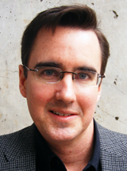

- Johnson, Bart (Landscape Architecture) Host
Dr. Bart Johnson is an Associate Professor in the Department of Landscape Architecture at the University of Oregon. Both his teaching and research focus on the integration of ecology into landscape design, planning and management, with a particular emphasis on conservation planning and ecological restoration. Current research focuses on biodiversity conservation and fire hazard management in the context of climate change and urbanization. This includes landscape planning, simulation modeling, restoration experiments, prescribed fire, and historical vegetation reconstruction. The ecological context of these studies centers on Willamette Valley oak savanna, upland prairie and wetland prairie, all imperiled ecosystems. http://landarch.uoregon.edu/people/faculty/johnsonb
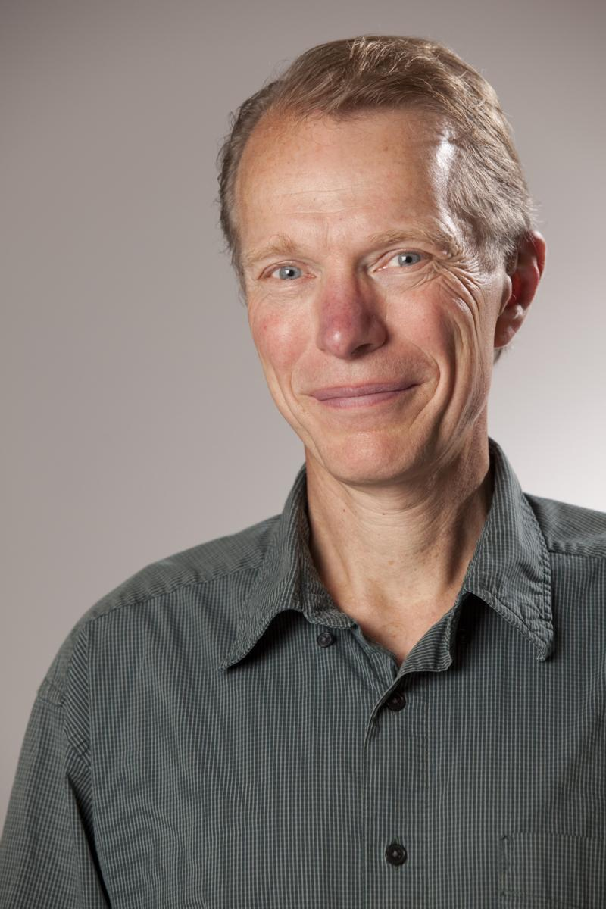

- Moore, Erin (Architecture) Host
Assistant Professor Erin Moore works in teaching, research and practice on lifecycle thinking in ecology, design and construction. She uses her research practice FLOAT architectural research and design as a testing ground for designing with explicit intentions for the life spans of materials and for designing with materials to connect buildings and their inhabitants to their ecological contexts. http://floatwork.com/ Moore also works in teaching and research on the life cycle environmental impacts of buildings using a life cycle assessment (LCA) methodology. In partnership with graduate students, she has recently completed an LCA evaluating a Passive House upgrade on a multifamily housing project.
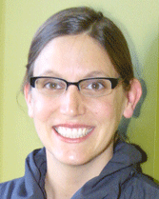

- Muller, Brook (Architecture) Lecture
Associate Dean for Academic Affairs Brook Muller examines synergies between ecological processes and urban development. He considers relationships between architects' initial conceptual organizational ideas and the environmental responsiveness of what is built. His work with Portland Metro Nature in Neighborhoods' Integrating Habitats competition lead to the adoption of community guidelines. He teaches design studio as well as courses in architectural theory, urban ecological design and sustainability. He also directs the interdisciplinary Graduate Certificate Program in Ecological Design. In 2009, he was recognized with a Civic Engagement Award by the Oregon Campus Compact for his leadership in sustainable design education. http://architecture.uoregon.edu/about/faculty/mullerb
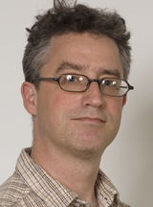
- Prof. Nute, Kevin (Architecture) Lecture+Host
Professor Kevin Nute's research focuses on visual qualities of built environments that resonate directly with building users, particularly visible manifestations of time. Professor Nute is currently studying the natural animation of passive energy-and rainwater saving techniques as a means of improving the well-being and effectiveness of building occupants while saving energy and water. http://www.livingspaceonline.org He began that work with a Japan Society for the Promotion of Science Research Fellowship at the University of Tokyo. Professor Nute's most recent book is, Place, Time and Being in Japanese Architecture (Routledge, 2004).
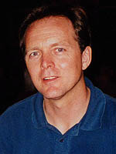

- Reynolds, John (Architecture) Lecture
Since joining the university in 1967, Reynolds has championed the importance of passive solar architecture. He has inspired countless students in his environmental control systems course and for many years was co-author of the textbook used nationwide in architecture classes, Mechanical and Electrical Equipment in Buildings. He also helped write Inside Out: Design Procedures for Passive Environmental Technologies, with G.Z. Brown. His 2002 book Courtyards: Aesthetic, Social and Thermal Delight celebrates the passive cooling performance of vernacular buildings in hot climates. Reynolds has received the UO’s Ersted Award for Distinguished Teaching and the James Haecker Distinguished Leadership Award from the Architectural Research Centers Consortium. He was recently elected to the board of directors of the International Solar Energy Society, continues as the board president of the Energy Trust of Oregon, and previously chaired the American Solar Energy Society board. http://architecture.uoregon.edu/node/146
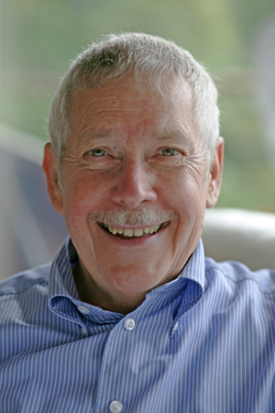
- Dr. Ruggeri, Deni (Landscape Architecture) Lecture
Dr. Ruggeri is Assistant Professor in the Department of Landscape Architecture. Dr. Ruggeri has worked on urban design, park design, streetscape and land planning projects for the SWA Group and Design Workshop, Inc. Dr. Ruggeri has recently been awarded a grant by the Department of Agriculture entitled “From Rust to Green in NY State,” whose goal was to promote a shift in the narratives of many rustbelt cities from economic depression and job loss to sustainable development and green infrastructure. http://landarch.uoregon.edu/people/faculty/ruggerid


- Dr. Schlossberg, Marc (PPPM) Lecture+Host
Marc Schlossberg is Associate Professor at Department of Planning, Public Policy and Management who directs the University of Oregon Sustainable Cities Initiative (SCI) http://sci.uoregon.edu/, a nationally-recognized program that directs university research and teaching towards solving community problems. His research focuses on the use of GIS personal digital assistants (PDA) for public participation, understanding walkability of the built environment, and safe routes to school for children. He is an Associate Director of the Oregon Transportation Research and Education Consortium (OTREC).
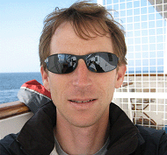

- Speranza, Philip (Architecture) Host
Philip Speranza is an Assistant Professor in the School of Architecture and Allied Arts at the University of Oregon and directs the Life, City, Adaptation: Barcelona, Urban Design Program. Philip holds a Masters of Architecture from Columbia University and is a practicing architect. He has worked with Steven Holl and Carlos Ferrater. Design projects in the US and Spain have included urban design projects, civic art with artist Janet Echelman, infrastructure, mixed-use and homes. His design entry, Foot-Hills, was selected as finalist and third-place honors for the Market Value International Design Competition. His Bottom-Up Urban Design Initiative B.U.U.D.I investigates frameworks for participation across time to reflect and strengthen local identity. http://speranzaarchitecture.com
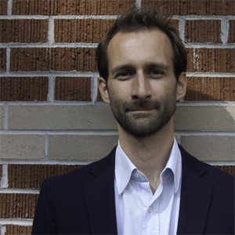

- Dr.Yang, Yizhao (PPPM) Lecture+Host
Yizhao Yang is Assistant Professor at Department of Planning, Public Policy and Management. She is also one of core faculty of Sustainable Cities Initiative (SCI). Her research focuses on environmental planning, design and analysis for sustainable and active living; land use planning and growth management, housing and residential quality, and feminist study of the built environment. Through multiple trips, she has researched eco-city development in China. http://sci.uoregon.edu/featuredfacultyyizhao


