**Rome Little Theatre Marketing Plan**

Susanna Brown

I. Introduction and Overview of Plan

**HISTORY AND MISSION**

Rome Little Theatre is a community theatre located in Rome, Georgia (population City: 36,300 County: 96,250). The Rome Little Theatre Mission Statement is: The purpose of Rome Little Theatre is to present amateur theatrical productions, encourage interest in drama, and contribute to the cultural and educational life of the community. RLT is an active supporter of the arts in Rome and Floyd County.

The theatre, founded in 1933, functions as an amateur community theatre within the city limits of Rome, Georgia. The theatre took a hiatus during World War II but began productions again in 1956. The location of the theatre productions has moved since its beginning but remains on Broad Street in the downtown area of Rome. RLT puts on a full theatrical season, each year complete with 8 season shows, 6 regular adult shows and 2 RLT Jr. shows for kids only. In addition to the 8 regular season shows there are frequently additional summer stock shows. It is hard to point to a specific distinctive or unique feature of this community theatre. To its members the theatre is special because of its ability to have performers, volunteers and directors back again and again.

The organization employs only two full time positions, an office secretary and an executive director. These two staff members, board members and volunteers fulfill all duties and responsibilities. As you could guess, lots of volunteers are involved in every aspect of running this theatre.  This organization functions under a ‘working board’ with every member of the board extremely active in the theatre productions. At the beginning of the year new outside Executive Director was hired and joined the RLT team.

The building is part of what makes RLT unique. The company performs in one of Georgia’s first movie theatres (Historic Desoto Theatre). There have been many renovations since they have started using this space, most in the last 5 years. The space is not ideal for a theatre as there isn’t much space in the wings for dressings rooms, props, etc. That being said, it is a beautiful space inside and out and they make it work for their needs. The exterior of the building has the original marquee for the old movie theatre, which adds to the charm and makes it stand out on the main street of town. The interior has recently been renovated, repainted, carpeted, new seats, new concession area, etc.

**MARKETING GOALS, STRATEGIES**

Based on my knowledge of the Rome Little Theatre and a conversation with one of the board members about some of the recent conversations and upcoming priorities of the organization I have developed a three-fold marketing plan. Based on the growth and evolution of the theatre company in the last 5 years I believe a full rebranding of the organization is needed. This rebranding could take many forms but the goal of the rebrand would be to create a clear and appropriate brand that represents what the theatre wants to be, not what it used to be. My second marketing strategy will focus on targeting a specific audience, adults 18-24, that the organization is currently missing out on. Rome, Georgia is home to Georgia Highlands College, Berry College and Shorter University with a large population of college students and recent graduates. My strategy focuses recruiting a social media student intern who can develop and help implement a sustainable social media plan for the organization. I will focus on adding the platform Instagram to target the 18-24 populations in the Rome area. Recent surveys from January 2016 say that 53% of Instagram users are within the ages 18-29. My third strategy will be focused around building a donor base for the organization, increase contributed revenue from individual donors. While Rome Little Theatre currently produces all of its productions at the Historic Desoto Theatre, they do not own the building, and would like to have the funds to perform in different spaces in the future. With the 60th anniversary of the theatre happening in the 2016-2017 year, it is a great time to begin hosting an annual fundraiser/benefit/gala. This event will help celebrate the organizations 60th anniversary and show the community and donors the importance of community theatre. Following the event and hopefully increase in donors, a communication strategy must be implemented to keep building their donor relations.

1. Rebrand to creating a more appropriate and clear brand for the future of the organization.
2. Increase audience ages 18-24 by focus on creating an Instagram identity and hiring student intern from a college in town.
3. Increase donor base and celebrate 60th anniversary by organizing and promoting a fundraising event and follow-up communication strategy.

**DESIRED OUTCOMES**

The desired outcomes for my first marketing strategy, focused on rebranding, includes creating an identity that clearly represents the theatre’s focus on the community and facilitates the continued growth of the theatre. The desired outcomes for my second marketing strategy, focusing on building the audience of 18-24 year olds, include more active participation in the theatre from the targeted demographic and future partnerships with local colleges and universities. The desired outcomes of my third marketing strategy, focused on building a donor base, would include increasing revenue from individual donors eventually allowing the theatre to use different performance spaces, and the integration of a Customer Relations Management tool to implement communication strategies with current and potential donors.

II. Situational Analysis (This section was completed in fall term)

**ECONOMIC SCAN**

Rome Little Theatre operating budget comes almost solely from regular season shows, including ticket sales and concession. Each show is responsible for working with sponsors, which are mostly organizations in the City of Rome. They have recently started to add small ‘black box’ shows between the regular season shows to help fundraise for specific projects. RLT does not have a position or board member dedicated to development and fundraising. They do not receive much, if any, support from grants, state/federal funding, or individual donors. The building they rent, the Historic Desoto Theatre, has it’s own board that help raise funds for renovations and building maintenance. The theatre knows that they make the most money on children’s shows and has implemented a RLT Junior series to cater to that audience.

There are a few small theatre companies in Northwest Georgia but within Rome city limits RLT is the only community theatre that produces regular shows. The other competition could come from the two colleges in the town that put on theatre performances and have theatre majors.

**CULTURAL SCAN**

As mentioned in the organization description, the two full time staff members, working board and volunteers run all aspects of the organization. From the board members I know personally and my experience with the theatre it seems to be a very laid back environment that relies on the time of mostly volunteers.

The theatre performs in a great location, downtown Rome, where most people from the city go to bars and restaurants. It helps to attract audience members to the shows and partner with other downtown businesses. The theatre is located in the South and generally the active members and audience members tend to be more conservative and that can affect the artistic offerings. RLT has pushed those boundaries in the past and have reached audience members outside the regular RLT patron.

Rome Little Theatre has embraced technology in the years past by updated their online ticket system and by maintaining a heavy Facebook presence. Their website really needs a full redesign with a more organized structure.

**DEMOGRAPHIC SCAN**

Rome Little Theatre audiences are generally made up of a wide range of ages and typically middle-class families. Their main audience demographics seem to be children and adults. The theatre has not completed a survey of the types of audience members attending their shows but I think that would be a great start to building a marketing plan focused on audience growth. They are thinking about starting a RLT Senior series of shows because they know there is a large population of seniors in the Rome area.

I can only take from my personal experience with the theatre but most of the active participants come from upper middle-class families, primarily Caucasian with some higher education. Recruiting minority populations to participate in the performances has and will continue to be a challenge for this community theatre. There are three colleges in Rome and I think that would be a great resource for the theatre that they aren’t currently taking advantage of.

II. Situational Analysis (This section was completed in fall term)

**SWOC ANALYSIS**

**Cultural Products:**

**S**trengths- The products produced by RLT reach a broad audience: children, musicals, variety of plays, and older audiences. The quality of the productions has increased over the past few years because of more experienced directors, producers and better volunteer coordination.

**W**eaknesses- There is limited staff and board time to devote to the production of shows. Without expanding the board responsibilities or staff positions the theatre cannot expand their productions or quality of productions.

**O**pportunities- RLT has such an opportunity for growth with more revenue sources. If they applied for grants, foundation or government they could attract more donors or vice versa. With more of a budget they could produce more shows or create new positions.

**C**hallenges- The main challenge is simply what happens within a small community theatre, for the most part the same people are the actors, directors, producers, board members and volunteers. That can make it hard to have an objective view for any decision about a production to be made.

**Place/Access:**

**S**trengths- RLT performs in the Historic Desoto Theatre, which is located in downtown Rome, where most people go to hang out of the weekends or for other cultural events. Great location!

**W**eaknesses- The theatre company is currently limited to the time available in the theatre because it is a rental space. It will be a challenge to expand their season, if they begin to grow substantially. There are general limitations to using a space that is historic and rented out for other performances/events.

**O**pportunities- There are opportunities for RLT to take more advantage of technology to promote access to their shows. Opportunities to partner with schools/colleges to offer students better access to performances and involvement. Also, there are opportunities for partnership with colleges/universities for additional performance space.

**C**hallenges- Money. To use different spaces or to expand the productions, the organization will need more revenue.

**Promotional Efforts:**

**S**trengths- RLT has a strong Facebook and e-mail presence and members/actors in the theatre promote individually to their networks. Many partnerships for promotion with existing organizations in the community.

**W**eaknesses- Limited staff to create content and communication strategies. Promotional efforts are limited to Facebook and e-mails.

**O**pportunities- There are opportunities for RLT to partner more with downtown businesses for promotion opportunities. Possibly, dinner and a show ticket pricing and marking within the restaurants. There is an opportunity to find a student intern from a local college or university, at a low cost, to help with implementing promotional efforts.

**C**hallenges- I believe their website is challenge and really needs to be redesigned for easier navigation and an updated look. Really it comes down to limited staff but the board/volunteers and step in to help.

**AUDIENCE ANALYSIS**

At this time no audience surveys or analysis have been completed. There are lots of kids and families because of the Junior shows. The “regulars” at the theatre are mostly adults 30-45.

There is a need to increase the18-24 year old audience population. They are commuted to serving seniors also and currently looking to add a Senior Series of shows for that demographic specifically.

III. Scheme

**REBRANDING**

The rebranding should be implemented through three major strategies: surveying the community, creating the new brand, and unveiling and integrating the new brand. When rebranding an organization must receive community, patron, actor, board member and volunteer “buy-in.” The goal of rebranding RLT is to create a brand and identity that represents their focus on the community and that helps to facilitate continued growth. These goals are communicated through the process of rebranding by having the community of Rome and the communities of the theatre (actors, directors, board members, etc.) take part in the rebranding process. When creating the new logo/brand for RLT, there are many factors to consider along with the results of the surveys. That includes word and image choice, integration of special series, the use of the acronym, etc. Also, many avenues can be explored as to how or who will create the logo? Once the brand is decided upon by the Board of Directors there must be a strategic plan created to unveil and implement the new brand.

**Three rebranding strategies:**

1. Survey the community:

* Create a survey for people involved in the theatre including board members, volunteers, actors, directors that helps define what Rome Little Theatre means to the people that make the productions happen.
* Create survey for audience members and community members, to gather data from people who attend shows and people who have never attended a RLT production. This will help position RLT in the community and learn more about the needs of the Rome community.
* Evaluate the data from the surveys: What are the main reasons people are involved in RLT? What are audience members attracted to? What are the priorities of the board as reflected in the surveys? What are consistent themes coming up in the surveys? How did people react on the survey to an organization name change?
* Use the data to evaluate the organization’s mission. Does the mission need to be edited or rewritten to align with the rebrand?

2. Creating the brand:

* Using the data and mission of the organization create multiple brands for consideration. The logo designs could be commissioned by local graphic designers (possibly a contest for submissions based on specific requirements).
* Look at changing the name from Rome Little Theatre to Rome Community Theatre to help emphasize the theatre’s focus on the community.
* Look at dropping ‘At the Historic Desoto Theatre’ to help future growth of the organization outside that particular performance space.
* Ask questions like: How would the junior and senior series shows fit into the brand? What is cost effective for the organization?

Current logo:

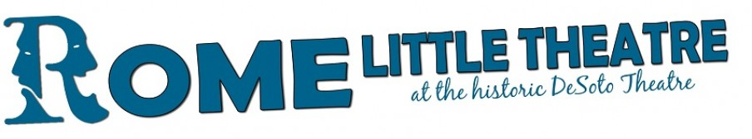

Examples of new logo:

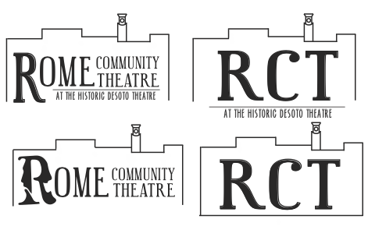

3. Unveiling and integrating the new brand

* Before, during and after the rebranding process let the patrons and community members know that the process is taking place: social media, e-mail, show bills. This is a ways to build excitement around the rebranding process.
* Have an informal unveiling of the new logo party for employees, board members and theatre patrons
* Build a communication strategy around the unveiling and implementation

**SOCIAL MEDIA-Instagram**

The social media plan should be implemented through two major strategies: hiring a student worker or intern from local college or university and focus on creating a Instagram identity and following to reach 18-24 aged population. Both of these strategies focus on the goals of growing the RLT audience and building partnerships with local colleges and universities.

1. Hire a social media student worker or intern from local college or univeristy

* Look for marketing or communication student who has experience with social media planning if possible.
* Work with student to create sustainable social media (Facebook and Instagram) communication plan.

2. Focus on Instagram Identity

* Build Instagram communication plan in congruence with Facebook plan
* Focus on 18-24 (college and recent graduate population)
* Messaging should focus on building excitement around the theatre, how college aged students can gain practical and/or theatrical experience at RLT, and give aways for college students(scavenger hunts for free tickets on campus)
* Creating hashtags that are relevant to the college-aged populations

**INCREASE DONOR BASE**

In an effort to increase overall revenue for the theatre a strategic focus on increasing individual donors and giving amounts is the proposed strategy. This should be initiated through three strategies: designating a board member to development duties, begin using a Client Relation Manager to organize and communicate with donors, and plan a 60th Anniversary fundraising event. All of these strategies help reach to goal of increasing contributed revenue and allowing the theatre to expand performance spaces, offerings and community reach.

1. Designate a board member to development duties

* Create development committee and chair/director within the Board of Directors to facilitate donor relations and fundraising events
* This board member helps create content for communication to donors, focuses on recruiting donors, and cultivates relationships with current donors

2. Use free Client Relations Manager (CRM) to manage and communicate effectively to donors and donor prospects

* Input all current donors, board members, season pass holders and other leaders within the organization
* Create simple and sustainable communication strategy for donors and potential donors

3. Plan fundraising event celebrating 60th Anniversary

* Create marketing strategy to promote event and anniversary through e-mail, social media, billboards, etc.
* Procure items from local organizations, board members, and any barter money/items that haven’t been used to create silent auction items and food and drinks for the event
* Set ticket price and logistics of event
* Create other sources of revenue: wine wall, raffle, etc.
* At the end of the night have a paddle call for donations after talking with donors and attendees about the importance of community theatre and one specific initiative

IV. Implementation (Time line and required resources to implement each marketing strategy).

**IMPLEMENTATION FOR REBRANDING**

* Marketing calendar with dates for announcing and implementing rebranding
  + Announcing rebranding project (July)
  + Surveys- July 1-September 1
  + Analyzing data from surveys and creating guidelines, priorities, and wording choices based on surveys for graphic designers-month of September
  + Create campaign/contest for graphic designers with some reward for winning design (low cost)
  + Call for designs (Oct 1- Nov 15)
  + Review designs and final decision made by board by January 1
  + Reveal party and communication January 15
  + Create stickers to help create brand awareness that people can use around town
  + Create coasters that can be used in local bars and restaurants to increase new brand awareness
* Survey for theatre people and community members
  + Created by board members and executive director
  + Print and online
  + Designate staff or board member to input data into spread sheet for analysis
* Budget:
  + Printing surveys
  + Printing of new collateral
  + Stickers and coasters for initial brand reveal and awareness
  + Party- simple and informal, mostly for board/staff/volunteers

**IMPLEMENTATION FOR SOCIAL MEDIA**

* Hiring student worker/interns from local college or university
  + Contact for Berry College: Mark Kozera, Director of Community and Industry Work Experience Program, [mkozera@berry.edu](mailto:mkozera@berry.edu), 706.378.2903
  + Contact department chairs in Marketing and Communications at all colleges and universities
  + Create description of social media student position
* Create Instagram identity
  + Marketing calendar
    - Goal-post daily (Monday-Friday) with variety of content
  + Content Themes
    - Productions-announcing auditions, cast list, production dates, ticket sales, sneak peaks
    - People: highlight actors, board members, new executive director, volunteers
    - Place: Historic Desoto Theatre, downtown Rome, Marquee sign
    - Scavenger hunts-on college campuses, arranged with student activities office, free tickets w/ popcorn and drink
    - TBT-past productions
    - Events outside of theatre productions: rummage sale, summer camps, classes

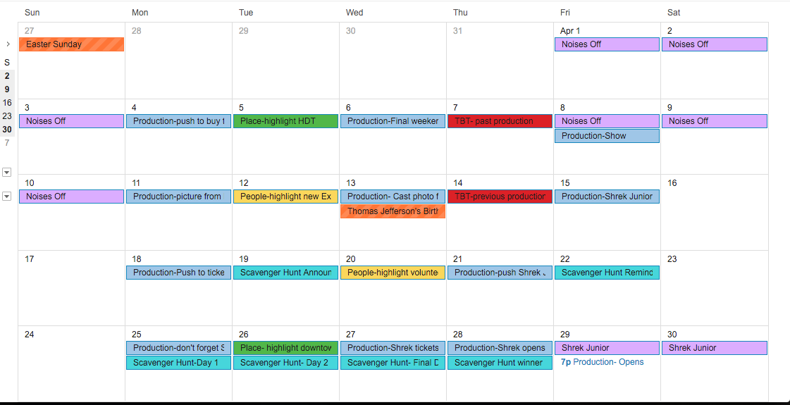

* + Hashtags: #rct #noisesoff #downtownrome #desototheatre #romecommunitytheatre or #romelittletheatre
  + Content targeting to 18-24 aged population
  + Use Hootsuite to organize Instagram initiatives with Facebook events and postings
* Budget:
  + Either paid student worker or non-paid internships
  + Sign at theatre entrance to encourage pictures and hashtags at performances

**IMPLEMENTATION FOR INCREASING DONOR BASE**

* Free CRM, must be used by staff and designated board of director
  + [**https://www.fracturedatlas.org/site/artfully**](https://www.fracturedatlas.org/site/artfully)
* Marketing calendar for promoting the event
  + Event- Mid-November
  + Start promotions-September
    - Announce event through e-mail and website
    - Promote event through Facebook and Instagram twice throughout month
    - Open ticket sales online
    - Create team to create video and decide on content
  + October
    - Promote event through social media once a week
    - Send out invitations in mail in mid-October
    - Conduct interviews from board members, volunteers, and actors for video – “what does Rome Little Theatre mean to you”
  + November
    - Promote events 2-3 times a week
    - Send out reminder e-mail to patrons
    - Build excitement about the event in final days before
* Logistics of event
  + Target audience-board members, season pass holders, current and potential donors
  + Cost $40 per ticket to event, includes food and drinks
  + Assign each participate a paddle number to donate at the end of the night
  + Require board to contribute to wine wall
  + Organize short scenes and musical numbers from current or future for performance during event
  + Use all available bartering for food and drinks for event
  + Silent auction
    - Board must facilitate procurement of items
  + Create video to show before paddle call focused on the importance of community theatre and RLT’s mission
* Create a follow-up communication plan to all attendees and organizations that donated to support the event (silent auction, food and drinks)
* Budget:
  + Food/drinks from places you have barter credit with
  + Printed invitations
  + Advertisement around town
  + Video created by volunteers and board members

V. Evaluation Plan (Measuring and evaluating outcomes)

1. Rebrand to creating a more appropriate and clear brand for the future of the organization.
   1. Add 10 new community partners by end of 2017-sponsors, event partners, marketing partners, etc.
2. Increase audience ages 18-24 by focus on creating an Instagram identity and hiring student intern from a college in town.
   1. Currently 1061 followers (8 posts), increase to 2500 followers by end of year
   2. Complete audience survey two years after initial survey to see if demographics change
3. Increase donor base and celebrate 60th anniversary by organizing and promoting a fundraising event and follow-up communication strategy.
   1. Have at least 50 donors in CRM and 100 prospects

Recommendations for future

* Create new website
* Raise donation levels
* Write grants for specific projects