Here are some general hints for Identifying Sentence Errors.
- Read the entire sentence carefully but quickly.
- Look at choices (A) through (D) to see whether anything needs to be changed to make the sentence correct.
- Don't waste time searching for errors. Mark (E) No error, on your answer sheet if you believe the sentence is correct as written.
- Move quickly through questions about Identifying Sentence Errors. The other kinds of questions (Improving Sentences and Improving Paragraphs) will probably take more time.
- Mark questions that seem hard for you and return to them later.
The following sentences test your knowledge of grammar, usage, word choice, and idiom. Some sentences are correct. No sentence contains more than one error. You will find that the error, if there is one, is underlined and lettered. Elements of the sentence that are not underlined will not be changed. In choosing answers, follow the requirements of standard written English.
Directions:
If there is an error, select the one underlined part that must be changed to make the sentence correct. If there is no error, select E.

Question 1:
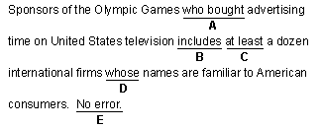

Question 2:
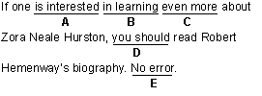

Question 3:
