Step 1: Make sure you are the right person
- If this information is incorrect, STOP. Contact parking@uoregon.edu.
- Select “I verify this is my correct account information.” from the dropdown.
- Click the “Next” button.
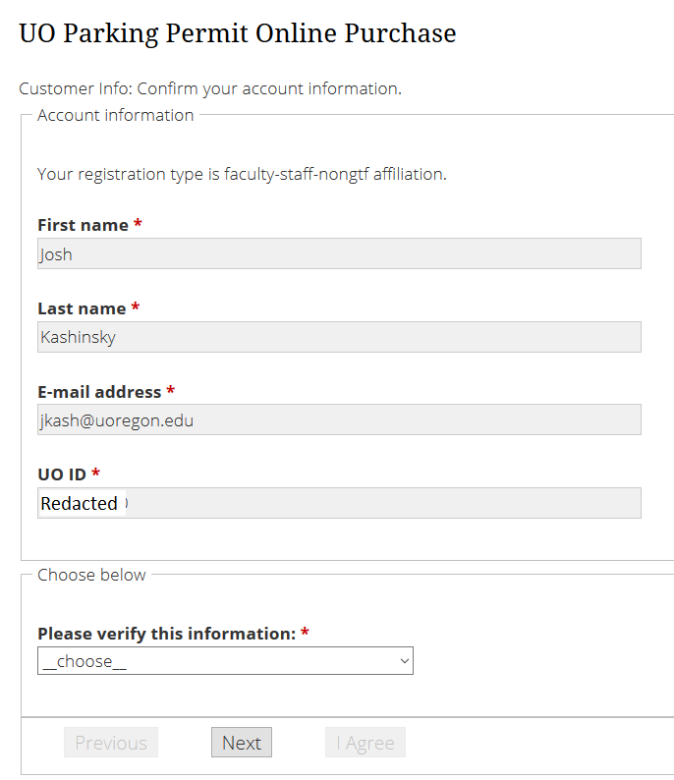

Step 2: Address information
- If this information is correct, choose “I verify this is my correct address” from the dropdown, then click the “Next” button.
- If this information is not correct, choose “I have manually entered…”
  - This will give you the ability to edit the address fields.
  - Edit the appropriate fields, then click the “Next” button.
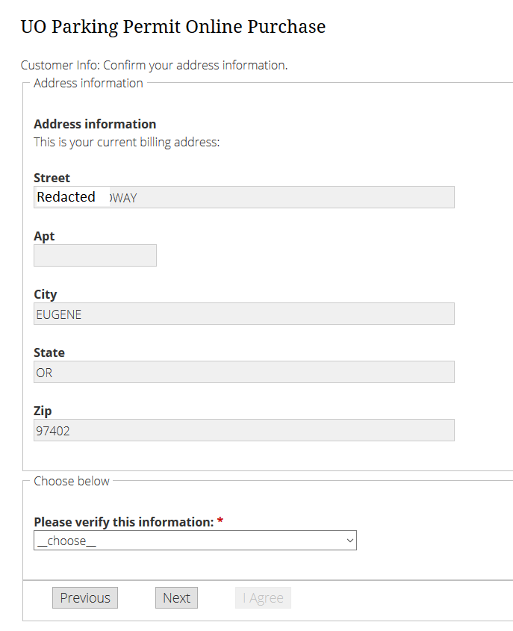
Step 3: Vehicle Information
- Select a vehicle to link to your permit.
  - All vehicles on your account are shown.
  - You may only link one vehicle to your permit with this form.
  - To add additional vehicles to your permit, contact parking@uoregon.edu
- If you wish to add a different vehicle to your permit, choose “_add new vehicle_” in the dropdown.
  - Enter the vehicle license plate number and choose the state, then hit “Next”
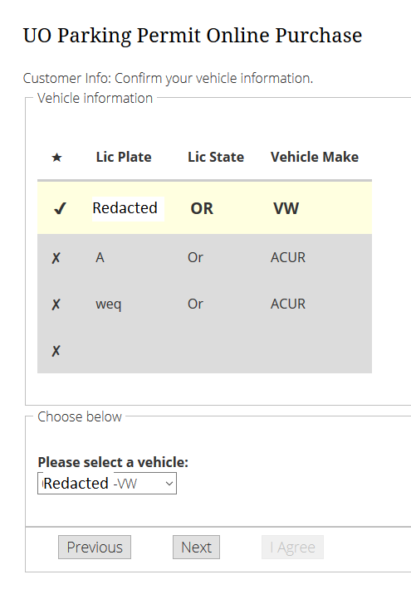

Step 4: Permit Duration
- Select whether you wish to purchase a permit with a June expiration or September expiration.
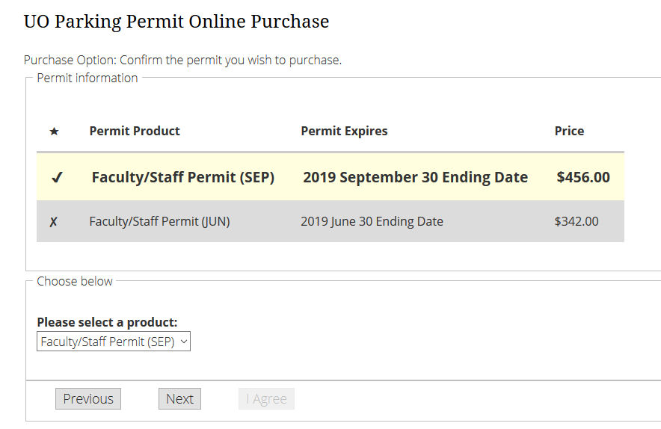
Step 5: Payment Type
- Choose your payment method
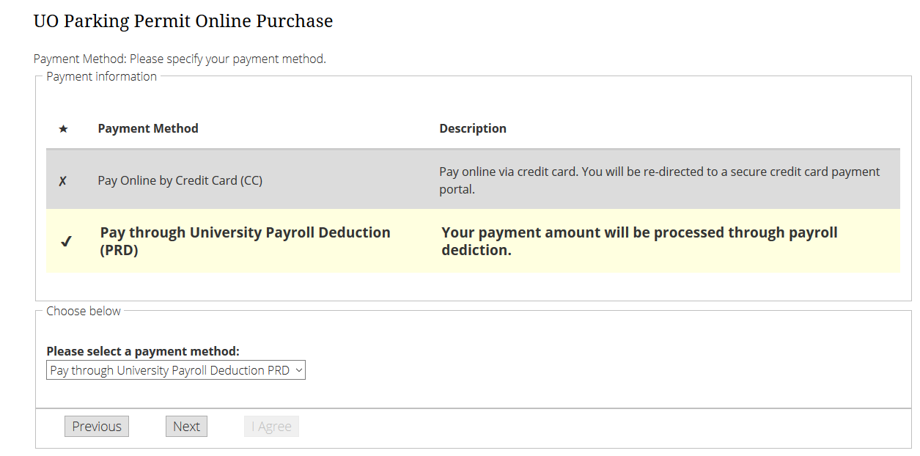
Step 6: Review Your order
- Check to make sure all information is correct. You can use the “Previous” and “Next” buttons to go back to previous steps.
- Your permit order will not be processed until you press “I Agree”
- If you chose to pay by credit card, you will be taken to the University of Oregon’s QuikPay billing site for payment to complete your transaction.

