|  |
| --- |
| Lemonweir Elementary PBIS Staff Handbook |
| Tomah Area School District |
| 2013-2014 School Year |

Table of Contents:

What is PBIS?……………………………………………………………………………..……….. 3

Team Information…………………………………………………………………….………… ..6

2012-2013 Meeting Dates………………………………………………………………….………7

2012-2013 Expectations Schedule……………………………………………………….……..… 8

Behavioral Support System…………………………………………………………………..….. 9

Teaching Cool Tools…………………………………………………………………………..…..11

Acknowledgement System……………………………………………………………..……..… 12

Discipline System……………………………………………………………………….………...13

PBIS Assessments………………………………………………………………………….……. 14

Resources:

Behavior Matrix………………………………………………………………………. …15

Classroom Matrix…………………………………………………………………….…. 16

Flow Chart………………………………………………………………………………..17

Behavior Definitions………………………………………………………………..…... 18

Discipline Referral Form…………………………………………………………………19

CICO Form………………………………………………………………………………..20

Lesson Plans………………………………………………………………………………21

What is PBIS?

PBIS (Positive Behavior Interventions and Supports) is an organized, data-driven system of interventions, strategies, and supports that positively impact school-wide and individualized behavior planning.

Using the most current best practices, strategic teams are trained to positively impact behavior at three key behavioral tiers: Universal or primary (whole school); Secondary (individual child or group of at-risk children); and Tertiary or Intensive (children with complex needs and behaviors that severely impact the child, school and/or community functioning).

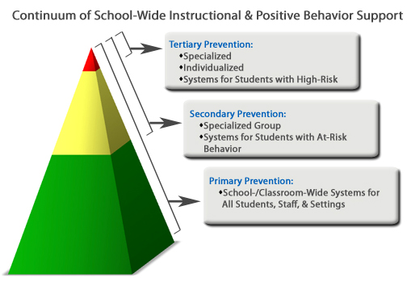

**Why is it so important to focus on teaching positive social behaviors?**

Frequently, the question is asked, “Why should I have to teach kids to be good? They already know what they are supposed to do. Why can I not just expect good behavior?” In the infamous words of a TV personality, “How is that working out for you?”

In the past, school-wide discipline has focused mainly on reacting to specific student misbehavior by implementing punishment-based strategies including reprimands, loss of privileges, office referrals, suspensions, and expulsions. Research has shown that the implementation of punishment, especially when it is used inconsistently and in the absence of other positive strategies, is ineffective. Introducing, modeling, and reinforcing positive social behavior is an important step of a student’s educational experience. Teaching behavioral expectations and rewarding students for following them is a much more positive approach than waiting for misbehavior to occur before responding. The purpose of school-wide PBS is to establish a climate in which appropriate behavior is the norm.

**What is a systems approach in school-wide PBIS?**

An organization is a group of individuals who behave together to achieve a common goal. Systems are needed to support the collective use of best practices by individuals within the organization. The school-wide PBIS process emphasizes the creation of systems that support the adoption and durable implementation of evidence-based practices and procedures, and fit within on-going school reform efforts. An interactive approach that includes opportunities to correct and improve four key elements is used in school-wide PBS focusing on: 1) Outcomes, 2) Data, 3) Practices, and 4) Systems. The diagram below illustrates how these key elements work together to build a sustainable system:

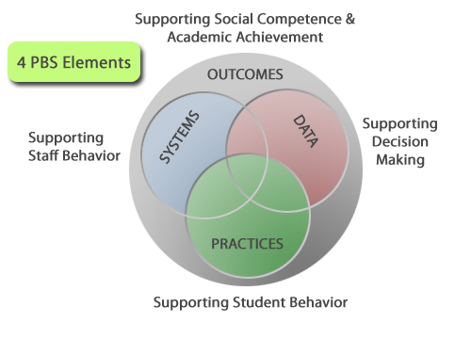

◦Outcomes: academic and behavior targets that are endorsed and emphasized by students, families, and educators. (What is important to each particular learning community?)

◦Practices: interventions and strategies that are evidence based. (How will you reach the goals?)

◦Data: information that is used to identify status, need for change, and effects of interventions. (What data will you use to support your success or barriers?)

◦Systems: supports that are needed to enable the accurate and durable implementation of the practices of PBIS. (What durable systems can be implemented that will sustain this over the long haul?)

**What does this mean for staff?**

* All staff need to recognize and acknowledge children who are following the school-wide expectations.
* All staff need to be ready to give out paws to students in the classroom and throughout the building.
* All staff need to know the Behavior Flow Chart and be consistent with their responses.
* All staff need to complete an Office Discipline Referral Form if a child’s response to a problem behavior indicates the need.
* Teaching staff need to post the School-wide Expectations in their class and other areas that children often use.
* Teaching staff need to include “Cool Tools” in their lesson plans as indicated on the Expectation Schedule and as needed (for whole group or individuals).
* All staff need to CELEBRATE successes as much as possible!

Team Information

**Tomah Area School’s District PBIS Mission Statement:**

*Tomah Schools is committed to proactively teaching students appropriate behaviors essential to valuing self, valuing others, and valuing learning.*

**Lemonweir Elementary PBIS Teams:**

Universal Team:

* Nicki Pope- Administrator
* Amanda Betcher- Internal Coach
* (OPEN)- External Coach
* Terri Rung- Represents Special Education
* Joanna Oswald- Represents K-1
* Michelle Pitts-Clark- Represents Title Program
* Krista Tardiff- Represents 2-3
* Michelle Briner- Represents 4
* Vicki Siler- Represents 5
* Julie Schoonover- Represents Support Staff
* PTO

Building Intervention Team (BIT):

* Nicki Pope
* Amanda Betcher
* Terri Rung
* Katherine Meyers

2013-2014 Meeting Dates

**Lemonweir PBIS Committee: 3:05 in room 113 (Second Monday of the month)**

|  |  |
| --- | --- |
| September 16, 2013  October 14, 2013  November 18, 2013  December 9, 2013  January 13, 2014  February 10, 2014  March 10, 2014  April 14, 2014  May 12, 2014  June 9, 2014 |  |

**Building Intervention Team (BIT): 1:30-3:00 in the office (Every other “A” day)**

|  |
| --- |
| September 3, 2013  September 17, 2013  October 2, 2013  October 17, 2013  October 31, 2013  November 15, 2013  December 4, 2013  December 18, 2013  January 14, 2014  January 31, 2014  February 24, 2014  March 11, 2014  March 25, 2014  April 9, 2014  April 28, 2014  May 12, 2014  May 27, 2014  June 10, 2014 |

|  |  |
| --- | --- |
|  |  |

2013-2014 Expectations Schedule

Please follow the tentative schedule for teaching and refreshing school-wide and classroom behavioral expectations.

August 28 & 29, 2013

* Review school-wide and classroom expectations and schedule with staff
* PBIS Open-house/ Family Kick-Off

September 3-13, 2012

* PBIS Kick-Off Assembly (see Kick Off Schedule)
* Teach school-wide and classroom behavioral expectations as many times as possible.

September 2013 through November, 2013

* Teach school-wide and classroom behavior expectations 2-3 times per week.

December 2013 through March 2014

* PBIS Booster Assembly
* Teach school-wide and classroom behavior expectations weekly.

April 2014 through June 2014

* Teach school-wide and classroom behavior expectations as needed.

Review/ Reteach School-wide and Classroom Behavior Expectations:

* December 2, 2013 (After Thanksgiving Break)
* January 6, 2014 (After Winter Break)
* April 22, 2014 (After Spring Break)

Behavioral Support System

**Tier 1:**

Tier 1 provides high quality instruction and behavioral supports for all students in general education. More than 80% of students will be successful in this tier. Classroom management and individual student behavior is based on expectations, responsibility, and proactive feedback.

If a student fails to learn at a level/ rate similar to his/her classmates, the teacher will:

* Change the type of instructional or behavioral strategy (**intervention**)
* Increase the **intensity** or level of the intervention (for example, adding small group instruction to whole group instruction).
* Increase the **duration** of the intervention (for example, increase small group instruction from 15 to 30 minutes).
* Increase the **frequency** of the intervention (for example, from twice per week to four times per week).

Once several interventions have been unsuccessful, and the student is not responding adequately, the student will be referred to the Tier 2/ Building Intervention team to discuss further interventions.

**Tier 2:**

Check In/ Check Out (CICO)

Students may be referred to CICO by either acquiring 3 majors or 6 overall Discipline referrals within a 30 day period of time, or by teacher request. The student will be assigned to an adult greeter to follow the CICO procedures with a daily goal of 80%. Progress will be monitored and graphed for at least 6-8 weeks. If there are no improvements within 2-4 weeks, the team will re-evaluate. After students are meeting their goal on average for about 4 weeks they will begin to fade. This means the student will complete their CICO form independently and the teacher will also complete using a pen. If scores agree and student is maintaining their goal, they will complete the program.

How is CICO implemented? **\*See Resources for CICO forms**

* A student checks in with a specific adult at the start of the school day.
* The adult gives the student a point sheet that has the goals/ expectations the student is working on.
* The adult speaks briefly with the student in a positive manner, to encourage them and remind them what they need to focus on to meet their goal.
* The student goes through their day with the point sheet having each teacher check how well they did during that time period.
* At the end of the day, the student checks out with the same adult they checked in with. The adult briefly talks with the student, asking them how they feel they did, what they did well on, and what they need to work on.
* A copy or the score should be turned into Mrs. Betcher for monitoring progress.
* The student then takes their point sheet home to show and discuss it with their parent to be signed and returned if need be.
* The daily goals may be used along with a reward system where the student receives an incentive for meeting their goal.

Social/ Academic Instructional Groups (SAIG)

When CICO isn’t working students may be referred to SAIG groups. These groups will meet weekly and will focus on re-teaching and practicing specific appropriate behaviors. Students will be placed in groups with same age peers and will participate for 9 weeks. Behaviors will be observed to monitor progress. If after 4 weeks, the student is not responding to tier 2 interventions, a more intensive or additional intervention and/or consult referral may be considered. Prior to a consult, the teacher must complete a Request for Assistance Form (BIT/IRT). This can be found on the district website.

Mentoring Program

Tier two students may be placed into a mentoring program with a peer of the same age or older, or an adult. They will meet with the student 1-2 times per week to practice behavior expectations or build a relationship. Students will participate for 6-8 weeks. If after 4 weeks, the student is not responding to tier 2 interventions, a more intensive or additional intervention and/or consult referral may be considered.

Teaching Cool Tools

**Helpful Tools for Teaching the Expectations of Value Self, Value Others, and Value Learning:**

1. Pre-Teaching: Review the behavior expectation for a particular common area before transitioning to and from that area. Develop a rhyme or song that reinforces the behavior as you transition.
2. Direct Experience: Take the students to a particular common area and have them “practice” the expected behavior (i.e. walking feet in the halls).
3. Get the children’s input: Use children’s literature to stimulate a group discussion about a common problem behavior, such as hitting. Have the students identify the problems with this behavior and brainstorm coping strategies or solutions with them. Use the behavior Expectations Matrix for that area to guide your discussion.
4. Role-Play: Have the students act out scenarios that address the expected behaviors in common areas to ensure their understanding as well as to provide them an opportunity for feedback. Encourage students to use the words on the Behavior Matrix.
5. Reflection: Have the students talk about any experiences they have had at school and process their responses in relation to the Cool Tools and Behavior Matrix.
6. Acknowledgement: Whenever possible positively acknowledge students who are demonstrating school-wide behavior expectations by utilizing the school-wide acknowledgement system.

**Videos & Lesson Plans:**

Cool Tool videos and several lesson plans can be found on Lemonweir’s PBIS Webpage. To get to them, go to the district website, click on buildings- Lemonweir. Choose the PBIS link and then click on “jump to PBIS resources.” Videos and lesson plans are listed at the bottom of the page.

**\*See Resources for available Behavior Lesson Plans**

Acknowledgement System

**Level 1 Acknowledgement: (Teacher and Team Led)**

This acknowledgement is based on students earning paws for demonstrating school-wide expectations. All staff will carry paws with them and hand out to students who are “caught” following the expected behaviors. A student may not ask for a paw. Every two weeks a different cool tool will be focused on. The first of the two weeks will be teaching the expectations daily and recognizing frequently by handing out paws and giving verbal praise, stating exactly what the student is doing correctly. During the second week, the class will set a goal to reach for a classroom wide incentive. Classes who met their goal will be announced at the end of the two week period. One incentive during the month will be teacher led, and the other will be team led (refer to schedule for dates).

**Celebration Ideas:**

|  |  |  |
| --- | --- | --- |
| * Pajama Day * Free Choice Time * Special Snack * Lunch with the Teacher * Extra Recess Time * Computer Use | * Teach a Lesson Outside * Popcorn and a Movie * Game Time * Dance to Music * Story time with the Principal | * Use a Pen or Marker for the Day * Take a Walk * Mentor/ Read to another Class * Bring a Stuffed Animal for the Day |

**Level 2 Acknowledgement: (Team Led)**

Each quarter, students with zero discipline referrals will be recognized with an additional acknowledgement (i.e. donuts, award, dance, field day, swimming, PTO events). These students will also receive a paw charm to attach to their backpack.

**Level 3 Acknowledgement: (Team Led)**

Staff will hold all-school celebrations monthly throughout the year to recognize the hard work of all students. All school celebration activities could be things such as Bingo over the intercom, special dress days, fancy lunch, extra recess, assemblies, popcorn, etc.

Discipline System

Correction Guidelines

Adult behavior when providing corrections is:

|  |  |  |
| --- | --- | --- |
| * Calm * Consistent | * Brief * Immediate | * Respectful |

|  |  |
| --- | --- |
| Prompt | Provide verbal and/ or visual cue. |
| Redirect | Restate the matrix. |
| Reteach | State and demonstrate the matrix behavior. Have student demonstrate. Provide immediate feedback. |
| Provide Choice | Provide an alternate choice that still accomplishes the same instructional objective. |
| Conference | Describe the problem. Describe the alternate behavior and explain why it is better. Practice. Provide feedback. |

Strategies to respond to inappropriate behavior: **Correction Technique How this can be used** Part of these guidelines were adapted from: Center for PBS, College of Education, University of Missouri, MO SW-PBS

Specific student conference procedures:

|  |  |
| --- | --- |
| 1. Positive, private, using quiet voice 2. Describe the problem 3. Describe the alternative 4. Discuss why alternative is better | 1. Have student practice by showing or telling 2. Provide feedback |

Data Collection

When student behavior is unsafe or noncompliant after being redirected, staff will document the behavior. Keep in mind the developmental age of the student. This can be done by either completing a discipline referral form (see form in resources), and turning it in to Mrs. Betcher; or by entering the behavior directly onto Infinity. You may refer to the behavior definitions in the resource section to assist in completing this form, if necessary. This data is compiled monthly and used to locate areas in need of re-teaching, as well as students in need of more intensive interventions. Please refer to the flow chart in the resource section for more information on providing consistency when correcting and documenting behaviors.

PBIS Assessments/ Recognition

**School-Wide Recognition:**

2013 School Of Distinction recipient

2012 School Of Merit recipient

**Self- Assessment Survey (SAS):**

The SAS determines the status of PBIS as perceived by all staff members and guides the action plan for improving PBIS.

* Completed annually in the **fall** by **ALL staff**.
* Fidelity is an average of **80%** or greater.

Lemonweir Scores:

* 2012-2013 86%
* 2011-2012 77%
* 2010-2011 44%

**Team Implementation Checklist (TIC):**

The TIC is also used to guide the action plan for improving PBIS implementation.

* Completed in the **fall & winter** by the **PBIS Team** until BOQ score reaches 70% or greater.
* Fidelity is an average of **80%** or greater.

Lemonweir Scores:

* 2012-2013 82%
* 2011-2012 68%
* 2010-2011 50%

**Benchmarks of Quality (BOQ):**

The BOQ assists in finding areas of strength and areas in need of improvement in PBIS implementation.

* Completed annually in the **spring** by the Internal Coach and each member of the **PBIS Team**.
* Fidelity is an average of 70% or greater.

Lemonweir Scores:

* 2012-2013 93%
* 2011-2012 89%
* 2010-2011 78%

Resources: Behavior Matrix

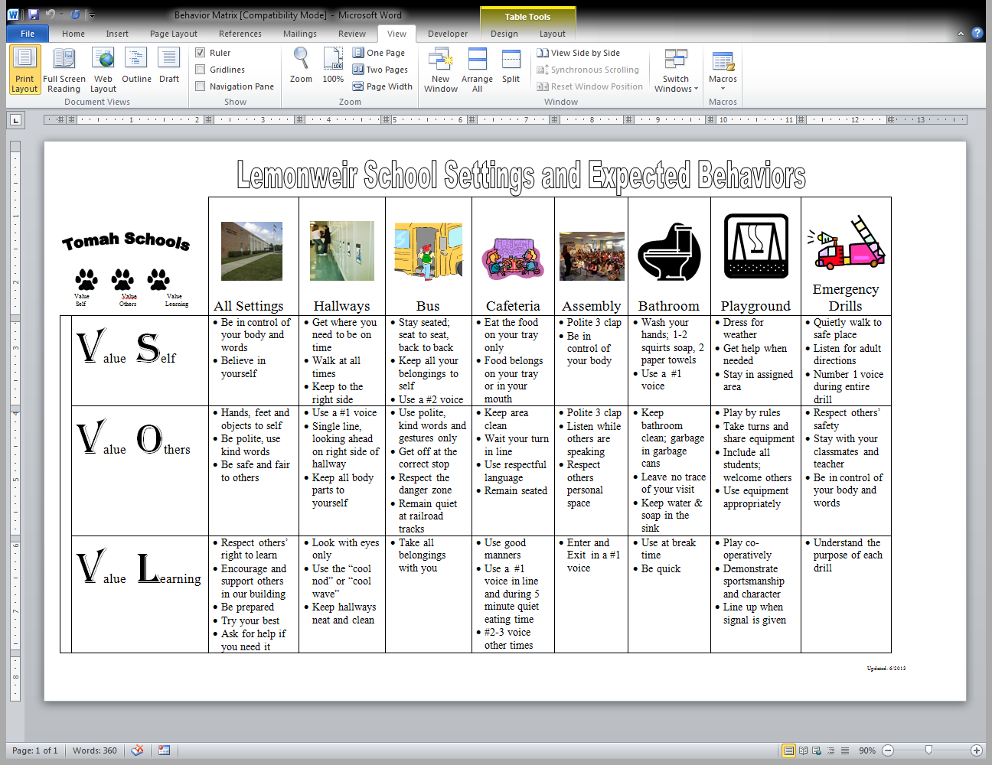

Resources: Classroom Matrix

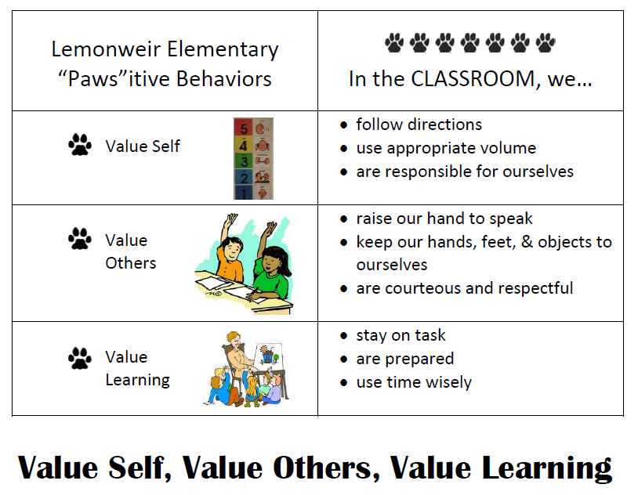

Resources: Flow Chart



Resources: Behavior Definitions

|  |  |
| --- | --- |
| Lemonweir Elementary Behavior Definitions | |
| **Minor Problem Behaviors** | **Definition** |
| Inappropriate Language | Student engages in low-intensity instance of inappropriate language. |
| Dress Code Violation | Student wears clothing that is not within the dress code guidelines outlined in the student handbook, such as wearing a hat, hood up, pants low, clothes with offensive designs or writing, etc. |
| Disrespect | Student engages in brief or low-intensity verbal or non-verbal display of rudeness or discourtesy. Example: arguing, tone of voice, eye rolling, etc. |
| Disruptive | Student engages in low-intensity, but inappropriate disruption such as noises, rocking chair, tapping pencil, blurting out, etc. |
| Failure to follow school rules | Disregard to school-wide expectations. Examples: running in the halls, inappropriate voice, taking turns, etc. |
| Physical Contact | Student engages in non-serious, but inappropriate physical contact such as not keeping hands to self, playing roughly on playground, picking up others, etc. |
| Property Misuse | Student engages in low-intensity misuse of property such as writing on books, destroying school supplies or property, using playground equipment improperly. |
| Defiance | Student engages in brief or low-intensity failure to respond to adult requests. Example: when asked to do something, student says "No, I don't want to." |
| Stealing | Student engages in minor acts of stealing. Example: takes pencils from another student. |
| **Major Problem Behaviors** | **Definition** |
| Abusive Language | Student delivers verbal messages that include swearing, name calling or use of words in an inappropriate way that is directed at someone. |
| Fighting/ Physical Aggression | Student engages in actions involving serious physical contact where injury may occur. Example, hitting, punching, throwing objects, etc. |
| Defiance | Student engages in continuous refusal to follow directions, talks back, and/or delivers socially rude interactions. |
| Disrespect | Student engages in continuous verbal or non-verbal displays of rudeness or discourtesy such as inappropriate gestures, arguing, yelling, etc. |
| Harassment/ Bullying | Student delivers disrespectful messages (verbal or gestural) to another person that includes threats and intimidation, obscene gestures, pictures or written notes. |
| Theft | Student is in possession of, having passed on, or being responsible for removing someone else's property without that person's permission. |
| Lying/ Cheating | Student delivers message that is untrue and/ or deliberately violates the rules. |
| Failure to follow school rules | Repeated disregard for school-wide expectations. |
| Weapons | Student is in possession of knives or guns (real or look alike), or other objects readily capable of causing bodily harm. |

Resources: Discipline Referral Form

All staff may pick up a yellow notepad of these forms in the office.

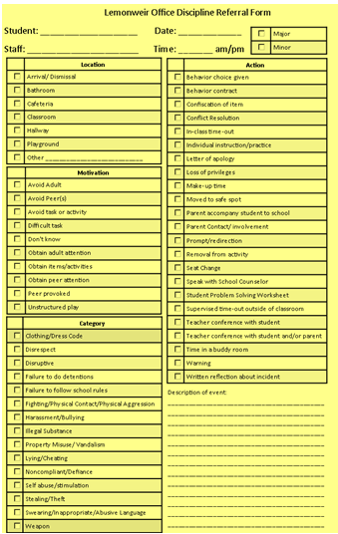

Resources: CICO Form

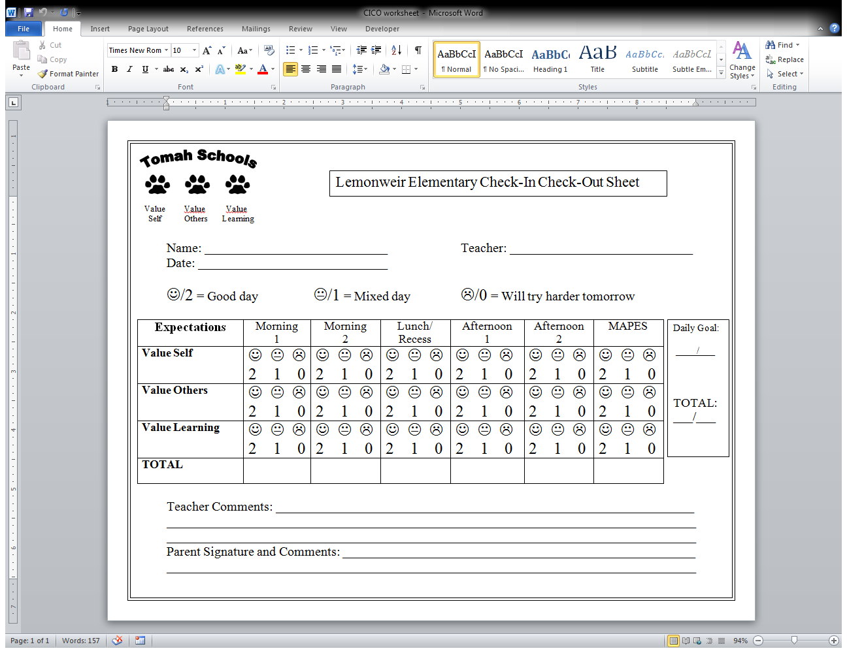

Resources: Lesson Plans

Additional available behavior lesson plans: (See Mrs. Betcher)

|  |  |
| --- | --- |
| Announcements  Apologizing  Asking for Help  Audience Behavior  Backpacks  Bathroom  Bus Line  Checking out Books  Coming From Recess  Communicating with Others  Completing Homework  Cross Age Buddies  Drinking Fountain  Eating in Cafeteria  Emergency Drills  Encouraging Others  Ending Day  Entering Auditorium  Entering Cafeteria  Entering Library  Exiting Auditorium  Field Trip  Following Directions  Getting in Groups  Going to Recess  Greetings  Group Work  Guest Speaker  Hallway  Independent Reading  Independent Work | Leaving Classroom  Lining Up  Listening  Maintaining Your Area  Morning Routine  Music  Partner Share  Peer Tutoring  Playground  Playground Equipment  Pledge of Allegiance  Refocus- Graceful Exit  Refocus- Graceful Entrance  Refocus Moment  Refocus- Welcome Back  Respect Property  Sharpening Pencil  Signal Clean Up  Sitting at Desk  Substitute Teacher  Taking a Test  Trying Your Best  Turning in Homework  Turning in Work  Using Recess Time  Problem Solving  Raising Hand  Walking in Line  Washing Hands |

Updated 8/19/2013 by A. Betcher