An Introductory Exploration of Native American Culture
Emily Lefebvre
Fall 2019

Abstract:
This unit is comprised of approximately 10 days of learning for 50- or 60-minute classes. It was developed to serve as an interactive and collaborative introduction to Native Americans and the similarities and differences between the varying tribes throughout North America. It incorporates strategies and activities that can be used with virtually any unit of instruction. The intention of this unit was to provide students with a base knowledge of culture, location, and the Native experience pre- or early-contact. The unit is largely collaborative to give students the opportunity to share and learn from others’ perspectives. Reflection is also a key component of this unit, to allow students personal time to make connections and process their learning in a safe and unjudged environment. While this unit was designed with the intent of teaching English Language Learners, the activities could be useful to any teacher hoping to introduce their students to Native Americans.

Title: Introductory Exploration of Native American Culture

Grade Band: 9-12 English Language Learners (can be adapted to any level of language speaker)

Curriculum Designer’s letter to other teachers, including own story:
I designed this unit after having spent almost a month learning with and from various members of Native tribes in Montana and North Dakota (Apsaalooke, North Cheyenne, Mandan, Hidatsa, Arikara, and Lakota). I was so fortunate to have the time and space to really reflect on what I learned and the people I learned it from. I wanted to create a simple unit that allowed students the time and space to reflect on their learning and approach it through a variety of modalities. I also created this unit with my students in mind. I teach high school English Language Learner US and World Histories. My students’ language abilities range from zero to near fluent. They also have had a wide scope of exposure to US history. The hope of this unit is that it provides both basic knowledge as well as specialized information that could be new to students who have learned bits before. Finally, I wanted to incorporate some of the fabulous documents and sources that were shared with me on my trip. This includes the Tribal Legacies project that is linked throughout the lesson. This is a magnificent source for primary sources that are in both video and written formats. The wonderful picture books and stories of Paul Goble, a non-native author who spent a copious amount of time and care portraying the stories of Native communities in stories for children and adults alike. And of course, the incredible book “The Spirit of Indian Women” by Judith and Michael Oren Fitzgerald. A book that gives a voice to the rarely written or recorded voices of Native women. Overall, I hope for this unit to serve as an introduction that can be built upon throughout the year.

Curriculum Designs Approach:
This unit was created with the intention of following the place-based multiliteracies design approach used by The Honoring Tribal Legacies Curriculum. This framework compiles learning about a “place” using both cognitive and physical activities that focus on the students’ visual, auditory, tactile, spatial, smell/taste, movement/gestural, linguistic, and spiritual needs and abilities. It was designed to appeal to the variety of students that could be in your classroom while also creating rigorous activities that teach students the intended content. This is accomplished through collaborative work, classroom discussions, journal writing, illustrations and artistic expressions, video and audio, and other activities designed to engage students holistically.

Curriculum expressions:
- Big ideas:
  - Collaborative Learning, Reflection, and Discussion that honor and promote exploring a topic from various perspectives

- 3 Essential question align with Trail/Tribal Themes:
  - Who are Native Americans?
  - What is the relationship like between Native Americans and their environments?
  - What is the relationship like between Native Americans and their ancestors?

- Key Knowledge Objectives:
  - Define indigenous, ancestors, and environment in a Cognitive Content Dictionary.
  - Identify, locate, and describe various Native tribes across America
  - Native Americans aren’t all the same.
  - Native American cultures have strong ties to their environments.
  - Native Americans have strong ties to their ancestors.

- Common Core State Standards within English Language Arts and/or Literacy in History/Social Studies, Science, and/or Technical Subjects:
  - CCSS.ELA-LITERACY.RH.9-10.4 - Determine the meaning of words and phrases as they are used in a text, including vocabulary describing political, social, or economic aspects of history/social science.
  - CCSS.ELA-LITERACY.RH.9-10.1 - Cite specific textual evidence to support analysis of primary and secondary sources, attending to such features as the date and origin of the information.
  - ELP ELA 2 - participate in grade-appropriate oral and written exchanges of information, ideas, and analyses, responding to peer, audience, or reader comments and questions

Daily Lessons:
- Learning Objectives that are alighted with appropriate Common Core State Standards (grade level and content area):
  - At minimum, students will be able to define and understand the deeper significance of the terms Indigenous, ancestors, and environment, along with other terms that arise in the lessons.
  - Students will be able to synthesize information about Native cultures today and in history.
  - To prove a claim or support a point, students will be able to cite textual evidence when analyzing primary and secondary sources.

- Materials and resources necessary for this unit:
  - Cognitive Content dictionary sheets
  - Notebook or group of paper for journal
  - Chart/poster paper
  - Expert group writings and content grid for each student
  - Biography readings/videos
  - Collaborative group role cards
  - Various primary and secondary sources
  - Document-Based-Questions handout (see appendices)

- Learning Modalities:
  - Visual: videos, picture books, photographs
  - Auditory: picture books, biographies, videos, discussions
  - Tactile: illustrations, collaborative roles

- Differentiated Instruction (for advanced and struggling learners and English Language Learners):
  - Given throughout the lessons.
  - For example, students with minimal English-language skills will not be expected to reach beyond the minimum vocabulary.
  - Students who have stronger visual and oral skills than writing skills will be allowed use art to express themselves and elaborate orally about their work directly to the teacher or an aide.

- Suggested Formative Assessment of Learning Outcomes:
  - Journal Quick Checks
  - Observation during discussion
  - Check-ins during collaborative work
  - Entry Questions

- Culminating Performance Assessment of Learning Outcomes:
  - Document Based Questions – primary and secondary source analysis and prompt response with evidence and proper citation.

Day 1
Length of lesson: 50-60 min
Big Idea: Vocabulary introduction, Know/Want-To-Know/Learned (KWL), initial journal work.
Learning Objective:
I can define Indigenous, ancestor, and environment in a way that is informed by Native perspectives.
I can personally reflect on past knowledge and connect it to the lesson given.
I can synthesize my knowledge and create questions for filling in the gaps.
Literacy Objective: Reading comprehension and writing at various levels.
Materials and Resources:
- Cognitive Content Dictionary worksheets (CCD)
  - Translation of vocabulary words into home languages if English Learners are in the class. (example with worksheets at end)
- Poster paper to record class CCD if document camera is unavailable (create 4 columns like on the handout)
- Paper or notebook for students to journal in daily
- Poster paper for KWL chart
Suggested Plan:
ENTRY QUESTION: When you hear “Native American” what do you think of?
- Cognitive Content Dictionary
  - 1 handout for each student
  - Write word above “heard/not heard”
  - Also write it on the class chart or under a document camera if available
  - Students self-select if they have heard the word or not
  - Add word in home languages
  - Have students write what they predict it means
  - Students share out and responses are compiled on class chart/copy
  - Next give students the dictionary definition
  - Finally, in the “oral” column, students write a sentence using the new word, share out, and selections are compiled on class copy.
  - REPEAT with the 3 vocab words
- Create a KWL chart of what students know and what to know about Native Americans. (fill in the K and W sections)
- Introduce Native Americans to students.
  - This could look very different depending on your students’ exposure, grade level, or past experiences.
  - Ex. My class is made up of students who have all come to the U.S. as refugees in the last 3-5 years. A couple have learned about Native Americans a little bit in middle school, but most have no concept of who or what a Native American is, so we will watch a video first to get a mental image and some base information before we continue.
  - You decide what your class needs or doesn’t need as an introduction to Native history or culture.
- Introductory video suggestion:
  - https://www.youtube.com/watch?v=XS8DEjd2QBg
- JOURNAL: With the last 10-15 min, give students time to journal for the day
  - Students respond to a prompt in their journals for the unit: “What part of Native American life in the past is most interesting or significant to you? Connect it to your own life using evidence from what you have learned.” (hints: way of life with regard to environmental considerations; how all people were supported in the community; the role of ancestors; gender roles; etc.)
  - Same prompt will be given later in the unit

Day 2
Length of lesson: 50–60 min
Big Idea: Become more familiar with who Native Americans are, some of their stories, and where they were located.
Learning Objective:
I can summarize a story using evidence.
I can create a visual representation of a text.
I can personally reflect on past knowledge and connect it to the lesson given.
Literacy Objective: Reading comprehension and writing practice.
Materials and Resources:
- Story to read/listen to describe either origin stories or connections to environment/ancestors.
  - Story suggestions:
    - “The Gift of the Sacred Dog” by Paul Goble
    - “Dream Wolf” by Paul Goble
    - Paul Goble Books
  - Video suggestions:
    - http://lc-triballegacy.org/eras.php?tribe=&era=1&subcat=1A
- A/B Partner Share-Out Protocol handout.
- Poster-sized map of original locations of Native tribes.
- Print out of expert groups worksheets.
Suggested Plan:
ENTRY QUESTION: Why is it important to study the indigenous people of a land?
- Read or listen to a story about either an origin story or a tribe’s connection to their ancestors or environment.
- After reading, have students pair up and summarize the key points or what they learned with each other.
  - A/B Partner share-out protocol handout (2 versions provided, one simplified for lower level language learners).
  - Advanced students might be asked to compare Native origin stories with origin stories (such as Genesis) often presented by religious groups around the globe. How are these different or similar?
Other options for sharing the story:
*Take a longer time with the stories and have students read them in groups, then share with the class what they read. Students could be given a “talking stick” to pass around the room while sharing what they learned. Only the student with the stick/object can talk while others respectfully listen. Use as a time to share about the history of the talking stick. If you use a “talking stick” explain its cultural significance first.
https://www.firstpeople.us/FP-Html-Legends/TraditionalTalkingStick-Unknown.html
*Students could also jigsaw a story in groups: divide the story into parts, give each group a part of the story to learn, then have either the whole class come together, and each group shares their part of the story to make it all fit together. Or create new groups that have one student from each part of the story in the group to tell the other students about their part.
- Present large map of former tribal land locations.
  - Discuss with students about what they notice, what has changed, or if this is what they expected?
  - https://lochgarry.files.wordpress.com/2011/11/indian-cultures-map.jpg
- Introduce contemporary land issues of one or more tribes to bring historical issues into the present.
  - The Turtle Mountain Band of Chippewa has “one of a few Native American reservations that protected its lands against white settlement.” It has both reservation lands (67 square miles) and off-reservation trust lands 233 square miles, widely dispersed. https://en.wikipedia.org/wiki/Turtle_Mountain_Indian_Reservation
  - In July 2020, the Supreme Court ruled that about half of Oklahoma (especially eastern Oklahoma) is land that pertains to Native American reservations. The Muskogee (Creek) Nation stated that the decisions “will allow the Nation to honor our ancestors by maintaining our established sovereignty and territorial boundaries.
https://www.npr.org/2020/07/09/889562040/supreme-court-rules-that-about-half-of-oklahoma-is-indian-land
- Present large map of former tribal land locations.
  - Discuss with students about what they notice, what has changed, or if this is what they expected?
  - https://lochgarry.files.wordpress.com/2011/11/indian-cultures-map.jpg
- Introduce expert group project.
  - Each group will have a writing that they will read together and draw an image for each section before continuing.
  - After they have read and depicted each section, they will create a poster with the information learned. Including a map of the country with their region highlighted. (emphasize that others will be using their poster to learn from, so they must be neat and organized)
Differentiated instruction for advanced and emerging language learners:
- Create expert groups that are a heterogeneous mixture of stronger language speakers and those who need more support.
- Use picture books with high level reading to accommodate both.
- Provide the written transcript or subtitles if watching a video.

Day 3 and 4 (may need 2 work days depending on class length or student speed)
Length of lesson: 50–60 min
Big Idea: Become more familiar with who Native Americans are, some of their stories, and where they were located
Learning Objective:
I can create a visual representation of a text.
I can personally reflect on past knowledge and connect it to the lesson given.
I can work collaboratively in a group.
Literacy Objective:
Materials and Resources:
- poster paper for each group
Suggested Plan:
ENTRY QUESTION: What is something new you have learned about Native Americans that changes the way you think about Native people?
- Students are working in their groups to complete their poster for tomorrow
- Last 10-15 min – JOURNALING
  - Students may either simply reflect on what they have learned so far and how this has affected them, or they may answer the prompt: “how do you interact with the environment around you? How does the environment you are in change who you are?”

Day 5
Length of lesson: 50–60 min
Big Idea: Become more familiar with who Native Americans are, some of their stories, and where they were located
Learning Objective:
I can record information from a text in an organized manner.
I can personally reflect on past knowledge and connect it to the lesson given.
I can work collaboratively in a group.
Literacy Objective:
Materials and Resources:
- either printout grids for students to fill out or have them create it in their notebook
Suggested Plan:
ENTRY QUESTION: What do you hope to learn about today?
- Students will participate in a World Café protocol for sharing information https://www.youtube.com/watch?v=7ODLvTBvKow (visual description)
  - Students start out in their original small groups and each group elects a LEADER.
  - When the teacher says to, the groups rotate to a new station, but the leader stays.
  - It is now the leader’s job to teach their content to the next group.
  - When the groups are done, each group now elects a NEW LEADER.
    - This can be voted on or determined by the teacher (e.g. student with the longest hair, nearest birthday, person who woke up earliest, shortest last name, etc.)
  - Now that new leader is in charge of teaching the station they are at to the next group that rotates to them. (i.e. the new leaders are not teaching their original information)
  - Repeat till groups have been to each station.
  - In the end there may be some people with gaps or missing information on their grid. Give students a few minutes at the end to meet up with their original group and compare notes.
- JOURNAL: same prompt as day 1 “What part of Native American life in the past is most interesting or significant to you? Connect it to your own life using evidence from what you have learned.” (hints: way of life with regard to environmental considerations; how all people were supported in the community; the role of ancestors; gender roles; etc.)

Day 6
Length of lesson: 50–60 min
Big Idea: Learn the stories of specific native people and share with others
Learning Objective:
I can work collaboratively in a group.
I can summarize a story using evidence.
I can personally reflect on past knowledge and connect it to the lesson given.
Literacy Objective:
Materials and Resources:
- Multiple copies of various (6-8) short biographies for students to read or listen to (either printed or digital depending on access to technology)
  - Suggestions:
    - “The Spirit of Indian Women” by Judith Fitzgerald and Michael Oren Fitzgerald.
    - Videos about Traditional Culture http://lc-triballegacy.org/eras.php?tribe=&era=2
    - Online Primary Source Collection https://shsulibraryguides.org/c.php?g=86715&p=558322
- Collaborative group role cards – choose the roles you would like and create one card of each for each group.
Suggested Plan:
ENTRY QUESTION: Compare and contrast two of the regions occupied by Native Americans that you learned about yesterday.
- Introduce to students the idea that they are now going to go from broad information about groups of Native peoples, to the personal stories of people’s lives and perspectives of what life was like.
- Provide students with a choice of who they want to read about. Students will self-select 1–3 documents (depending on reading level and speed) to read and annotate independently.
- When students are done, create heterogeneous groups of students with different biographies or accounts.
- Use the Collaborative Group Roles and assign each group member a role.
- Students will work in groups to share their learnings and fulfill their assigned roles.
  - ** Emphasize the necessity for everyone to perform their given role. Make connection to past Native communities where everyone had a vital role and others suffered if they did not perform.
Differentiated instruction for advanced and emerging language learners:
- Provide lower level or shorter readings for emerging learners, and longer or more difficult readings for more advanced students. Color code (if able) to remove the stigma of telling students who is at a lower and higher level.

Day 7
Length of lesson: 50-60 min
Big Idea: Learn the stories of specific Native people and share with others and work collaboratively with individual roles/responsibilities.
Learning Objective:
I can work collaboratively in a group by performing my given role.
I can personally reflect on past knowledge and connect it to the lesson given.
Literacy Objective: Reading comprehension and writing practice.
Materials and Resources:
- Copies of documents from yesterday
- Collaborative group role cards
Suggested Plan:
ENTRY QUESTION:
- Students complete their group work with their roles.
- When everyone is ready, each group can present their discussion question to the class.
  - Discussion norms should be determined prior to holding a class wide discussion.
  - Teacher may decide to arrange the classroom differently to promote fluid discussion around the classroom.
- Two options for the class discussion:
  - Traditional discussion where people are sharing and listening openly
  - Silent discussion. Each student poses a question. Their paper is then either passed around or posted and students walk to each paper to answer. Text evidence must be used. (worksheet attached below)
- JOURNAL at the end:
  - Students may either simply reflect on what they have learned so far and how this has affected them, or they may answer the prompt: “have you been surprised by anything so far? What and Why? What has that made you think of?”

Days 8-10 – Summative Assessment (Document-Based-Questions)
Length of lesson: 50-60 min
Big Idea: Analyze documents from varying perspectives and write a thorough response to the prompt with evidence from the documents
Learning Objective:
I can analyze both primary and secondary sources from various perspectives.
I can answer a question using evidence from both primary and secondary sources.
I can personally reflect on past knowledge and connect it to the lesson given.
Literacy Objective:
Materials and Resources:
- Mixture of both Primary and secondary sources that reflect a variety of native American experiences.
- DBQ (Document Based Questions) handout
Suggested Plan:
- Students will complete a DBQ handout for their summative assessment, using a mixture of primary and secondary sources.
- It will be up to you as the teacher to decide what question you would like them to focus on or which documents you will provide. Links and suggestions are below.
- Students will take a day or so to evaluate the various documents to determine what their perspective or response will be.
- Students will either use the DBQ sheet to write their response or as a graphic organizer to hold their thoughts depending on their language skills or teacher preference.
- JOURNALING:
  - Each day, students should journal about either their progress on the project or their own opinions about what they are learning.
Differentiated instruction for advanced and emerging language learners:
- Provide lower level or shorter readings for emerging learners, and longer or more difficult readings for more advanced students.
- Color code (if able) to remove the stigma of telling students who is at a lower or higher level.
Possible Prompts:
- Describe the ways the Native Americans used and interacted with their environment.
- Describe the ways the Native Americans remain connected to their ancestors.
- Describe the role of women in western Native American tribes.
Possible Sources to use:
- https://www.docsteach.org/topics/american-indians
- https://www.archives.gov/research/alic/reference/native-americans.html
- https://chroniclingamerica.loc.gov/newspapers/?state=&ethnicity=Indians+of+North+America&language?loclr=blogtea
- https://blogs.uoregon.edu/honoringtriballegacies/other-resources/
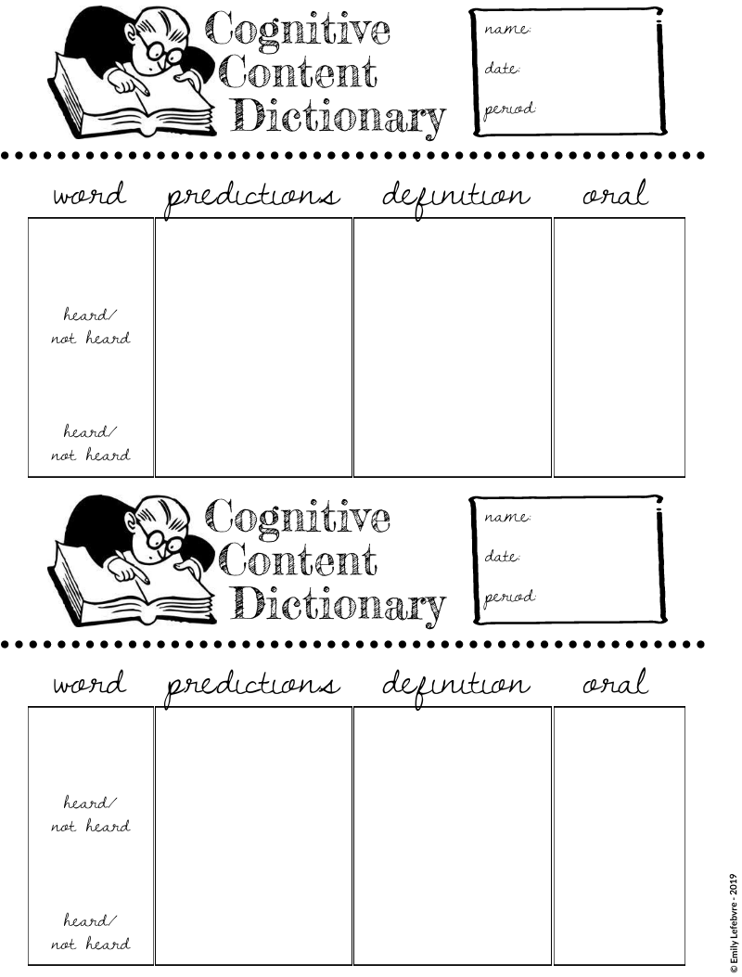
APPENDIX A - CCD
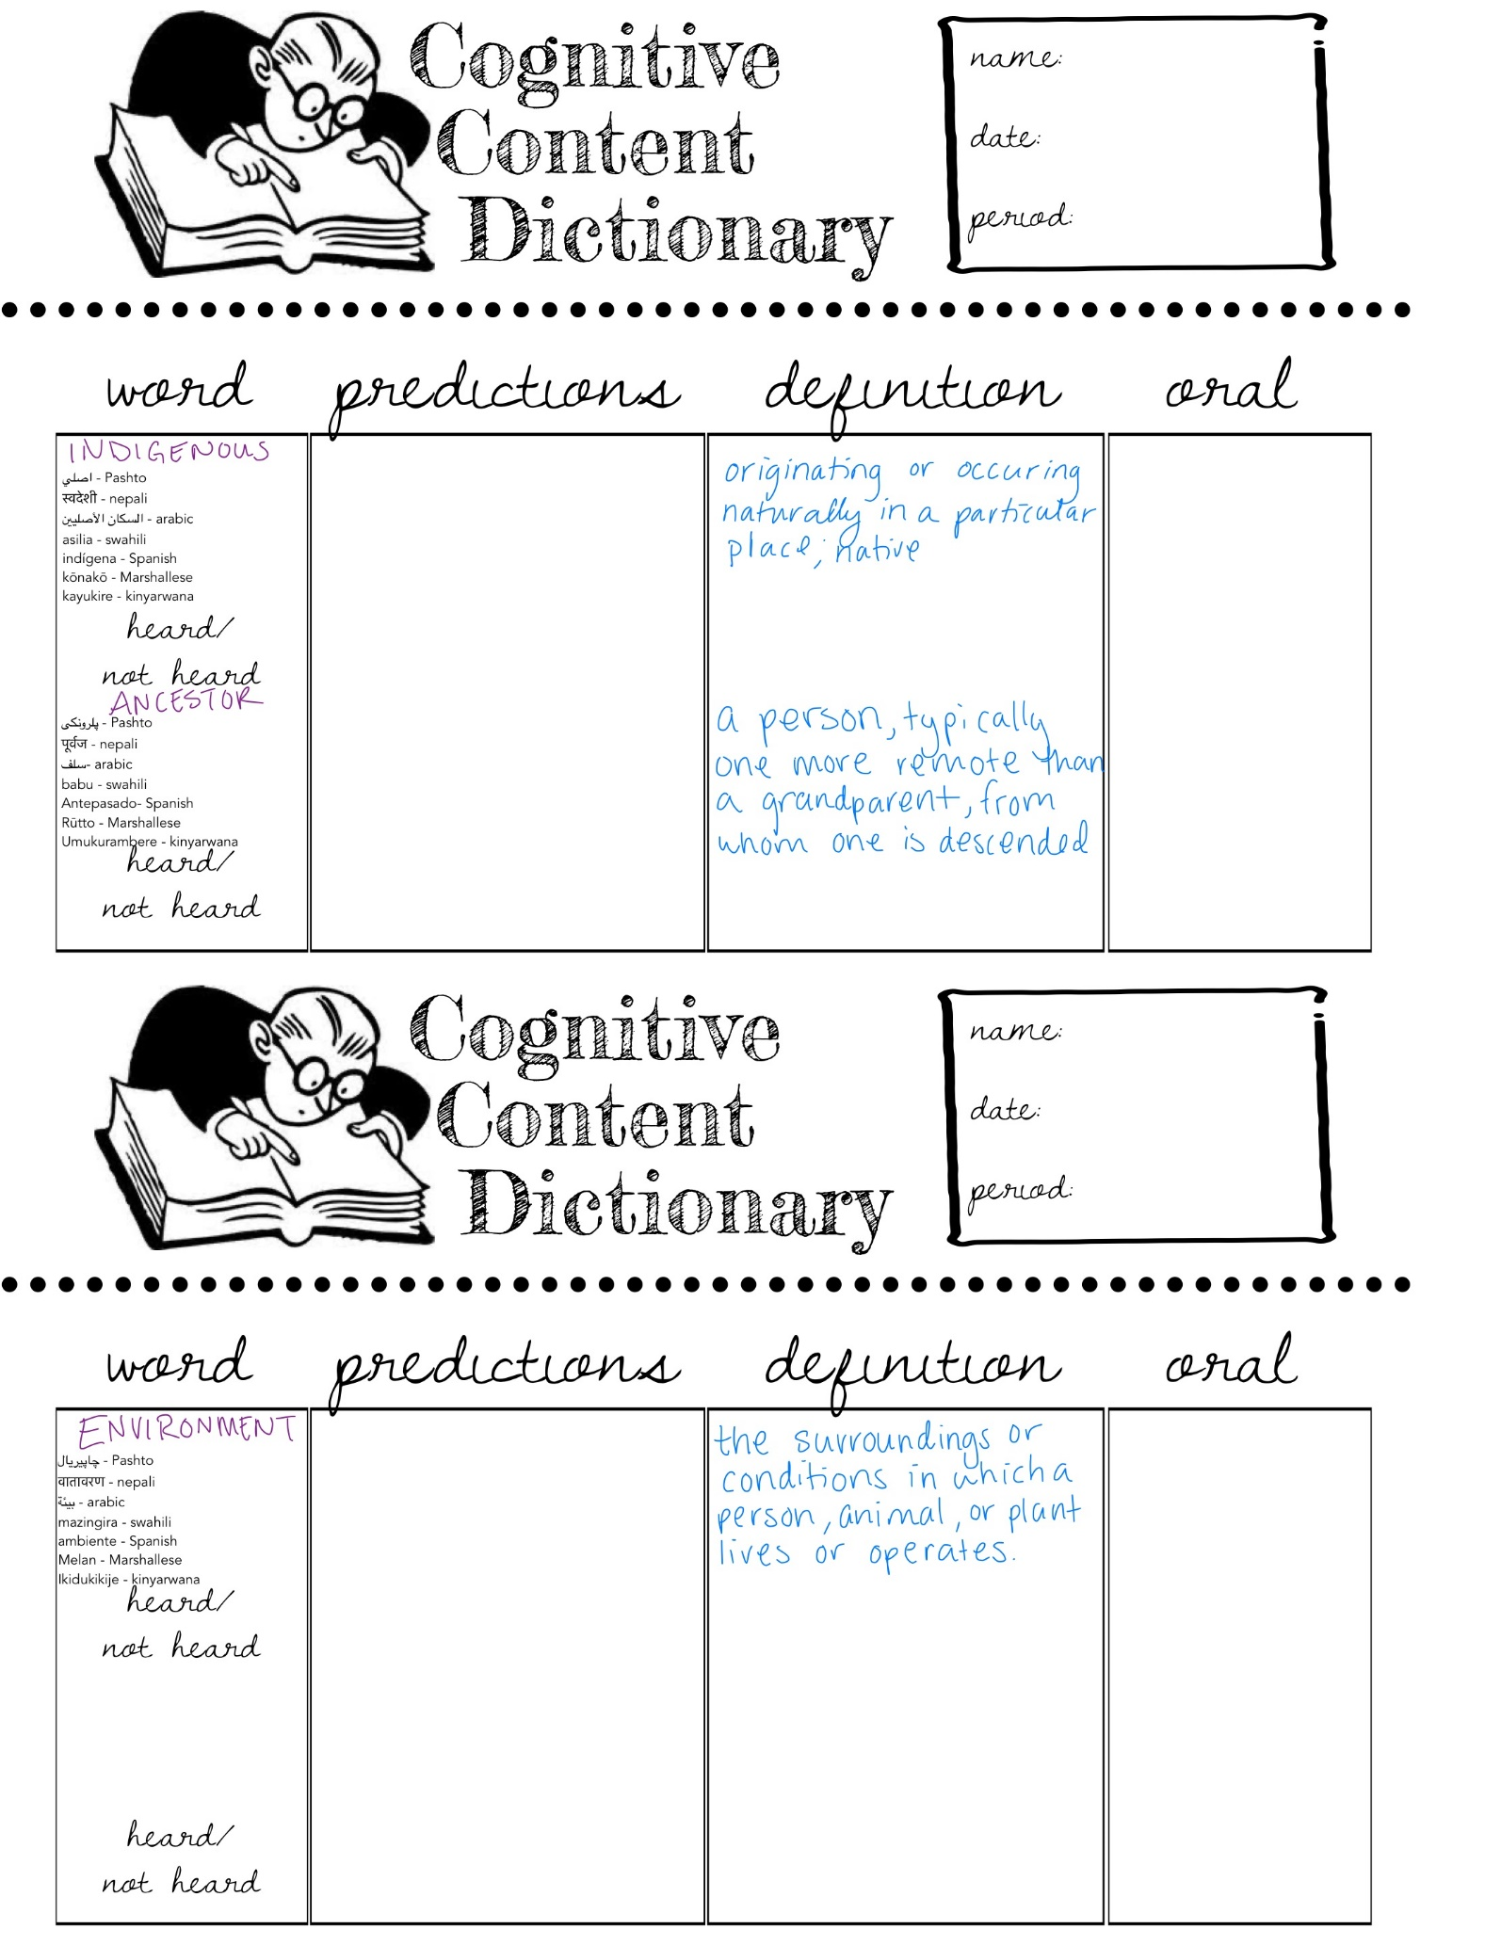
Expert group #1
Pacific Northwest Native Americans

Environment: The Northwest Native Americans lived along the Pacific coast from Southern Alaska through Oregon. The ocean is on the west and the mountains are on the east. The mountains and the ocean combine to create a mild, rainy climate. There are forests, lakes and rivers in this region.

Food: The Northwest Indians hunted and gathered their food from the ocean and forests. They hunted and ate whales and seals. From the forests, they hunted deer, goats, bears and other small animals. They also fished. In the fall, they could catch enough salmon to feed their families for the whole year. They smoked the salmon over smoky fires to preserve it from spoiling. We learned to smoke salmon from them. This is a cultural contribution. They also gathered shellfish, berries and other wild fruits and vegetables. They had plenty to eat.

Shelter: The Northwest Native Americans built large plank houses from planks of cedar trees. They decorated the houses with paintings and carvings. The richest and most important families had the largest houses. 4 or 5 related families would live in one house. Carved totem poles that told the family history and status, or how important they were, were placed outside the house. Totem Poles are a cultural contribution. You can see totem poles used as decorations in the Northwest.

Transportation: One of the ways they traveled was in dugout canoes. Long ago, the canoes were made by burning them and scraping out the ashes. Later when they received tools from the settlers and explorers, they became expert carvers and they carved beautiful pictures and animals onto the canoes. We still use canoes today although they are made differently. They also walked most places. They protected their feet with moccasins made out of animal hide and decorated them with colorful beads, shells, and porcupine quills. Today, a shoe modeled after the moccasin is sold. There were some horses after the 1600’s, but canoe and walking were the main modes of transportation.

Expert group #2
Plains Native Americans

Environment: The plains region is in the central part of the United States where the land is mostly flat and grassy. There were not many trees or mountains. In the summer, it was hot and dry. The winters were cold and snowy.

Food: Plains Indians hunted, grew or gathered their food. They hunted buffalo and antelope. Meat was thinly sliced and dried in the sun like jerkey, to preserve it. We learned how to do this from them and still eat jerkey today. Buffalo are raised on ranches today to provide meat for restaurants. These are both cultural contributions. Some tribes, that did not migrate, grew crops such as maize (corn) , beans, and pumpkins. The tribes that migrated with the buffalo and antelope also gathered wild fruits and vegetables.

Shelter: Plains Indians lived in teepees made of buffalo hides held up by wooden poles. Plains Indians followed the buffalo herds, so they had to be able to take down their camp and move quickly. Like modern tents, tepees were carefully designed to set up and break down quickly. An entire Plains Indian village could have their tepees packed up and ready to move within an hour.
Some tribes did not migrate; these Indians lived in earth or grass lodges. These lodges were dome-shaped and covered with earth. They were partially built under the ground. Many pioneers built their first homes this way. Teepees are still used today for recreational camping. Teepees are a cultural contribution.

Transportation: The Plains Indians first traveled by foot. They made soft shoes called moccasins out of buffalo hides. We use a shoe modeled after the moccasin today. Horses became very important after the 1600s when the Spaniards introduced them and were used to chase the buffalo and help them move their villages from one place to another as they migrated with the buffalo herds. Some who lived near lakes and rivers had canoes, which is another cultural contribution.
Expert group #3
Southwest Native Americans

Environment: The Southwest region has 3 types of environments. In the northern region are tall mountains and deep canyons like the Grand Canyon. The middle region has mountains and forests. The south is mostly sagebrush and cacti. The days can be very hot and the nights very cold. There is not much precipitation.

Food: Many of the Southwest American Indians were farmers and herdsmen. They grew corn, beans, and squash; corn was the main crop. Corn is a crop that the whole world eats today that came from the American Indians. Many recipes we eat today such as corn tamales and corn tortillas are cultural contributions from the Southwestern American Indians. They also hunted animals such as deer and rabbit. They also raised sheep and goats for their meat, wool, and skins.

Shelter: The Navajo tribes in New Mexico and Arizona lived in hogans. Hogans have six sides and are built from adobe. They had one room and the doorway was covered with a beautiful Navajo rug. A smoke hole in the roof allowed smoke from the fires to escape. Some tribes lived in pueblos. These were apartment style homes made of adobe which is a mixture of clay, sand and vegetables. Many families would live in one home with a flat roof. When they outgrew that home, another one would be built on top of it. A ladder was used to climb into the homes and pulled up at night to protect them from enemies. Today, some Native Americans still live in adobe pueblos and hogans. Adobe is a cultural contribution from the Southwestern American Indians.

Transportation: Southwest American Indians walked everywhere. There were many mesas and cliffs. They dug holes in the sides of the mesas and cliffs, and then could climb up the cliff holding onto the holes. We use rock climbing walls as recreation today. Tribes who lived near rivers would have used canoes, but there were not many rivers because there was so little water. They got horses and donkeys from the Spanish after the 1600s, and then some were able to travel by horse.

Expert group #4
Southeast Woodland Native Americans

Environment: There was plenty of rain in the Southeast. Winters were short and mild, and summers were long, warm, and wet. The climate was good for farming. There were many forests in this region and the Atlantic Ocean was nearby. Because there was so much precipitation, there were many rivers and lakes.

Food: The Southeast American Indians who lived by the ocean hunted whales, seals, and porpoise. Fish, turtles, and Alligators could be found inland in the streams, rivers, and swamps. The land was fertile, and they grew corn, squash and beans. Corn, beans, and squash are just a few of the foods the Indians introduced to the world and we still eat them today. They hunted deer, rabbit, and bear in the forests. In their villages, the women cooked the food for everyone, and they all ate together. The Southeast Woodland Indians had plenty to eat.

Shelter: They lived in planned villages. The tribes that lived in the very wet or swampy areas, like Florida, lived in chickees. Chickees were houses that were high off the ground and did not have any walls. They could lash tarps made of hide or cloth to the frame during rainstorms, but most of the time, the sides of the house were kept open to keep cool. You can see houses in these areas today that are built on raised platforms to keep dry. This is a cultural contribution. Other tribes, which did not live in very wet areas, built Wattle and Daub Houses on the ground called asi. They were made by weaving twigs, branches and stalks to make a frame, then covered them with a sticky plaster to fill in the holes. They looked like upside-down baskets.

Transportation: They traveled by foot using moccasins to protect their feet. A shoe modeled after the moccasin is sold in stores today. The moccasin is a cultural contribution. Since they were around so much water, they made dugout canoes by carving out trees. In many areas, the water wasn’t very deep. They stood up in the canoes and pushed the canoe along with long poles. Today people use canoes recreationally. After the Spaniards brought horses to the new world, they also used horses.

Expert group #5
Northeast American Woodland Native Americans

Environment: The Northeast Native Americans lived along the Atlantic Coast from the Great Lakes to Maine. The ocean is on the East and there are many forests, rivers and lakes in the area. The winters are cold and snowy, while the summer is warm and rainy. They receive lots of rain in this area.

Food: The Northeast Native Americans farmed crops called the three sisters: corn, squash, and beans. These are still some of the most commonly grown crops in America. They also grew pumpkins, sweet potatoes and sunflowers. The forests provided maple sap for syrup, berries, and nuts. Also in the forest, they hunted deer, rabbits, and turkey. From all the rivers, lakes, and the ocean, they fished for salmon, whales, and seals. They would dig pits, or holes, in their houses and store their food inside so they could store extras and keep it safe.

Shelter: The Northeast Native Americans built huge longhouses out of wood. Each longhouse would have up to 20 families living in it. There were smokeholes about each of the firepits inside so that the smoke could get out of the house. Each firepit was shared by 2 families, one on each side. Their villages were built on plateaus, or high up flat parts of land. The fence or wall around the village is called the palisade. The palisades were built out of trees and set up around the village to keep animals and unwanted people out.

Transportation: One of the ways they traveled was in a dugout canoe. Long ago, the canoes were made by burning them and scraping out the ashes of cedar trees. They would cover the canoes in bark made from cedar and birch. We still use canoes today although they are made differently. They also walked most places. They protected their feet with moccasins made out of animal hide and decorated them with colorful beads, shells, and porcupine quills. There were some horses after the 1600’s, but canoe and walking were the main modes of transportation. Because it snows lots in that area of the country, they also used snowshoes to walk through the snow.

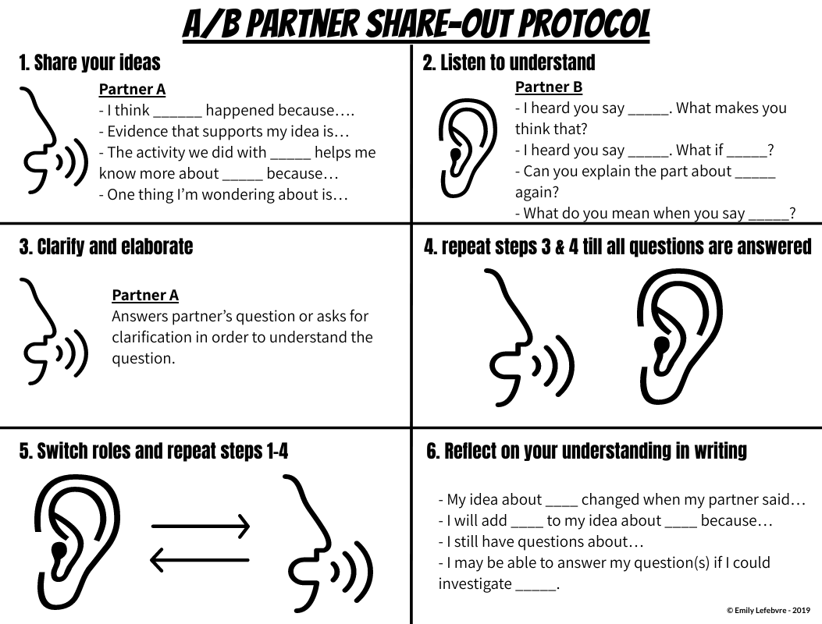
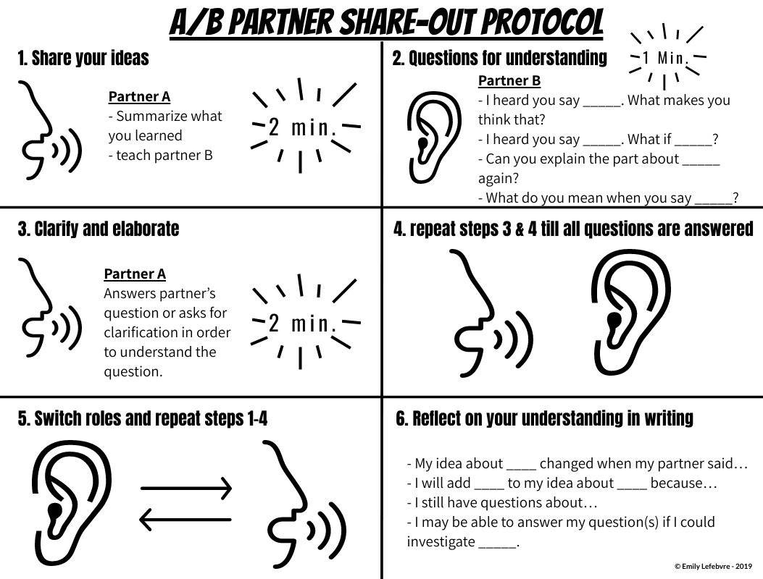

Group | Environment | Food | Shelter | Transportation | Lasting Traditions
Northeast Woodland
American
Indians

Plains
American
Indians

Northwest Coast
American
Indians

Southeast Woodland
American Indians

Southwest
American Indians

