“Survive with Your Tribe”
By: Aaron S. Kind
Chief Plenty Coups State Park
(with edits by Stephanie Wood and Shuo Xu)

Contents:
- Background Information --------------------------------------------------------------------------------------- 1
- Program Overview ----------------------------------------------------------------------------------------------- 2
- Volunteer’s Class Preparation and Responsibilities ----------------------------------------------------- 3
- Classroom Instruction ------------------------------------------------------------------------------------------- 4
- Supplemental Materials ---------------------------------------------------------------------------------------- 8
- Survive with Your Tribe Worksheet -------------------------------------------------------------------------- 9

Background Information

The ability for a society or culture to survive is related to its ability to utilize resources, cooperate, defend, and reproduce. American Indian nations filled the Americas in many different roles, utilizing many different survival tactics. Inuit/Alaskan tribes utilized large marine mammals as a basis for food and other types of manufacture in their society. Mesoamerica’s diverse planting and crop rotating systems fed large scale societies on a range of soils. But the Plains Indians uses of buffalo as food source, shelter, clothing, tools, glues, cordage, and ceremonial was truly staggering. Tails became flyswatters, hides became clothing and shelter, sinew became bowstrings, and horns became cups. While many of the Plains Indian nations utilized the buffalo, they were competing among themselves for the same resource. With the influx of Europeans and eventually Americans' westward expansion, traditional stone tools gave way to metal, the faithful dog was replaced by the horse, and bows gave way to guns. The acceptance and or rejection of new technologies could have dire consequences to the tribes. Early on the Shoshone, with access to horses from the south, rose to power throughout Montana, pushing many of their traditional enemies away from the best buffalo hunting grounds. Later on, the Blackfoot—with stolen horses from the Shoshones and access to firearms from the Canadians in the North—redefined “traditional” hunting grounds once again. By the time the Lewis and Clark Expedition reached the Lemhi Shoshones, Lewis described what he saw as their poor living conditions. Meriwether Lewis later noted, “Notwithstanding their extreme poverty they, The Shoshones, were most concerned about securing guns in return” for trade items they proffered. Lewis wrote that Cameahwait told him, “If we had guns, we could live in the country of the buffalo and eat as our enemies do, and not be compelled to hide ourselves in these mountains and live on roots and berries as the bear do.” (Lewis and Clark Journals) In this example, one newly introduced species (the horse) and one new technological advancement (guns) altered tribal boundaries in a very short period of time, especially when tribes used them on one another.
The following game, as mentioned in the lesson plan, is a version of the 'Prisoner’s Dilemma.'
“The prisoner's dilemma game can be used as a model for many real-world situations involving cooperative behavior. In casual usage, the label 'prisoner's dilemma' may be applied to situations not strictly matching the formal criteria of the classic or iterative games: for instance, those in which two entities could gain important benefits from cooperating or suffer from the failure to do so, but find it merely difficult or expensive, not necessarily impossible, to coordinate their activities to achieve cooperation.” (Wikipedia)
Students will have to cooperate within their “tribe” to make decisions about which tribal items to leave, which to take, cooperating with neighboring “tribes” or raiding them. Situations will be given by the moderator/presenter to see if the “tribal” decisions were helpful or harmful to their overall success. The moderator/presenter will present opportunities to the larger group to show how social and economic impacts affect their overall outcome.

*Note to Presenter: This game does not have a set time or clear winning strategy; the presenter can make up situations that may not be located in the curriculum, depending on how long the game is played and what outcome is desired.

**Note to Presenter: This program can be extended to 30-40 minutes for teachers looking for longer programs.

Program Overview

Introduction: 5 minutes (Outside of the Visitor Center) Introduce students to presenter and Chief Plenty Coups State Park. Remind students of behavioral expectations, raising hands, no yelling, no running, and most importantly, to be respectful of the objects that they may see in the Park. Finally, give a brief outline of the day’s program.

Visitor Center Exploration: 10-15 minutes (Inside Visitor Center) Depending on arrival, a standard exploration time is given to the class as a whole, approximately 10-15 minutes. At this time, students may touch objects inside the Visitor Center, use restrooms, and ask questions to staff. At the end of this exploration time, if necessary, the class can be divided into two groups.

Note: this portion can be reduced or eliminated if overall program time is reduced due to late arrival.

**IMPORTANT REMINDER!**

- Older students (8th grade-High School) will not get an Activity/Game.
- Class and House tour will be extended by 10 minutes apiece.

Instructional Component:
Group A—25 minutes | Group B—25 minutes | Group A& B—20 minutes
Where: Inside Visitor Center, in front of tipi.  25 minutes of student centered, inquiry-driven instruction of class.  - Brief overview of how societies are impacted by change.  - Brief introduction of the games rules and pieces (Further instruction below)  - Game.  - Review of concepts and clean-up of materials. | Where: Chief Plenty Coups house  25 minutes of touring through Chief Plenty Coups' house and a presentation at the Sacred Spring.  - House walking tour  - Spring tour  - Reminder: Remind students to be respectful of any offering seen at spring.  - Switch groups. | Where: Open areas around Visitor Center  Depending on teacher preference/weather activities include…  - Capture Butterfly game.  - Crow Coup relay.  - Nature hike with binoculars and field guides.  - Beading activity.  - Chickadee Challenge.  - Fishing.  Reminder: define activity area and safety concerns.

Switch Groups/Transition between activities: (if needed) 5 minutes

Closing: 5 minutes, thank students/teachers and chaperones for attending the program, gather belongings, and finalize any unfinished business with teachers.

Volunteer’s Class Preparation and Responsibilities

Before class arrives, prepare staff, volunteers on the class program, time issue,s and any special requests/concerns from teachers.

(Before Class set-up)
- Place class supplies box upstairs in Visitor Center.
- Review the class curriculum if needed.

(Teaching responsibilities)
- Assist teacher with filling out classroom reservation card located in day planner.
- Assist students in Visitor Center exploration.
- Help instructor/teachers with dividing class into two equal groups.
- Assist with classroom management/teaching/tour/activity if needed.
- Assist in cleaning up Visitor Center and putting supplies back into assigned places.

Classroom Instruction Lesson Plan: Survive with Your Tribe

Level
Grades 6th-12th (program may be changed to accommodate grade level)

Standards
Social Studies
(Benchmark for Grade 4)
Content Standard 5: Students make informed decisions based on an understanding of the economic principals of production, distribution, exchange and consumption.
#1 Give examples of needs and wants; scarcity, and choice.
#2 Identify basic economic concepts that explain events and issues in the community.

Science
(Benchmark for Grade 8)
Content Standard 5: Students understand how scientific knowledge and technological developments impact society.

Content Standard 6: Students understand historical developments in science and technology.
#2 Identify major milestones in science that have impacted science, technology and society.

Social Studies
(Benchmark for Grade 8)
Content Standard 1: Students access, synthesize and evaluate information to communicate and apply social studies knowledge to real world situations.
#1 Apply the steps of an inquiry process (i.e. identify question or problem, locate and evaluate potential resources, gather and synthesize information, create a new product and evaluate product and process)
#3 Interpret and apply information to support conclusions and use group decision making strategies to solve problems in real world situations (e.g. school elections, community projects, conflict resolution, role playing scenarios).

Content Standard 4: Students demonstrate an understanding of the effect of time, continuity and change on historical and future perspectives and relationships.
#5 Identify major scientific discoveries and technological innovations and describe their social and economic effects on society.

Content Standard 6: Students demonstrate an understanding of the impacts of human interaction and cultural diversity on societies.

Abstract
Survive with your Tribe will allow students to use cooperative skills to explore basic economic principals while identifying technological advancements effect on cultures through the use on gaming strategies.

*Note to Moderator/Presenter: Due to the limitless possibilities of this game, there is no right or wrong strategy by students. The Moderator/Presenter can steer the game in any direction that he or she chooses. Not all Situations are listed below; situations may be presented on the spot if needed.
Objectives
Students will be able to:
- Be introduced to basic economic principles.
- Become familiar with concepts of technological advancements having an impact on culture and societies.
- Work within their group to strategize, evaluate, and cooperate for best possible outcomes within the game.

Materials
- Small game box, one box for every 5 students.

Implementation Overview
Time Allotment: 20 minutes
Begin by having students divide into “tribes” of 5 members apiece. Explain to them that each “tribe” will receive the same game pieces (review game piece meanings in Supplement #1). Each tribe must keep the same four items, Tipi, Food, Horses, and Trade Bundles. Each tribe must also surrender (place in box) four items of their choosing. These pieces may not come into play during the game. Have the student’s set-up their remaining game pieces in front of their group so the presenter can see their “tribal” supplies to ensure fairness in the game. The survival of their “tribe” depends on the choices they make by keeping the remaining items. To “score” the game, Trade Bundles will be used as currency. “Tribes” can be rewarded or penalized one Trade Bundle, depending on the outcome of the situation. Example: “A late spring snowstorm has taken you by surprise, if you have your snowshoes it is not a problem, if you don’t have snowshoes, surrender one bundle to the moderator/presenter.” As mentioned earlier, this game has limitless possibilities dependant on the moderator/presenter; it is also an opportunity to share knowledge of the game pieces. Example: “Heart skins were used to carry water.” or “Food was stored in parfleche containers.” There can be situations that are not presented in the curriculum. Here is a list of possible situations that can be used in the game.

Opening scene
Your tribe is on the move. It is late spring, the air is cool, grasses are greening up and there are new leaves on the trees, and you are moving into the buffalo hunting grounds. The area you are entering has your tribe’s traditional friends and enemies. You must be careful, not only keeping track of what you packed on your travois, but being aware of new technologies and other people in the area. Are your friends still your friends? Are your enemies still your enemies? How you treat your neighboring tribes may dictate how well your tribe survives. You will be asked situations such as should you raid your neighbors? Should you trade for new technologies? Should you trust the new trade fort that has been established in the area? By working together and making strong decisions, hopefully your tribe will survive this changing world.

Situation 1.
“A late spring snowstorm has taken you by surprise, if you have your snowshoes it is not a problem, if you don’t have snowshoes, surrender one bundle.”

Situation 2.
“You need to keep your tipi warm, but don't worry if you didn’t pack firewood; on the Plains most tribes burned buffalo chips if wood wasn’t available.”

Situation 3.
“The snow has melted, it is a beautiful spring day again, and unfortunately half of your horses have run off during the night. You must use your rope to round them up again. If you don’t have your rope, surrender one horse.”

Situation 4.
“The wind starts to howl fiercely, and your tipi is in danger of being knocked over! What should you use to keep it from blowing down?” Wrong answer from students: tipi ring. Are you saying you took up valuable space on your travois to carry rocks? Tipi ring rocks were left at the campsites to be re-used the next time you came back. Hopefully you didn’t leave something of greater value behind to carry rocks!”

Situation 5
“Plains Indians were very resourceful, they used volcanic rocks, wood, and buffalo bones to make their tools and weapons before metal was introduced into America. Your tools and weapons are in need of repair, you can make new tools and weapons with chert and bones if you have them. If you don’t have both surrender one bundle, or you can trade two bundles to me for metal tools.”
Option: “Do you want to raid any tribe without metal tools?” — You may take one bundle.

Situation 6
“Cherts and flints were also used with metal to make fire. If you have chert and metal tools you get one extra trade item from me.” (Demonstrate Fire/Steel)

Situation 7
“Trading furs was a huge part of the world’s economy. What animal fur was most sought after by traders?” Answer: Beaver. The group that guesses the beaver first gets one extra trade bundle.

Situation 8
“You have been raided by a neighboring tribe, your tipi is destroyed, you can make another if you have either buffalo robes or an extra tipi, but you need extra tipi poles as well. If you don’t have tipi poles and hides or an extra tipi, surrender one bundle.”

Situation 9
“A trader is offering you guns, if you have 2 horses you may trade for them. The price is steep, four bundles. Are there any takers?”
Explain: "The two most powerful items on the Plains were horses and guns. The Shoshone Indians were one of the first tribes in Montana to have access to horses from the south. Once they had them, they took over the best buffalo hunting grounds, raided their enemies (the Blackfoot, and pretty much controlled a large area of Montana. The Blackfoot stole Shoshone horses, and they had access to guns from Canadian traders. The Shoshone begged Spanish traders for guns but they would not trade. By the time that Lewis and Clark met the Shoshone, he described them as being in 'poor condition' and having been pushed way back into the mountains, constantly being raided by the Blackfoot.”
Option: “You may raid every tribe of two bundles, a blanket and a horse.”

Situation 10
“It is now the middle of summer, and it is hot!” If you have your heart skins you can carry water back to camp, if not, surrender one bundle” “The outer lining of a buffalo’s heart was used as a water container; it does actually look like plastic/thin hide.”

Situation 11
“A different trader enters your camp. He wants to put a trade post on land of the tribe that raided you. He had a fight with them before and does not like them. He is offering for you to use his guns for free and will lend horses to you. Do you accept?”
Option 1: “If you participate in this raid you may take three bundles, a blanket and a horse.”
Option 2: “Or if two tribes join the tribe about to be raided there will be no war and everything stays the same.”

Situation 12
“A strange sickness has affected your people; you need a traditional healing plant. If you don’t have it, then you must give two bundles and a horse because there are not enough people to tend the horses.
“When new people come in contact with each other, diseases get spread. In Winter Count robes some of the symbols depicting the year’s events show people covered in spots. With no natural immunities many of the American Indian tribes were decimated by diseases.”
“What would the loss of half your tribe do to your ability to defend yourself?”

Evaluation/Review
Time Allotment: 5 minutes
- Ask the students if they felt their “tribe” worked well together.
- Did they feel that it was “fair” trades or situations?
- Lead a discussion about what was needed for survival in the beginning of the game, and how new technologies impacted the game?
- What happened to the “tribes” once new technologies were introduced?
- Have students replace materials in game boxes, replacing the appropriate number of each item to each box.

Supplement #1 -- Game Piece Identification and Trivia

(2) Horses—Horses were one of the most important animals to semi-sedentary tribes. They allowed for farther movement, larger tipi construction, better hunting practices, and were one of the two major sources of power on the Plains.
(1) Tipi—Tipis were traditionally made of buffalo hides. With the introduction of the horses, tipi sizes grew larger. Later trade replaced buffalo hide with canvas coverings.
(1) Extra Tipi—Commonly, tipis would wear out after a few seasons; women spent many hours gathering and sewing new tipis every few seasons.
(1) Extra Tipi Poles—One of Montana’s first lumber exports, extra tipi poles were cut and traded to interior Plains tribes for their use. Sometimes they were left at a campsite to be used at a later date.
(10) Trade Bundles—Representing furs and trade items. Beaver furs were sought after by traders to use in fashion applications.
(1) Tipi Ring—Rocks used to ring the base of the tipi; left at campsites to be used at a later date.
(1) Chert—Volcanic materials used in tool and weapon construction. They have the ability to have one of the sharpest edges. Unfortunately, a piece of chert does not hold a sharp edge for very long with repeated use.
(1) Bones—Used for tool and weapon manufacture
(1) Heart Skin—This outside membrane of the buffalo heart was used to carry water.
(1) Rope—Cordage, or rope, can be made of different materials, such as hair or hide.
(1) Plants—Represents medicinal or ceremonial plants.
(1) Firewood—Sought after for warmth and cooking, when firewood was not available, buffalo “chips” (dried excrement) also made excellent fuel.
(1) Snowshoes—Used for movement in deep snow, these shoes are documented historically for having been worn by hunters who were driving buffalo into deep snow. These special shoes kept the hunters from sinking into the deep banks of snow.
(1) Food—Food was stored in parfleche containers (decorated hide bags).
(1) Buffalo Robes—These robes had multiple uses, such as tipi coverings, clothing, and bedding.

Moderator/Interpreter-Trader box: contains (6) Flintlock Rifle cards, (6) Metal Tools and Weapon Cards, and Hairpipe Trade Bundles.
SURVIVE WITH YOUR TRIBE WORKSHEET
Created by: Aaron S. Kind

Directions: All Players must keep all the items below. (2 Horses, Food, Tipi, and 10 Trade Bundles)

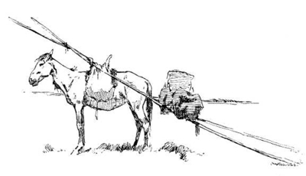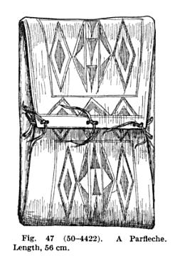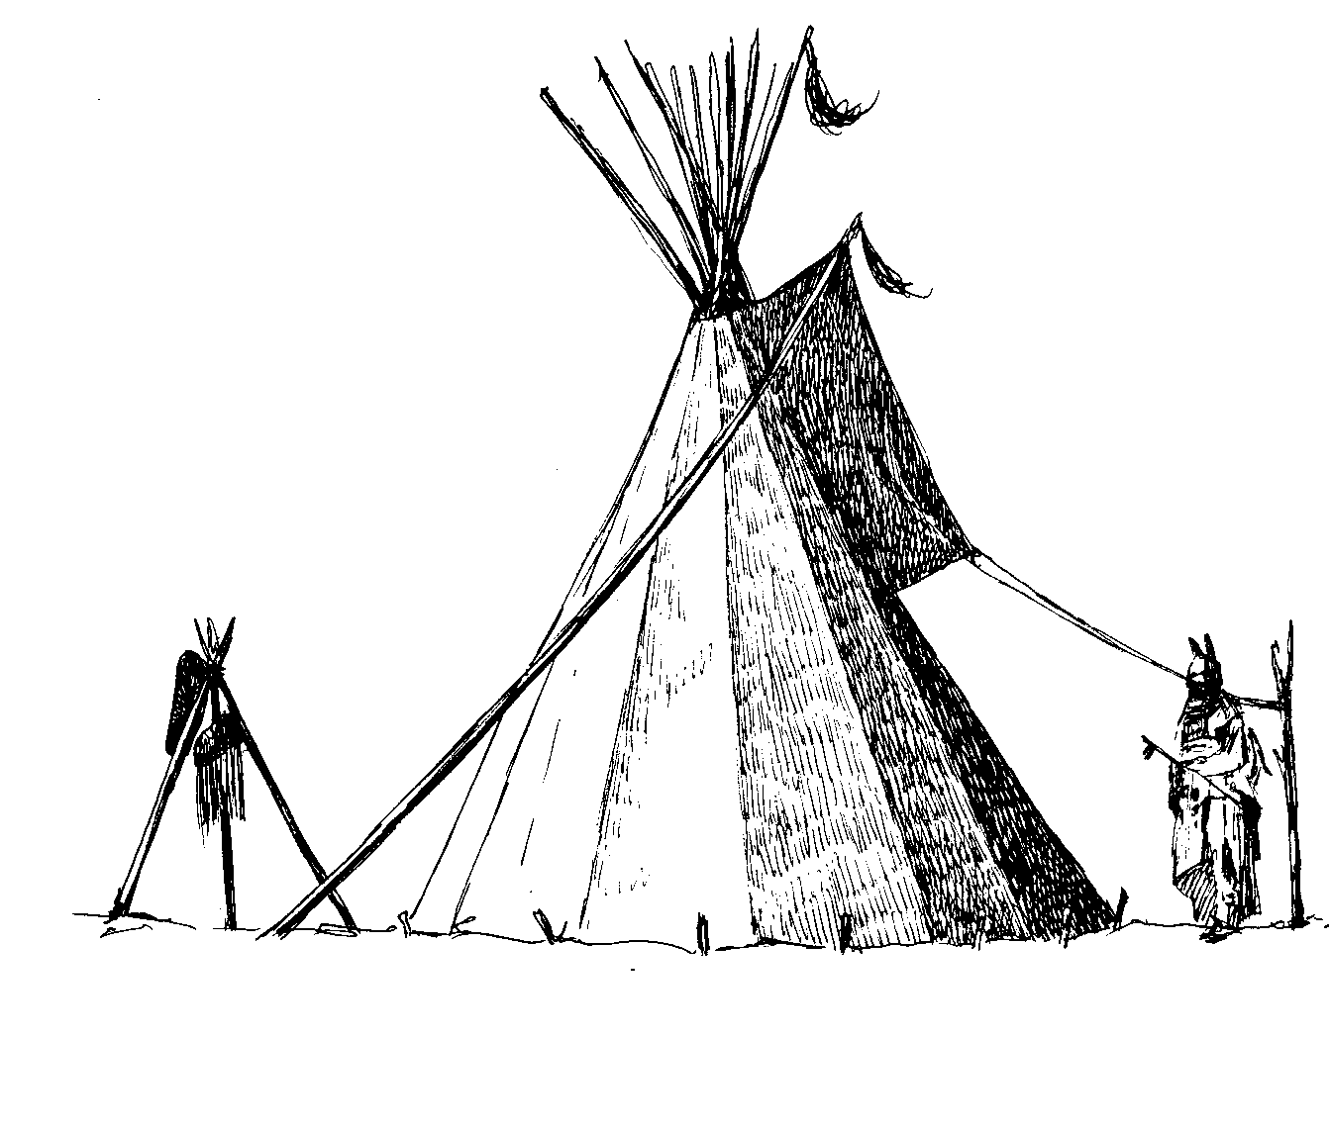
TIPI
HORSE
HORSE
FOOD

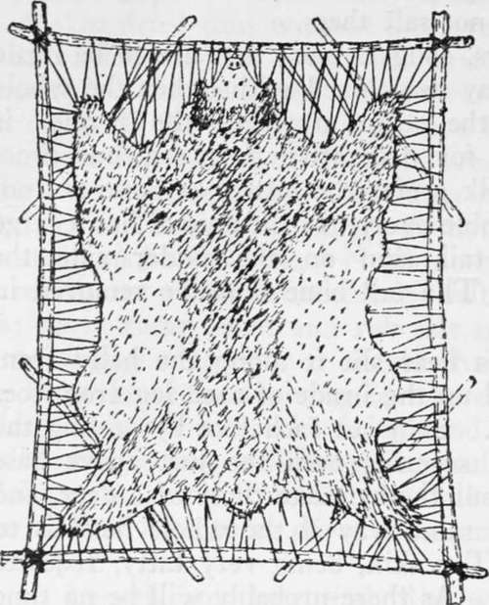
TRADE BUNDLES

Directions: All Players must cross-out 4 items below; crossed-out items may not be used in the game.
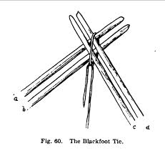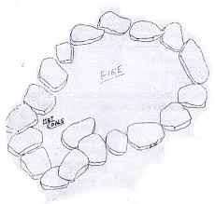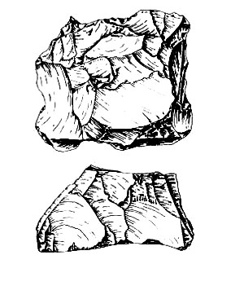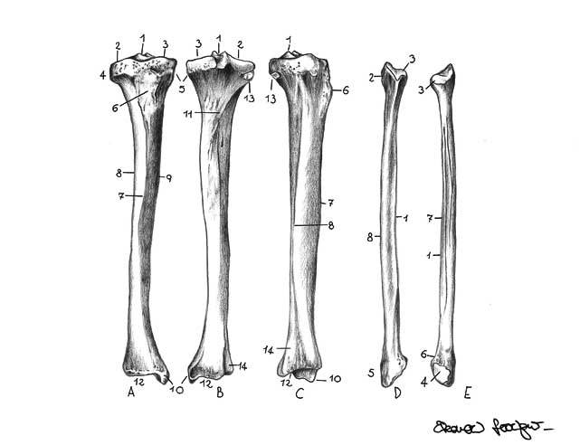
BONES
CHERT
TIPI RING
EXTRA TIPI POLES
EXTRA TIPI

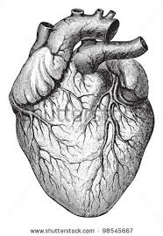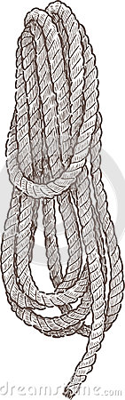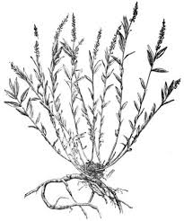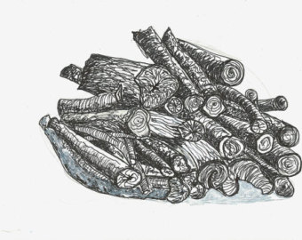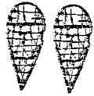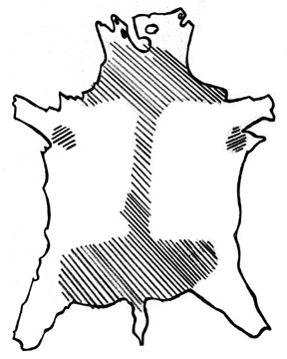
BUFFALO HIDE
SNOWSHOES
FIREWOOD
PLANT
ROPE
HEARTSKIN

Did you trade for metal tools and weapons? Yes No

Did you trade for firearms? Yes No

All “Tribes” must have these 4 items
(2) Horses
(1) Food
(1) Tipi
(10) Trade Bundles

All “Tribes” must place 4 of these items in box
(1) Extra Tipi
(1) Extra Tipi Poles
(1) Tipi Ring
(1) Chert
(1) Bones
(1) Heart Skin
(1) Rope
(1) Plant
(1) Firewood
(1) Snowshoes
(1) Buffalo Robes

