ONR Technical Report July 30, 2015

I. Heading

Michael I. Posner & Cristopher M. Niell University of Oregon
Understanding the molecular basis of skill learning N00014-15-1-2022

II. Scientific and Technical Objectives

To test the hypothesis that frontal theta is an important mechanism for achieving change in white matter.

To examine behavior before and after theta stimulation
To determine whether stimulation reduces anxiety and increases exploration.

III. Approach

Groups of mice will be stimulated by an implanted
light source to increase activity within the ACC. Stimulation
Will occur at 8 Hz (theta) 1 Hz, 40 Hz or no stimulation. Mice
will undergo stimulation for one hour per day for a month/

Before and after training the mice will be assayed for axonal
density, and mylination to determine efficiency of white matter
Behavior in crossing from a dark to light area, the presence of
novel objects or location will be used to determine the influence
of training on fear, anxiety and exploration.

There has been no from the proposal in the approach

IV. Concise accomplishment

The grant began March 2015. We have assembled a team of researcher to carry out the experiments. We have tested the stimulation method, and developed assays for white matter change and for behavioral change in the mice.

We have prepared 32 mice and made a preliminary analysis based on 22 mice. Our data suggest (see Figure 3) that both 1 and 8 Hz laser pulsing increased the white matter as measured in the corpus callosum.

We have examined the time each mouse was in the light box. We found preliminary evidence that the duration in the light following the laser pulsing was greater for the 1 and 8 Hz laser pulse that for controls. The 40 Hz group resembled controls.

V. Expanded accomplishments

Our grant began March 1 2015. In the four months so far we have prepared 32 mice to run in 12 groups of experimental and control animals.

The groups include PV-Cre/Arch, PV-Cre/Chr2, and PV-Cre. Each mouse group is assigned to one of 4 experimental conditions by frequency of laser pulsing. These are: 0 Hz (no stimulus), 1 Hz, 8 Hz or 40 Hz. In the case of 1 Hz, pulses of 200 millisec light are delivered once per second. For 8 Hz (theta), light is pulsed 8 times per second (25ms/pulse). For 40 Hz, light is pulsed 40 times per second (5ms/pulse). Sessions are 30 minutes in duration, 5 days a week for 4 weeks.

PV-Cre/Arch mice express the green light sensitive receptor archaerhodopsin. Pulses of 520nm light silence parvalbumin-expressing inhibitory interneurons expressing the receptor (see Figure 2), leading to a net increase in cortical excitation. PV-Cre/ChR2 mice express the blue light sensitive receptor channel rhodopsin. Pulses of 445nm light stimulate parvalbumin-expressing inhibitory interneurons expressing the receptor, leading to a net silencing of cortical activity. The PV-Cre mice are treated identically to the PV-Arch and PV-ChR2 groups, but do not express either light-sensitive opsin and thus serve as controls.

Prior to and following the one month period of laser pulses (or no laser pulse)
behavioral tests were run as follows:

Light/Dark Box: A measure of anxiety, this apparatus places into competition the natural desires to explore (entering the light box) and remaining safe (staying in the dark box). We will quantify time to first entry and number of entries into the light chamber, time spent in the light chamber, and rearing behavior (another measure of exploration).

Novel object recognition memory: An assay for attention and memory, this test assesses the preference for novelty. A novel object will be placed in an environment with one of two objects explored previously in the same environment. Number of interactions with, and time spent exploring, both objects will be quantified.

Novel location recognition memory: One of two previously explored objects will be moved to a new location within the same environment, and both objects will be re-explored.

Results.

Mouse Physiology

We first verified the electrophysiological phenotype of both optogenetic lines. Green light pulses in PV-Cre/Arch mice induced rhythmic activity in the local field potential (LFP) as well as pulse-locked increases in spiking activity of single neurons (putative cortical pyramidal neurons). Figure 1 illustrates the change in LFP in a PV-Cre/Arch mouse with 8Hz pulses.

Fig 1 Local field potential for theta (8hz) frequency stimulation.

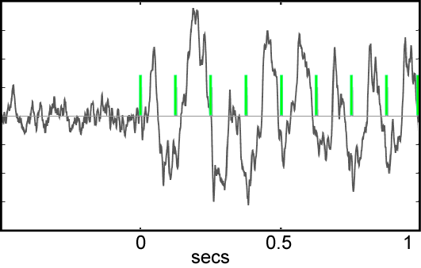

Rhythmic pulses with blue light in PV-Cre/ChR2 mice established a similar rhythmicity in the cortical LFP that was accompanied by a phase-locked suppression of spiking activity.

Figure 2 illustrates td-tomato labeled parvalbumin (PV) positive inhibitory interneurons in the anterior cingulate cortex (ACC). The cre-line responsible for this pattern of expression also drives expression of Arch or ChR2 specifically in PV-positive cells, and also serves as a control.

Figure 2 Red dots are td-tomato labeled parvalbumin (PV) positive inhibitory interneurons in the anterior cingulate cortex (ACC).

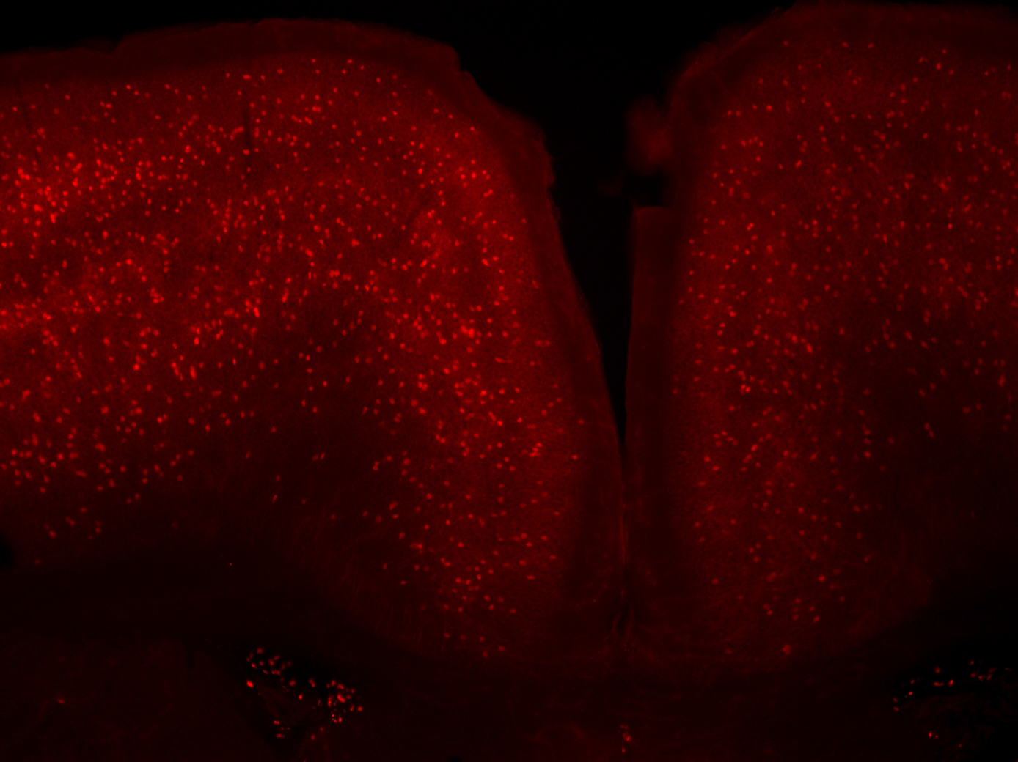

Data from 22 useable mice from the first 24 run were used to carry out a preliminary analysis of the data by measuring the width of the corpus callosum (CC width) for all mice after laser pulsing (or no pulse controls), while the CC was viewed by a confocal microscope. Since all analyses were blind the measurements were made without knowledge of the history of laser pulsing. Data were broken into conditions by another researcher. Preliminary data are shown below for 22 mice in Figure 3

Figure 3 shows width of corpus callosum for 22 mice in four conditions
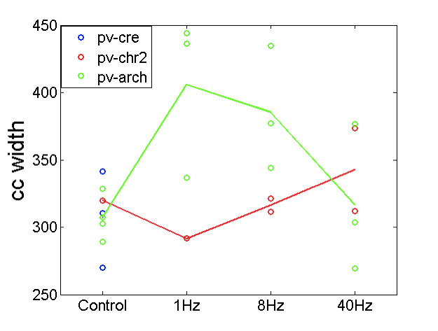

Mouse Behavior

We have made a preliminary coding of the relative preference of the mice for the dark and light box. We found that all group spent more time in the light prior to exposure to the laser light. The groups did not differ. However, following laser pulsing, while spending less time than in preteset, the 1 and 8 Hz groups spent more time in the light than all of the other groups.

Interpretation

These data, while very preliminary appear to support the hypothesis that white matter can be changed by laser pulsing of cells in the anterior cingulate. These data suggest that both pulsing of 1 or 8 Hz makes a difference to the size of the CC. The PV-Cre (control) group and pPV-Cre/chr2 (reduced spiking) group show no effect. The 40 Hz laser pulse group ,while producing spiking at the stimulated frequency, seemed to resemble controls. The data are too preliminary for any further interpretation. The behavioral data also suggested greater exploration subsequent to laser exposure in the 1 and 8 Hz group, both of which spent more time in the light than the other group.

Studies that have appeared in the literature since our hypothesis have generally supported the idea that enhancing neural activity through learning can cause the maturation of precursor cells into active oligodendrocytes (Gibson et al 2014; McKenzie et al 2014).

References

Gibson, E.M. et al (2014) Neuronal activity promotes oligodendrogenesis and adaptive myelination in the mammalian brain. Science 344 487

McKenzie, I.A. et al (2014) Motor skill learning requires active central myelination. Science 346/6207, 318-322

VI. Work Plan

Given these encouraging data we plan to run 8-12 mice in each of the following four conditions. PV-Cre/Arch at 1, 8 and 40 Hz and Pv-Cre only controls. We hope to finish this experiment during the remainder of the calendar year.

We also plan to assay both axonal density and myelination by electron microscopy and to examine the activation and/or creation of oligodendrocytes by immune-staining for newly created oligodendrocytes and and maturation of oligodendroctyes precursors. We also plan to assess the possible role of calpain and/or other proteases in these changes as proposed in our original research plan.
We will continue to analyze the behavioral tasks for each group.

Our work plan does not differ in any way from the proposal.

VII. Problems

We have not encountered any significant problems

VIII. Technology Transfer

D. We have received additional ONR support from Dr. Perez for a five year study
of human skill learning N00014-15-1-2048 Toward a neural model of human skill learning. I believe his interest arose from the proposal for this grant.

IX. Foreign Collaborations

None

X. Productivity

We have not yet published any thing under this grant. However, the hypothesis that formed the basis for the grant was published and is included with this submission.
- Posner, M.I., Tang, Y.Y. & Lynch, G. (2014) Mechanisms of white matter change induced by meditation. Frontiers in Psychology published: 27 October 2014 doi: 10.3389/fpsyg.2014.01220

E. Conferences
Invited plenary address Association for Psychological Science Fostering Attention for Human Welfare May 2015 New York

G. Invited to deliver Kavli address to the Association for Psychological Science (see above)
Invited to deliver Founders lecture British Assoc. for Cognitive Neuroscience
Talk is to be Sept. 8 2015

XI. Award Particpants

Michael I. Posner, Prof. Emeritus Univ of Oregon
Cristopher M. Niell, Asst. Prof. Univ of Oregon
Mary K. Rothbart Prof. Univ. of Oregon
Denise Niell, Research Assoc. Univ of Oregon paid .3 time
Aldis Wieble Research Assoc Univ of Oregon
Pascale Voelker Research Assoc. Univ. of Oregon
Gary Lynch Prof. Univ Calif at Irvine Consultant
Yiyuan Tang Prof. Texas Tech. Univ. Consultant.

