**Your 2nd family member**

Draw a person

Draw calendar name

Draw personal name

**Your family member**

Draw a person

Draw calendar name

Draw personal name

Place your family member is from

Place you are from

**You**

Draw a person

Draw calendar name

Draw personal name

Family History Codex: Practice

Draw a personal name

Practice drawing

Name:___________________________________

**Designing a Personal Name**

1. What special characteristics do you have?
2. What animals are associated with those characteristics?

3) What special skills, interests or hobbies do you have?

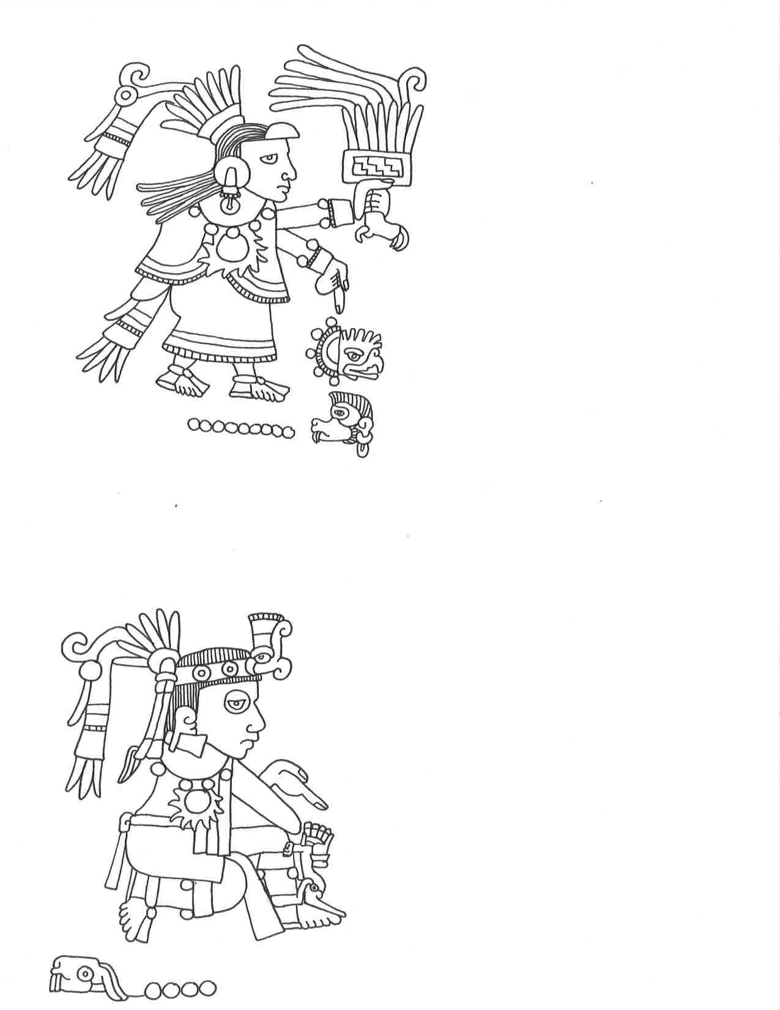

DO NOW: Copy the Mixtec name into the box