Mixtec Codex
Do Now: Draw a picture of where you are from
Name:__________________

Color in Mexico on the map below:
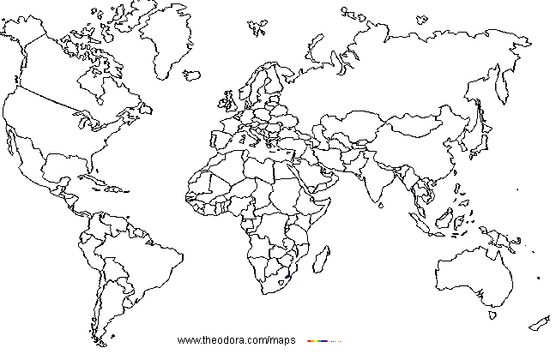
The _________ are an indigenous group living in some parts of Mexico.
They ruled parts of the Mesoamerican civilization in ______________ times.
They recorded their history using in a type of document called a _________, using their own form of ___________ writing.

.
Drawing Place Glyphs
- What places are in your family history?

- What do the names sound like?

What do the names mean?

- What landmarks, important features does the place have?

- Draw some ideas here:

Place glyph 2:
Place glyph 1:

