An abridged excerpt from “Gonzalo,” from Seedfolks, by Paul Fleischmann
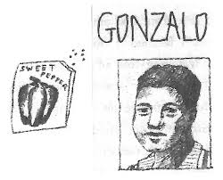
The older you are, the younger you get when you move to the United States.

They don’t teach you that equation in school.

Two years after my father and I moved here from Guatemala I could speak English. I learned it on the playground and watching lots of TV. Don’t believe what people say--cartoons make you smart. But my father, he worked all day in a kitchen with Mexicans and Salvadorans. His English was worse than a kindergartner’s. He would only buy food at the bodega down the block. Outside of there he lowered his eyes and tried to get by on mumbles and smiles. He didn’t want strangers to hear his mistakes. So he used me to make phone calls and to talk to the landlady and to buy things in store where you had to use English. He got younger. I got older.

Then my younger brothers and mother and Tío Juan, her uncle, came north and joined us. Tío Juan was the oldest man in his pueblo. But here he became a little baby. He’d been a farmer, but here he couldn’t work. He couldn’t sit out in the plaza and talk--there aren’t any plazas here, and if you sit out in public some gang driving by might use you for target practice. He couldn’t understand TV. So he wandered around the apartment all day, in and out of rooms. Talking to himself, just like a kid in diapers.

One morning he wandered outside and down the street. My mother practically fainted.

He doesn’t speak Spanish, just an Indian language. I finally found him standing in front of the beauty parlor, staring through the glass at a woman with a drier over her head. He must have wondered what weird planet he’d moved to. I led him home, holding his hand, the way you would with a three-year-old. Since then I’m supposed to baby-sit him after school.

