Lesson plan developed by Deborah Strother and Christy Gill

Stories in Clay: Oaxacan Ceramic Folk Art

The cultural richness reflected by its artisan work is seen most clearly in that most popular of folk arts, pottery. This is the most widely practiced craft in Oaxaca, indeed in all of Mexico.
— Lois Wasserspring
Oaxacan Ceramics
Subject and Grade Level: Sculpture, grades 9-12

Title: Stories in Clay

Time Required: Six class periods
Lesson Description and Goals:
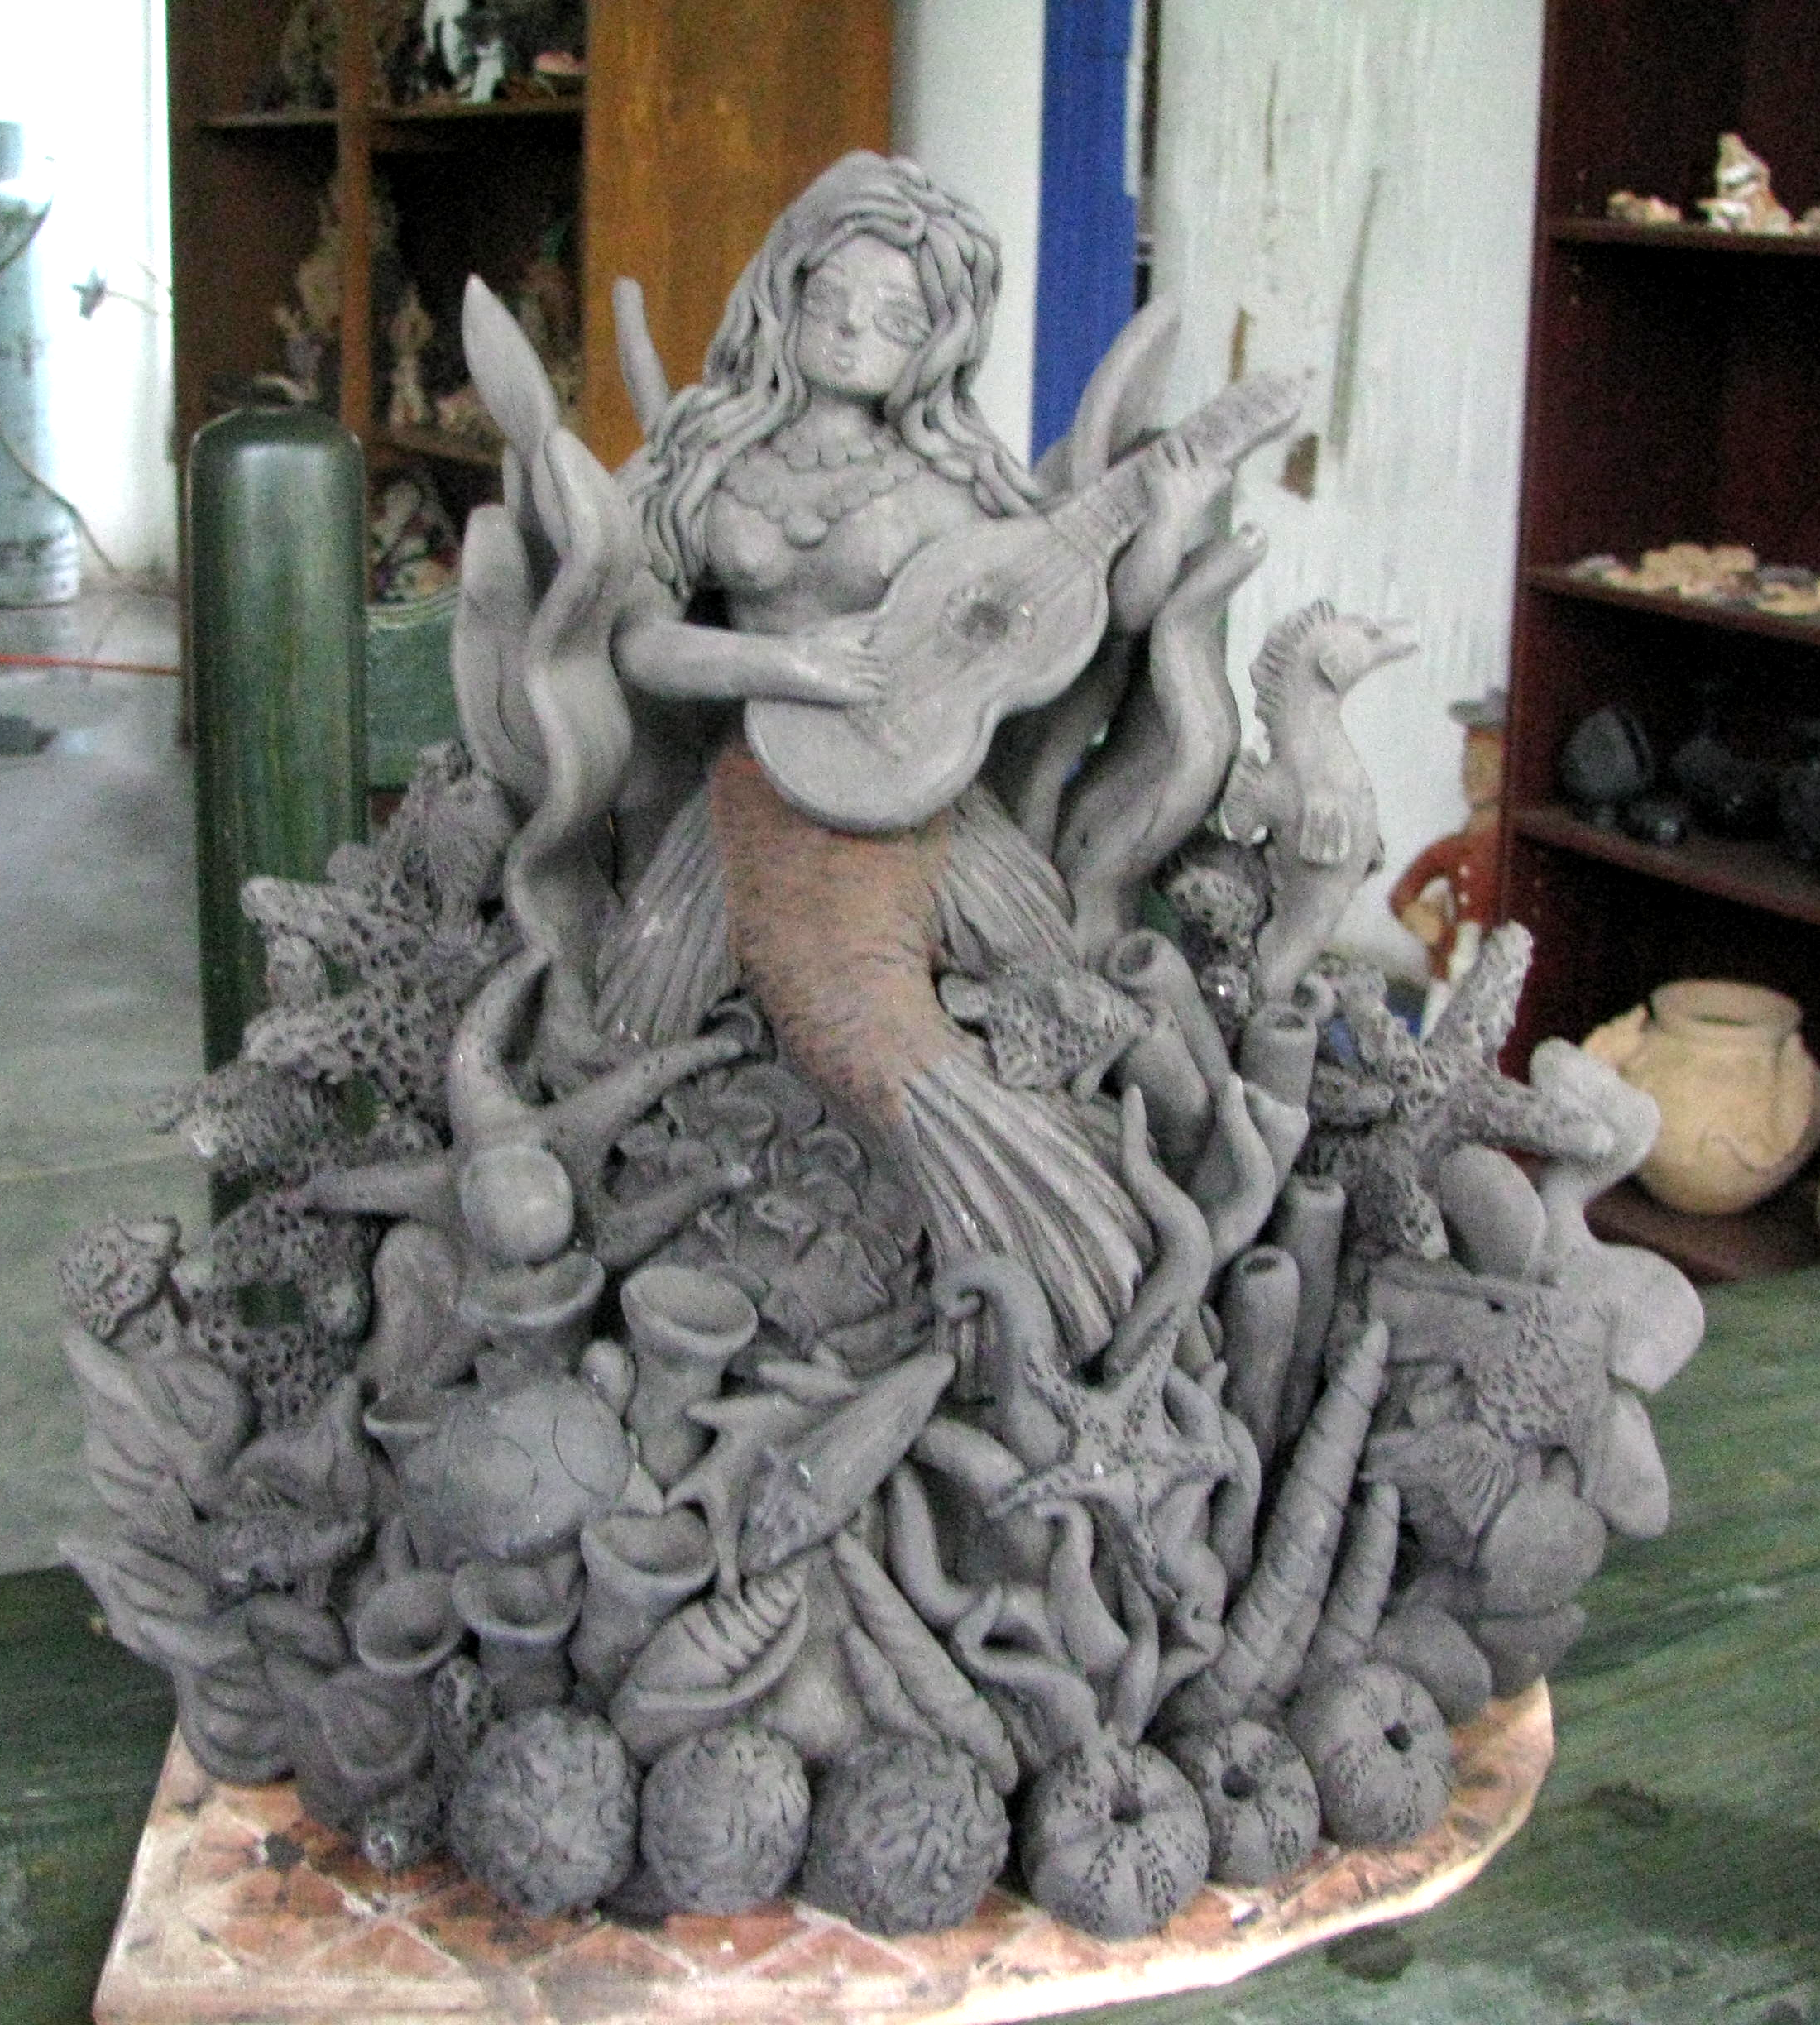
After a general introduction to Oaxaca and Mesoamerican culture, students will hear about clay forms that tell stories, view examples of these forms – Oaxacan figural sculptures, Árbol de la vida (trees of life) and nahuales (animal spirits) – and see video clips of Oaxacan artist Angélica Vásquez making a figure with a story very important to her life.
Students will research ideas for their own figures, draw a design and make their own Oaxacan-inspired sculpture.
Objectives:

Students will learn
- general information about Oaxaca
- a brief history of Mesoamerica
- the importance of arts in Mexico
Angélica Vásquez, La Sirena
- popular ceramic forms, including trees of life, nahual and figural group sculptures
- Spanish ceramics vocabulary
- techniques for making clay sculptures inspired by Mexican forms

Key Ideas and/or Driving Questions:
- Mexican arts and crafts are as diverse as the continent,
its people, languages, and cultures.
- Mexican ceramic folk art includes excellent examples of three-dimensional design as well as references to folk tales, daily life and personal philosophies about life.
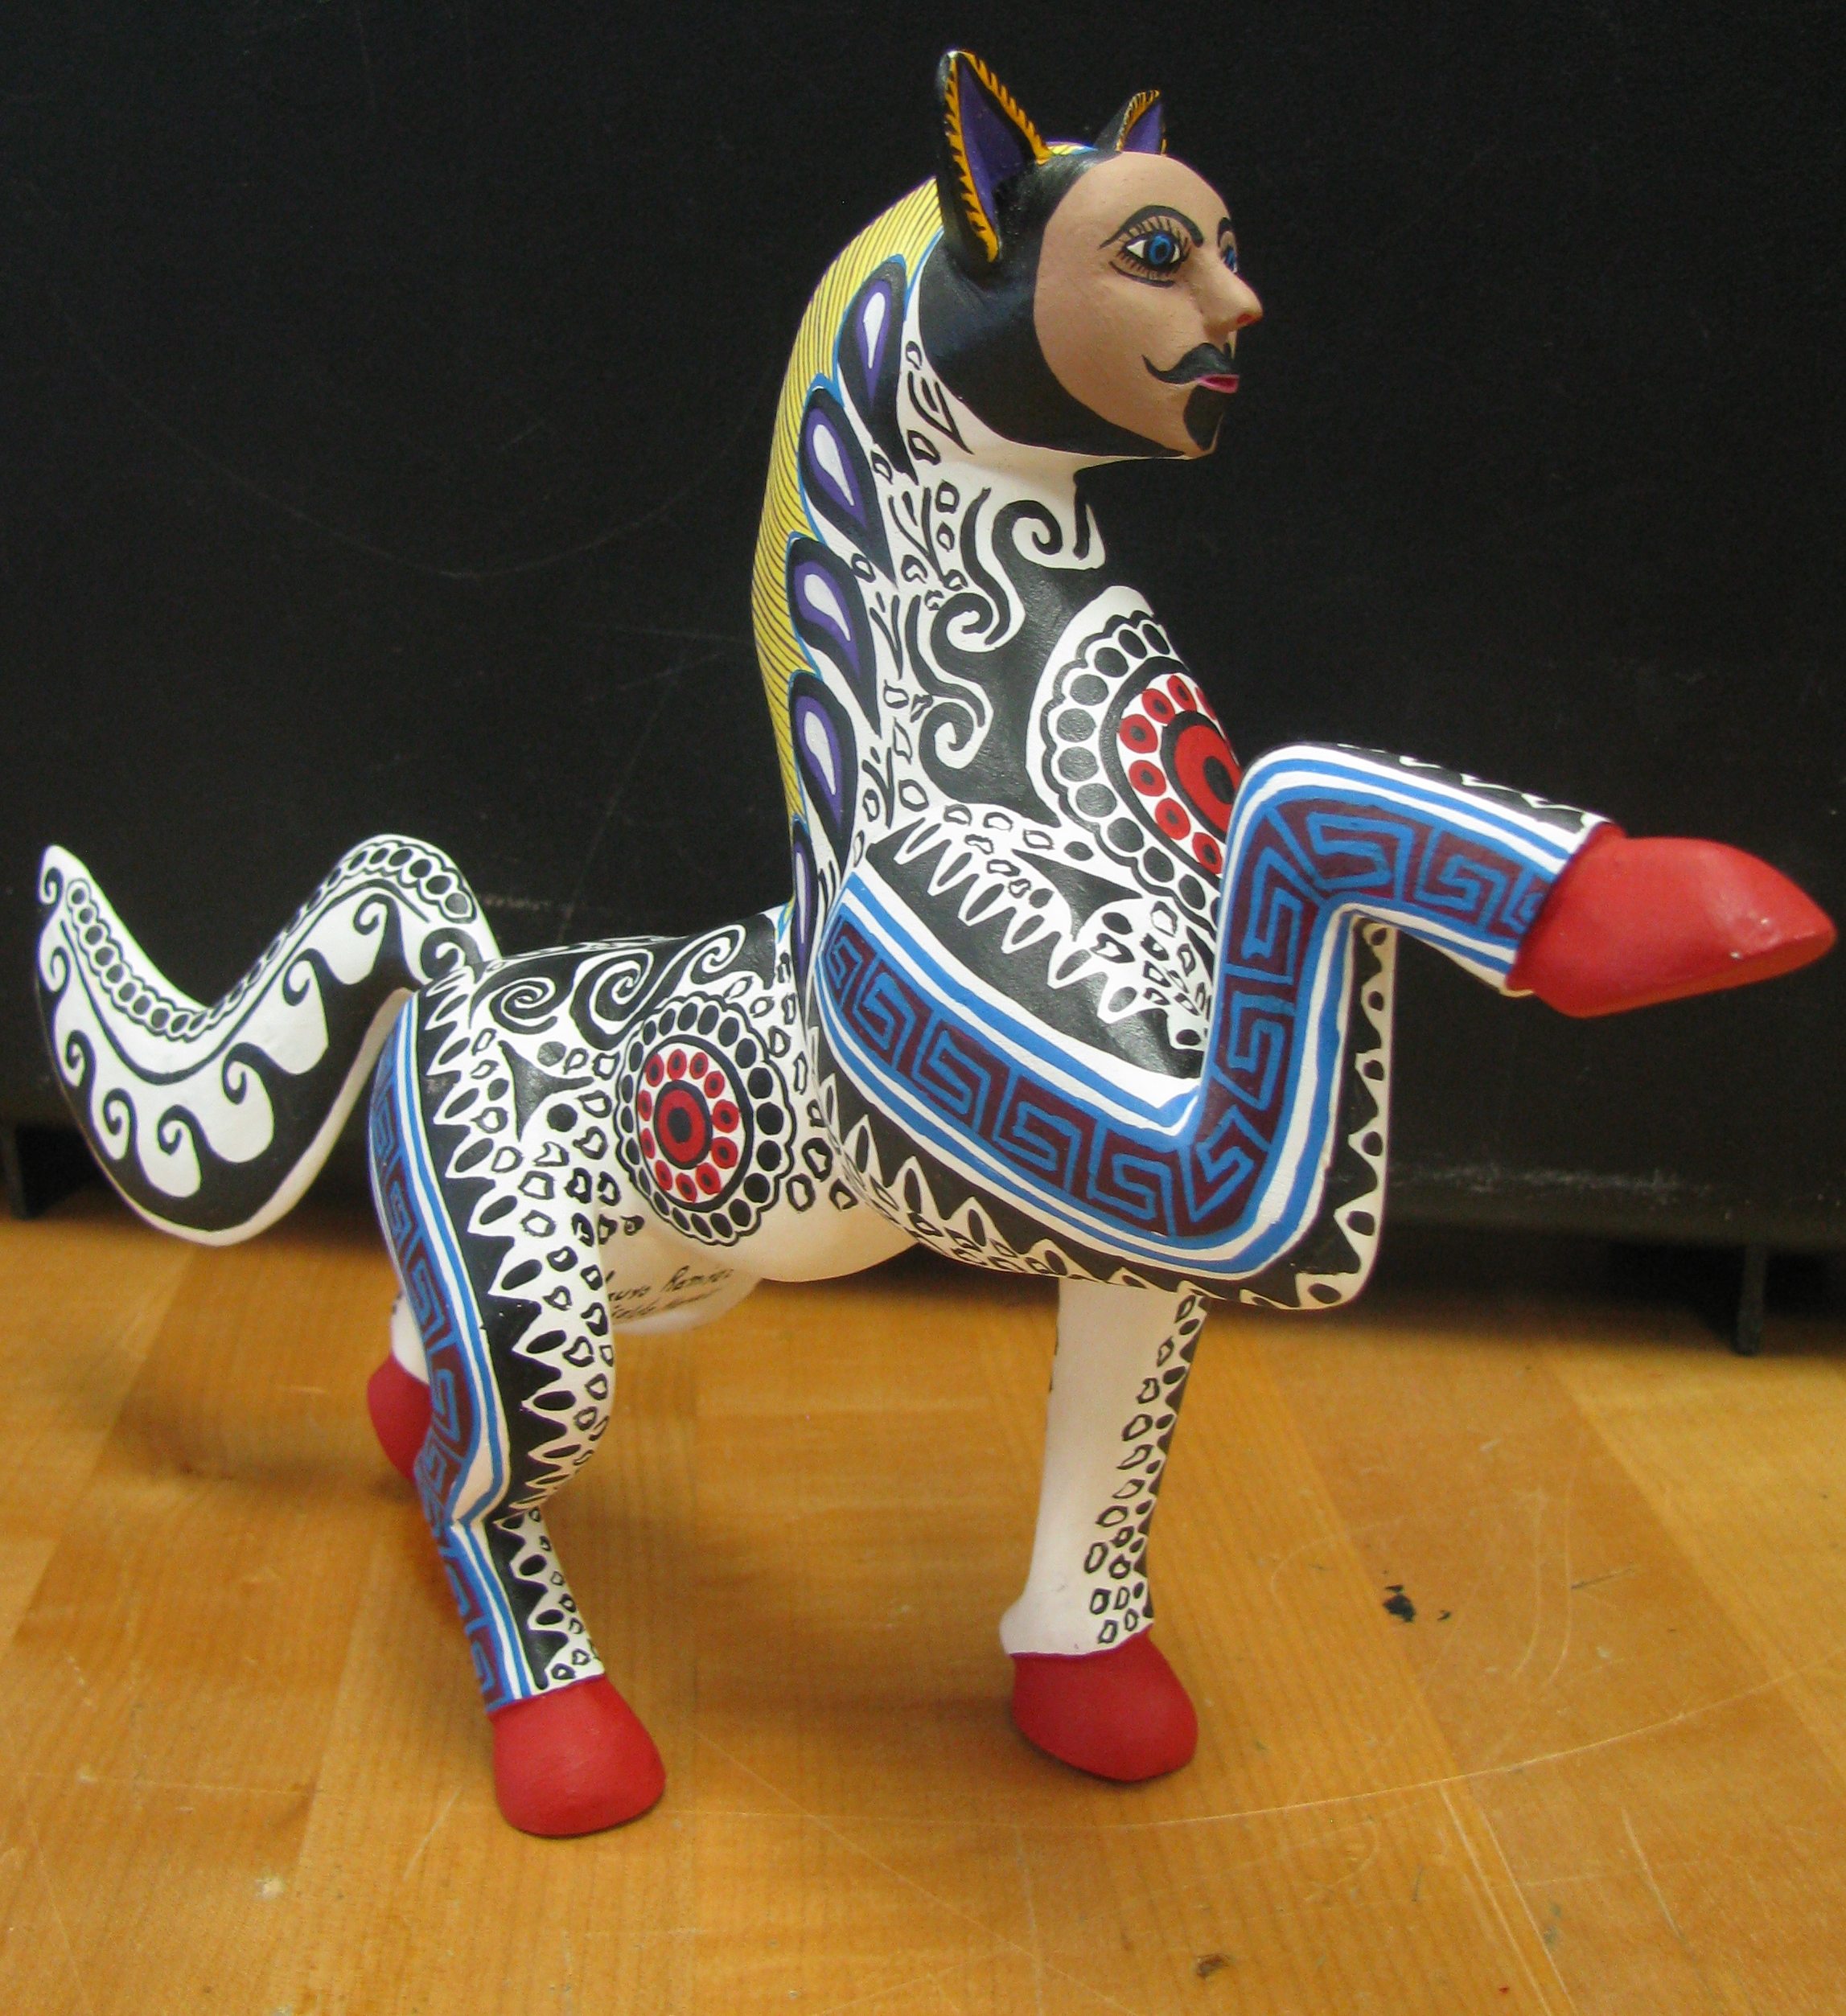
- What stories are told in Mexican ceramic forms?
A nahual is a spirit being closely associated with a human being. Each person has his or her own nahual which acts a double, a shadow, or as a protective spirit. A nahual often takes the shape of animals such as dogs or jaguars
- What are the techniques used in making the forms?
- What are the uses of sculptures?
- Are issues of gender equity evident in sculptural work?

Background for Teachers and Students:
General knowledge of Mexican folk art, Mesoamerican culture and ceramic tools and techniques. View attached PowerPoint Slide Show. See Web Links and Books below.

Text and photos of clipping that appeared in local newspaper in August, 2010.
Brown County High School art teacher Deborah Strother is in Oaxaca, Mexico, for part of the summer, studying Mesoamerican art. She is writing occasional reports on her experiences. This is her first.
Letter from Oaxaca, July 17, 2010
“Buenos dias Angélica. Soy Deborah. Estoy feliz de concerla.”
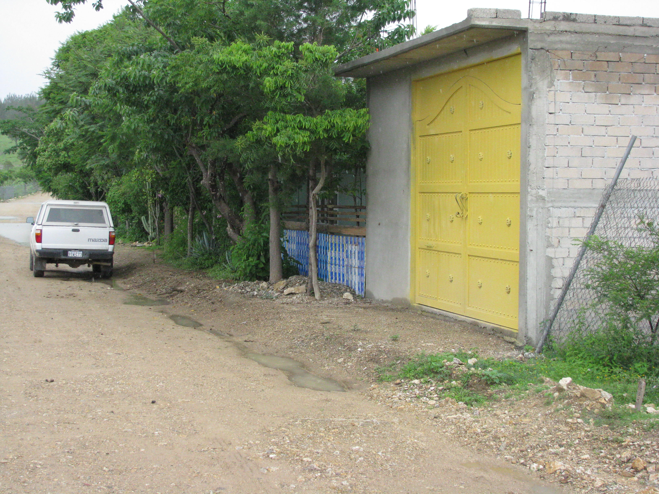
My Spanish pronunciation might have been fractured, but I hope what I was trying to say — that I was extremely happy to finally meet Mexican artist and women’s rights champion Angelica Vasquez Cruz — came through loud and clear.
I finally was at her doorstep, atop a high hill just outside of Oaxaca (pronounced wa ha ka) after months of e-mail exchanges — hers in Spanish, mine translated from English to Spanish by a friend in Bloomington — and a failed attempt the day before to reach her home by taxi, when we were turned back because the roads were blocked by demonstrators in this hotbed of political activism.
I’m in Oaxaca, in far southern Mexico, to study Mesoamerican culture, both past and present, and to bring its lessons and history back to my art students at Brown County High School from this National Endowment for the Humanities summer teachers’ seminar.
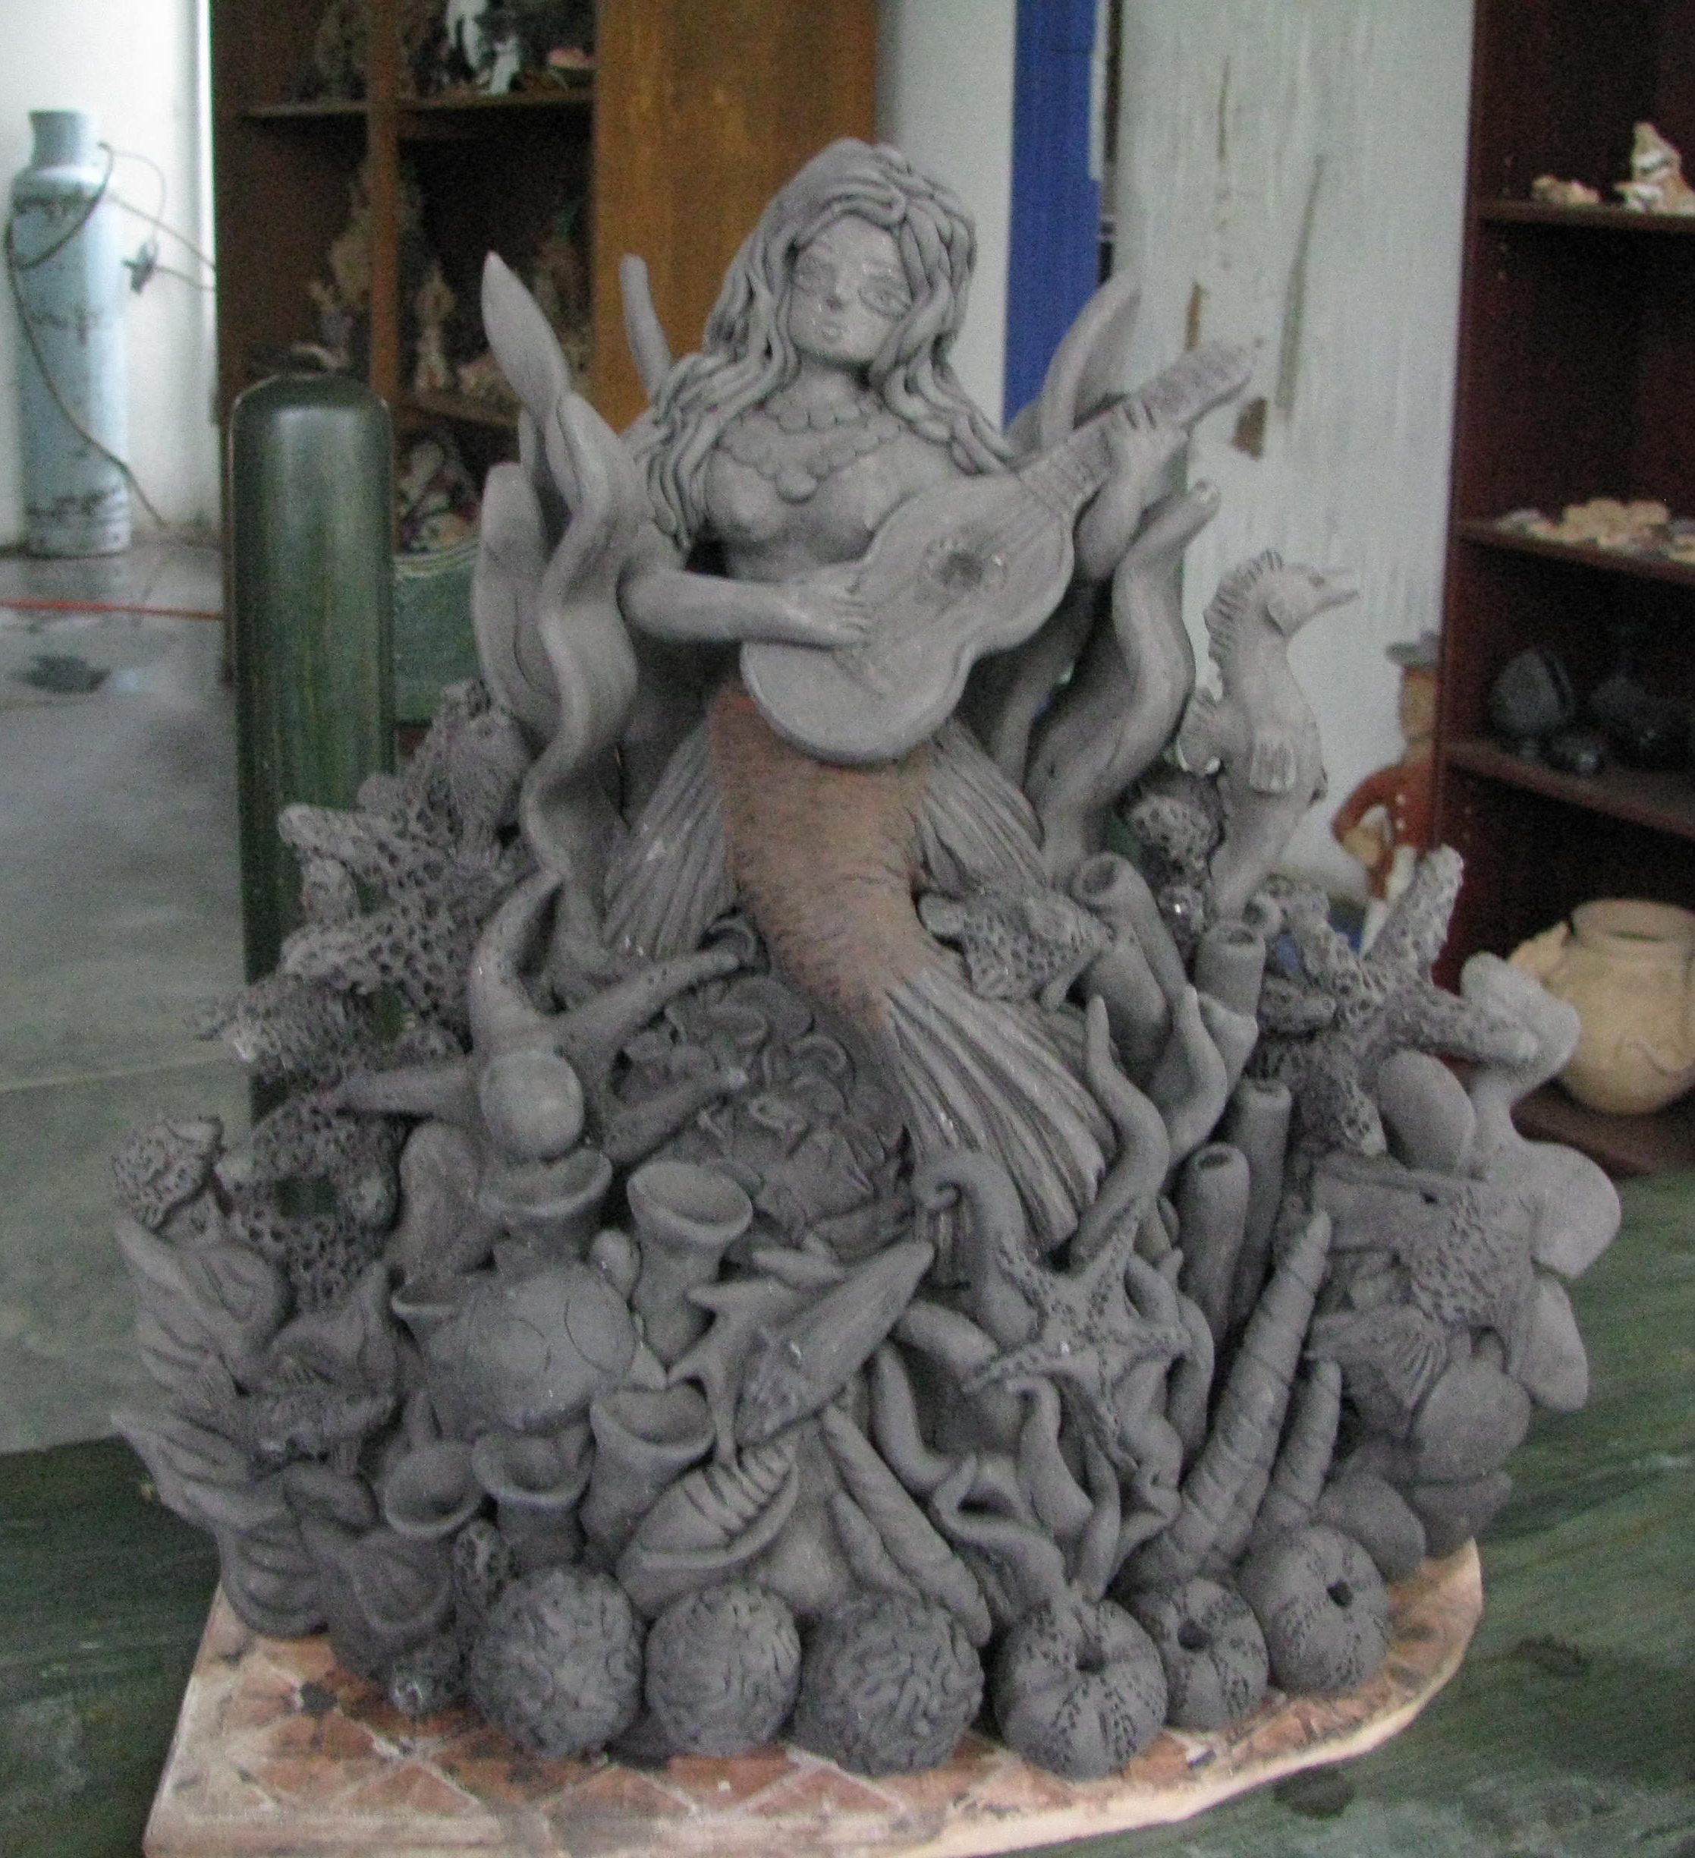
Visiting with and learning from Angélica (pronounced Anhelica in Spanish) is a key part of my plan. On my second — and finally successful — attempt with cab driver Bernardo (who gave me Spanish and Zapotec lessons along the way), the roads were clear of demonstrators and I made it up the hill as far as the taxi could take me, walking the last few hundred yards of steep dirt road that seemed too extreme for any wheeled vehicle.
Angélica, a master ceramic sculptor whose art has focused on traditional cultural icons and figures from pre-European and early colonial times as well as modern pieces, would introduce me in this first of what I hope will be several hands-on lessons on how to go about making her pieces, employing centuries-old tools and techniques that she is fighting to preserve.
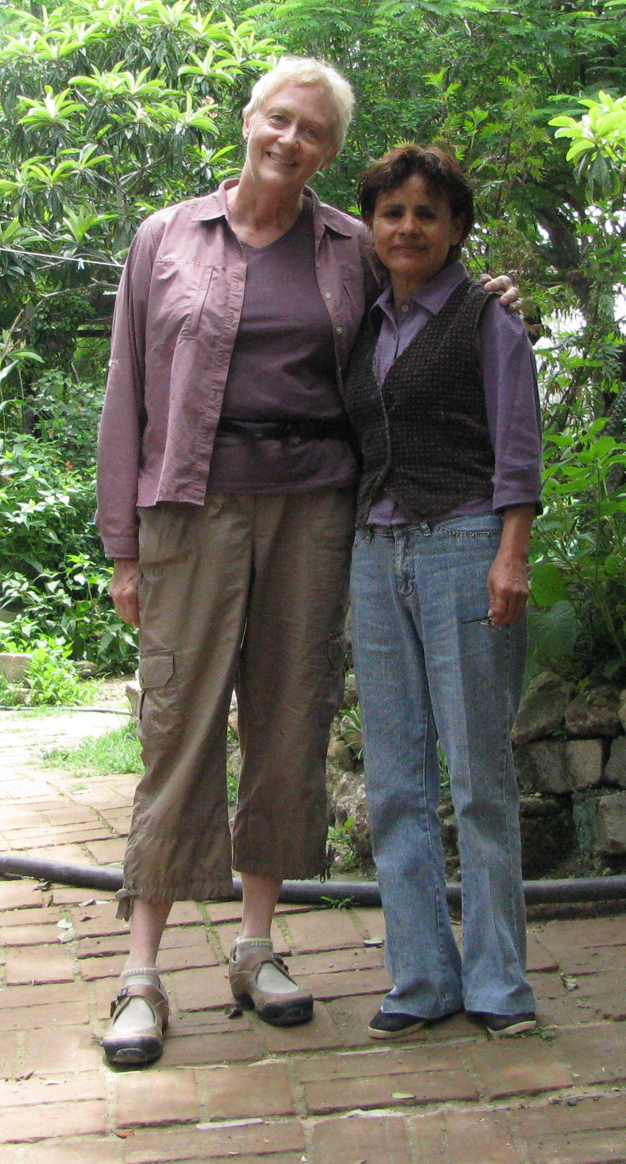
After a short tour of her beautiful garden, Angélica introduced me to the clays, to the 32 minerals that she crushes with a metate (a large flat stone mortar and pestle) to add to the clay for natural coloring and the simple tools we would use in this first lesson, production of a traditional angel figure.
Those tools, which Angélica calls rustica (rustic), are clay, an espina (a spine from one of her trees), water in a clay basin and a chamois cloth for smoothing edges. But the real tools are her hands, which she uses with great delicacy and expertise. Her fingers dance over the clay as she shapes and smooths the figures, occasionally moistening her fingertips to keep the clay damp. I attempted to follow along, my own fingers feeling more like bananas than ballerinas.
Finished and side-by-side, my pobre ángel (poor angel) looked so crude and lumpy next to hers. But everyone, my students at Brown County included, must start somewhere to get anywhere — and this, with its grace and long history, is worth the time to start.

Key Vocabulary: Source: Oaxacan Ceramics (see Books, below)
Árbol de la vida “Tree of life.” A very popular image in Mexican folk art depicting the interconnectedness of the life cycle. Can include biblical subject matter.
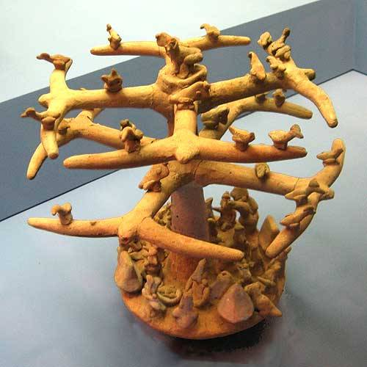
Arte popular “Popular art.” The art created by Mexican artists inspired by Mexican popular culture; folk art
Barro “Mud:” Clay used to make ceramics and folk art – it can be barro áspero (rough), barro de golpear (coarse clay) or barro liso (smooth clay)
A pottery tree from the western Mexico shaft tomb tradition and found in the Nayarit area, American Museum of Natural History, New York. 300 BCE to 600 CE.
Bordado decorations put on clay, inspired by
the work of Teodora Blanco of Atzompa
Horno “oven” or kiln
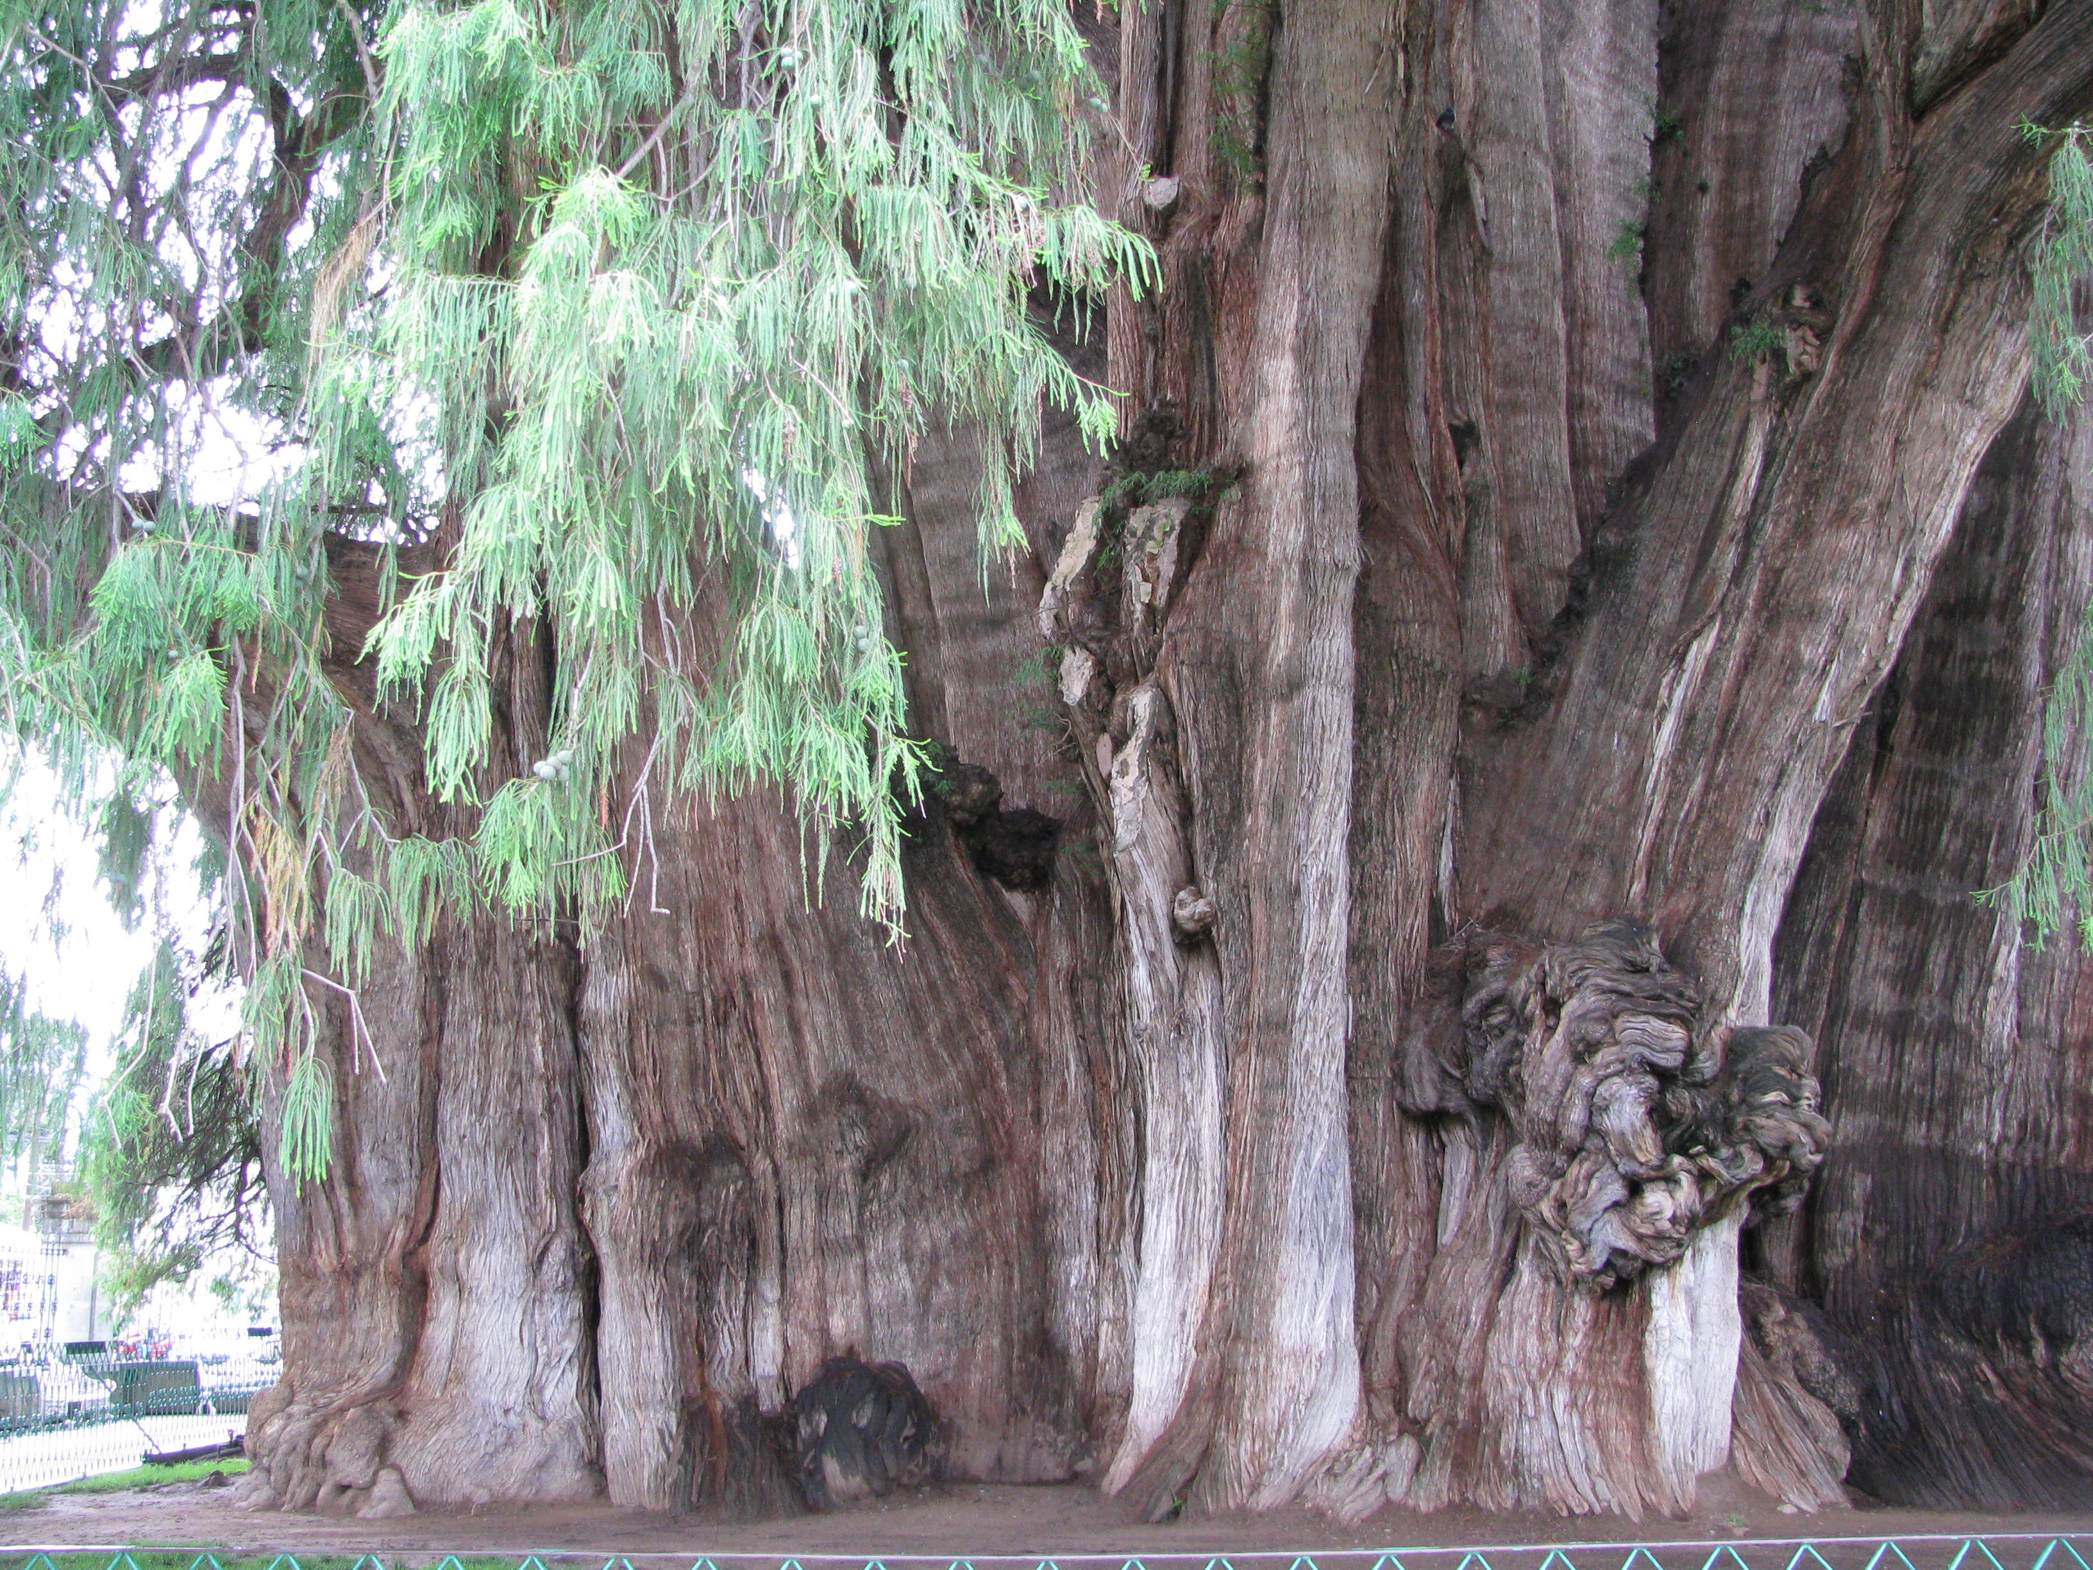
Juego “set” The multi-figured scenes of Mexican ritual and daily life depicted in clay
Juguete “toy”
La Lolorona “The Weeping Woman,” a popular Mexican folktale of the tragic woman who kills her own children and is doomed to wander forever in search of them.
2000 year old Árbol del Tule,
Oaxaca, Mexico
Muñeca “doll”; refers to the large unglazed clay
female figures laden with elaborate clay
Musico “musician”; refers to the ceramic animal figures playing musical instruments.
The Olmec "Tree of Life" (Mesoamerican Cosmology). The lineage founder, 2 Grass, is being born from a twisting World Tree. Detail from Selden Codex page 2. Source: FAMSI FzzzFFFAMSIhttp://research.famsi.org/schele_list.php?_allSearch=Selden Codex
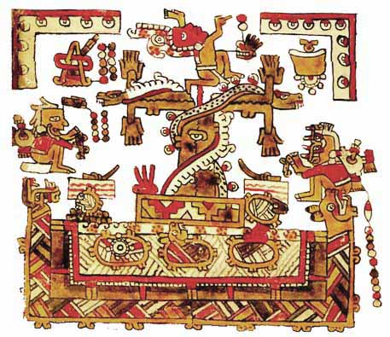
Nahual animal spirit with the power to either protect or do harm to humans. Magical animals are an important source of imagery in Mexican art; sometimes called “nahual”
Sirena “Mermaid”; important source of imagery

Materials:

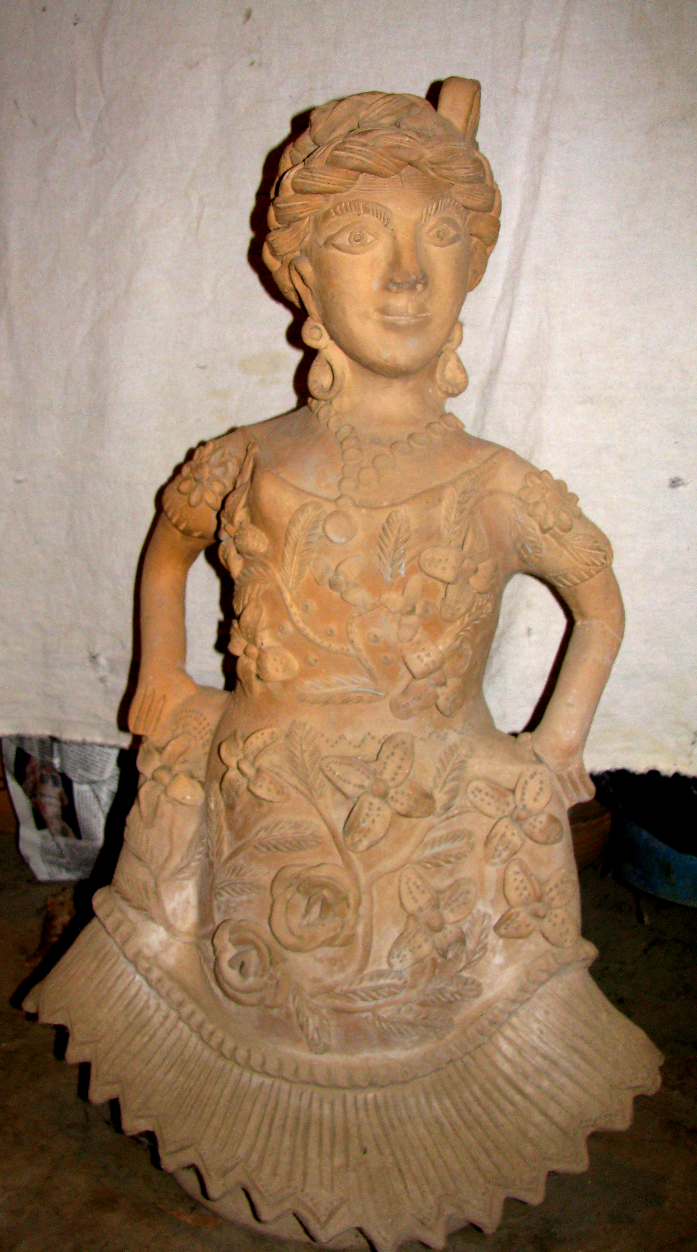
clay
simple modeling tools, including tree spines and chamois
ceramic tools
examples of Oaxacan ceramics
PowerPoint slide show

Procedures:
- Introduce project
  - Present PowerPoint slide show
  - Show Oaxacan figural sculptures and explain their meanings and use
- Explain and demonstrate ceramic techniques for making a three dimensional form inspired by Oaxacan ceramics
Figure by
Teodora Blanco
(1928-80) major Mexican folk artist. As a teenager she invented the unique animal musicians, now created by many artists in Atzompa. In her late twenties she began to make her female figurines, the basic shape derived from the bases for Oaxacan clay water-coolers.
Blanco’s main interest was surface decoration. She created clay appliqué or bordado on her figures and dressed them in various Oaxacan Indian costumes.
- Students will create a design from research, using teacher handouts, books, the internet and personal experiences.
- Students will begin to express their conceptual ideas as they model their figures. The teacher will work individually with students to help them with techniques and details.
- Once the sculpture is completed it will air dry and be bisque fired.
- While sculptures are drying students will record their thoughts describing the meaning of their sculptures for use in a critique.

Closure & Assessment (tie to key ideas - what was learned):
Students will self assess using a rubric (see attached) to assess their knowledge in the following areas:
- general knowledge of Oaxacan folk art and Mesoamerican culture
- their stories encoded in their sculptures
- creativity of design
- quality of sculpture

Extensions/Connections (including possible grade level and interdisciplinary modifications):
This lesson has many possibilities for extension and connection. In addition to students making their sculpture, they could:
- Create an exhibit of their work for their school
- Create a wall mural, using the idea of tree of life
- Draw their own tree of life
- Plan a fiesta day to share what they’ve learned about Oaxaca and Mesoamerican culture.

Grade level is very flexible depending on choice of clay project and depth of research about Oaxaca and Mesoamerican culture.

Related National and State Standards:

RESPONDING TO ART: History
1 Students understand the significance of visual art in relation to historical, social, political, environmental, technological, and economic issues.
H.1.2 Pro Identify function and how it relates to the history, aesthetics, and culture of the work.
H.1.3 Pro Identify iconography in an artist’s work or a body of work and analyze the meaning.

2 Students recognize significant works of Western and non-Western art and understand how art developed over time.
H.2.1 Pro Recognize works of art and identify them by artist, period, style, and geographic location.
H.2.3 Adv Analyze issues related to chronology and discuss or debate these issues in relation to historical perspective.

CREATING ART: Production
7 Students observe, select, and use a range of subject matter, symbols, and ideas.
H.7.2 Pro Make informed choices about specific subject matter or concepts and defend those choices when given a range of objects or spaces.
H.7.3 Adv Borrow symbols from art and describe the origin, function, and value of these functions in their personal work.

9 Students develop and apply skills using a variety of two dimensional and three dimensional media, tools, and processes to create works that communicate personal meaning.
H.9.1 Pro Create artworks that demonstrate skill and understanding of different media, processes, and techniques.

INTEGRATED STUDIES
14 Students understand the ways art forms (visual arts, dance, music, theater, and media arts) are related to each other.
H.14.1 Pro Compare the materials, technologies, media, and processes of the visual arts with those of dance, music, media arts, or theater.

Resources (include useful web links):

- Web Links:
http://www.famsi.org/
Bilingual site of the Foundation for the Advancement of Mesoamerican Studies, Inc. with extensive information about Mesoamerica
http://hearstmuseum.berkeley.edu/outreach/pdfs/mexican_folk_art.pdf

Based in part by the exhibition Tesoros Escondidos: Hidden Treasures from the Mexican
Collections curated by Ira Jacknis, Research Anthropologist, Phoebe A. Hearst Museum of
Anthropology. Can be viewed almost like a slide show.

http://www.bbc.co.uk/ahistoryoftheworld/objects/rxxK1FgBQNSsipmXhCIAXQ
http://www.bbc.co.uk/ahistoryoftheworld/objects/Hvi54RDiQym6Pgd3_IsRKA
A joint project from The British Museum and the BBC – A History of the World in 100 Objects – that includes 15 minute podcasts.

http://www.flickr.com/search/?q=Oaxaca+ceramics
More than 500 images of Oaxacan ceramics, including figural — both ancient and modern — and utilitarian.

http://www.archive.org/details/pottery_workers_of_oaxaca
This film showcases the work of the Jiménez family of Oaxaca, and the legendary Zapotec potter Doña Rosa Real de Nieto, and her traditional technique of below-ground firing. Filmed in 1952 by Ralph Adams.

http://www.archive.org/details/dona_rosa_potter_of_coyotepec

Beautiful color film on Doña Rosa de Nieto, from San Bartolo Coyotepec, Oaxaca, Mexico, showing her making an olla, and firing her creations in an underground kiln. Filmed in 1959 by Orville Goldner.

http://oaxaca-travel.com/guide/index.php?&lang=us
Award-winning travel Guide for the State and City of Oaxaca: 1000+ photographs and 400+ pages of text describing all Natural and Cultural Attractions of Oaxaca, including Huatulco, Puerto Escondido, the Guelaguetza, Mitla, Monte Albán, and many more. Also contains travel tips for Oaxaca, local events and activities, up-to-date weather forecast, and maps of the area.
http://www.wellesley.edu/Psychology/Cheek/Narrative/home.html
Narrative Identity, a course offered at Wellesley College. Everything you could possible want to know about mermaids, with extensive links and an annotated bibliography, including the Mermaid Myth, the Psychology of Mermaids and Artwork and Representation

- Books:
Baquedano, Elizabeth. Aztec, Inca & Maya, New York: Alfred A. Knopf, 1993.
Gallagher, Jacki. Companions of the Dead: Ceramic Tomb Sculpture from Ancient West Mexico, Los Angeles: Museum of Cultural History (UCLA), 1983.
Glassie, Henry. The Spirit of Folk Art, New York: Harry N. Abrams, 1995.
Miller, Mary Ellen. The Art of Mesoamerica from Olmec to Aztec. London: Thames and Hudson Ltd, 1986.
Mulryan, Lenore Hoag. Ceramic Trees of Life: Popular Art from Mexico, Los Angeles: UCLA Fowler Museum of Cultural History, 2003.
Mulryan, Lenore Hoag. Mexican Figural Ceramists and Their Works, Monograph Series Number 16, Los Angeles: Museum of Cultural History, UCLA, 1982.
Mulryan, Lenore Hoag. Nagual in the Garden: Fantastic Animals in Mexican Ceramics, Los Angeles: UCLA Fowler Museum of Cultural History, 1996.
Toor, Frances. A Treasury of Mexican Folkways (12th printing), New York: Crown Publishers, Inc., 1971.
Wasserspring, Lois. Oaxacan Ceramics: Traditional Folk Art by Oaxacan Women, San Francisco: Chronicle Books, 2000.
Whipperman, Bruce. Oaxaca (Fifth Edition), New York: Avalon Books, 2008.
Winter, Marcus. Oaxaca: The Archaeological Record, Minutiae Mexicana (1990).

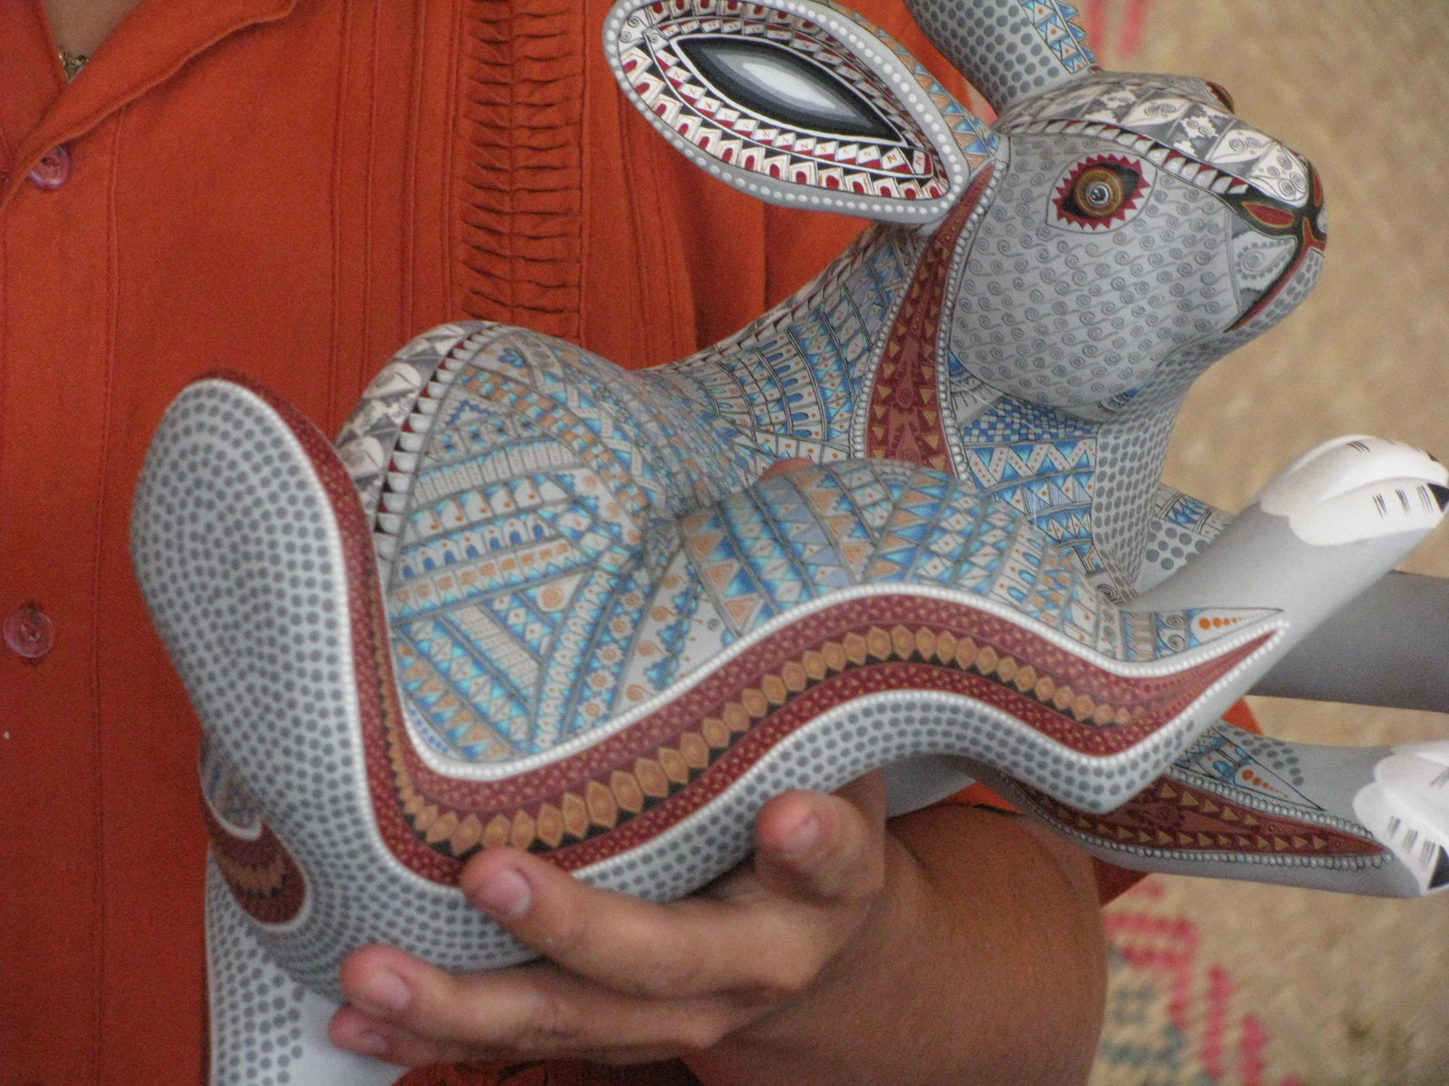

Mexican Folk Art can be seen at this link

Hearst Museum, Berkeley California

Rubric for Figural Sculpture Project:

Please self evaluate your work according to the descriptions below. What was the quality of your work in each phase of this project. Please enter your score for each phase.

Self assessment Name__________________________

Outstanding | 25 total points | Satisfactory | 15 total points | Unsatisfactory | 5 total points
Completed research and excellent design of your figure |  | Minimal research and satisfactory design |  | Did not complete description and design of figure
Completed figure according to design |  | Partially completed design, but not according to design |  | Did not complete figure and did not follow design
Finished sculpture is well formed with recognizable subject matter. |  | Finished sculpture is not quite finished, but has recognizable subject matter. |  | Finished sculpture is incomplete and poorly formed.
Decorations are well modeled and related to original design |  | Details are minimal and don’t necessarily relate to original design |  | There are very few decorations and they do not relate to original design
Total your points here

Describe one thing you like about this project and why you like it:

Describe one thing that you would do differently and why:

What were you trying to accomplish or say with this project?

