La cocina prehispánica (Lista 4)

Comidas y bebidas especiales
Spanish | Náhuatl | English | Photo | Image in Codex
atole | atolli | atole  (beverage made with ground maize) | (L. Albrich, Tacos Álvaro, Oaxaca, 2014)  (L. Albrich, Itatoni, Oaxaca, 2014)  champurrado  (chocolate atole) | Códice Tudela
guacamole | ahuacamolli | guacamole  (dish made with mashed avocado, often with chile) | (L. Albrich, Oaxaca, 2014)
taco | tlaco  (word meaning half, middle, center) | taco | (L. Albrich, Tacos Álvaro, Oaxaca 2014)
tamales | tamalli | bread-like steamed cornmeal | (L. Albrich, Oaxaca, 2014)  (L. Albrich, Oaxaca, 2014) | Códice Florentino, libro 2, capítulo 37
tejate |  |  | (L. Albrich, Oaxaca, 2014) | Códice Tudela
tlayuda |  | tlayuda | (L. Albrich, Oaxaca, 2014)
tortilla | tlaxcalli |  | (L. Albrich, Teotitlan del Valle, 2014)  Making quesadillas with handmade tortillas  on the comal | 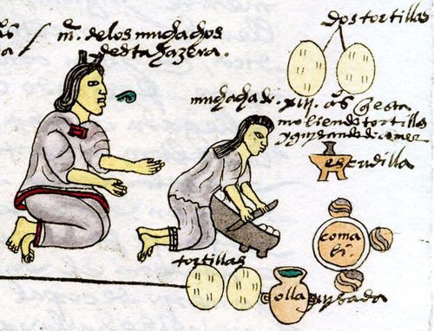  Códice Mendoza
huitlacoche | cuitlacoch | delicacy, fungus that grows on maize | (L. Albrich, Oaxaca, 2014)

