**Aligned Design**

*After engaging these materials, you should feel more confident about your ability to:*

*___ communicate compelling goals for student learning and design courses tightly aligned with those goals (backward design).*

Backward design [1] is an approach to course design that focuses on student learning rather than on teacher performance. It is called “backward” because it starts with what students should know, understand or be able to do by the end of the unit/course/degree and works backward from there to develop course materials specifically designed to facilitate successful achievement of the learning goals.

As shown in Figure 1 below, the first steps in the backward design process are to identify the learning goals and objectives you have for the course. Next, determine what evidence will convince you that students have achieved the desired goals; these become the course assessments. Note that summative assessments are final measures of students' achievement, and formative assessments are low-stakes exercises the instructor and students can use to gauge progress toward achieving learning outcomes. Finally, with the achievement target clearly defined, create learning activities that will help students achieve the desired goals.

Figure 1: The backward design process.

The backward design process makes it easier to ensure that the knowledge and skills you target on assessments are consistent with what you ask the students to do to prepare for those assessments—in other words, what they do in class and as homework. Bloom’s taxonomy ranks cognitive skills and activities from basic to complex. Here, we use a modified form of Bloom’s taxonomy, shown in Figure 2, which shows the hierarchy of the lower order cognitive skills (LOCS) and the more equal cognitive difficulty of the higher order cognitive skills (HOCS). When you complete the alignment mapping exercise below, try to align the cognitive level of each learning objective and the assessment you use to gauge students’ attainment of that objective.



**Higher order cognitive skills**

**Lower order cognitive skills**

Figure 2: Bloom's Taxonomy adapted to show its inherent partial hierarchy. (Figure adapted from [3])

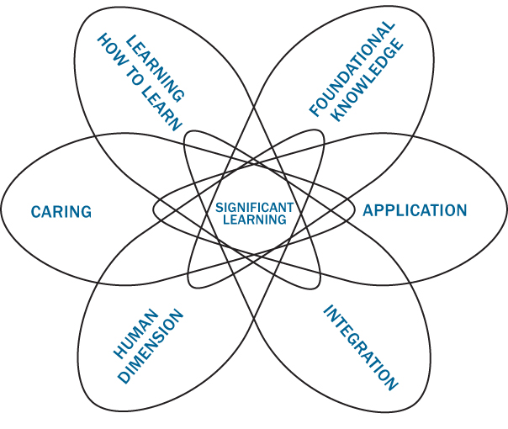First, though, it is important to identify the overall goals of your course. Begin by asking yourself what you want students to take away from the course that they will retain after a year or more. These goals may extend beyond specific content knowledge and skills to include a variety of affective qualities and metacognitive abilities. L. Dee Fink [2] identifies learning goals that fall into the six categories depicted in Figure 3.

Figure 3: Fink's Taxonomy of Significant Learning [4]

**Reflection: What are THREE to FIVE big picture goals you have for your students?  What do you want them to know, feel, or be able to do by the end of the course—and even beyond it?** Your list should include skills, abilities, attitudes, or content knowledge that are absolute musts for students to learn during the term. You’ll have an opportunity to refine these more later. Consider goals that draw on a range of range of lower order and higher order cognitive skills, and even the affective and metacognitive skills we learned about from L. Dee Fink.

*For example: Students will develop confidence to critically read not just novels but also the world around them.*

1.

2.

3.

4.

5.

**Activity: Alignment of Goals with Assessment and Feedback**

As part of your course redesign, you will align what you want students to be able to accomplish with the ways you will assess their learning and provide feedback. Use this table to create alignment between what you want students to learn in your course and where/how they are receiving feedback and grades for their efforts.

Each of the elements from the table is described in more depth below.

|  |  |  |
| --- | --- | --- |
| **A. What skills, abilities, attitudes, or knowledge do you want students to gain during the course?**  Take each of the big picture goals from above and write what students will be able to do to demonstrate their skills, abilities, attitudes, or knowledge.  These statements are called student learning outcomes.  **Students will be able to...** | **B. How will you measure and assess students’ performance in each skill, ability, attitude, or knowledge area?**  For each student learning outcome that you wrote in Column A, think of a possible summative (end) assessment.  This could be an exam, project, paper, presentation, etc. How do you want students to demonstrate their understanding? | **C. How and when will you give students feedback on their progress towards mastering each skill, ability, attitude, or knowledge area?**  For each end assessment where students demonstrate their level of mastery, how will they receive feedback on their progress during the term? |
| *For example:*  *Students will be able to analyze a passage from a primary text and identify key evidence to support the author’s claims.* | *Students will write a final research paper in the course that will include xx primary research articles to support their….* | *In class, students will practice interpreting evidence from primary literature.*  *Students will submit one sample analysis two weeks before the final paper...* |
|  |  |  |
|  |  |  |
|  |  |  |

**Activity: Alignment of Goals with Activities.** How are your goals for student learning animating the daily choices you make about how students spend their time?

|  |  |  |  |  |  |  |
| --- | --- | --- | --- | --- | --- | --- |
| Week | Daily learning outcome(s) | Work between classes or activities in class | Daily learning outcome(s) | Work between classes or activities in class | Daily learning outcome(s) | Work between classes or activities in class |
| 1 |  |  |  |  |  |  |
| 2 |  |  |  |  |  |  |
| 3 |  |  |  |  |  |  |
| 4 |  |  |  |  |  |  |
| 5 |  |  |  |  |  |  |
| 6 |  |  |  |  |  |  |
| 7 |  |  |  |  |  |  |
| 8 |  |  |  |  |  |  |
| 9 |  |  |  |  |  |  |
| 10 |  |  |  |  |  |  |
| Finals |  |  |  |  |  |  |

**Additional Notes on Aligned Design:**

References

[1] G. Wiggins and J. McTighe, Understanding by Design, 2nd Ed., Alexandria, Virginia: Association for Supervision and Curriculum Development, 2005.

[2] L. D. Fink, Creating Significant Learning Experiences, San Francisco: Jossey-Bass, 2013.

[3] C. Dirks, M. P. Wenderoth and M. Withers, Assessment In the College Science Classroom, New York: W. H. Freeman, 2014.

[4] The Northeast Texas Consortium of College and Universities, “Dee Fink’s Taxonomy of Significant Learning,” [Online]. Available: https://www.netnet.org/for-faculty/course-development/taxonomy-of-significant-learning/. [Accessed 21 May 2019].