Converting personal Zoom accounts using your @uoregon.edu email address to UO Enterprise

Step 1: Sign into with your existing account at https://zoom.us, the Zoom Desktop Client, or the Zoom Mobile app to authorize:
- If the user signs in using desktop client or mobile client, they must choose the “Sign in with SSO”
- If the user doesn’t select SSO they may be assigned a basic account for 24 hours.

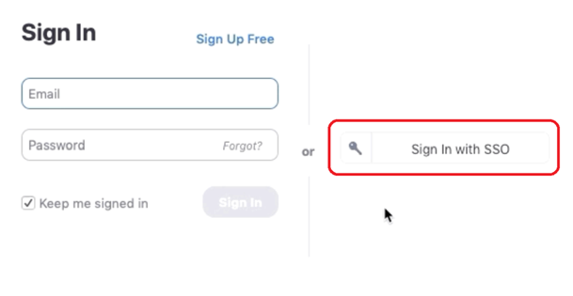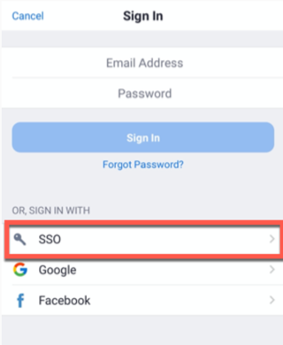

Step 2: After successfully signing in, user will be prompted to either:
- Join the Account – Transition the account to the UO Zoom environment
Or
- Change Email Address – Update the email address associated with the account to keep it separate from the UO Zoom environment

Step 3: Choose Join Account and click Continue

Step 4: If the existing Zoom account was a paid account with time remaining on the subscription, the next page will allow you to choose a reimbursement option to refund the unused time.

Step 5: If your existing Zoom account was a free account, you will only see the confirmation page. Click Sign In to Profile Page to continue using Zoom.

Note that the way you log in will now change. Follow the Signing into Zoom steps at Getting Started with Zoom.

