OSLP Arts & Culture Marketing Plan Proposal
Victoria Lee | Brea deMontigny | Joshua Cummins
Marketing, Media, and Communication II

ORGANIZATIONAL BACKGROUND

Mission
﻿The OSLP Arts & Culture Program breaks down barriers to participation in the arts for people of all abilities and builds bridges to a more diverse and inclusive community.﻿

Vision
​OSLP Arts & Culture Program is a leader in inclusive community arts for people of all abilities. This vision is achieved through its diverse and inclusive classes and workshops, on-and-off site exhibitions, mentorships, and unique community collaborations.

History
Oregon Supported Living Program (OSLP) was originally founded in 1978 and worked in conjunction with the University of Oregon to serve adults with mild disabilities who were living independently. After the need for more care for a wider range of disabilities became a reality, OSLP extended its efforts to round the clock care for residential programs, while still assisting those living independently.

The Arts and Culture sector formed in 2012 in response to the segregated and lack of opportunities available for people with disabilities. They designed a program that offers over ten different art classes taught by professional artists on a quarterly basis. The program serves OSLP clients, adults with disabilities from other programs, and the general public--aiming to provide inclusive arts & culture programming for Eugene.

Facility
The Lincoln gallery is the official gallery of the OSLP Arts & Culture Program. We are located at the intersection of W. 4th Avenue and Lincoln Street in Eugene, OR. We are open Monday through Friday from 10:00am to 5pm.

The Community Room Gallery is a small gallery attached to the Lincoln Gallery at the OSLP Arts & Culture Program. The Community Room Gallery features month-long exhibitions by featured artists in the community.

Make-Up
Gretchen Dubie--Executive Director of OSLP, creator of the A & C program.
Jamie Walsh-- Program Director, but ultimately does the majority of the work. Manages programs, membership, workshop fees, donations, marketing, and most of the program.
Mija Andrade-- Development Director
Sterling Israel-- Resident Artist
Emily Payne-- Development Assistant

SWOC ANALYSIS

Cultural Product
- Strengths: The Arts and Culture program offers a diverse range of classes covering a wide variety of artistic genres. These classes, and the program as a whole, aims to provide a space for those with developmental disabilities to create and express themselves in ways they might not otherwise be able to. That being said, the program is one of inclusiveness and is open to all members of the community seeking to create a bridge. Their classes and one time workshops are quite extensive and offer a wealth of opportunity.
- Weaknesses: While OSLP offers a variety of art classes there a couple things that come to mind as potential weaknesses. The first, and most glaring, is that they offer no digital media or design classes. Most of their classes are centered around traditional art mediums and performing arts. While this is great, they leave out a large market sector that may be interested in digital arts courses or a space for them to work on designs. Especially considering how commonplace digital design is in this day and age. The second, and this will come into play again in later analysis, is that it is not always clear who the class is for. Meaning it is not entirely clear that classes are for EVERYONE and not just their main constituent base of the developmentally disabled.
- Opportunities: The Arts and Culture program has a wonderful opportunity to diversify their class offerings even further. We would recommend considering the addition of digital arts and media design classes to supplement or replace some of the courses they have right now that might not be doing as well. They could offer courses involving the use of the Adobe Creative Suite, perhaps pairing that design software with a photography class. Courses involving digital painting, Auto CAD and other structural design software, or, if they were feeling ambitious they could offer courses utilizing 3D printing or laser cutting.
- Challenges: The obvious challenge to this approach is the funds. Digital media and technologically based art can be very costly. Were they interested in something like this we would recommend appealing to current partners and making new ones to seek out philanthropic donations of the software (many companies such as Apple and Adobe offer software and hardware at discounted prices to non-profits/students and teachers) or being very selective in the courses they wish to implement. Additionally, they would need to find artists/instructors who are trained enough to be able to teach a course like this. Some of the traditional artist they have employed may not be trained in this software so it may involve adding more staff which would further strain finances. The benefits of implementing these courses is vast but they need to be careful how they finance it to avoid too many expenditures.
Pricing
- Strengths: They have quite large range in pricing for their classes going from $35.00 to $120.00, so participants have many options to choose from as far as their income is concerned. Additionally, they offer several limited time workshops that are significantly cheaper than their regular programming.
- Weaknesses: The prices listed on their website and in their flyers do not tell the whole story. It is not explicitly clear whether the prices listed buys the entire course run or if the price is per class. It would behoove them to clarify this on their listings for each class. Additionally, they do not have a very dynamic price range. While they have a large range, the average price for a class comes out to $68.00 (not including one time workshops). This price includes the ENTIRE duration of the class, not simply one session. Pricing is ultimately a huge weakness for the organization as a whole. They simply are not charging enough. The costs to hold art classes is high and their current model does not reflect that. If they continue at their current pace, there is simply no way they can attain sustainability and may even go towards shutting down entirely. They simple cannot rely solely on their parent organization for their funds. Changing their pricing would go a long way towards rectifying the issues .
- Opportunities: In order to increase membership and appeal to a young adult audience, they may wish to consider a dynamic pricing strategy. There are a number of ways they can implement this. They could go towards a membership style of pricing (if their organizational bylaws allow for such a thing) wherein they charge patrons membership fees for the privilege to use the facilities and participate. They could install sliding scale pricing strategies where they set prices per student based on a number of factors pre-determined by the organization. Finally, they could offer package deals for their classes wherein they group together classes of like subject matter or of a particular appeal and offer them at a limited promotional rate (i.e. 3 classes for the price of 2 etc.).
- Challenges: The cost of creating and teaching art is high. If they alter pricing and implement the above strategies to be accommodating to a larger audience they will need to budget accordingly and make sure they are adequately prepared for taking a hit on an undersold class (Which they likely already are). Should they not do this, they will find themselves operating at a deficit sooner rather than later. There is of course, also the possibility of some resistance from their board of directors or their current consumer base if they alter the pricing too much as many may have grown accustomed to the current pricing model. Particularly true if they take the recommended route of raising of their pricing. They need to be transparent with their consumers about why the change is necessary.
Place
- Strengths: The Arts and Culture program is relatively centrally located on W 4th Ave. Not too far from Downtown and 5th St. Market, with fairly easy access from the highway and other areas of Eugene thanks to the LTD.
- Weaknesses: The location of the program is pretty decent already. The only issue is some of their workshops and classes that take place off site. There is also a stigma surrounding the area of 4th and Lincoln as being a bit seedier than other locations in town but given the large transient population in Eugene that will follow just about any location really as it is a city wide stigma.
- Opportunities: The LTD has multiple bus routes that stop just short of their location. There is the excellent opportunity to partner with LTD via advertisements or offering class discounts with an LTD pss etc. LTD has partnered with many organizations in the past to offer similar arrangements so it might be worth exploring. This could go a long way towards expanding the reach of the organization.
- Challenges: As with all promotional and expansions operations, there are financial metrics to consider and before looking to expand the reach of their one location they need to explore all options and budget accordingly.
Promotional Efforts
- Strengths: A&C appears to have a relatively regular and robust use of printed media. They have several flyers, posters, postcard handouts, mailers, etc. So as far as printed materials go they are relatively set, they just need to work on a consistent voice and design.
- Weaknesses:There is virtually NO consistency with their promotional material. They have multiple uses of their logos, wildly different color schemes and presentations. This can be confusing and confuse their message and overall appearance to the general public. Additionally, they simply do not use social media. At all. They may post occasionally on facebook but not nearly enough to matter. It is nearly a criminal oversight that they do not utilize Instagram as an arts organization. They should be posting images and videos on instagram at least every other day if not daily. This needs to be changed immediately.
- Opportunities: They have the opportunity to strengthen their relatively weak brand. If they are seeking to revamp and vitalize their organization they may want to consider a re-branding and developing thorough and specific graphic standards. They also have the opportunity to increase their use of and cultivate social media. This will not only add a vibrancy to their organization but will appeal to the public and a younger audience.
- Challenges: Pricing. Rebranding and social media is time consuming and can be very costly if not managed effectively. We recommend proceeding carefully and budgeting accordingly. Additionally, since they do not use social media enough, they have no real clear online voice. They will need to be careful to create a consistent voice on social media with an uptick of usage.

CURRENT STRATEGY ASSESSMENT

We’re living in a world with instant data at our fingertips
Bombarded with new images, a never-ending, growing list
It’s easy to be over it, we see a lot, but more we miss

Desensitized to advertised messages before our eyes
There’s a lot of competition for attention spans that shrink in size
And behind our minds everything is compartmentalized
So it can be a trying time to get your message stuck inside

Oregon Supported Living / Program now is out there getting
Arts and culture in this city, participation, and donor giving
There are a few ways that they’ve done this bidding
And, time permitting, I will outline them in this one sitting:

Social Media

OSLP uses Facebook and YouTube to market
Its programs, events, and experience are targets
They spark it: an interest; invested to win trust
It seems thus that they use these platforms to reach us; the audience
It’s obvious that hobbyists, newcomers and frequent fliers
Have access to all of the information of their desires
From location to contact info, updates on events and things so
Folks can find a class or exhibit or some background on what they didn’t know

The posts are a bit infrequent and the platforms both are needing
More engagement with their crowds to keep the energy their feeding on
Videos can be too long - 10 minutes?
That’s some interest that their banking on me keeping on
After just a couple, I think most people are leaving; gone
The Facebook is efficient; it’s sufficiently proficient
I can find the dates I need or ask a question that is missing
But there’s not a lot of talk, of conversation with their patrons
They could keep it more updated but it’s a start

Grassroots / WOM

Grassroots is another part, another start right from the mark
A poster or a flyer or a business card promotes the art
And flyers are a great idea, a way to bring attention near
But design is so important and here, it just isn’t clear
Brochures are full of words that are perhaps best left unheard
Too much text should get an X; left aside to gain interest
I guess / they wanted to be thorough but now my brow is furrowed
And brevity is good though, there’s no need to ask for too much of my time
If the posters catch my eye then I’ll swing by or go online

Visualization is important for the dissemination of the story
Text instigates some boredom so your graphics should be forward
But it’s not that helpful if no one ever gets to see
What a company means to me is what they appear to be
And that appearance is a product of the thoughts that are brought to screens
See, it’s about that visibility, where people go and want to be
Again, it’s a good start and this is sort of what I’d like to see
But as I mentioned I believe / there’s still a bit of work to do

Email/Newsletter

Lastly and perhaps the / most direct connect that sends your news right to your guests
Is a letter of your bests and intents for future steps
These subscribers are your nest, the ones who want to hear what’s left
So let’s assess your best interests
Give them reasons to click for readings or to forward on to friends
This doesn’t have to be text heavy, even though I know you’re surely ready
But images and links are all it takes
Keep your points brief and exciting; get curiosity igniting
Driving traffic to your site that’s on the web
Some people think in terms of form that the newsletter is dead
As we’re bombarded with content that’s rising up above our heads
In the midst of a shifting social scene
It seems it's click, delete, repeat, so it's important to be seen
To make it clear why you’re unique, to not get brushed beneath our feet
It’s okay to take a risk and wait and see

PROPOSED MARKETING STRATEGIES AND IMPLEMENTATION
In focusing on donor relations, we identify a strong need to strengthen retention and cultivate new donors. According to the OSLP Arts & Culture website, only five donors are scheduled for recurring gifts. Regular monthly giving is an important part in developing a strong organization, let alone a marketing plan. In assessing donations, we utilize loyalty and messaging marketing.

Loyalty marketing as strategy focuses on creating a lasting relationship between the brand and the consumer. The intent is to create a connection in which the consumer feels bound to the company in such a way that they will likely return without much conscious decision or effort. This connection is, unfortunately, sorely lacking with OSLP A&C. One way to facilitate this connection is through incentivization or donor tiers. This schematic encourages donors to return in order to “level up,” so to speak.

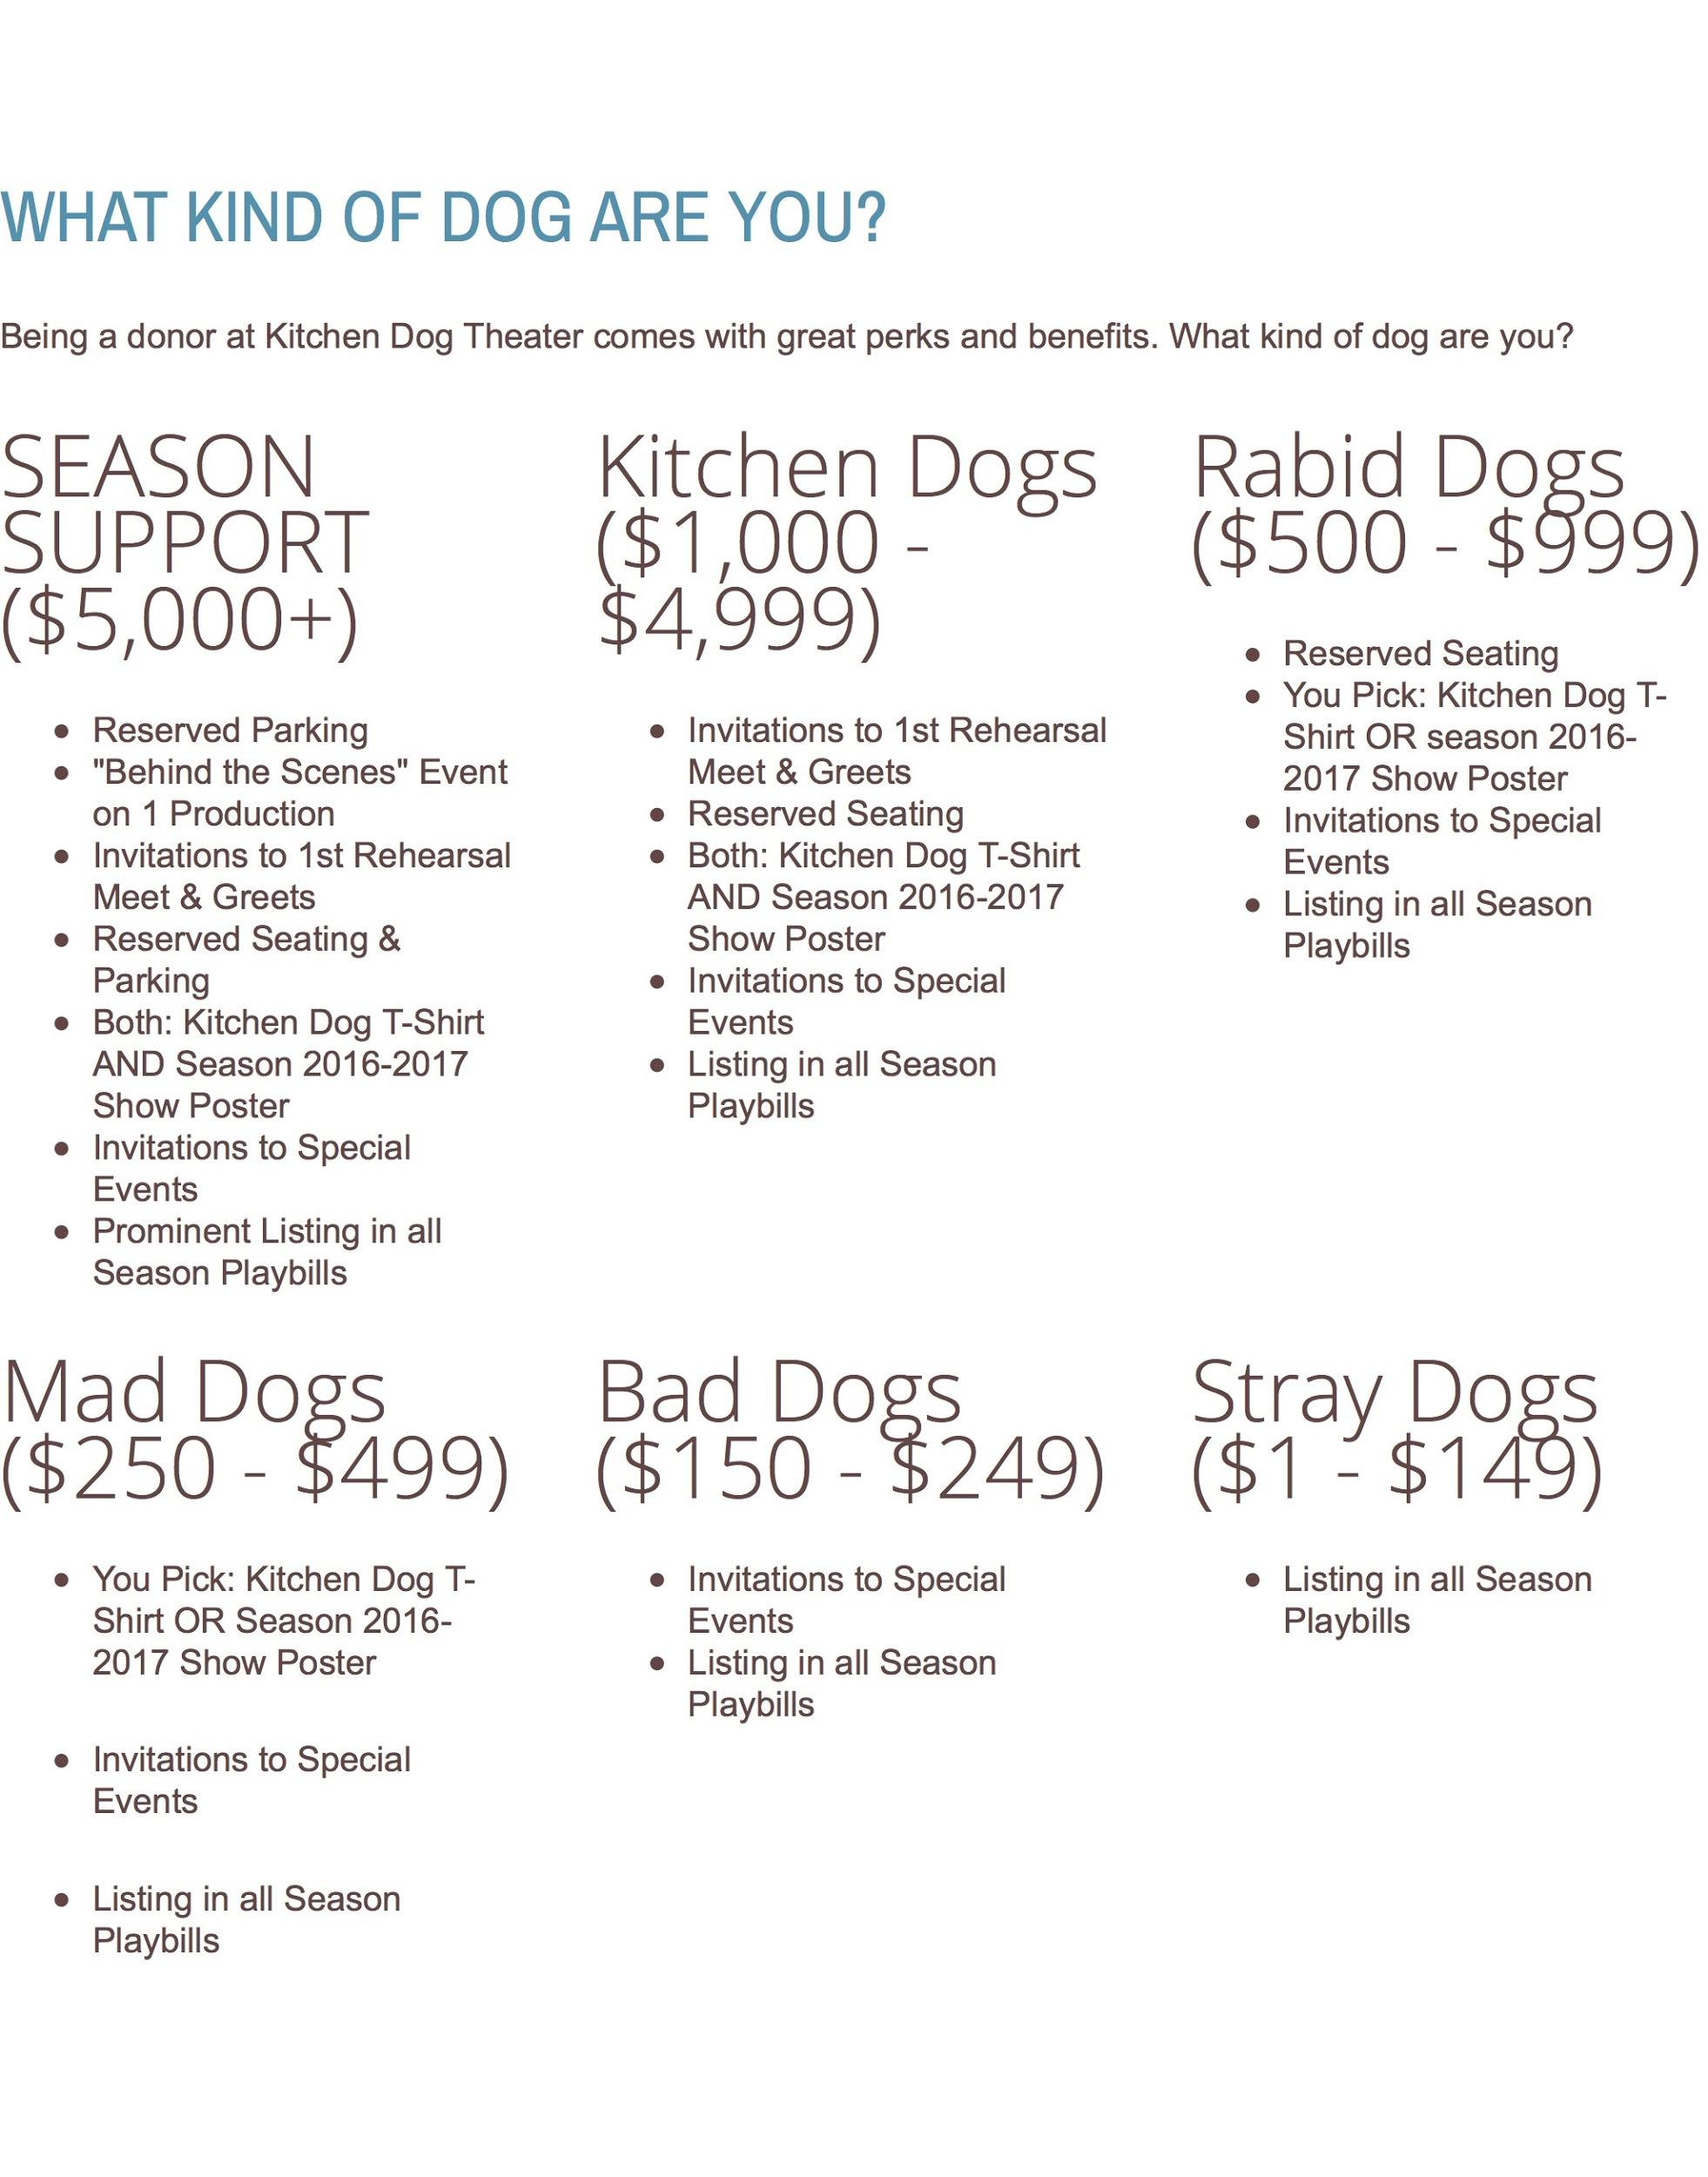
We propose a tier structure similar to that seen on crowdfunding platforms such as Kickstarter or Indiegogo. In these platforms, donors are given an incentive in return that increases depending on the amount donated (often called “stretch goals”). This is a great incentivization for one-time donors to increase their spending or return for future campaigns with the hopes of new incentivization. If this schematic is adapted to a loyalty strategy, we can use the tier system to foster repeat donors. This works through a series of donor checkpoints or levels with associated rewards. In implementing this strategy, we recommend emulating the way in which performing arts organizations utilize this tier structure. See the image to the left for an example of how Kitchen Dog Theatre employs tiered structure in their donor strategies.

The example from KDT is an excellent use of these tactics. They provide various tiers for prospective donors to join and then clearly define the incentives and rewards attached to each tier. They tier their structure around the amount of the donation but there are limitless options. What might this look like for OSLP A&C? Well, you could begin by structuring it by number of times donated. For example, a first donation might receive a personalized thank you note with a photo of a student they helped support. After reaching a new checkpoint, the donor might receive a piece of artwork custom made for them and a t-shirt. The pattern would continue in growing increments to keep donors interested. This model creates donor satisfaction and continues development in the long-run. The structure should be very clearly outlined on the donor website and on any direct marketing donor materials. A sample tier might look like:
Donation Checkpoints | Donor Gift
$1-150 | Personalized thank you letter with a photo of a class the donation supported. Name listed on company collateral and gallery brochure.
$151-400 | Invitation to a VIP gallery event with a tour of the space. Plus all items from Tier 1.
$401-750 | A piece of art made by one of the students with a photo of the student. Dedication at gallery. Plus all items from Tier 2
$751-1,000+ | An invitation to participate in a class of their choice. For personal use or family member. Plus all items from Tier 3.

Donors can also be made to feel connected to the brand if they are shown exactly what their money will be contributing to. Before making a monthly commitment, it will be helpful to outline what different dollar amounts equate to. Donors like to see where their money is going not only does it show the organization as transparent and relatable, it also encourages the donation of more money as they see what more money would provide an organization they hopefully believe in. Why not pair this with a little emotional marketing and put a photo of a happy student with some art supplies, etc. next to your table? See below for an example:
Donation Amount ($/Month) | What is Equates to
50 | Buys supplies for a class
100 | Covers teacher expenses
500 | Sponsors a gallery event

Implementation at its simplest level requires only the updating of the website for this strategy, however, OSLP will also want to provide a message to the community on this structural change. A personnel staff member will have to be responsible for the updating and maintenance of the new page. This requires the use of web editing software that OSLP is already using to maintain their sites. The staff member should update the existing page as a draft for approval from senior staff and the larger OSLP network. After approval and usability testing, the page will be published live on the web.

Messaging strategy is another effective means to maintain donor retention. By creating a story around the brand and its constituents, donors are able to develop an emotional connection and will thus be more likely to continue involvement. This can be applied to the web in addition to the loyalty tier but can also be used in email outreach.

The online donation form contains no content relevant to the donors other than how they might give a gift. There is no incentive for them to donate and no story or point of empathy to draw them in. By creating a narrative, we hypothesize that donors will be more likely to engage in the brand. What’s more appealing to you? A personalized message? Or a grayscale PayPal page? Delivering the message can occur via several formats.

- Videos and photos - Images and video can be used to show donors what type of work is being done and who it is affecting. If donors have a better sense of the people and programs their money will be helping, they will be more likely to donate. Creating a story around the everyday operations and the people behind them is one way to foster a perceived sense of connection. This could include short videos of classes in action and photos of student work, the students themselves, the gallery space, staff at work, and events.
- Testimonials - Testimonials allow donors to get a better sense of the people involved and how the program is benefitting their lives. By hearing from participants directly, donors are more likely to feel that they know the company and its constituents. Developing a sense of familiarity and emotional response is likely to draw donors in and keep them returning.
- Social media - By linking to (or incorporating a direct feed) of social media outlets, donors will be able to gain insight into past operations. They can peruse programs and participants through time to create a narrative about the company and its work. This narrative goes a long way towards building a community around supporters and gives donors a tangible representation of what their money is doing.

Messaging and loyalty strategies are all about building up your community. That community extends beyond your staff and your consumers. Your donors form an important part of your community and we cannot stress enough the importance of building a community around your supporters so that they feel welcome and wish to support you in the future. To effectively do this, not only do you need to use direct messaging like testimonials and social media content, you need to develop an increased presence outside of your own space.

What we mean by this is that you need to increase your community’s awareness surrounding your organization. OSLP A&C has been around for a number years and while you have your core constituents, the larger community has no real comprehension of what your message is, or worse, that your organization even exists. A clear example of this is your February “VIP” gallery opening. The majority of the people in attendance were the AAD cohort who had no real vested interest in your organization. This is a problem. These gallery events need to be premier events for your donors and supporters; you take the cohort out of that event and you aren’t left with many attendees with vested interest. These need to be events that you invite BOTH recurring donors and prospective donors and should be utilized as major fundraising events.

We recommend changing how you approach gallery and other events in this manner but how do you do that? What this boils down to is awareness.You cannot have loyalty, donor or otherwise, if people are not aware of your brand or your message. You need to go out and build your network. Cultivating your community network can occur in a variety of ways.
- Board Advocacy: Your board members are active in a number of community circles. As such, your board should cease to be a hands off board and should become more of a participatory and fiduciary board. They should attend organization events, advocate on behalf of the organization and cultivate donors.
- Corporate Sponsors: A&C already has a few corporate sponsors and has used them for pop-up installations and exhibitions. This is a good thing but are these sponsors invited to events? Are they made to feel like part of a community? Take advantage of your corporate sponsors’ desire to participate and stay involved. Seek out more organizations that offer programs like corporate contribution, matching gift programs, and offer in-kind support
- Cultivate Donor Experience: We have mentioned this before but your sponsors are more than just means to ROI. You are building a relationship with your sponsors and donors. Craft promotional material specifically for your donors. As cliche as it sounds, make them feel special. Send out donor newsletters quarterly or monthly via e-mail or direct mail to keep donors up to date on the organization and the metrics. Most importantly, create donor specific events. Whether this be an art auction, special gallery opening, annual fundraiser, etc. make it specific to the donors and cater to their whims. It is easy to get a donor to say yes but difficult to keep them around.
- Broaden Community Engagement: To get more donors you need to put yourself out there more. We have touched on this already but this means participating in more community events (other than art walk). Making yourself visible at larger community and city events. Whether this be attending or partnering with other charity events or participating in various community festivals is up to you. The point it, you need to increase your visibility by making yourself more available to the broader Eugene/Springfield Community.
There a many routes one can take to cultivate donors and through loyalty marketing. We have by no means outlined a definitive list or exhausted the possibilities. We have simply provided a framework from which you can begin to doctor your current donor methods into something more sustainable and robust.

EVALUATION
For loyalty and messaging marketing, we are looking for very tangible results.
-Increased participation in events
-Increased donations
-Increased awareness of services and events being offered
Timeline:
During this process, it is important to track and follow any changes that are directly related to the intended marketing strategies. Set up a timeline for how a testing period, and then have intermittent check-ins to evaluate what is and isn’t working.
Things to consider at each check-in:
- Assess what is working best, and see if you can do more of it or expand upon it
- Keep track of participation & donations coming in: check who is engaged, who is fully or partially participating (or recurring donors versus individual), and what these audiences need to better engage.
- Check for content and how it is affecting your audiences--which messages are more compelling?
Here are a few other evaluation suggestions as OSLP A&C continue to pursue these methods:
- Launch periodic online surveys of up to five questions to solicit feedback and test perspectives. A simple easy, free source is Survey Monkey.
- Set up and analyze website and social media impact via Google Analytics--get a better sense of who is checking what source. (If applicable to staff time and knowledge).
- Log the number of incoming email, social media, and phone queries, including the source (how the person found out about your program).
- Go directly to the source: ask donors or program participants, how they heard about the program or petition. Ideally, you’ll ask them what was the last “campaign” they saw before investing and what other campaign elements influenced them along the way.

https://www.networkforgood.com/nonprofitblog/how-measure-impact-your-nonprofit-marketing/

