Tribal First Foods
American Indian first foods, legends, and traditional ecological knowledge
along the route of the Lewis and Clark Corps of Discovery
Crystal Boulton-Scott
Lenape-Rancocas
Joseph C. Scott
Confederated Tribes of Siletz Indians
This curriculum is designed for use in the early elementary classroom.
Common Core State Standards referenced are for 2nd grade
We are Salmon People
At the beginning of time, animals and humans were the same. Creator was preparing to bring the Human Beings into the world. Creator called a Grand Council of all things. He asked the Council for Salmon to come forward, because the Human Beings were helpless, and would not survive alone in the new world. From this Grand Council, the Salmon People came forward and offered themselves. Their bodies would feed the people. Water came next. Water knew that the Salmon People would need a home. From Water, the Creator drew up the Human Beings. Creator handed to them the natural laws and promised that if Human Beings obeyed them, Salmon would always fill the rivers. One after another, everyone at the Council came forward and made an offering—but Salmon and Water were first. From them came the Human Beings. Salmon, Water, and Human Beings were there at the beginning of creation. We have always been relations, and we will always be there for each other as long as we obey the laws the Creator gave to us.
- Joseph Scott, Siletz, 1994

Gender and Gender Roles
In many cultural activities, and in the telling of many traditional stories, gender roles become apparent in language and practice.
Where possible, lessons have been shared using words that reduce the prevalence of gender-specific language, pronouns specifically. With that in mind, it is sometimes inappropriate to change traditional stories from the version being shared. This frequently includes the use of gender pronouns. As with cultures throughout the world, gender and gender roles contribute to the shape of everything from daily activities to ceremony and worship. Found in the story of Salmon People, Creator is assigned a male gender. You will also find that in another story from the Salmon People lesson, the Watcher is a she. This is the way many stories are told. Some tribal cultures trace their creation—and the associated origin stories—to genderless beings, some to male, and some to female. Many storytellers will emphasize the importance of preserving oral narratives verbatim, and point out that the stories they tell have been handed down to them in this way since the beginning of time.
Food ways are arguably even more complicated. Individual food practices, including cultivation, harvest, and preparation, are frequently guided by strictly prescribed gender specific roles. This often extends to the construction of food—specific tools: woven storage baskets, carved utensils, knives, spears, canoes, and the web of prescribed gender roles found in any given culture becomes very complicated very quickly. Educators and learners should be aware of the existence of these constructs, as they often serve to define the collaboration required to maintain the health and well being of a community.
The lessons shared in this unit are universally guided by gender roles on some level. From a woman’s traditional tending of the Three Sacred Sisters to the men dip netting and spearing salmon, cultural practices associated with First Foods are generally shaped by gender. An educator will find that these roles are complementary, and do not imply levels of superiority or inferiority. There are reasons for these practices that are rooted deeply in traditional ways of knowing, and are in no way unique to tribal cultures.
The recognition of gender roles and exploration of their importance would arguably make for a wide and rich teaching and learning experience. It could be argued that young learners are ready to begin exploring the reasoning behind differentiated gender roles, as they are exposed to them constantly on a daily basis. A comparative view could be considered by educators who feel that their students are ready for such an exploration. In the meantime, tribal stories shared in these lessons are offered verbatim, and will often be found to assign gender in their exploration of origin and cultural norms. In the context of the First Foods activities, the prevalence of gender roles have largely been minimized, as these roles are flexible across and between tribal cultures, and the adherence to one set of cultural norms might conflict with another. In a larger sense, a strict exploration of cultural gender roles would become overly burdensome, and would restrict learning opportunities for both students and teachers.
First Foods
This is one of the many, many explanations of the origins of tribal first foods. Members of the Lewis and Clark Corps of Discovery very well may have gathered around a cedar fire in a long Celilo (Wy-am) and heard this very story on their travels down the Snake and Columbia Rivers. We do know that they were made familiar with the sacred nature of the Salmon People (http://lewis-clark.org/article/2302). Perhaps in knowing the familial relationship among river tribes and the Salmon People, the Corps were reminded of the sacredness of the corn, beans, and squash they shared among the Mandan (http://www.lewis-clark.org/article/18041223), the buffalo that sustained them across the plains (https://lewisandclarkjournals.unl.edu/item/lc.jrn.1804-08-23), and the shimmering blue camas flowers that filled valley bottomlands as they neared the Pacific Ocean (https://digital.libraries.uc.edu/collections/lewisandclark/exhibits/botany/common_camas.php).
The exploration of first foods goes far beyond the study of plants and animals crucial to the dietary needs of tribes encountered by the Corps of Discovery. First foods embody a deep and sacred understanding of self and place. These understandings shape tribal societies and guide the rounds that tribal people have made since the beginning of time as they pursue physical, cultural, and spiritual prosperity. Carried within these rounds are the laws of Creator, the values of the people, and an understanding that tribal people are not simply from a place. Tribal people ARE that place as much as any other part of the landscape. The knowledge of traditional foods is often where Western science and traditional ecology meet. In good times, first foods are plentiful, lush, and full of the nutrition that sustains old and new generations. This is a time for celebration. In hard times, the Human Beings know in their hearts that the Creator has purpose and justification for sending a challenge. Tribal ways of knowing offer non-natives a science for academic understanding of traditional knowledge.
This story of Salmon People, as it is passed along through the generations in its many versions, contains truth that cannot be dismissed as quaint entertainment by outsiders. The oral tradition has functioned to keep balance among people, place, and spirit since time immemorial. These stories of creation and life are often held as gospel, and they should be respected as such.
Resources
This unit presumes that as a part of the general curriculum, a basic understanding of the Lewis and Clark expedition will be shared, and the themes of exploration, community, and national identity will be explored as part of a strong early elementary scope and sequence. While many sources of information are described in the bibliography, there is no shortage of additional resources. There are primary documents—the field notes, maps, and illustrations created by the Lewis and Clark Corps of Discovery party. There are similar notes, journals, and illustrations kept by early botanists, biologists, entrepreneurs, immigrants, explorers, Indian agents, Indian killers, soldiers, and prospectors. The tribes themselves are often an excellent resource for archival documents, photographs, recordings, and other means of preserving tribal ways of knowing. Cultures, values, and food ways are embedded in the research of early explorers with interests outside the study of plants and animals of the West.
Due to the absence of practical transportation during rainy seasons that occurred in the relatively brief period of time between first contact and the development of reliable roads, most descriptions of tribal cultures come from the observation of “summer rounds”. This is the time when weather conditions allowed outsiders to move about the territory relatively unimpeded by mud, landslides, storms, and rushing rivers. Because of this, many of the earliest colonial accounts of Native Americans’ ways of knowing food, place, and related spiritual practice are limited to observations made during times of safe and convenient travel. Outsiders frequently carried the weight of cultural bias, and in the times of first contact, this was particularly true. To learn the story of a tribe’s entire seasonal food round requires some exploration of place and time, often under the guidance of tribal practitioners, academics, foragers, and indigenous foods authorities. It would be an essentially impossible task to capture a comprehensive list of plants—first foods, medicines, cultural materials—and the associated peoples encountered by Lewis and Clark in their path through the homelands of nearly unquantifiable peoples, so a short list of colonially identified tribes will be addressed in this unit’s teachings.
Risks
The identification and study of First Foods can result in contentious feelings among tribal peoples. Appropriation by profiteers is a constant threat to the cultural significance of these foods, as is a poor understanding of the medicinal qualities and sacred roles they play among American Indian societies. This knowledge is often carefully guarded against a generally colonial attitude that may advocate the process of taking first and asking later. Using First Foods as a tool for education might carry with it certain risks in this regard, so the lessons described have been designed carefully in an effort to avoid this type of controversy. First foods are universally tied to a web of knowledge of associated environments. Generally speaking, it would be considered irresponsible to explore plant foods and medicines in isolation, but in the interest of education, and with the blessing of indigenous practitioners, certain norms can be suspended. This is a teaching in and of itself.
In addition, an exploration of a place and the sum of life that sustains it can sometimes expose learners and educators to real danger. In fact, Lewis and Clark and the Corps of Discovery learned this the hard way when consuming improperly prepared camas bulbs (https://franceshunter.wordpress.com/2011/07/26/nearly-all-the-men-sick-lewis-and-clark-meet-the-camas-root/). Foods that trigger allergic reactions—and living things that can either be toxic as they are or when improperly prepared—are good examples. There are others. This should not discourage exploration. It can, in fact, provide extended educational opportunities. A simple suggestion is to know the needs of yourself and your learners, observe the world carefully, and use an abundance of caution.
Teaching, Learning, and the 200th Anniversary of the Lewis and Clark Corps of Discovery Expedition
These teachings are the product of extensive research and development in collaboration with the University of Oregon’s Honoring Tribal Legacies project, which has been funded by the National Park Service. These lessons recognize that the teaching and learning of tribal ways of knowing must be tied to the history, culture, and values within the tribe of origin. Equally, multiple perspectives are crucial to an understanding of the Lewis and Clark expedition. Over time, National Parks such as the Lewis and Clark National Historic Trail have shaped peoples’ understanding of place, and have sowed a new curiosity of the responsibility we all have to honor diverse viewpoints and explore new historical perspectives. The National Parks Service’s recognition of the 200th anniversary of the Lewis and Clark Voyage of Discovery included an often overlooked recognition of the tribes and bands affected by their voyage, captured using a wide variety of media, and shared through the traveling Tent of Many Voices.
Working with Tribal Youth and Tribal Communities
- Never assume there are or are not Native American students in your classroom, school, or community. Expecting ethnic identity to include a dependent visible stereotype, and making assumptions based on appearance and/or behavior can have unpleasant consequences for a productive educator/student relationship. If Native American youth are in your class, and they wish to be known as such, it is their prerogative to share this.
- Even if you and your class are aware of Tribal students in your classroom, never single them out to speak or perform for ALL Native Americans as the topic emerges in your teachings. Native American cultures, values, languages, and histories are as varied, rich, and diverse as any other identity.
- Many Tribal people have a tradition of naming members of their respective communities based on stages of life, social status, and other cultural markers. These things are often not for sharing. The same goes for spiritual beliefs.
- Native students often exhibit learning styles with which an educator trained in a colonized fashion might not be familiar. Native students are often raised to trust their community. Tribal youth often work best in collaboration with fellow tribal members and peers. Tribal children and families often carry a traumatic mistrust of the dominant Western model of education. This model has been forced upon them since first contact, and it can be regarded with resentment.
- The impacts and consequences of historical trauma are all too real, and often produce a very challenging environment when working with tribal youth, families, and communities. Tribal people have survived culturally destructive and outright genocidal treatment by outsiders: a history of boarding schools, the appropriation of tribal culture, and, ongoing disenfranchisement of tribal peoples in their constant battle to assert sovereignty. Government and social forces continue to seek assimilation. Government includes school.
- If you are unfamiliar with the principles of Diversity, Equity, and Inclusion, as an educator you must remedy this. Tribal communities are frequently disproportionately affected by the impacts of poverty and all associated maladies. These include everything from youth as head-of-household to a lack of reliable utilities. Tribal families often face incomplete access to learning tools often taken for granted by many learners.
A Curriculum Model and an Educational Philosophy
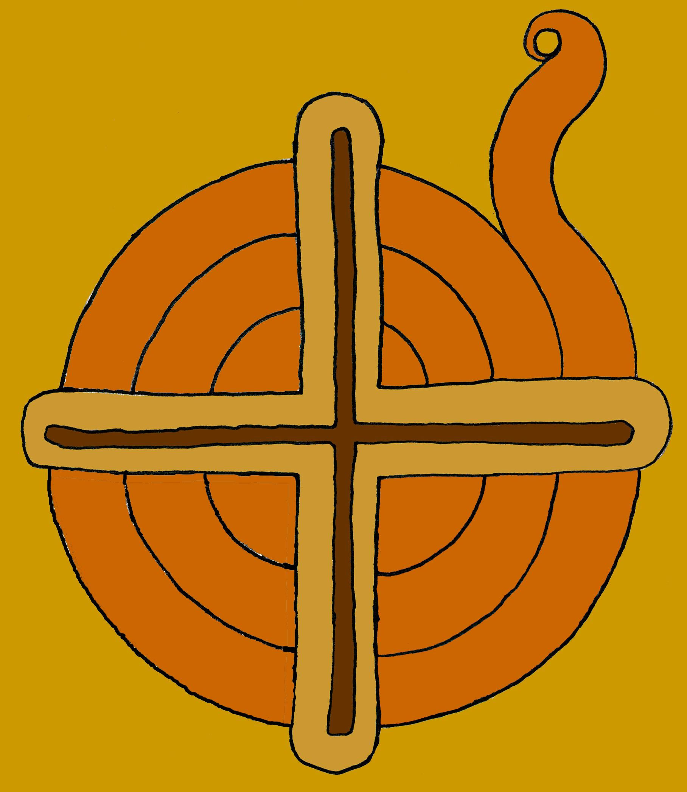
copyright Joseph Scott
This visual representation serves as both an educational philosophy and a literal structure for teaching and learning. The model
- reflects an understanding of the role and importance of culture;
- provides a universal representation of learners’ Place as necessary for positive outcomes;
- illustrates a connection of channels that describes the model’s subject-area integrative nature;
- offers learners the opportunity to take responsibility for their own progress and establish their own pace;
- follows the core philosophies captured by a recognition of the four cardinal directions and their connection to season, evolution, and change as a philosophy, and the stages through which learners pass;
- describes the path of lifelong learning;
- generates an easily recognizable structural metaphor; and,
- is centered and balanced on the intersection of family and community.
The curriculum model creates a directional illustration of multiple intelligences and a cardinal approach to diverse learning styles.

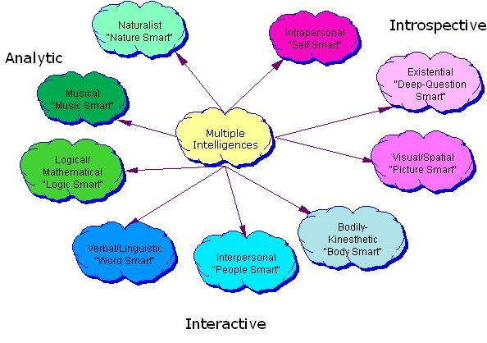
Image courtesy TeachersPayTeachers website

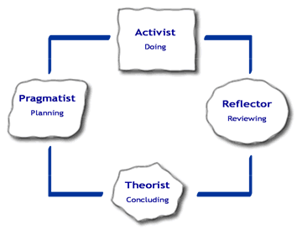
Image courtesy TeachersPayTeachers website

