Digital Display Plasma Template Instructions

Font:
Attached is a zipped file called “Open Sans”. This is the font file for Microsoft Office products—these fonts must be loaded on your machine for MS Office software to render properly. You can either install them yourself, or get your IT person to install them for you.

- Launch the PowerPoint Template. It opens with 4 options in the left pane window. Choose the one you desire and delete the other pages

- Adding an image/photo: Drag and drop your image (or click the icon) in the gray box to place your photo in the placeholder where it says “Drag picture to placeholder or click icon to add” (Figure 2)

Figure 2

- Adding your school brand: Fill in your text as needed in “School, department, program, or other”. If you have branded header on your plasma, delete this text or text box

- Adding your event information: Type in the text box: “Event Title Here” “Speaker Name” etc. Remember less is more, the viewer will only see this for a few seconds. Leave blank or delete any lines of text that are not needed.

- Saving your screen: Save as a JPEG: go to File > Export > near bottom of window change File Format to JPEG and dimensions to: Width: 1920 x Height: 1080

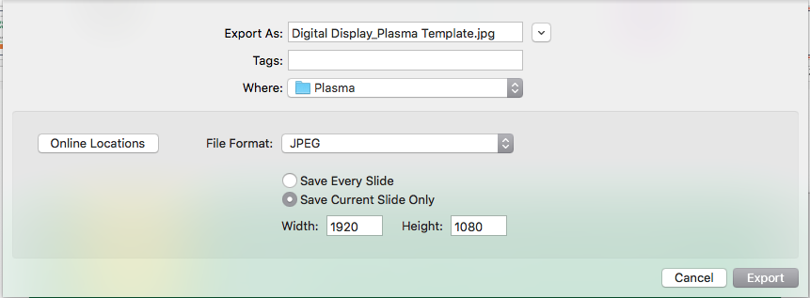
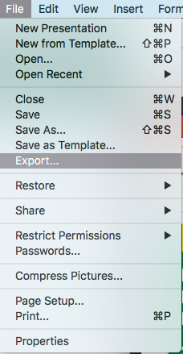
Figure 4
Figure 3

Created by: Mikayle Stole, Oct. 27, 2017

Revised by:

