University of Oregon SAIL High School Mentoring Program
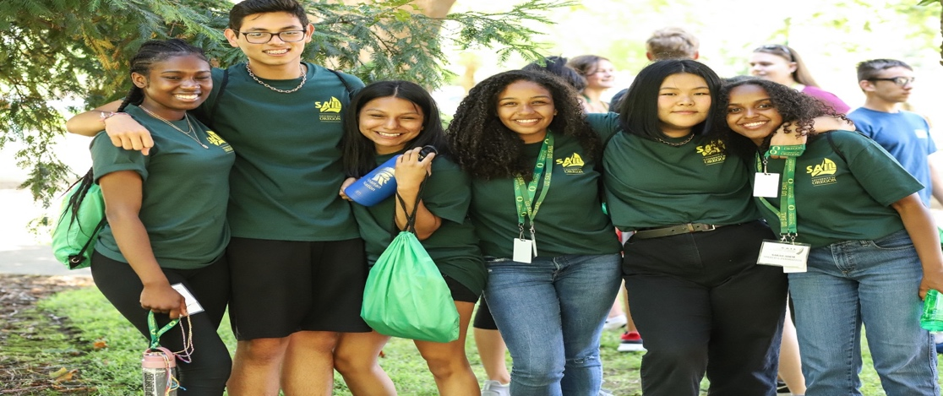

The University of Oregon SAIL Program is seeking college students to become influential mentors for 8-12th grade students. Mentors assist and inspire students as they prepare for college, transition into high school and explore their future options. We are seeking motivated individuals, capable of affecting meaningful change and are positive role models.

For more information please contact the SAIL Office 541-346-4668 and/or email aburgdo2@uoregon.edu

Part-time Paid (work study), Volunteer and Internship Positions Available

Must attend of the Following:
Room 141 Oregon Hall

Thursday, Oct 3rd 2:00 – 4:00pm
Friday, Oct 4th 1:00 – 3:00pm
Monday, Oct 7th 10:00 – Noon

