Whiskeytown National Recreation Area

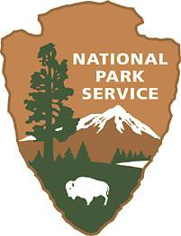
2018 National Parks Artist in Residence Program

The National Parks Artist-in-Residence Program at Whiskeytown National Recreational Area offers established l artists the opportunity to pursue their particular art form while being surrounded by the inspiring landscape of the park.
The park provides a rustic cabin for participants for up to a three week program. This program is open to any creative artist and through any media that may enhance the value or mission of the park.

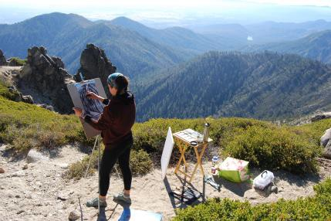
Whiskeytown National Recreation Area is located approximately four hours north of the San Francisco Bay Area and two and one-half hours north of Sacramento. Whiskeytown is situated just seven miles west of Redding, California. The park features 39,000 acres of oak woodland and forests and a beautiful 3,200-acre lake nestled amongst the hills and valleys of California’s Klamath Mountains. The cabin is a great base from which to explore the park by boat, car, or on foot.
Clarissa Fortier on Shasta Bally.

Who is eligible: Established professional artists with a history of exhibiting work are eligible. The 2018 Artist-in-Residence Program submissions may be in any creative media and are not limited to visual arts. The artist’s work should
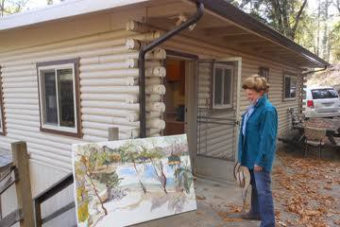
contribute to a greater understanding of, or appreciation for, the Whiskeytown’s natural or cultural resources, or how humans interact with this environment.
Joellyn Duesberry at the cabin.

The Artist Cabin: The cabin has a living area with a wood stove, two bedrooms, one
bathroom and a small kitchen. The cabin is fully furnished, including linens and kitchenware. The living room is often used as a studio.

Artist Contribution: In return for their stay, participating artists are asked to donate to the park an original artwork, representative of their artistic medium, inspired by their stay in the park. Willing artists are encouraged to present a public demonstration during their residency if schedules allow. Examples of programs include a lecture, explorative hike, or an art demonstration.

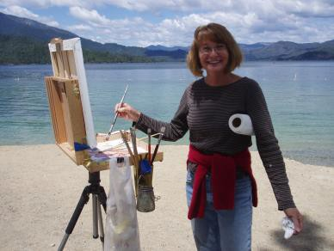
The selection process: A jury of qualified local or regional artists, along with park staff, will review the submissions. The deadline for entry is March 31, 2018. Selected artists will be notified by park staff in mid-April 2018. Selection is based on artistic merit, the statement of intent, and
Lynn Cunningham on the beach.
appropriateness to a National Park residency.

How to apply: Required 2018 application materials are:
- Artist’s resume and exhibition record.
- Statement of Intent for residency, not to exceed one page in length.
- Sample of artistic works.
- Indication of preferred residency dates.

Mail applications to: Whiskeytown National Recreational Area, Artist-In-Residence Program, P.O. Box 188, Whiskeytown, CA 96095.

Calendar: Entries are accepted for the 2018 program with postmarks dated no later than March 31, 2018. Applications postmarked after the deadline will not be considered. Notifications of finalist will be made in mid-April. The program runs from April through November.
For more information contact Tommie Scherf at (530)242-3410 or tommie_scherf@nps.gov.

