National Park Service  U.S. Department of the Interior | Whiskeytown National Recreation Area |  | P.O. Box 188  Whiskeytown, CA 96095  530-242-3400 phone  530-246-5154 fax
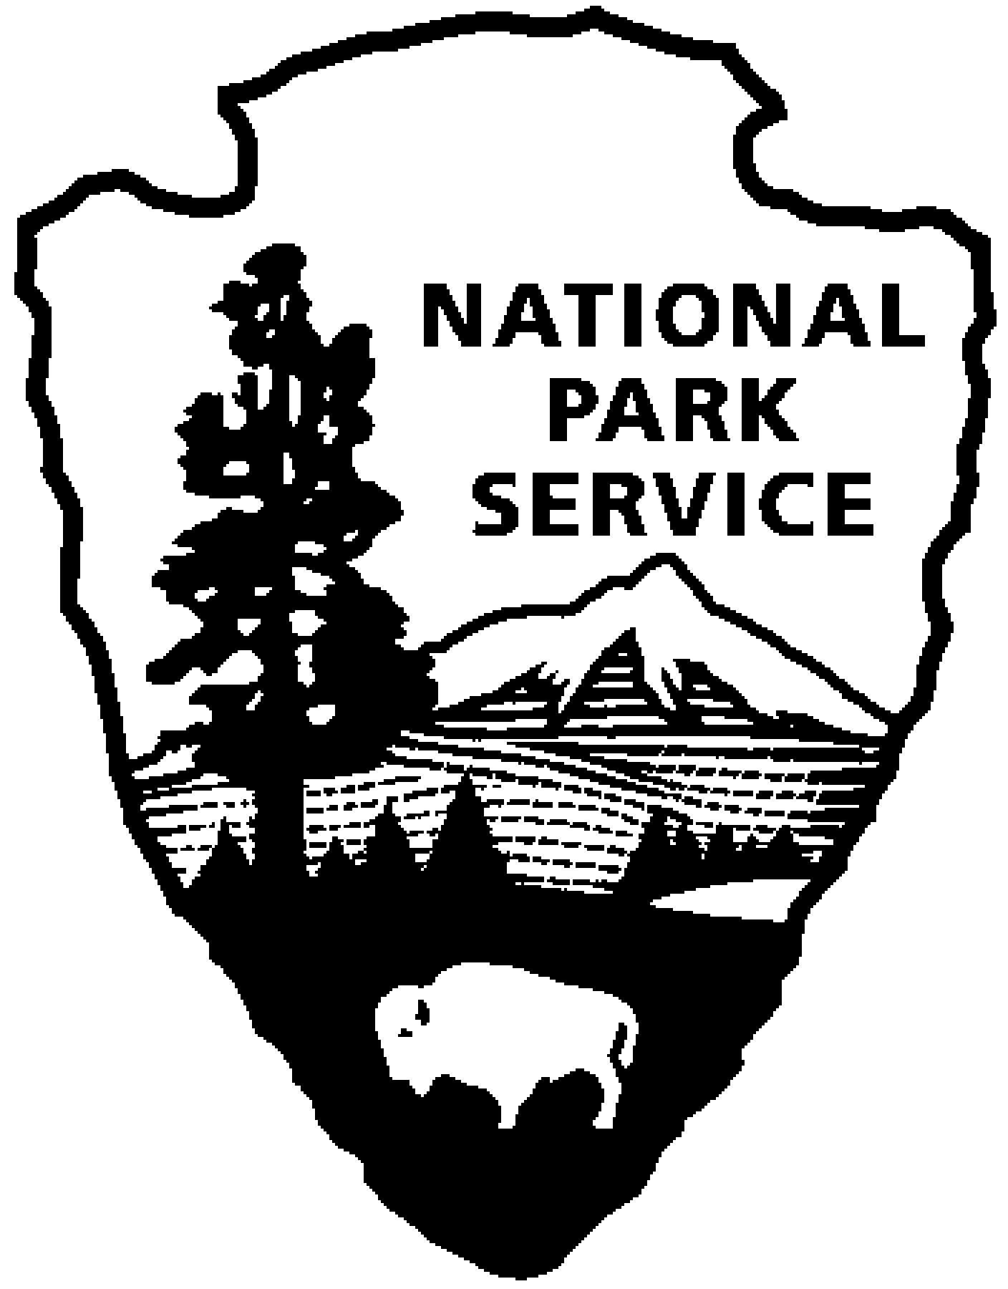
Whiskeytown News Release
Feb 22, 2018
For Immediate Release
Tommie Scherf - (530) 242-3410

A Call to Artists
Artist in Residence Program at Whiskeytown National Recreation Area
Applications Period is Open through March 31, 2018

The National Park Service, in partnership with the Friends of Whiskeytown, is pleased to announce the 16th year of hosting an Artist-in-Residence program. The park is seeking established artists with a history of exhibiting work to apply for this year’s residencies.

Artists selected are offered a rustic two bedroom cabin tucked in the forest of Whiskeytown National Recreation Area to use as a studio and base camp. Residencies are scheduled through the spring, summer and fall for stays from one to three weeks. In return, the artists donate one painting created at Whiskeytown during their stay. The donated art becomes part of the art collection at Whiskeytown National Recreation Area. Artist must supply their own meals and transportation to Whiskeytown; however, there is no charge for rent or utilities while staying at the cabin.

Whiskeytown National Recreation Area is a 42,000 acre forested park with a large lake in a mountain setting with four waterfalls, and peaks over 6,000 feet high. Over the past fifteen years, the park has hosted artists from all over the United States. We believe that through art comes appreciation for the place, and by developing a collection of art from the artist-in-residence program, the public will grow to appreciate and value Whiskeytown National Recreation Area even more.

We ask each applicant to submit the following:
1. Artist resume and exhibition record.
2. Statement of intent for the residency.
3. Sample CD with 5 to 8 images of artistic works (please also include a printed
version of the images).
4. Preferred residency dates.

Applications will be accepted until March 31, 2018. Artists will be notified by mid-April 2018, whether or not they have been accepted.

Please contact Tommie Scherf at 530-242-3410 for questions regarding this program or email at Tommie_scherf@nps.gov. Mail applications to: Whiskeytown Artist-in-Residence Program, P.O. Box 188, Whiskeytown, CA 96095.

Whiskeytown National Recreation Area: The park is 3 ½ hours north of San Francisco and 2 hours north of Sacramento by car. Summer temperatures are often over 100 degrees F, however, the park’s forest offer cool shade and the lake offers refreshing cool water to enjoy while swimming, kayaking, sailing and sunbathing. Whiskeytown National Recreation Area was established in 1965 and has over a million visitors a year. The park is home to black bear, mountain lions, bald eagles and migrating salmon from San Francisco’ Golden Gate. Old growth forest in the park date back 400 years in age and are made up of large Douglas fir, ponderosa pine, black oak and incense cedar and sugar pine. The park host over 90 miles of hiking trails and is popular to mountain bike users, equestrians, and trail runners. Check out the park’s website at www.nps.gov/whis or check out the Friends of Whiskeytown website at www.friendsofwhiskeytown.org.

-NPS-

