Marketing Plan

New Avenues Thru Soup
March 16, 2015 * Catrina R. Mathewson

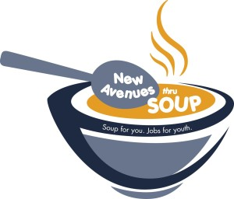
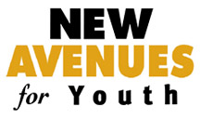

Table of Contents
Introduction & Overview | 3
Marketing Plan Goals & Objectives | 4
Situational Analysis | 5
SWOC Analysis | 8
Scheme 1: Loyalty Marketing | 11
Rewards Card Sample | 14
Evaluation Sample | 15
Scheme 2: Mobile Marketing: Text Coupons | 16
Mobile Coupon Sample | 19
Scheme 3: Social Media Marketing: Facebook & Youtube | 20
Internship Description Sample | 24

I. Introduction and Overview of Plan
History
New Avenues for Youth was founded by Portland business members in 1997 to address the street kid problem in the city of Portland, OR. The founders believed that every youth should be offered the opportunity for food, shelter, education and job training. New Avenues takes a multi-faceted approach to solving youth homelessness. The organization focuses on at-risk youth, foster youth and homeless youth. New Avenues has three social enterprise operations: New Avenues Ink, two Ben and Jerrys Partner Shops and as of 2016, a brand new soup cart. This plan will focus on the Soup Cart social enterprise called New Avenues thru Soup. The soup cart is located at the plaza of Portland State University and is open from 11am-2pm and gives crucial job experience to unemployed homeless teens.

Mission:
To work in partnership with our community to prevent youth homelessness and provide homeless and at-risk young people with the resources and skills needed to lead healthy, productive lives.
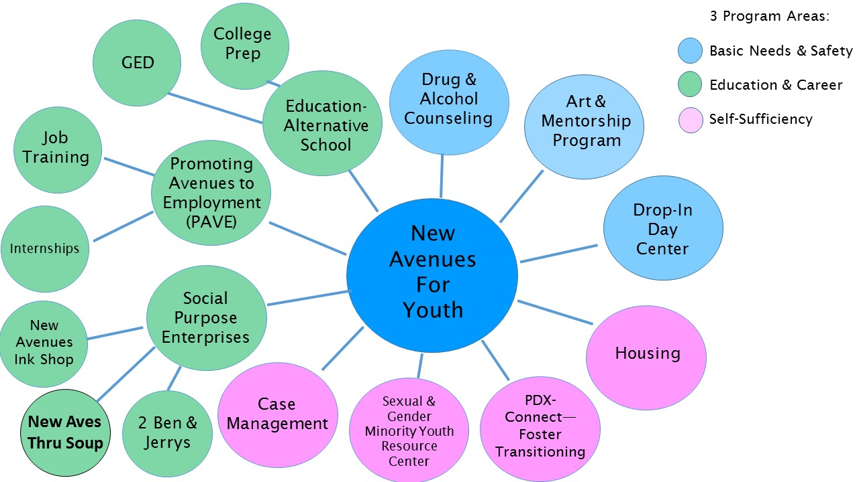
Goals and Objectives
Goals 1: Increase customer traffic and sales through reaching a wider demographic.
Objectives:
- Utilize the proximity to campus by marketing directly to Portland State University students and faculty.
- Outreach to surrounding downtown businesses.
- Create a loyalty program that will increase the number of repeat customers.

Goals 2: Increase awareness of youth homelessness and spread knowledge of New Avenues for Youth mission.
Objectives:
- Include the New Avenues for Youth logo on all promotional materials.
- Market the impact that New Avenues thru Soup has on the homeless youth. Make sure customers know their purchase is directly benefiting New Avenues for Youth clients and why it is important to the community.

Proposed Strategies:
- Mobile Coupons
- Loyalty Program- Rewards Card
- Social Media- Facebook & Youtube Integration

Desired Outcomes:
- Increase sales at the soup cart.
- Increase the number of customers at the soup cart.
- Increase New Avenues for Youth website traffic.
- Increase New Avenues for Youth donations.

II. Situational Analysis
Economic Scan
The economic scan will be accessed through comparisons of the 2011-2012 annual report and the 2013-2014 annual report, available publicly at www.newavenues.org.

- Contributed Income-

Fiscal Year | Contributed Income
2011-2012 | $416,474
2013-2014 | $399,038
Difference | -($17,436)

- Earned Income-

Fiscal Year | Special Events | Social Purpose Enterprise Sales
2011-2012 | $709,304 | $195,746
2013-2014 | $966,390 | 298,033
Difference | +$257,086 | +$102,287

- Government Income-
Government income has increased, this may be due to the increasing trend in serving homeless agencies. Homelessness has been back in the spotlight due to the tiny house and housing first movement. Both new movements look at housing homeless issues first and then providing services such as addictions counseling, job trainings and medical assistance. There has also been a recent shift in the LGBT services since marriage equality was passed and people are realizing there is a need to focus on this marginalized population. This is important due to the large number of LGBT youth who are homeless. With the focus on both of these issues, there has been more government funding available for organizations serving both populations.

Fiscal Year | Government Income
2011-2012 | $1,873,375
2013-2014 | $ 1,950,454
Difference | +$77,079

4. Organizational Economic Past & Present-
The organization is in very good health, each year their revenue is higher than their expenses. They have recently expanded their services to include a new shelter for homeless LGBT youth, the first shelter specifically for that population in Portland. e. Other Factors- Recently, the mayor of Portland has declared a state of emergency for homelessness. This could directly affect New Avenues for Youth in one of two ways. Firstly, New Avenues could have access to more government funding or an increase of donations could begin as people see homelessness as an emergency. Secondly, more shelters could open which would potentially take away funding from New Avenues or displace the current residents.

Demographic Scan
The demographics of the population served are youth from age 14-24 years old. New Avenues focuses on at-risk youth, currently in foster care as well as though who are currently homeless. New Avenues offers services for all genders and gender identities. Last year, 1,348 youth received services at New Avenues for Youth. The education level for the youth is at all different levels due to the wide range in age. For those without a high school diploma, there is an educational program to assist youth in achieving their GED or enrolling in college. The demographic that is at most concern for the organization, at this moment, is homeless LGBTQ youth. 40% of all homeless youth identify as LGBTQ (www.thinkprogress.org). LGBTQ youth are also at a higher risk of suicide (62%), twice the likelihood of heterosexual homeless youth (29%) (http://www.endhomelessness.org/pages/lgbtq-youth). This year, New Avenues for Youth opened Oregon’s only homeless shelter specifically built for LGBT youth, called SMYRC (Sexual & Gender Minority Youth Resource Center).

Cultural Scan
The culture of the organization is a youthful one. The leadership is made up of a Board of Directors, Ambassador Board and the paid Executive Leadership. The Board of Directors consists of 27 senior level professionals from around Portland. The Ambassador Board consists of 23 young professionals (Age 25-40). The Executive Leadership is made up of three individuals. Having a strong corporate world is very beneficial for gathering donations, promoting the organization and establishing legitimacy as “the best” in what they offer the city. The organization focuses on fundraisers that target young professionals; beer festivals, comedy nights and musical acts.

Other Environmental Elements
Political- As mentioned above, Portland has recently declared homelessness a state of emergency. It is still unsure how this will affect organizations that serve the homeless.

Audience Analysis
There will be three different audiences that this plan will focus on.
1. Portland State University Students
2. Business professionals surrounding Portland State University
3. Prospective Donors
4. Online audience

Organizational SWOC Analysis of Product, Price, Place and Promotions
Product: Soup

Strengths
  - Easy to produce in bulk
  - Lots of different flavors
  - Serving requires no expertise
  - Can prepare off site
  - Local/Organic Soup from Heritage Specialty Foods
  - Franz Family Bakery donated rolls
  - Quick- no prep required- Scoop into bowl and serve
  - Can be both healthy and unhealthy

Weaknesses
  - Not everyone likes soup
  - Do the bowls come with lids?

Opportunities
  - Four soups a day to choose from- could offer a 5th
  - Vegan Options
  - Gluten-Free rolls
  - Use compostable containers/silverware
  - Desert soups
  - Soup condiments- cheese, sour cream, oyster crackers, etc.

Challenges
  - Weather- Will people stand out there and wait for their soup in the rain?
  - Do people want hot soup in the summer?

Price: $5.00
Strengths
  - Includes Soup & Roll
  - Affordable for College students

Weaknesses
  - Debit/credit card fees- Most people won’t purchase more than 1 bowl so they would be paying many fees on small purchases
Opportunities
  - Only one size bowl, could expand to multiple sizes: Cup vs. bowl
  - Discount if people bring their own bowl/soup thermos- sustainability

Challenges
  - Lots of surrounding restaurants that are priced at “college friendly” prices

Place: Portland State University Plaza
Strengths
  - Near downtown businesses
  - The majority of the surrounding restaurants are International Cuisine
  - 28,000 Students at PSU

Weaknesses
  - Competes with other on-campus food.
  - PSU Events may take up plaza and the Soup Cart won’t have a space
  - Lack of tables, shelter, umbrellas for customers
Opportunities
  - Only one other soup restaurant on campus “Hot Pot City”
  - Only open from 11am-2pm M-F, Could relocate on the weekends near farmer’s markets

Challenges
  - Lack of parking
  - Only accommodates foot/bike traffic
  - Downtown foodcart area closed-More carts could relocate to PSU

Promotion

Strengths
  - Media Release
  - Social enterprise- benefits nonprofit
  - Homeless youth as staff.
  - Main Investor is Portland’s “Soup King” Rod “Harry” Harris- Brings his good Reputation
  - Promote that it is local
  - Soup company is well known- Heritage Specialty Foods

Weaknesses
  - Doesn’t have its own social media page
  - Difficult to find on the New Avenues website, should maybe have its own tab

Opportunities
  - Food carts are trendy
  - Proximity to downtown- lots of businesses they can promote to
  - Email receipts- Could prompt “Would you like to be added to our email/phone promo list?”

Challenges
  - Food Cart trend, lots of competition
  - Having consistent staffing, youth that are travelers may disappear

III. Scheme
Loyalty Marketing
Goal:
1. Create repeat customers.
2. Expand the customer base.
3. Spread the mission of New Avenues for Youth.
Objectives:
        - Offer current customers a punch card that will give an incentive for them to return, therefore retaining existing customers. (10th Bowl of soup is free!)
        - Create a colorful punch card that promotes both New Avenues thru Soup and New Avenues for Youth.
        - Network with surrounding businesses and reach new customers by giving out partially punched cards.
Target Audience:
- Customers: new, current & employees at surrounding businesses.
Resources:
  - Punch cards
  - Staff members
  - Hole Punch

Implementation:
      - Design punch cards. (Example below)

      - Call local print shops to get price quotes.
        - Are any of the businesses interested in donating the rewards cards? Sponsors?
        - If none are interested in donating, will any print them for discount?
        - Staples can print 1,000 cards, front/back color for $23.99 (the cost of 5 bowls of soup)

      - Choose a launch date to begin handing out the rewards card.

      - Create a list of 30 surrounding businesses that are not competing restaurants.

      - Send staff members out on foot to these businesses and have them give out cards that have 2 holes already punched.
Talking Points:
Hello! My name is ****** and this is ******, we are youth that currently receive services with New Avenues for Youth. New Avenues has recently opened a soup cart located at the Portland State University plaza. The soup cart employs New Avenues Youth, giving us an opportunity to gain real world job skills. All proceeds go directly to New Avenues for Youth.

      - On the launch date: Start handing out rewards cards to customers.
Talking Points:
        - “Have you received a rewards card?”
        - “With our new rewards card, your 10th bowl of soup will be free!”
        - “Each bowl benefits New Avenues for Youth work program!”

Timeline
April
1st- Design punch cards
5th- Complete price check for punch cards
8th-Send punch card design to the Board for editing and approval
14th- Send final design to the print shop- 1,000 cards
14th- Establish 2 walking teams of 2 people each that will go to businesses & help pre-punch cards
21st- Pre-punch 2 holes in 300 cards
25th- Create a list of businesses that you want to hand out the pre-punched cards to- 30 total
May
1st- Send out walking teams on foot- Each team will visit 7 businesses- 10 cards to each business
3rd- Send out walking teams on food- Each team will visit 8 businesses- 10 cards to each business
1rd-21st- Record each time a rewards card is brought in on the Evaluation Sheet (below)
June
1st- Begin offering customers rewards cards at the cart. (not pre punched)
1st-30th- Keep a running count of how many rewards cards are brought in (Returning Customers)

Evaluation:
The strategy will be evaluated on whether it meet the marketing goals and how it answers the evaluation questions listed below.
1. Keep track of the number of rewards cards brought in from businesses May 1-21st. Tally which businesses are bringing in cards. The businesses that are bringing in the most cards could always have more delivered at a later time. Or, additional marketing could be directed at that business.

2. June 1-30th- Keep a running tally of how many rewards cards you see each day.

3. Compare sales for the month of June to the month of April and see if there has been an increase in sales since the rewards cards were given out.

Sample Punch Card

Evaluation Sheet
New Avenues thru Soup- Evaluation
Business- Rewards Card

Business Name | Tally- Number of Cards brought in
24 Hour Fitness
2nd & Madison Dental
Arlene Schnitzer Concert Hall
Banner Bank
Columbia Bank
Downtown Portland KinderCare
Fed-Ex Print & Ship Center
Hilton Portland
Hotel Rose Portland
Mercedes-Benz of Portland
Oregon Dept. of Motor Vehicles
Oregon Historical Society
Oregonian Publishing
Pioneer Place
Portland Art Museum
Portland City Hall
Portland Marriot Downtown Waterfront
Portland Police Museum & Historical Society
River Place
Safeway
Washington Federal
Wells Fargo

Mobile Marketing: Text Coupon
Goals:
1. Increase sales on slow days.
2. Widen the customer base.
Objectives:
- Gather student phone numbers for text coupons.
Resources:
1. Database for storing phone numbers.
2. Mobile platform for mass-texting or App.
3. Sign for the front of cart.
4. Signs staff members can wear when they walk around.

Target Audience: Student Population

Implementation:
1. Find a mobile platform, such as mobilecause.com where mass text messages can be sent out as marketing. Or develop an App that could be used for a SMS mass text system.
2. Begin accumulating phone numbers.
- Find a lecture hall to plug the message
- Stand outside dormitories with signs! “Text ####, to receive coupons”
- Find a mass email list or Facebook group to share it on
- Have a sign on the front of the cart where people can opt in for text updates
- Ask at the cash register, did you want to give us your phone number to receive text coupons?
3. Enter all of the phone numbers into the database.
4. Choose two days in the month that are generally slower in revenue.
5. On that day, be prepared to serve extra soup.
- Add a 3rd staff member.
- Have extra product and supplies on hand.
6. On the day of the text coupon, send the text at 9:00am (2 hours before opening).
- Text example included below

Timeline:
April:
1st- Begin researching mobile platforms with mass text capabilities. Test drive them for ease of product. Is there technical support included? Gather product bids.
5th- Create a sandwich board sign for a staff member to wear reading:
“Text #### to receive soup coupons- New Avenues thru Soup”
5th- Create a sign to put up at the soup cart offering text coupons.
7th- Since you use an electronic check-out, where people sign on an I-Pad. Add a screen to the check-out process asking for the person’s phone number.
7th- Choose which calendar day in May you would like to do the text coupon- based on January, February and March sales trends. (for simplicity of plan we will choose May 16)
May
9th- Order more product for the next week than usual to prepare for the coupon promo.
16th- Send out the mass text coupon at 9:00am
Evaluation:
The strategy will be evaluated on whether it meet the marketing goals and also if there are an increase in the below evaluation marks.
1. Compare the sales for that day to a comparable day the month prior, or the week prior. Was there an increase?
2. Measure if there was an increase in the number of customers.

Sample Mobile Text Coupons:

NewAvesSoup:
Double Punch Tuesday! Show this Txt when u get soup 2day & receive a double punch on your rewards card!!
Open 11-2pm
NewAvesSoup:
Show this Text today at the New Aves Soup cart and receive $1 off a bowl of soup!
Open 11-2pm
[Grab your reader’s attention with a great quote from the document or use this space to emphasize a key point. To place this text box anywhere on the page, just drag it.]

Social Media Marketing: Facebook & Youtube
Goals:
1. To demonstrate the connection and impact New Avenues thru Soup has on the clients of New Avenues for Youth.
2. Increase Donations for New Avenues for Youth.
3. Increase the number of “Likes” on Facebook.

Objectives:
- Create a Youtube video promotion series that interviews clients of New Avenues for Youth, filming 3 sequential videos of the same client. (1 minute videos)
- Release 1 video every 4 days on Social media, with the final video showing the client at the Soup Cart working.

Resources:
1. Hire an intern that has experience with video editing and communications.
2. Video Equipment and editing software- Student can get this on loan
From school library.
3. Two clients willing to interview.

Target Audience: Social Media followers and prospective donors.

Implementation:
1. Hire a Media Intern-
1. Draft the job description and post it on Craigslist, Idealist, Portland State University, Art Institute of Portland and Portland Community College.
- Summer Internship June-Aug 30th
- School most provide the media equipment
- Decide if there’s money to provide a stipend.
2. Perform Interviews of potential Interns.
3. Choose who is going to supervise the intern.
4. Hire Intern

2. Choose which clients to interview- two clients

3. Have the intern film the client’s interview videos and edit them.
  - Two Clients total- Each Client will have 3 videos- 1 minute each.
  - Video #1- Why are you homeless? Circumstances?
  - Video #2- Where do you sleep? What brought you to New Avenues for Youth?
  - Video #3- What have you learned so far working at the Soup Cart? What would you like to do for a future career?

4. In September, begin posting of first video (schedule in the timeline below).
  - Post the videos on the New Avenues Youtube Channel and also on Facebook.
  - Sponsor the Facebook video posts- $10 each for Client #1’s videos and if that is satisfactory do the same for Client #2. If the audience it reaches is small, sponsor Client #2’s videos with $20.

Timeline:
April:
1st- Draft an internship description and have several people edit the description. Internship Start Date: June 1st- August 30th (summer only) (Sample Internship Description below)
10th- Post the internship on Craigslist, Idealist and also with Portland State University, Art Institute of Portland and Portland Community College.
May:
14-31st- Interview intern candidates and make a job offer to one.
31st- Choose which two youth will be featured in the short videos.
June:
1st- Intern begins
2nd-30th- Intern films the short videos with the youth.
July-August:
- Intern edits videos- 3 sequential videos- 1 minute each with each of the two clients.
September:
1st- The first video is posted of Client #1
5th- The second video is posted of Client #1
10th- The third video is posted of Client #1
10th-30th- Evaluation Questions listed below
October:
1st- The first video is posted of Client #2
5th- The second video is posted of Client #2
10th- The third video is posted of Client #2
10th-30th- Evaluation Questions listed below

Evaluation:
The strategy will be evaluated on whether it meet the marketing goals and also if there are an increase in the below evaluation marks.
1. Was there an increase in website traffic in the days following the video releases?
2. Was there an increase in donations, the days following the video release?
3. Was there an increase in sales at the New Avenues thru Soup cart?

Internship Sample Description
Video Production Intern
LOVE GOODLY - Los Angeles, CA
LOVE GOODLY is a shopping platform for natural and eco-friendly products through trial and subscription boxes and ecommerce. LOVE GOODLY's office promotes a fun atmosphere in a creative loft/office in the arts district of downtown LA. We are recently funded by a leading Los Angeles angel investor.
We are looking for a bright, motivated candidate who loves video production and editing, knows YouTube video best practices (keyword, intro, links) and can work both independently and collaborate with team members. This position will help edit and produce short digital video content for LOVE GOODLY to use on YouTube and our blog.
We are looking for up to 8 hours (one day) per week. Initially we are looking for someone who wants work experience or academic credit with potential for promotion - this is initially an unpaid internship for experience and to grow their portfolio. Experience creating video content for brands on YouTube and a passion for healthy lifestyle, eco brands, beauty and style a plus. Prefer to come in to the office, located in downtown LA. Prefer candidate with own computer and editing software.
Responsibilities include shooting using either iPhone6 or their own equipment, video editing and producing short content for YouTube. The ideal candidate is creative with high attention to detail, can creatively craft stories with video, and able to work under pressure with tight deadlines.
THE IDEAL CANDIDATE WILL BE/HAVE:
- Familiar with online video hosting platforms (YouTube)
- Well-versed in media file management
- Experience creating short format video content
- Good storyteller
- Experience adding logo, links etc. to promote subscription to YT Channel
- Resourceful, problem-solver who can work independently
- Sample of short video content they have shot and produced (portfolio)
Job Type: Internship
Local candidates only:
- Los Angeles, CA 90013
Required experience:
- Video production and editing: 1 year

