City of Coburg – Financial Review 2009-2017
Strengths & Weaknesses
Six years of Audited Financial Statements were available on the City of Coburg website (2009-2014). The City’s fiscal year runs from July 1 to June 30. The Coburg Budget Committee recently adopted the 2016/17 budget and data from 2015/16 and budget 2016/17 data was included in the analysis. The effects of the 2007 recession were apparent in the 2008/09 financial statements. Police and street resources were halved and payroll liabilities were reduced. In 2009, Coburg initiated development of a waste water treatment facility paid for primarily through ODEQ grants and URA loans. City debt was increasing and revenues were decreasing (Figure 1). With prudent budgeting and corrective-actions the City was able to build a new sewage treatment facility and have end of the year reserves for FY 2016/17 total over $900,000. However, the financial position of the City is still precarious with current ratios hovering around .75. Cash on hand fluctuated greatly ranging from a deficit of $5,000 in 2009 to a surplus of $1.5 million in 2014. (Figure 11) Financial solvency is trending downwards as the property tax revenues have been relatively stagnant compared to debt increases. (Figure 15)
Until fiscal year 2016/17 the City of Coburg had 11 separate funds, which was collapsed in 2007 from 23 funds. The Finance Manager and the Auditor both recommended collapsing the budgets into 5 funds with all activity related to a particular revenue/expense being contained within that fund. For example, rather than having a Street Fund and a Street CIP fund, the Street CIP fund would be collapsed into the Street fund. The collapsing of funds will result in a decrease in the administrative costs related to budgeting. Having 11 funds is likely what lead to the budgeting error in 2007 that was not found until a recent audit (Note 1). There was an interfund transfer of roughly $240,000 that was not recorded until 2013, but by that point the City was close to a balanced budget. Property taxes have remained relatively steady around $500k/year but one weakness is that the URA is under-performing because multiple properties are not assessed at their actual value.
Revenues & Expenses
The primary sources of revenue are city property taxes, urban renewal agency taxes, system development charges, fees for service, gasoline tax, and grants. The City Council is considering a diesel fuel tax and increasing waste water fees (an annual increase in the monthly waste water fee of $5.10 for 10 years). Current waste water fees do not cover the cost of maintaining the system. Lane County will be reassessing several properties within the Urban Renewal District and tax revenue from these properties could partially reduce the waste water fee increase. The City is also considering a new rental system for park facilities; rates are currently between $20-40 per day and the parks committee is considering a proposed increase to $60/four-hour block. The budget committee and City Council also approved a waste water pumping fee for commercial buildings.
The primary expenses are the related to the waste water treatment facility, the drinking water system, streets, parks, public safety, and city administration including planning and economic development. There is also a significant expense related to debt service to pay for the new waste water treatment facility. The City also recently purchased a new City Hall. Coburg has payroll related expenses for all of these programs as well as retirement obligations and maintenance of its capital facilities. Some assets are restricted for certain uses (Note 2).
Assets & Liabilities
Assets are classified as either Current or Non-current, Governmental or Business-like, with a separate category for the Urban Renewal Agency. The waste water treatment facility, City Hall, library, parks, roads, and equipment are the primary assets. The new Coburg Loop is also an asset and was developed with minimal input of City funds. There was a land donation that served as match for a two grants totaling nearly one million dollars. The City will have contributed $20,000 to secure this asset. The largest liabilities are the debt service for the waste water treatment facility and payroll, as well as retirement funds, which will increase in the next 10 years according to City Staff.

Appendix A

Figure 1)
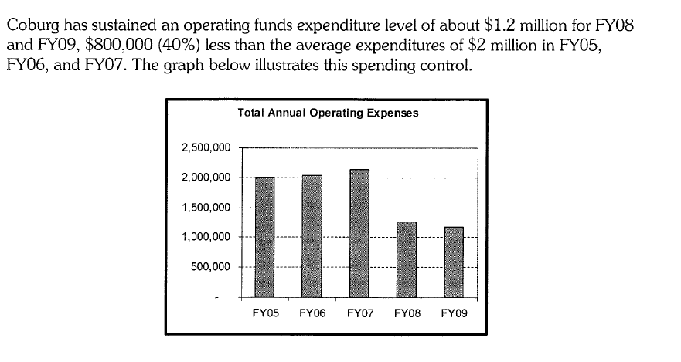

Note 1 – The 2009 Financial Statement noted that in the beginning of FY 2008 the City had also reduced the total number of funds. It’s unclear exactly how many funds they had to begin with, but in the 2015/16 budget the following funds were in operation:

Current Funds
Recommended Fund Structure
- General Fund
  - Planning
  - Police
  - Court
  - Economic Development
  - Park
    - Park CIP
  - Building Development
- Street Fund
  - Street CIP
- Water fund
  - Water CIP
- Sewer fund
  - Sewer CIP
  - Sewer debt
- Police evidence

- General Fund
  - Planning
  - Police
  - Court
  - Economic Development
- Park
- Street
- Water
- Sewer
- Parks Capital
- Street Capital
- Water Capital
- Sewer Capital
- Sewer Debt
- Building
- Police Evidence * Not really a fund in that the money in this fund is evidence and cannot be spent.

Note 2 – There are restricted funds for the Library, Economic Development, DARE, Debt Service, Street Trees, Parks SDC, Transportation SDC, and Water SDC.

Figure 2

 | End 2009 | End 2010 | End 2011 | End 2012 | End 2013 | End 2014
Assets | $8,971,845 | $9,404,519 | $10,376,991 | $19,694,278 | $25,255,403 | $31,349,777
Liabilities | $6,557,918 | $6,491,637 | $7,057,762 | $14,787,852 | $17,269,232 | $21,191,139
Assets/Liabilities | 1.37 | 1.45 | 1.47 | 1.33 | 1.46 | 1.48
URA | 2008/09 | 2009/10 | 2010/11 | 2011/12 | 2012/13 | 2013/14
Assets | $1,352,766 | $1,386,107 | $1,358,344 | $1,688,034 | $1,666,962 | $1,682,558
Liabilities | $41,364 | $0 | $0 | $0 | $15 | $3,878
 | 2008/09 | 2009/10 | 2010/11 | 2011/12 | 2012/13 | 2013/14
Total Current Assets | $1,226,273 | $648,042 | $499,451 | $2,878,899 | $1,182,315 | $2,508,240
Total Current Liabilities | $1,367,965 | $1,449,906 | $1,258,194 | $3,674,678 | $3,286,472 | $3,346,264
CA/CL | 0.90 | 0.45 | 0.40 | 0.78 | 0.36 | 0.75
 | 2008/09 | 2009/10 | 2010/11 | 2011/12 | 2012/13 | 2013/14
Property Tax | $508,507 | $502,359 | $511,952 | $513,544 | $511,955 | $461,934
Intergovernmental | $385,417 | $336,901 | $323,359 | $137,179 | $203,624 | $149,969
Waste Water Fees | $0 | $0 | $0 | $0 | ($35) | $42,063
Waste Water Intergovt. | $196,737 | $100,000 | $140,000 | $268,998 | $0 | $0
Ending GF Balance | ($790,346) | ($625,261) | ($403,743) | ($381,847) | ($382,504) | ($349,298)
SF Ending Net Position | $0 | $1,739,980 | $1,932,028 | $2,481,807 | $7,853,158 | $8,829,127
Grants | $479,533 | $115,580 | $50,000 | $1,315,114 | $1,502,447 | $2,838,603
Police Expenditure | $414,627 | $349,099 | $413,157 | $404,294 | $424,482 | $409,261

Figure 3

Figure 4

Figure 5

Figure 6

Figure 7

Figure 8

Figure 9

Figure 10

Figure 11

 | 2009 | 2010 | 2011 | 2012 | 2013 | 2014
net assets | $2,063,740 | $3,198,310 | $3,319,229 | $4,906,426 | $7,986,191 | $10,158,638
total revenues | $1,699,702 | $1,273,489 | $1,347,273 | $2,598,635 | $3,243,933 | $4,660,715
Equity Balance Ratio | 1.21 | 2.51 | 2.46 | 1.89 | 2.46 | 2.18
Figure 12

Total cash | 2009 | 2010 | 2011 | 2012 | 2013 | 2014
 | ($5,714) | $16,068 | $8,833 | $650,542 | $48,637 | $1,527,181
Figure 13

 | 2008/09 | 2009/10 | 2010/11 | 2011/12 | 2012/13 | 2013/14
Total Debt | $5,458,104 | $5,349,120 | $6,116,009 | $11,294,698 | $13,982,760 | $17,184,478
Assets | $8,971,845 | $9,404,519 | $10,376,991 | $19,694,278 | $25,255,403 | $31,349,777
Figure 14

 | 2008/09 | 2009/10 | 2010/11 | 2011/12 | 2012/13 | 2013/14
solvency | 0.61 | 0.57 | 0.59 | 0.57 | 0.55 | 0.55
Figure 15

 | Budget | Budget
 | 2015/16 | 2016/17
Property Tax | $514,274 | $423,537
Intergov. Transfer | $149,969 | $149,969
Waste Water Fees | $621,831 | $645,000
Waste Water Intergovt. | ($186,034) | ($352,908)
Ending GF Balance | ($514,274) | ($423,537)
Figure 16

