Bip
(GRP78)
THE UPR RESPONSE
ATF6
IRE 1
phospho
PERK
phospho
PDI
eIF2
inactive
PUMA
BIM
P
CALNEXIN
Cleavage in
the golgi.
Protein synthesis
XBP1
ATF4

chop
Foxo3a
transcriptional regulation
UPR genes
Apoptosis genes
Mitochondrial UPR/
mitophagy
Auto phagy

APOPTOSIS
In normal conditions, BiP or GRP78 is bound to and inhibits three distinct trans-membrane proteins that are also known as stress sensors: the kinase PERK, the kinase/endonuclease IRE1, and the transcription factor ATF6. Upon accumulation of unfolded proteins within the ER, GRP78 is titrated away from these stress sensors leading to their activation. The trans-membrane kinase/endonuclease IRE1 gets activated after a step of homodimerization and autophosphorylation before splicing the mRNA of the transcription factor X-box Binding Protein 1. The spliced form of Xbp1 induces transcription of a specific subset of genes coding for proteins that play a role in ER-mediated peptide folding. Moreover, IRE1α cleaves microRNAs that control the levels of caspase family cell death proteases.
Similarly the transcription factor ATF6 in its GRP78 unbound form translocates into the Golgi where it is cleaved and activated. Activated ATF6 can induce transcription of the molecular chaperones GRP78 and GRP94 as well as of Xbp1, indicating a cross-talk between these two arms of the UPR .
The transmembrane kinase PERK homodimerizes, undergoes autophosphorylation and inhibits the alpha subunit of the eukaryotic initiation factor 2 (eIF2a). As a result de novo protein synthesis is blocked preventing novel polypeptides from accumulating in the ER lumen. However, prolonged eIF2a phosphorylation leads to the activation of the transcription factor ATF4, a member of the cAMP-responsive element- binding protein (CREB) family of basic zipper-containing proteins. ATF4 induces the transcription factor CHOP/GADD134 that in turn induces the pro-apoptotic protein Bax and Bim and inhibits the anti-apoptotic protein Bcl-2. Based on the time of activation, the UPR has opposite effects on cell fate: while at the early stage it induces cell survival and increases refolding activity within the ER by activating ATF6 and IRE1 branches, at later time points results in cell death induction by activating the PERK-eIF2-ATF4 axis.
Although PERK and IRE1alpha share functionally similar ER-luminal sensing domains and both are simultaneously activated in cellular paradigms of ER stress in vitro, they are selectively engaged in vivo by the physiological stress of unfolded proteins. The differences in terms of tissue-specific regulation of the UPR may be explained by the formation of distinct regulatory protein complexes. This concept is supported by the recent identification of adaptor and modulator proteins that directly interact with IRE1alpha.
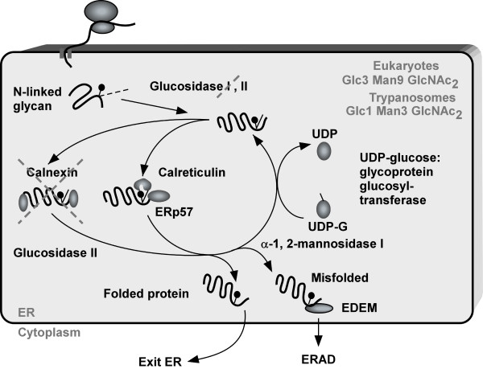

Asparagine-linked glycans (N-glycans) are displayed on the majority of proteins synthesized in the endoplasmic reticulum (ER). Removal of the outermost glucose residue recruits the lectin chaperone malectin possibly involved in a first triage of defective polypeptides. Removal of a second glucose promotes engagement of folding and quality control machineries built around the ER lectin chaperones calnexin (CNX) and calreticulin (CRT) and including oxidoreductases and peptidyl-prolyl isomerases. Removal of the last glucose residue causes the release of N- glycosylated polypeptides from the lectin chaperones. Correctly folded proteins are authorized to leave the ER. Non-native polypeptides are recognized by the ER quality control key player UDP- glucose glycoprotein glucosyltransferase 1 (UGT1), re-glucosylated and re-addressed to the CNX/CRT chaperone binding cycle to provide additional opportunity for the protein to fold in the ER. Failure to attain the native structure determines the selection of the misfolded polypeptides for proteasome-mediated degradation.
BiP is the DnaK class chaperone of the ER lumen and its expression is transcriptionally up-regulated by the UPR^{er}. As this process has a latency of several hours, it has yet to be determined how cells respond to physiological fluctuations in the rate of secretory protein translation, which often occur over a shorter timescale). Furthermore, BiP has a long half-life of up to 48 h. Amino acid starvation or protein synthesis inhibitors, which lower the flux of unfolded proteins into the ER, causes ADP ribosylation of BiP.

ATF6 is packed into vesicles that are transported to the Golgi apparatus. Here two proteases – S1P and S2P – cut the full length ATF6: first by removing the luminal domain and subsequently the membrane anchored domain The remaining N-terminal cytosolic fragment moves into the nucleus to activate UPR target genes. ATF6 binds to the ATF/CRE element and to the ER stress response elements I and II (ERSE-I, CCAAT-N9-CCACG and ERSE-II, ATTGG-N-CCACG, ER-resident proteins involved in protein folding, such as BiP, PDI, GRP94, CHOP are targets for ATF6
The ER lumen is the major storage of intracellular Ca2+ and Ca2+-binding chaperones mediate the proper folding of proteins in the lumen of the ER. It is well established that Ca2+ trafficking in and out of the ER regulates a diversity of cellular responses and signaling transduction pathways relevant to stress response, modulation of transcriptional processes, and development. For instance, acute release of Ca2+ from the ER through the so called translocon, whose opening increases Bip levels as indicated by treatment with puromycin (and blocked by anisomycin), can trigger a variety of signaling mechanisms that promote cell death mainly by Ca2+-mediated mitochondrial cell death. Conversely, pulses of Ca2+ delivered via IP3Rs at contact sites of ER and mitochondria promote oxidative phosphorylation, which sustains ATP levels and cell survival.
Other proteins involved in ER Ca2+-mediated apoptosis are Bax and Bak. Transient over-expression of Bax results in release of ER Ca2+, with a subsequent increase in mitochondrial Ca2+ and enhanced cytochrome c release. In contract, cells with deficiency of both Bax and Bak have reduced Ca2+ release from ER upon stimulation with IP3 and other ER Ca2+-mobilizing agents. Calreticulin, a major Ca2+ binding ER chaperone is also a key component for folding of newly synthesized proteins and for other quality control pathways of the ER. Therefore, fluctuations of the levels of Ca2+ in the ER can severely impact folding capacity and trigger cell death. For instance, fibroblasts from calreticulin-deficient embryos have impaired agonist-induced Ca2+ release and deletion of this gene in embryos is lethal [27]. In summary, alterations in Ca2+ dynamics seem to play an essential role not only in the ER but also some ER stress-associated mechanisms of cell death.

PDI protein disulfide isomerase induces disulfide bond formation as a part of protein refolding in the ER. It catalyzes the SH-SH bridge by a thioredoxin-like mechanism. The protein can also act as a chaperonin for proteins that do not have a disulphide bond.

