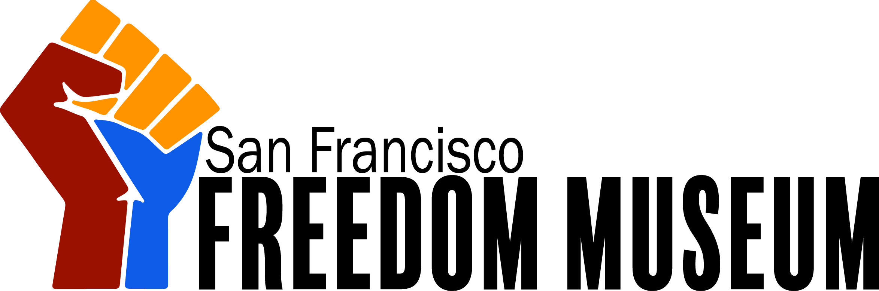

San Francisco Freedom Museum
Programs and Education Coordinator
Reports To: Director of Inspiration
Status: Non-Exempt

Job Summary
Under the leadership of the Director of Inspiration, the Programs and Education Coordinator is responsible for the planning, development, and implementation of education and public programming projects aimed at upholding and exceeding the mission of the Freedom Museum. Projects and duties include forming and maintaining critical community partnerships, education and public program development and execution, and duties related to furthering the goals of the Museum and of the Department of Inspiration.

Primary Relationships
This position reports to the Director of Inspiration and serves as a member of the middle management team. This position collaborates with staff in the Department of Inspiration and with staff from other departments in various capacities in order to fulfil the roles of the position.

Primary Duties
The tasks listed below are those that represent the majority of time spent working in this position. The Director of Inspiration may assign additional related tasks as necessary.
- Identifies curricular and educational connections between exhibitions and community education needs to design and develop school and public tour programs for varied audiences
- Deepens participation of visitors by producing dynamic public programs related to the Museum's exhibitions and/or focused on the Museum's target audiences
- Expands the reach of the Museum’s programs by cultivating strategic partnerships with the San Francisco educational community and with local community groups with similar goals regarding justice
- Develops and implements evaluation tools to measure, interpret, and analyze the outcomes of education and public programs relative to strategic goals
- Designs and conducts training programs for docents, interns, and volunteers assisting with educational or public programs
- Evaluate, review and revise education programs to maintain alignment with current state education standards and alignment with the mission and vision of the Freedom Museum
- Develop public tours for groups visiting the Freedom Museum, collaborate with staff and docents to ensure all efforts align with the mission and are inclusive and positive
- Forming and maintaining community partnerships to further the efforts of the Department of Inspiration and the Museum
- Performs other duties as assigned within the scope of responsibility and requirements of the position

Qualifications
Required:
- Excellent interpersonal and written communication skills
- Ability to successfully manage multiple projects simultaneously
- Self-motivated starter and independent learner
- Strong organizational skills
Other:
- Minimum of 2 years experience in education or public programming, with demonstrated success, preferably in the not-for-profit sector
- Bachelor’s degree in arts administration, education, museum studies, or related field preferred. Graduate degree in a related field is desirable.

