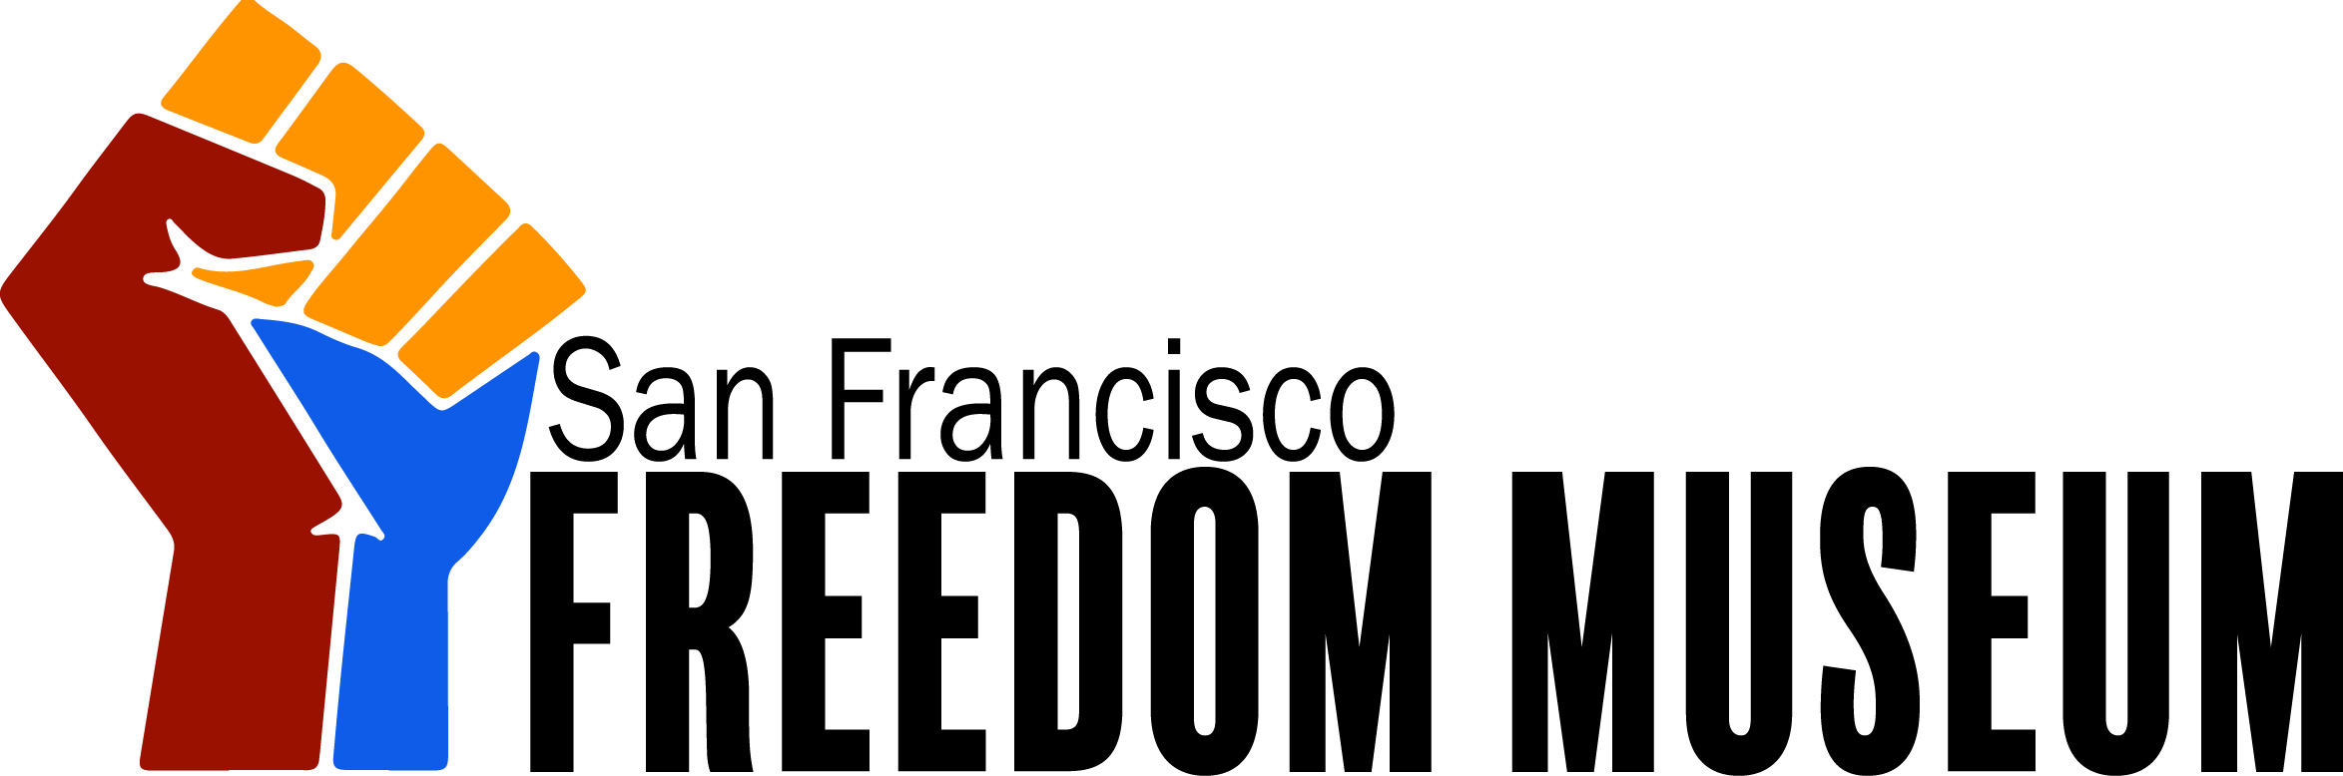

Organizational Chart
The organizational chart of the Freedom Museum aims to reflect the institution’s mission and values of supporting and inspiring change towards social justice. While the organizational chart is self explanatory, the organization would like to highlight a few key aspects of its structure.
The Freedom Museum’s board of directors is comprised of grassroots organizers, activist artists, and people who are working towards social justice. All directors will serve on the board without reimbursement. The executive director, his or her assistant, and all other senior management including that of finance, operations, marketing and communications, and inspiration are paid positions. The positions of development, security, volunteer, programs/education, and collections/curatorial coordinators, and HR manager are also paid positions.
As an organization we strive to provide local marginalized communities opportunities to participate in shaping the Museum’s activities and role in the community. The Freedom Museum works to recruit local volunteers from marginalized groups and allies of social justice causes. Additionally, the Museum provides unpaid internships for those interested in supporting social justice causes and gaining experience in a museum setting. One form of direct community support the Freedom Museum provides is the leasing of the cafe space to a local community food and beverage company, who will provide food and beverage services for the Museum's patrons. Fifteen percent of all cafe profits will go to the Museum.
The Freedom Museum understands the discrimination faced by communities the organization endeavors to support. This is reflected in the way the organization approaches the role of security in the Museum. One example of this is reflected in the The Security Coordinator position. Within this position there is an expectation that applicants will have knowledge of the Bay Area and community issues that persist within it. All other security personnel are volunteers from local marginalized communities. All security personnel undergo an initial security training and subsequent periodical trainings. The Freedom Museum believes this empowers marginalized people and make the museum a welcoming and accessible place for local communities. This not only directly supports marginalized communities but also makes the Museum, which is an important cultural institution, theirs.

Organizational Context
The Freedom Museum draws inspiration from the history of protest and social change movements in San Francisco; especially black and latinx activism originating in the Mission District. Like most neighbourhoods in San Francisco, the Mission District is undergoing a process of gentrification. As an organization, we do not aim for our presence in the Mission District to exacerbate this process, but instead the Museum can be a resource for marginalized communities, providing help in strategizing and organizing the handling of gentrification.
To fulfil its mission, the Freedom Museum partners with organizations fighting for the same ideal of justice. These organizational partners can provide expertise in various fields regarding justice and resistance, as well as resources and the potential for collections loans to broaden our exhibit capabilities. One of our most important allies is The Freedom Archives, with whom the Museum is affiliated. The Freedom Archives is an important resource for the Freedom Museum as the Museum’s initial exhibits are based on material from the Archives, including audio recordings, video recordings, and texts on freedom struggles in the United States. Other partners helping the Museum meet its mission include The Human Rights Commission of San Francisco, The Museum of African Diaspora, The Beat Museum. The Museum of Tolerance in Los Angeles, Design Action Collective in Oakland, The Museum of Women’s Resistance in New York, and The International Museum of Human Rights in San Diego. Moreover, artist activists such as JR and Marc Levin are also important partners for the organization.
The Freedom Archives is an important resource for the Freedom Museum as the Museum’s initial exhibits are based on or supplemented with material from the Archives. This material includes audio recordings, video recordings, and texts on freedom strife within the United States.
The Freedom Museum partners with the Human Rights Commission of San Francisco to enable a connection to social movements globally. The Museum will also gain resources from the Human Rights Commission to plan exhibits, write interpretive labels, and develop programming.
The International Museum of Human Rights is an collaborator for the Freedom Museum in creating exhibits and programming that address human rights concerns. This concept is a cornerstone of the Freedom Museum, and this partnership is invaluable in helping to share those stories with our visitors.
The purpose of the Museum’s partnership with the Museum of African Diaspora is to share resources and gain expertise relating to the lives, cultures, and resistance movements among people in the African diaspora.
The Museum of Tolerance examines racism and prejudice globally with a focus on the history of the Holocaust; this provides an important partnership with the Freedom Museum, in its efforts to validate social protest against racism and discrimination. The Freedom Museum will partner with the Museum of Tolerance in creating relevant exhibits and programs targeted towards examining racism.
The Beat Museum provides guidance to the Freedom Museum with counterculture exhibits and programming with a specific focus on tolerance and compassion. Through their knowledge of counterculture in San Francisco, the Beat Museum will be a valuable in helping develop walking tours that will be organized by the Freedom Museum.
The Freedom Museum partners with the Museum of Women’s Resistance in creating exhibits and programming about women’s rights concerns today, and the history of women’s resistance. The knowledge and collections of the Museum of Women’s Resistance helps the Freedom Museum highlight the role of women in resistance and in fights for justice.
The Design Action Collective works to provide graphic design and web development to social movements working towards social and economic justice. The Freedom Museum partners with this organization in creating in interpretive exhibits, website development, online outreach, and graphic design.
The Museum also partners with the Design Action Collective in creating content for the walking tours the museum will organize, which will extend beyond the boundaries of the Museum’s walls, and into the San Francisco community to better impart the tour’s message.
Marc Levin is a partner whose work is informed by marginalized cultures in US cities. Partnering with Marc Levin in organizing film festivals on social justice concerns helps the Museum attract wider audiences and creates a new level of accessibility and visibility around these issues.
Along with Marc Levin, JR, a photographer who exhibits his work in large format in public spaces to highlight marginalized people’s dignity and presence, showing they cannot be ignored. The Freedom Museum’s partnership with this artist will be in developing walking tours and programming to empower marginalized people in creation of their art to enhance their presence in the community and throughout the world.

