Team name: __________KEY__________________________________

Leg 1 of 5: Website/Basics

In this leg of the race, explore the UO Libraries’ website (library.uoregon.edu) to answers these questions!

- What’s the phone number to text a librarian for help (hint: ask a librarian)? ___ (541) 233-0275__

- Librarians create research guides to help students get started with research. If you’re in the Undergraduate tab> Research guides> Human Physiology guide, what is the name of the first suggested database for finding articles? (hint: this database covers articles in biomedical topics from the National Library of Medicine): _____Pubmed________________________
- You can still borrow items we do not have at the UO called Interlibrary Borrowing. What are the 2 methods for borrowing items not available at the UO?
1)___Summit___________________ 2)____________Interlibrary loan (ILL)______

- Some faculty members put readings for their classes on Course Reserves so that everyone can use the material. For the HPHY 323: course, what is one book on reserve
for the course? Fill out this info:

Book title: ______________see below_____________
Call number: __________________________________________
Loan period: __________________________________________

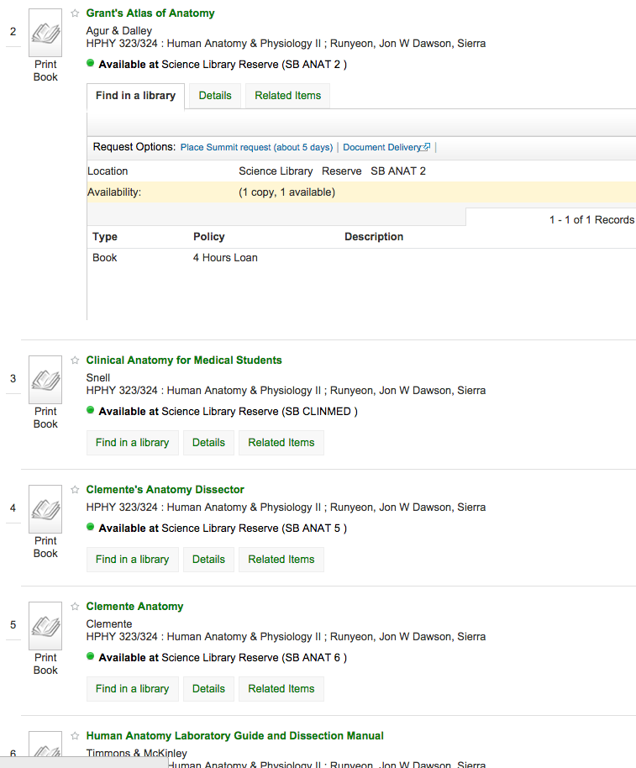

Leg 2 of 5: Finding an article

In this leg, go to the Research guide for Human Physiology, under Articles, scroll down to see Academic Search Premier. You are asked to find a recent scholarly (peer-reviewed/academic) article on:
Taking stimulants (like adderall) in college without a prescription.
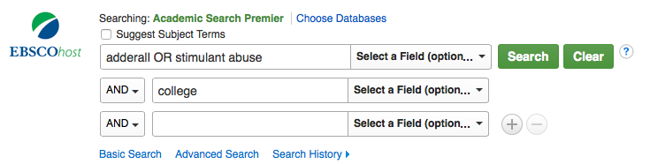 | 1. Type “oxygen uptake” into the first box, “running speed” into the second box.
By typing the words into the different boxes with the word “and” in between, you are asking the database to find articles with both the words oxygen uptake and running speed

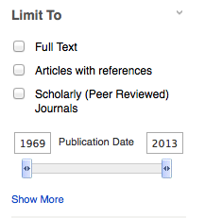 | 2. On the RESULTS screen  (or the 2nd screen after you click above)  Under “Limit To”, limit the search so that you only get articles that have been published in the last 10 years.

Part 1:
- Fill in the information below for an article that would be relevant AND is full text online (articles not deemed relevant will be returned):
1st Author: ______see attached for first few pages_________ How many others are there?: _______
Name of journal article was published in: _____________________________________________________
Year of publication: ______ Volume number: ______ Issue number: ______ Page numbers: __________
Article title (1st 5-7 words is FINE!): __________________________________________________________
If it is not readily available in full-text in this database. Click on the “FindText” link to see if it is available from another database.
- Can you link directly to the full text or do you need FindText?

Part 2:
Find the article: Gomes, J., Song, T., Godwin, L., & Toriello, P. J. (2011). Prescription Stimulant Abuse on University Campuses. Journal Of Human Behavior In The Social Environment, 21(7), 822-833. doi:10.1080/10911359.2011.615680.
- Is it available electronically (remember to check FindText to be sure)? ___NO________________________
2. If it isn’t available, fill out the View it > Interlibrary loan/Document Delivery > Article Request form. You’ll log in and fill out a form, take a picture of the screen where you request the article and bring it up with your completed sheet. Or bring your laptop up to the front.
If you place the request by accident, please delete the request unless you want this article

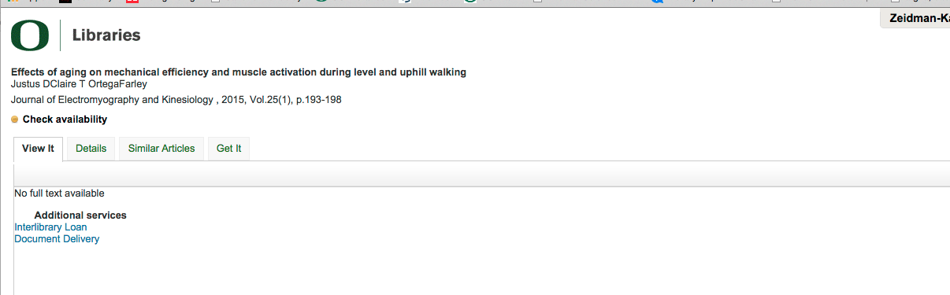

MAKE an account
Get to the screen that says article request, but don’t submit it.

Use floorplans of the Science library to give to students. Confirm that they have read that they are going to the REFERENCE section.
Have TA stand at the check out desk and help if needed. Point out the scanner, if possible.
Round up anyone who isn’t done by :40

Leg 3 of 5_{6s}: Using Encyclopedias

- As a team, use the map to go and find this encyclopedia in the reference section of Science Library.

2. According to the table 373-1 on page 2600, how long should an athlete with a 2nd grade 2 concussion plan to recuperate?

At least 2 weeks following complete resolution of symptoms at rest or exertion

Leg 3 of 5_{7s}: Using Encyclopedias

- According to the table 66-1 on page 1834, excluding NONE which form of contraception has the highest failure rate for typical use? Which one has the lowest failure rate with perfect use?
Spermicides
inplanton

Leg 3 of 5_{8s}: Using Encyclopedias

- How many athletes were assessed in the development of the University of Virginia’s Sports as a Laboratory Assessment Model (SLAM)? (volume 3, page 84) What is the title of the entry/article with this information?
2300 football players
Mild head injury

Leg 3 of 5_{9s}: Using Encyclopedias

- According to Table I and Table II, how many 12 oz Mountain Dew drinks do you need drink to get the same amount of caffeine in a standard adult doses of No-Doz (2)? (volume 2, Page 277)

4-5

Leg 4 of 5: Finding the impact of an article and getting a journal

In this leg, you are asked to use Web of Science to assess the impact an article made. Then get the article from the shelf and tell me how to scan a highly cited journal article to use in your research:

Light, K. C., Grewen, K. M. & Amico, J. A. (2005). More Frequent Partner Hugs and Higher Oxytocin Levels Are Linked to Lower Blood Pressure and Heart Rate in Premenopausal Women. Biological psychology, 69(1), 5–21.
1. Complete the following from Web of Science:
- Times cited: __121____
- Number of items in the bibliography (cited references): __68___

2. Use FindText (in the blue menu).
- Which tab tells you where you can find the print copy?
a. view it b. details c. tags d. similar articles e. get it
- What is the call number if you wanted the print? _____ QP351 .B4 _______________________

Leg 5 of 5: Space/Asking for help

- How far in advance do you need to book a room or study space in a library? Between 2- 24 hrs
- There are specific librarians assigned to each subject or major. Who is the subject librarian for Human Physiology? _________Annie Z-K____________________
- To connect from off-campus what software should you install? [See Technology section on Library homepage] _VPN_
- Of the 7 different ways that you can Ask a Librarian for help which one would you use?
Chat, email (general reference), phone, text, ___L-net_____ , ___Subject specialist contact______ , in person.

Homework leg and bring to your next discussion section. We’ll review the answers in discussion 3:

Finding the impact of an article and getting a journal

In this leg, you are asked to use Web of Science and Google Scholar to assess the impact an article made. [remember the list of databases on the HPHY Research Guide- http://researchguides.uoregon.edu/HPHY]:

1. Find this article in PubMed and add it to your Mendeley account. More on getting started with Mendeley on the back.

Lau, H., Tucker, M., & Fishbein, W. (2010). Daytime napping: Effects on human direct associative and relational memory. Neurobiology of Learning and Memory, 93(4), 554-560.

2. Find the Lau, et. al. (2010) article again in Google scholar (scholar.google.com):
- Cited by: ___67___
- Can you see the bibliography/reference list here (yes/no)? _____
- To see UO holdings using FindText, what does it look like?
a. b.

[Use Settings > Library Links > University of Oregon to see FindText (if you don’t already)].

3.Complete the following from Web of Science (for the same Lau,… (2010) article):
- Times cited: __25____
(Hint: The next 2 questions refer to the “cited references” part of WoS)
- Number of items in the bibliography (cited references): ___32__
- How many times has the most cited reference in the bibliography been cited? 8,467
- Use FindText (in the blue menu).
Which tab tells you where you can find the electronic copy ?
a. view it b. details c. tags d. similar articles e. get it

- Why is the citation count different between Web of Science & Google Scholar for the same article?

- Consider this statement: It is especially true in the sciences that research is a conversation. How would you support or refute this, especially in light of the skills you practiced in 1-3 above?

If you are done before the end of class you may start this reflection:
Canvas > Modules> Discussions> Amazing Race Skills> opens an Office 365 document

Mendeley help on the back of this sheet.

