Media Map for Lane Youth Theater
Facebook
Pros
- Lots of users of all ages: more followers or “likes”
- Create events, people can share if they are “interested”
- Ability to post videos, photos, elegantly shares links
- Ability to archive photos
Cons
- People get inundated with ads and event invites on FB
- Must post frequently and with high quality photos/videos
- Paid ads are high maintenance
Implementation
LYT uses Facebook to promote shows and events. It also allows users to get a good sense of who we are and what our shows look like, because Facebook is rich in photos and videos. LYT does not pay for ads, but, if executed well, it could greatly benefit our name recognition. This would require more page maintenance, though.
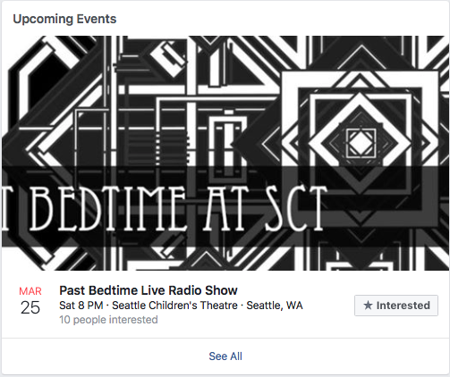
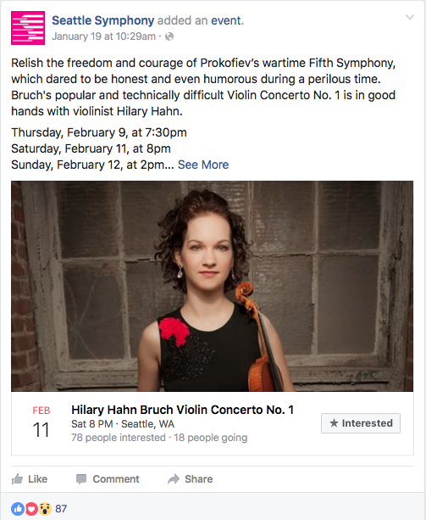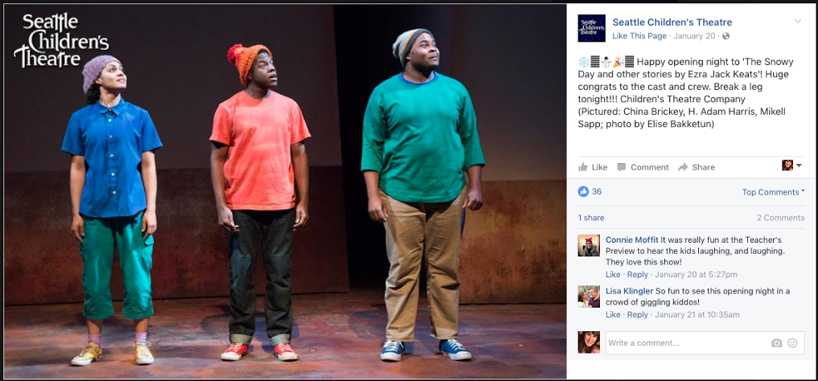

YouTube
Pros
- We are performing arts: post a clip of the performance
- Let cast make their own promotional video
- Post an interview with guest artist or cast
- Can be shared on other social media
Cons
- People don’t follow us on YouTube unless they specifically search LYT or the title of the performance
- Copyright for music
- Must be high quality video
Implementation
LYT does not have an official YouTube page. They post some videos on Facebook, but they could be higher quality. There are also YouTube videos out there of us, but they are not official. Having a YouTube channel could authenticate the high quality videos we want to post. YouTube is also a means for extended “behind the scenes” content, like rehearsals, interviews with the cast/directors, and we could even have the youth create their own promotional video. Anything we put on YouTube, we can share on Facebook. These two media platforms can boost their other’s recognition.
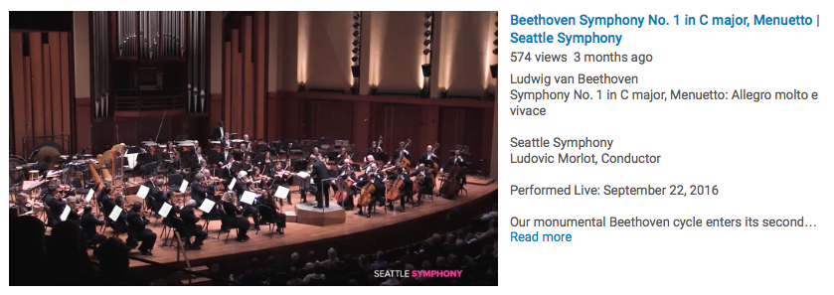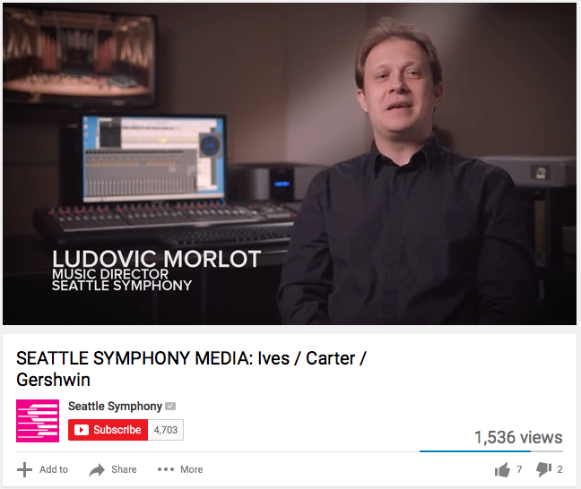

Twitter
Pros
- Retweet: connect with those who tag you (audience, guest artists, performers)
- Be funny: post gifs. You’re trying to attract youth
- Links
Cons
- There aren’t as many youth on Twitter as we may think
Implementation
LYT does not have a Twitter. We could use Twitter to show our “fun” side. Share gifs and memes that are theatre-related. Young users will follow us as a comedy source. Twitter is also a means to connect with those that are coming to our shows. Many companies have gained social credit for retweeting those who tag them.
