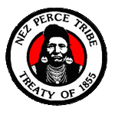
Nez Perce Tribe: Clearwater River Subbasin Climate Change Adaptation Plan

“This plan acts as a catalyst for the regional community to begin developing and implementing detailed adaptation strategies in order to better withstand the impacts of a changing climate upon the natural resources, economy and social structure of the Clearwater River Subbasin in the decades to come.” -The Clearwater River Subbasin Climate Change Adaptation Plan

Introduction
Climate impacts are expected to significantly alter the ecology of ecosystems which are both culturally and economically important to tribes throughout the Western US (Wildcat 2013). In an effort to prepare for changes to their homelands’ ecology, the Nez Perce Tribe’s Water Resources Division (NPT WRD) created a climate change adaptation plan for the Clearwater River Subbasin in 2011. The plan focuses on climate impacts to water and forestry resources, two areas of natural resource management that are both culturally and economically important to the Nez Perce Tribe (NPT). This plan will increase awareness of climate change issues in their region, and is also intended to aid the NPT and regional organizations in integrating climate adaptation into existing and future management plans.

Adaptation plan goals include:
The Nez Perce Tribe’s Water Resources Division received a grant and technical support from the Model Forest Policy Program (MFPP) of the Climate Solutions University (CSU) to that supported development of this plan. For more information about the MFPP, visit: http://www.mfpp.org/csu/

- Creating partnerships to research local effects of climate change on water resources, forestry, and the economy.
- Including climate change adaptation assessment data, goals, and objectives into local and regional planning documents.
- Affecting a change in planning and zoning regulations along waterways and restoring the 100-year floodplain.
- Protecting and restoring water quality and quantity for human health and anadromous fish.
- Managing wildfire risk.
- Reducing and/or reinforcing infrastructure in landslide-prone areas.
- Developing ecologically connected networks of public and private lands to facilitate fish, wildlife and plant adaptation to climate change.

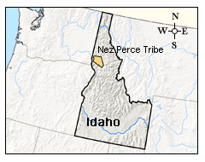
The plan includes a strong emphasis on regional collaboration. For many tribal communities, collaboration with surrounding communities may be a vital aspect of successful adaptation efforts. This is certainly true for the NPT, who has chosen to focus on both ecological goals and strategies for cooperation for their climate adaptation efforts.

Nez Perce people and homeland
The Nez Perce traditional homeland spans over 17 million acres and includes north central Idaho, southeastern Washington and northeastern Oregon, with additional accustomed gathering areas in western Montana and Wyoming. This homeland includes the Clearwater River Subbasin, as well as the South and Middle forks of the Salmon River. Nez Perce people traditionally moved seasonally throughout their territory. During the late 1870s, Nez Perce people were forcibly removed from their traditional homelands and confined to a reservation. Today, the Nez Perce Tribe is a federally recognized tribe with approximately 3,500 enrolled tribal members. The Nez Perce Reservation is located in north central Idaho, squarely within the Clearwater River Subbasin.

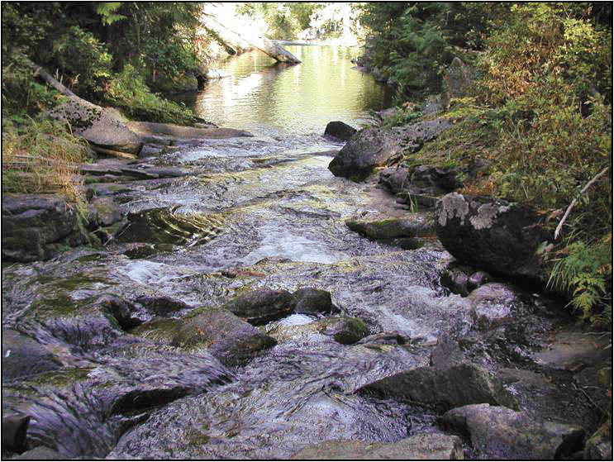
Clearwater River Subbasin
The Clearwater River Subbasin is an ecologically diverse area. It is 9,350 square miles in size, and is made up of a 100 mile north-south and 120 mile east-west territory that spans the Idaho-Washington border to the west and the Idaho-Montana border to the east. The Clearwater River flows nearly 75 miles from the Bitterroot Mountains in the east to the Snake River. The subbasin is made up predominantly of evergreen forests, but because elevations range from 730 to 9,400 feet, there are many different ecosystems within the subbasin. Variable precipitation conditions are also found within the subbasin, with some regions having as little as 12″of precipitation/year, and others as much as 85″.
Yoosa Creek, a tributary of the Clearwater River. Photo by Columbia River Intertribal Fishing Commission

In addition to the NPT, a number of other agencies and private landowners lay a claim to land within the subbasin. About 60% of the land within the subbasin is federally owned; private owners, the NPT, and the State of Idaho own the remainder. Almost half of the land in the subbasin is classified as protected, either as inventoried roadless areas, federally designated wilderness, Wild and Scenic River corridors, or Research Natural Areas. Because of the multiple owners and managers of this land, it is important that parties work together to formulate and adopt sound management strategies in climate adaptation. Several management plans exist in the region today, but these plans do not include a focus on climate impacts.

Climate Impacts to the Clearwater River Subbasin:
The Clearwater River Subbasin faces a variety of climate impacts. Risks identified in the Tribe’s adaptation plan include:

- An increase in wildfire intensity and severity.
- Changes in the current distribution and composition of forest communities.
- An increase in the number and distribution of invasive/destructive plant and insect species.
- Loss of productivity in key timber species.
- An increase in the elevation of typical winter snowline.
- Earlier spring peak streamflows.
- Higher summer water temperatures, and a decrease in water quality overall.
- A change in habitat types for fish and wildlife.
- Negative impact to non-irrigated farmland, from drier conditions in summer.
- An increase in wildfire suppression costs.
- Negative impacts to recreation and tourism.

The adaptation plan focuses on three areas: forest resources, water resources, and economic impacts. Each area includes an assessment of existing conditions in the subbasin, and data on how changes in climate may impact forests, waters, and the local economy.

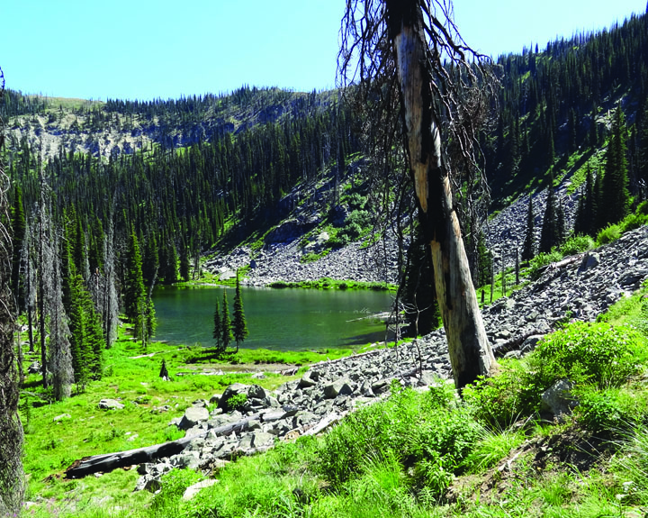
Forest Assessment
Forests are a major area of concern, especially given that approximately two-thirds of the acreage of the subbasin is evergreen forest. There is an extensive history of logging in the region; accompanying this is a period of fire suppression-based forest management. Both of these factors have heavily influenced the species distribution in the subbasin today, and will continue to affect the region as climate impacts in the subbasin become more pronounced. Impacts to forests from climate change may include the following:

- Changes to species range and population: Due to changes in temperature and precipitation, tree species are likely to shift in range and abundance. This has implications for ecosystem health and will likely result in consequent changes to fauna species distributions. For example, Douglas fir—a notable timber species—is projected by USDA Forest Service models to experience significant loss of habitat within the subbasin over the next century. Other species, such as lodgepole pine, are predicted to no longer occur within the subbasin by the end of the century.
Magruder Road Corridor, Clearwater National Forest. Photo by USFS

- Invasive species and pests: Elevated temperatures brought on by climate change often favor invasive species and pests such as the Pine Beetle. Native ecosystems are likely to suffer in the face of rapid climate changes, while highly competitive invasive species have opportunities to expand, due to the weakened state of native ecosystems. For example, existing research on yellow starthistle (an invasive species currently found within the subbasin) has shown that it experiences dramatic increases in growth and size when exposed to increased temperatures, precipitation, and other factors associated with climate change, while native grasses do not.

- Wildfires: Several factors influence fire risk, including the fuel load or density of the forest, seasonal amounts of precipitation, average temperatures, and the lengths of seasons. In the subbasin, climate impacts are projected to increase the length of the fire season by causing earlier snowmelt. Additionally, invasive species such as yellow starthistle may increase the fuel load of forest and grassland ecosystems, creating potentially hotter and deadlier wildfires.

Water Assessment
The Clearwater River Subbasin has extremely variable precipitation patterns and stream flow rates, because of the range of elevations found within the region. The subbasin is considered a snow-dominant watershed, as most of the precipitation that feeds into the watershed comes from snowmelt. While the subbasin features seventy dams in its waterways, some of the largest tracts of roadless land in the lower 48 states are also found there. These unique factors make classifying the precipitation patterns in the Clearwater River Subbasin a complex task. However, several climate change impacts on water resources are obvious concerns across the subbasin and may include:

- Changes to seasonal water flows: Earlier runoff of snowmelt is expected to change the seasonal flows of streams. Spring flows will peak earlier, while summer flows will decrease, making summer seasons drier. One potential impact is to wetlands in the region. Wetlands perform a variety of important ecosystem services, included water filtration. They depend on regular stream flows, and many wetlands are likely to disappear with earlier snowmelts.

- Decreased water quality: Increased water temperatures, especially during summer seasons, are a major water quality concern. Warmer waters affect wildlife, can encourage the growth of harmful algae and bacteria, and alter nutrient composition of water.

- Loss of Snow Water Equivalent: Snow Water Equivalent (SWE) is the amount of water found within snowpack. Over the last 50 years, SWE has decreased across the region, and this trend is expected to continue over the next century. Also, precipitation as rain is projected to increase at the same time. Snowpack serves an important role in maintaining stream flows and providing water to ecosystems throughout the year. Because of this, changes to seasonal snowpack could have major impacts on ecosystems within Clearwater River Subbasin.

- Impacts to wildlife: Aquatic species are highly sensitive to changes in water quality and quantity. Existing research indicates that cutthroat trout, a native species, is likely to be heavily impacted by the changes listed above. Other salmonid species are also likely to be impacted in similar ways, which is a major concern for the NPT.

Economic Assessment
The plan draws upon census data to provide demographic data about population, age and income across counties in the Clearwater Subbasin. Drawing on this data, the authors identify agriculture, forestry, tourism and recreation, and fishing as areas of the economy that face significant impacts from climate change.

- Agriculture: Almost all of the agriculture in the subbasin is non-irrigated dryland farming. Consequently, changes to seasonality and amount of rainfall could have major impacts on farms.

- Forestry: USDA Forest Service climate models project a decrease in Douglas fir habitat within the subbasin. Douglas fir is a major source of timber revenue, and loss of this species would impact the timber industry.

- Tourism/recreation: While there is no regional data on the amount of revenue generated by tourism and recreational activities, state-wide data indicates that these industries are significant. Changes to forests and streams will in turn impact recreation in the subbasin.

- Fishing: Both tribal and recreational fishers use the subbasin extensively. The economic impacts of decreasing fish health could be major. For example, in a single season, fees from anglers generated about $24 million in expenditures in the Clearwater River Subbasin.

Opportunities for Adaptation
This plan focuses on opportunities to prepare for and adapt to the impacts of climate change. Using a risk matrix that considered adaptive capacity and impact probability to calculate risk, the tribe developed a list of risks for each resource area, as well as goals to guide future adaptation efforts, and objectives to inform future tribal and regional management decisions. By including specific goals, objectives, and measures of success for each objective, the tribe ensures that this plan can be applied across a wide range of adaptation efforts. This format also encourages readers to view the plan as a living or working document, which can continually inform and aid in adaptation efforts, and not merely provide static information about climate impacts. Creating goals to address specific impacts creates a path for the NPT to take as they move forward with climate adaptation efforts. In the example provided below, the plan identifies avenues for protecting water quality in the near future. The development of specific strategies to meet climate adaptation and ecological restoration goals gives a clear pathway to promote actions that directly address climate impacts.
Goal 2. Protect and restore water quality and quantity for human health and aquatic organisms.
Objective: Protect and restore springs and wetlands to abate peak flooding, maintain base flows, and improve water quality.
Strategies:
- Identify and map historic wetlands.
- Prioritize springs and wetlands for protection and restoration based on cost/benefit analysis.
- Provide education and outreach on the importance of wetlands for water storage in a rain-dominated climate
Measures:
- Development of historic wetland maps.
- Development of a prioritization matrix or model.
- Development and distribution of educational materials.
Source: Clearwater River Subbasin Climate Change Adaptation Plan
Moving Forward
Within the Clearwater River Subbasin, climate impacts will create a diverse set of risks which are likely to vary across time and space. The large variety of elevations and ecosystems found within the subbasin form a complex web of risks from climate change. This adaptation plan addresses the diverse and continually changing nature of climate impacts in the region.
The NPT has developed an adaptation plan that is marked by both a regional focus and an emphasis on proactive adaptation strategies. By developing a plan that focuses on both tribal and surrounding lands, the NPT has created opportunities for collaboration with others in the region. This may be vital in addressing climate impacts that occur across boundaries and impact neighboring groups, such as federal lands and agencies, municipalities, and private landowners, in addition to the NPT. The tribe also intends for the plan to serve as a “call to action,” in hopes of spurring proactive solutions to ongoing climate impacts. By focusing on collaboration and proactive adaptation strategies, the NPT WRD has developed an adaptation plan that can act as a starting point for successful adaptation strategies in the Clearwater River Subbasin. Implementing the plan and moving forward with adaptation strategies will require dedicated funding to support organizational capacity and specific adaptation measures.

Resources
- Clark, Ken and Jenifer Harris. 2011. “Clearwater Subbasin (ID) Climate Action Adaptation Plan.” Nez Perce Tribe Water Resources Division; Model Forestry Policy Program; Cumberland River Compact.
- Model Forest Policy Program (MFPP), Climate Solutions University (CSU): http://www.mfpp.org/csu/
- Nez Perce Tribe. “History.” Website. Accessed March 30, 2014
- Wildcat D. 2013. “Climate change and indigenous peoples of the USA.” Climatic Change 120(3): 509-515.

Nez Perce Tribal Contact:
Ken Clark, Water Quality Program Coordinator, Water Resources Division
Nez Perce Tribe, P.O. Box 365, Lapwai, ID 83540
Office: 208-843-7368 ext. 3903
kenc@nezperce.org

Tribal Climate Change Profile Project:
The University of Oregon Environmental Studies Program and the USDA Forest Service Pacific Northwest Research Station are developing tribal climate change project profiles as a pathway to increasing knowledge among tribal and non-tribal organizations interested in learning about climate change mitigation and adaptation efforts. Each profile is intended to illustrate innovative approaches to addressing climate change challenges and will describe the successes and lessons learned associated with planning and implementation. For more information about the PNW Tribal Climate Change Project, contact Kathy Lynn at kathy@uoregon.edu, or visit http://tribalclimate.uoregon.edu/.

Carson Viles, a University of Oregon undergraduate research assistant with the Project, is coordinating development of these profiles. Carson is an enrolled member of the Confederated Tribes of Siletz Indians. He is in the Clark Honors College and completed his degree in Environmental Studies in December 2013. Carson can be contacted at cviles@uoregon.edu.

