Understanding the genetic basis of human skill learning
Posner/Rothbart/Voelker

A. Specific Aims

1. We have found that two to four weeks of mental training can alter the efficiency of white matter as measured by Diffusion Tensor Imaging and that these changes are accompanied by an increase in theta activity recorded from scalp electrodes at locations that have been related to anterior cingulate activity. To test whether the increase in theta rhythm can cause changes in white matter pathways we are currently using a mouse model in which we impose a theta rhythm via optogenetic modulation of basket cells that control the output from the anterior cingulate. Under this proposal we will examine which genes have been turned up or off by comparing control mice with those who undergo a month of theta rhythm stimulation. We will then select those genes expressed in humans that have frequent polymorphisms to further examine their role in human skill learning using the methods describe in aim 2 to determine their role in skill learning.

2. We have found in 7 year old children that individual differences in the rate of improvement of reaction time with practice depends upon a gene supporting the process of gene methylation. We want to test the generality of this finding by studying skill learning in adults and determining if the rate of improvement with practice differs depending upon allele-specific differences in methylation efficiency and in the efficiency of neurotransmitter-dependent signaling relevant to the behavioral task performed. Ultimately, we hope to demonstrate that skill learning is methylation-dependent, and varies with differences in neural activity.

B. Background and Significance

The overall goal of our project is to carry out studies at multiple levels that link significant aspects of human development to underlying neural networks and eventually to the molecular events from which these networks arise. Our longitudinal study from infancy to childhood conducted under our previous NICHD grant has provided many findings relating parenting to building the networks that underlie higher levels of attention and self regulation. Our findings provide an important role for changes in brain connectivity in these events and show that genes related to executive attention are important part of individual differences in the efficiency of these networks. A new grant may allow us to move forward to show how molecular events influence white matter and how genetic alleles that modulate learning may integrate with these developments to facilitate human skill learning

Practice leads to improved performance in a large variety of cognitive tasks. The mechanisms of this improvement remain somewhat obscure. Recently a number of studies of specific skills such as juggling, music or working memory have revealed that changes in functional connectivity between neural areas may play an important role in this improvement ( for a review see Zatorre, Fields & Johansen-Berg, 2012). In work with 725 children age 4-21 (Fjell et al 2012) it was found that improved reaction time in the flanker task was correlated with the size of the anterior cingulate before age 7 and improvements in reaction time after that with the functional connectivity of the white matter pathways around the ACC.

In our work we have found that a few weeks of mental training based on mindfulness meditation can improve the efficiency of white matter tracts surrounding the anterior cingulate (Tang et al 2010). The widespread behavioral consequence of this training include improved attention and reduced stress (Tang & Posner, 2012).

How can white matter change in as little as 2 weeks to 4 weeks of training? Based on new ideas about the dynamic nature of white matter (Bierowski, 2012) we propose that sustained theta rhythms in mid frontal areas (Xue, Tang & Posner, 2014) leads to increased protease activity which induces dormant oligodendrocytes to increase myelination and thus improve the efficiency of conducting neural activity (Posner, Tang & Lynch, in process). This idea, if confirmed by experiment could provide an important way of linking various forms of practice (Tang & Posner,2012) to brain changes.

Genetics of Individual Skill Learning

In the section above we examine how changes in white matter may occur following practice. It is well established that reaction time generally improves with practice, but the rate of improvement depends on the individual. In our work we have uncovered several
Genes related to individual differences in attention (Posner, Rothbart & Sheese, 2007) and shown shown how some of them interact with parenting to shape behavior in childhood (Sheese et al 2007; 2012).

Learning of skills in adult frequently involves a long period of improvement in reaction time with practice. Part of this may be due to the while matter changes we have discussed above, however, practice or priming may change RT within millisec so not all changes in RT are due to white matter changes. Our studies of children have shown improvements in RT with practice but after some period of practice RTs tend to increase. We think the increase in RT may be due to fatigue. Our study of seven year olds found that performance in one reaction time task (Attention Network Test) improved significantly from session 1 to session 2 and was slightly worse in session 3. We found that the improvement in RT from session 1 to 2 was related to a gene influencing methylation, interacting with a dopamine gene related to executive attention. We found that reduced performance from session 2 to 3 was related to the same methylation gene interacting with a gene related to alerting via norepinephrine.

We propose to test the generality of this result by genotyping and running 70 adult subjects in several different skill learning tasks including the Attention Network Test, implicit learning of sequences and verbal paired associate learning.
If our findings generalize across ages and tasks they may be an important link between epigenetic mechanisms and individual differences in human skill learning.

C. Preliminary Results

Training and White Matter

In our studies of mental training in adults (Tang et al 2010) we found significant increases in fractional anisotropy (FA) following 2 to 4 weeks in several pathways surrounding the anterior cingulate shown in color in Figure 1.
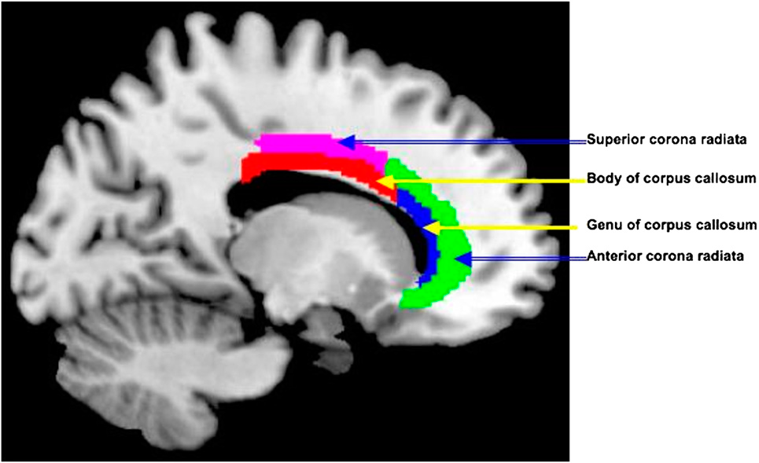
Subsequent studies showed that after two weeks these changes involved axonal density
as measured by reductions in axial diffusivity
while after four weeks both axial diffusivity and
radial diffusivity (related to myelination) declined (Tang et al 2012).

We also found that the same form of mental
training increased theta activity in midline frontal electrodes (Xue, et al,2014) that we had found to localize to the anterior cingulate gyrus (Deheane, et al 1997). Figure 1: White matter tracts
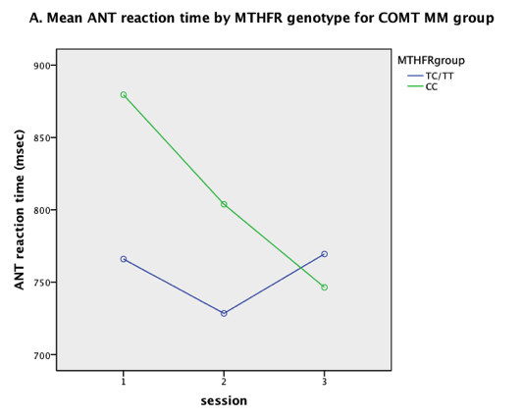
Based on the literature review in B above we have
hypothesized that theta activity is central to the finding of increased FA
following mental training.
In order to test this hypothesis further we have formed a collaboration with Prof. C. Niell who has been carrying out optogenetic studies on mice for several years. He will work with us to impose theta activity FIGURE 2
in midline frontal areas to carry out the research described in more detail in C below.

Genetic Studies

In our longitudinal study conducted last year we found that 7 year old children homozygous for the C allele of the MTHFR gene, which supports more efficient methylation, showed significantly greater improvement in reaction time (RT)with practice on the attention network test. This result is illustrated in Figure 2 . We also found that the level of methylation interacted with the COMT gene such that the differences in RT were associated entirely with the met/met genotype. Allelic differences of COMT have been related to differences in neural activity in the prefrontal cortex during cognitive tasks (Egan et al, 2001; Bishop, Fossella, Croucher, and Duncan, 2008; Jaspar et al, 2014).

Many children showed an initial improvement in RT followed by a decline in performance. We found that alleles of the DBH gene, whose function is associated with sustained attention (Greene et al 2009), in conjunction with MTHFR were related to this performance decline. Allelic differences in DBH have been associated with differences in temporal activity during an oddball cognitive task (Windemuth et al, 2008), to date there have not been reports demonstrating allele-specific activity differences in the ACC. These results show dissociation between genes related to improvement in learning a skill and those related to reduction in performance with continued practice

C. Research Plan
Specific Aim 1
To examine Aim 1 we have decided to use a mouse model. The idea is to infect PV basket cells in the mouse ACC to control the output of pyramidal cells from ACC to other areas of the network. To target these neurons we would use PV-cre driver mouse lines in combination with adeno-associated virus to deliver channelrhodopsin2 (ChRs) rendering the neurons light sensitive. We will use optical fibers implanted in deep layers of the ACC to deliver 1 millisec pulses of blue light at 6 Hz (mean of theta rhythm) for 30 minutes per day. Sixty inbred mice FIGURE 3
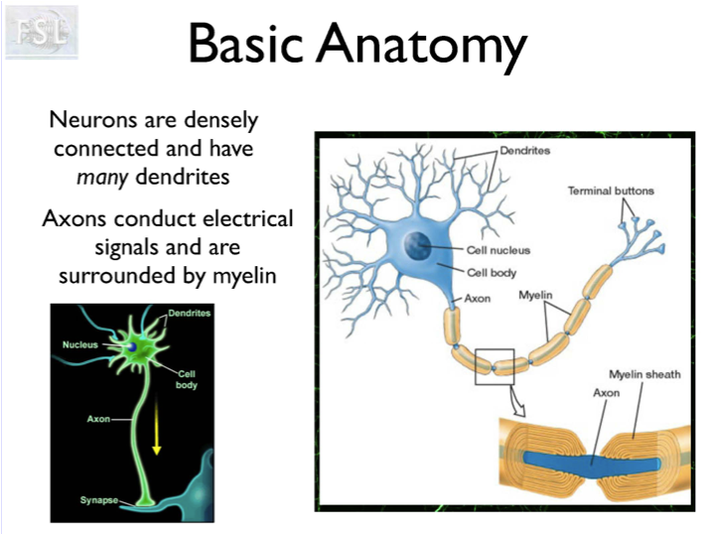
will be divided into two equal groups.
Group 1 will be a control population and used
to assay axonal density and myelination in axons surrounding the anterior cingulate.
(see illustration in Figure 3).

Group 2 will be assigned to two weeks of light pulses .5 hour each day 5 days a week at 6 hz. This theta wave stimulation is designed to simulate the increased theta activity found in the midfrontal brain areas of humans. Following the two weeks of stimulation the second group white matter will be assayed in the same manner as group 1. The comparison will tell us whether and exactly what changes in white matter pathways will result from theta stimulation

To determine which proteases may be involved, samples from the anterior cingulate will be harvested in order to quantify transcript levels and assay proteolytic activity. In particular, we will identify any changes in the expression of candidate proteases, such as calpain and nogo, and characterize other differences in transcriptional expression as the result of theta induction.

According to our hypothesis the protease involved is calpain. To test this idea
we will examine the theta exposed and control mice for calpain levels by assaying calpain activity in excised brain tissue. A cytosolic preparation will be quantified for activated calpain using a fluorometric assay to compare fluorescent cleavage product intensity from the treatment sample with the control to determine differences specific to calpain activity. This result will be contrasted by utilizing an assay for general proteolytic activity to allow for the possibility of other proteases mediating or contributing to the treatment effect.

To determine the role of oligodendrocytes in this process we will examine their activation/inactivation level in Group 1 and compare with Group 2 after theta wave stimulation.

Finally we will use tissue from the two groups of mice to assay genes that are influenced by the theta wave stimulation. A preparation of transcripts will be isolated from the excised tissue and contrasted by group using mouse expression microarray analysis. A whole-genome expression profile will enable us to identify shifts in transcriptional gene expression that result from changes in gene regulation. We expect to see increased expression of genes supporting neuroplasticity and myelination, complementing observations of white matter changes that occur due to treatment. Calpain, in particular, has been implicated in the cleavage of several transcription factors (c-Jun, c-Fos, MEF2, NFκB) and has been shown to indirectly regulate glutamate receptor components and PSD95, which plays a role in synaptic plasticity. We hope to identify components within gene pathways recruited to facilitate neural change in order to characterize the mechanism of response to theta induction.

Specific Aim 2

Reaction time (RT) generally improves with practice, but after learning has progressed RT may remain steady or even increase. Many have thought the increase in RT may be due to fatigue. Our study of seven year olds found that performance in one reaction time task (Attention Network Test) improved significantly from session 1 to session 2 and was slightly worse in session 3. We found that the improvement in RT from session 1 to 2 was related to an interaction of a methylation gene related to learning and a dopamine gene related to executive attention. We found that reduced performance from session 2 to 3 was related to the same methylation gene interacting with a gene related to alerting via norepinephrine.

We propose to test the generality of this result by genotyping each person for MTFHR, COMT, and DBH as we did in the previous study. With the inclusion of an orienting task, we will also include gene polymorphisms that have been shown to modulate acetylcholine neurotransmission associated with orienting by genotyping allelic variations of CHRNA4 and APOE. We plan to run 70 adults volunteers who will be students at the U of O between the ages of 18 and 28. Each participant will come for three one hour session. We plan to use three diverse skill learning tasks as outlined below.

Attention Network Test (ANT)
All 70 subjects will perform the ANT three times, once in each session. The test will involve 248 trials in each of the sessions. The ANT takes about 20-30 minutes to perform.

Paired Associates Learning Task (PAL)
All 70 subjects will perform the PAL in one session. We will look at performance of word association learning. The PAL should take 20-30 minutes to complete. Using computer graphics, 30 word pairs will be shown sequentially, this will be followed by a testing phase. In the testing phase stimulus words will be displayed for 2 seconds, during which the person will generate a response by naming its paired word, after his response the stimulus and response words will be shown together for 2 seconds. Subjects are instructed to try to name the word prior to the response appearing. Trials continue until the participant has been correct on all pairs. The % correct for the 30 pairs will be measured on each replication and number of trials to completion will be scored.

Spatial Sequence Learning Task (SSL)
All 70 subjects will perform the SSL in one session. We will look at the efficiency of spatial learning. The SSL should take 20 minutes to complete. The method will follow that used in a study by Curran and Keele (1993). Using computer graphics, a presents a sequence of targets is arranged in four locations on the screen. When an ‘X’ is presented the participant is to press the key under that location as rapidly as possible. Performance on trials with a repeating fixed sequence is compared with trials in which the sequence is random. The increased speed with the repeating trials is a measure of learning of the sequence.

We expect to see individual differences in the rate of learning that corresponds to allelic differences in neurotransmitter metabolism for the neurotransmitter that mediates the specific skill evaluated. This observation should interact with allelic differences in methylation capacity in order to identify a relationship between activity-dependent methylation and performance. If our findings generalize across ages and tasks they may be an important link between epigenetic mechanisms and individual differences in human skill learning.

E References

Beirowski B, (2013) Concepts for regulation of axon integrity by enwrapping glia.
Frontiers in Cellular Neuroscience 2013, 7:256

Bellgrove MA, Hawi Z, Gill M, Robertson IH.(2006) The cognitive genetics of attention deficit hyperactivity disorder (ADHD): sustained attention as a candidate phenotype. Cortex. 42(6):838-45. PMID: 17131588

Bishop SJ, Fossella J, Croucher CJ, Duncan J. (2008) COMT val158met genotype affects recruitment of neural mechanisms supporting fluid intelligence.
Cereb Cortex. 2008 Sep;18(9):2132-40. doi: 10.1093/cercor/bhm240.
PMID: 18252743

Curran, T. &Keele., S.W. (1993). Attentional and nonattentional forms of sequence
learning. Journal of Experimental Psychology, 19(1), 189-202.

Day, J.J., Childs, D., Guzman-Karlson, M.C., Kibe, M., Moulden, J., Song, E., Tahir, A.
& Sweatt, J.D. (2013) DMA methylation regulates associative reward learning
Nature Neuroscience 16/10 1445-1452

Dehaene, S., Posner, M.I. & Tucker, D.M. (1994). Localization of a neural system for
error detection and compensation. Psychological Science, 5: 303-305.

Egan MF, Goldberg TE, Kolachana BS, Callicott JH, Mazzanti CM, Straub RE, Goldman D, Weinberger DR. (2001) Effect of COMT Val108/158 Met genotype on frontal lobe function and risk for schizophrenia.
Proc Natl Acad Sci U S A. 98(12):6917-22. Epub 2001 May 29.
PMID: 11381111

Fjell, A. M., Walhovd, K. B., Brown, T. T., Kuperman, J. M., Chung, Y., Hagler, D. J., Jr., et.al. (2012). Multimodal imaging of the self-regulating developing brain.
[Multicenter Study Research Support, N.I.H., Extramural Research Support, Non-U.S.
Gov't]. Proceedings of the National Academy of Sciences of the United States of
America, 109(48), 19620-19625.

Greene, C.M. Bellgrove, M.A,.Gill, M. & Robertson I.H. (2009) Noradrenergic genotype predicts lapses in sustained attention
Neuropsychologia 47 591–594

Jaspar M, Genon S, Muto V, Meyer C, Manard M, Dideberg V, Bours V, Salmon E, Maquet P, Collette F. (2014) Modulating effect of COMT genotype on the brain regions underlying proactive control process during inhibition.
Cortex.50:148-61. doi: 10.1016/j.cortex.2013.06.003. PMID: 23859480

Posner, M.I., Rothbart, M.K. & Sheese, B.E. (2007) Attention Genes Developmental Science 10, 24-29

Posner M.I., Tang, Y.Y. & Lynch, G. (in process) Mechanisms of White Matter Change Induced by Changes in Brain State To be submitted to a special issue of Frontiers in Psychology Sept. 2014

Sheese, B.E.,Voelker, P.M., Rothbart, M.K., & Posner, M.I. (2007) Parenting quality
interacts with genetic variation in Dopamine Receptor DRD4 to influence
temperament in early childhood Devel & Psychopathology 19, 1039-1046

Sheese, B.E., Rothbart, M.K., Voelker, P., & Posner, M.I. (2012) The dopamine receptor D4 gene 7 repeat allele interacts with parenting quality to predict Effortful Control in four-year-old children Child Development Research vol 2012 ID 863242 doi:10.1155/2012/863242

Tang YY, Lu Q, Fan M, Yang Y,& Posner MI (2012) Mechanisms of white matter changes induced by meditation. Proc Natl Acad Sci U S A 109: 10570-10574.

Tang Y, Lu Q, Geng X, Stein EA, Yang Y, & Posner MI (2010 Short term mental training induces white-matter changes in the anterior cingulate. Proc Natl Acad Sci U S A 107: 16649-16652

Tang YY, Ma Y, Wang J, Fan Y, Feng S. Lu Q, Yu Q, Sui D, Rothbart MK, Fan
M, & Posner MI (2007) Short term meditation training improves attention and self
regulation. Proc Natl Acad Sci U S A 104:17152-17156.

Tang YY & Posner, MI (2014) Training brain networks and states Trends in Cognitive Science http://dx.doi.org/10.1016/j.tics.2014.04.002

Windemuth A, Calhoun VD, Pearlson GD, Kocherla M, Jagannathan K, Ruaño G.
(2008) Physiogenomic analysis of localized FMRI brain activity in schizophrenia. Ann Biomed Eng. 36(6):877-88doi: Epub 10.1007/s10439-008-9475-2. PMID: 18330705

Xue S, Tang YY, Tang R, Posner MI:: Short-term meditation induces changes in brain resting EEG theta networks. Brain and Cognition 2014, 87:1-6

Zatorre RJ, Fields RD, Johansen-Berg H. (2012) Plasticity in gray and white: neuroimaging changes in brain structure during learning. Nature Neuroscience 15:528-536

\

