Rainfall and landsliding - the relationship between pore pressure and slope instability
In saturated soil or rock, water in voids imparts a buoyancy force that reduces the contact force between grains. As a result, saturation reduces the frictional strength of saturated soil or rock making it susceptible to slope failure. 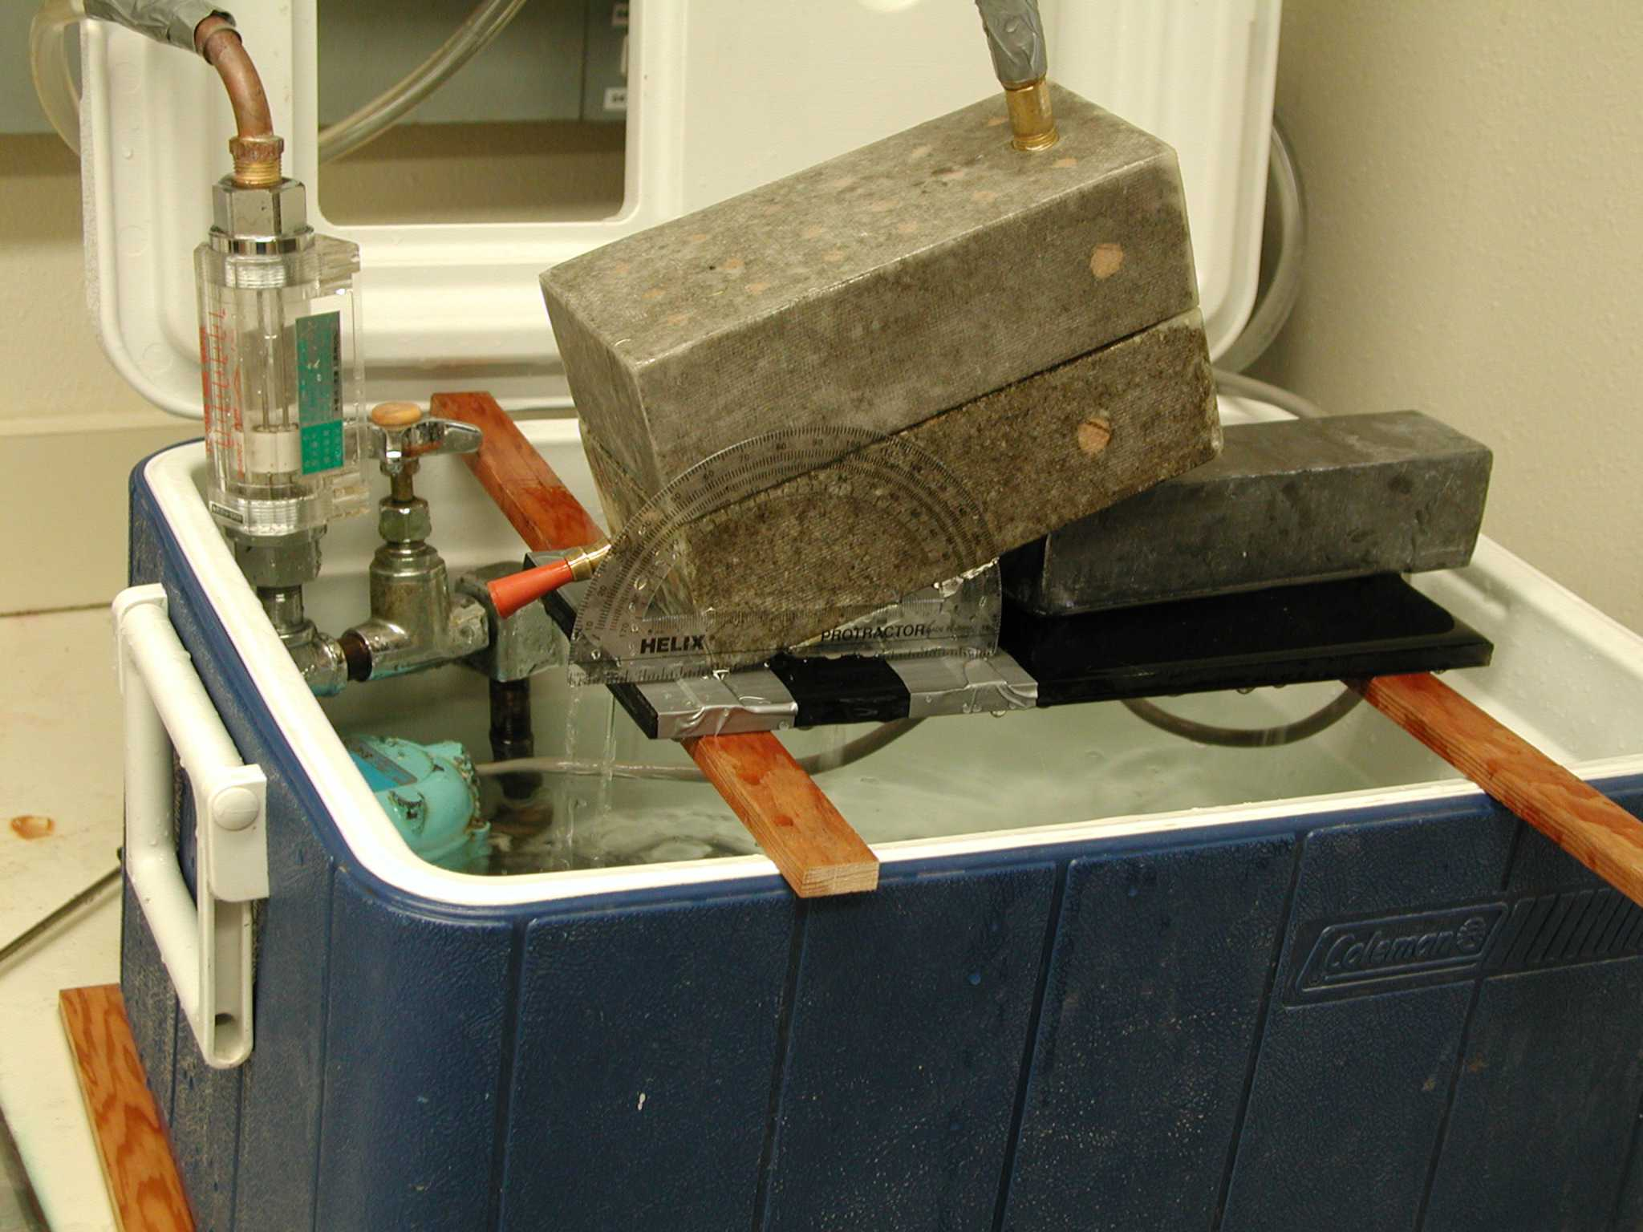
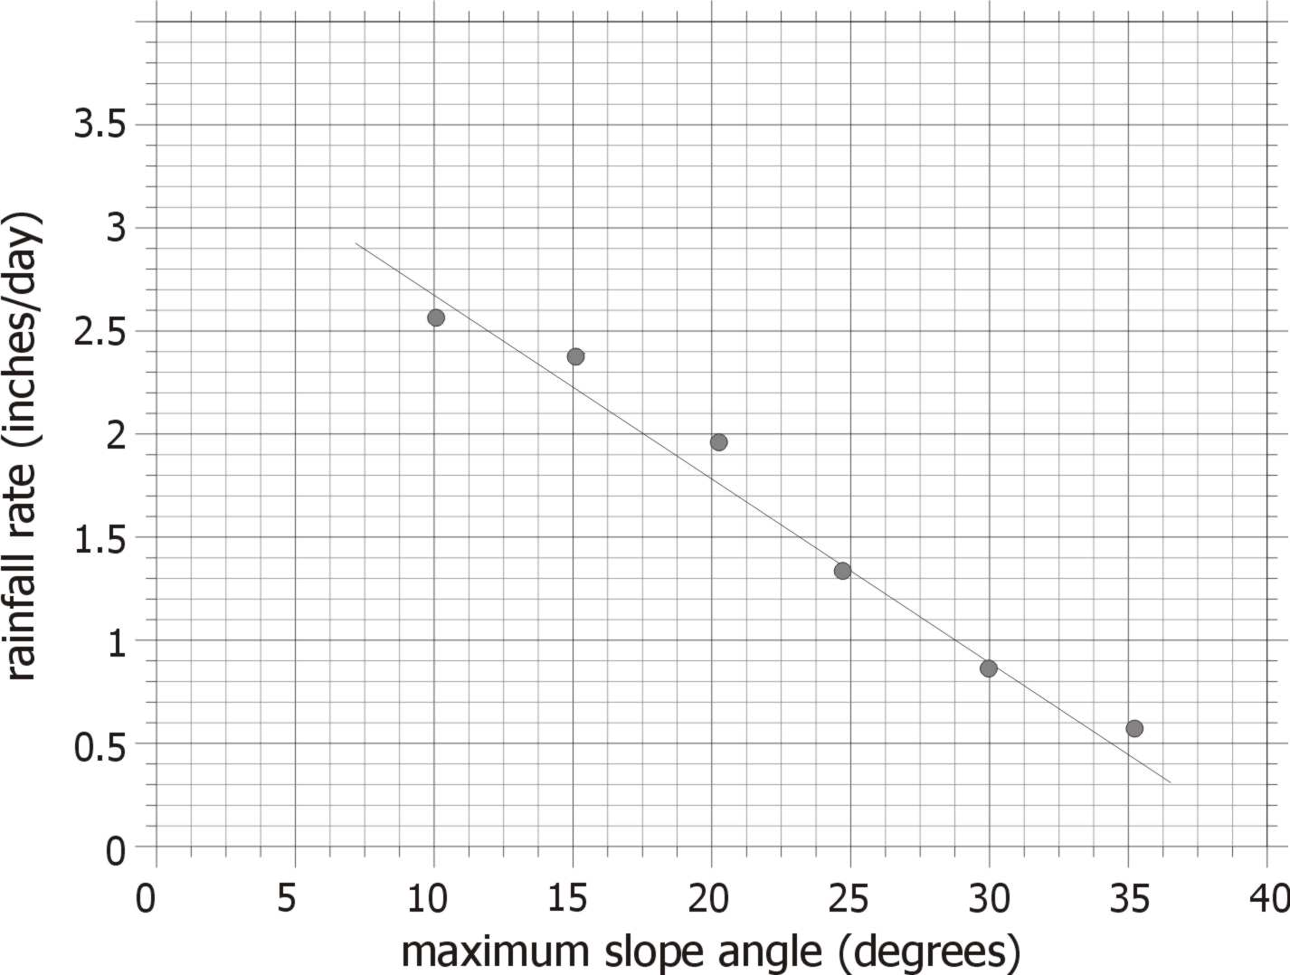
The magnitude of fluid (or pore) pressure between grains depends on the level of the water table. As the water table rises (and approaches the surface), fluid pressures rise and increase the likelihood of landsliding. High rainfall rates tend to cause rapid rise of the water table. We use our laboratory landslide model to explore how rainfall affects landsliding. Specifically, we determine how the rainfall rate (or water input rate) affects the slope angle at which landslides occur. A pump attached to the upper of two porous cinder blocks delivers water at a controlled rate. The water infiltrates through the upper block and percolates into the lower block until that lower block becomes saturated. If the water pressure along the cinder block interface is sufficient to reduce the frictional contacts, failure results and the upper cinder block slides off (Landslide!). The amount of water pressure (controlled by the pump) necessary to induce failure depends on how steeply the blocks are titled. Steeper blocks require less water for failure. For this in-class demonstration, we tilt the blocks at different angles and then slowly increase the water input rate until failure is induced. The valve enables us to record the water input rate at the time of failure, which can be roughly correlated with water pressure along the cinder block interface. An example relationship between water input rate (which is actually measured in liters/min) with the slope at which the blocks slide.

